Weather Preferences Distributed Databases App
Goian Sergiu
244

This web app allows users to organize their preferences in different moules by country, location and min and max temperatures, then based on the preference from a certain location, an option ot trigger the forecast for the next 7 days for the location’s coordinates and filtered by the min and max temperatures added by the user in his preferences. The project is implemented using Jakarta Servlets, EJB for managing service class instances, JPA as layer between the app’s service and databases, Reactjs for frontend and for persistency 3 databases in a distributed architecture (Sql Server to store Countries, Postgres to store locations and oracle to store weather preferences).

Functional Flow
Users can add / remove / modify country:
-name
-region
CountriesServlet implements the get, post, put, delete methods:
-each Http method comunicates with the underlying layer (service) that provides business logic
-validates data, handles errors
LocationsServlet implements the get, post, put, delete methods:
-each Http method comunicates with the underlying layer (service) that provides business logic
-validates data, handles errors
-communicates with the Geoapify API to get latitude and longitude coordinates for a specific location
WeatherPreferencesServlet implements the get, post, put, delete methods:
-each Http method comunicates with the underlying layer (service) that provides business logic
-validates data, handles errors
-communicates with the Open Meteo API for getting 7-day forecasts for given coordinates of a location and filter them based on the user’s weather preferences at that location (minimum / maximum temperatures)

Diagram:
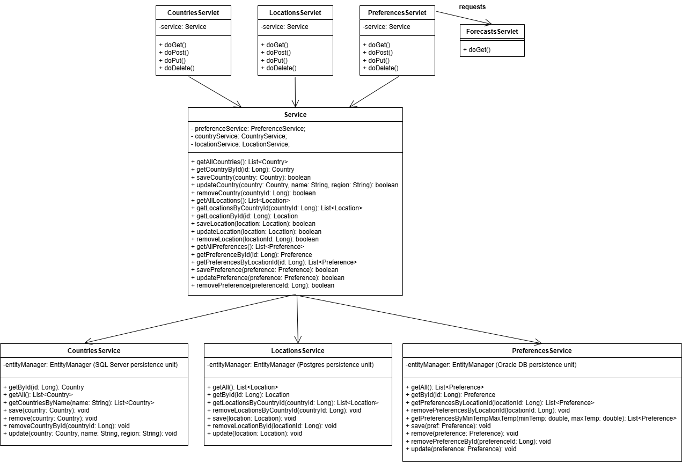

External Services:
For this task, 2 external APIs were used:
-Geoapify Geocoding API: converts location / address to coordinates, which are extracted form the JSON response; this API needs an API_KEY
-Open Meteo Forecast daily API: Retrieves for the extracted coordinates the weather forecast for the next 7 days, for each day a max and min temp, extracted from the JSON response; API_KEY is not required
Components:
The components of the system interact as below:
CountriesServlet:
URL: /countries
Injected: @EJB Service service
Purpose: CRUD operations for Country entities
Methods:
GET - list all or get by countryId
POST - create a new country
PUT - update existing country
DELETE - remove country by ID
Notes: Returns JSON, validates input, handles duplicates and persistence errors
LocationsServlet:
URL: /locations
Injected: @EJB Service service
Purpose: CRUD operations for Location entities with geocoding
Methods:
GET - list all or filter by locationId/countryId
POST - create location (fetch coordinates from Geocoding API)
PUT - update location (update coordinates if name changes)
DELETE - remove location by ID
Notes: Returns JSON, validates input, handles API and persistence errors
WeatherPreferencesServlet:
URL: /preferences
Injected: @EJB Service service
Purpose: CRUD operations for Location entities with geocoding
Methods:
GET - list all or filter by locationId/countryId
POST - create location (fetch coordinates from Geocoding API)
PUT - update location (update coordinates if name changes)
DELETE - remove location by ID
Notes: Returns JSON, validates input, handles API and persistence errors
ForecastsServlet:
URL: /forecasts
Injected: None
Purpose: Fetch and filter weather forecasts for coordinates
Methods:
GET - fetch forecasts using lat/lon and filter by min/max temperature
Notes: Returns JSON, calls Open-Meteo API

Service:
Type: @Stateless EJB
Injected:
- @EJB PreferenceService preferenceService
- @EJB CountryService countryService
- @EJB LocationService locationService
Purpose:
- Centralized business logic for Country, Location and Preference entities.
- Handles CRUD operations for all three entity types.
- Coordinates deletions across related entities in „cascade” (emoving preferences before deleting a location).
- Provides a single service interface to be injected into Servlets.
Key Methods:
- getAllCountries(), getCountryById(), saveCountry(), updateCountry(), removeCountry()
- getAllLocations(), getLocationsByCountryId(), getLocationById(), saveLocation(), updateLocation(), removeLocation()
- getAllPreferences(), getPreferenceById(), getPreferencesByLocationId(), savePreference(), updatePreference(), removePreference()
Notes:
- All methods perform basic input validation and exception handling.
- Deletes are managed carefully with separate transactions to avoid JPA detached entity issues.
- Returns boolean for success/failure of operations.
@Stateless:
- No client-specific state is stored between method calls.
- Multiple clients can share the same instance safely.
- Container handles pooling, transactions and lifecycle.
- Lightweight and scalable for handling many requests concurrently.

LocationService:
Type: @Stateless EJB
Persistence Unit: PU_Postgres
Injected: @PersistenceContext EntityManager
Purpose:
- CRUD operations for Location entities.
- Fetch locations by ID or by country.
- Supports batch deletion of locations by country with separate transactions.
Key Methods:
- getAll(), getById(), getLocationsByCountryId()
- save(Location location), update(Location location)
- removeLocationsByCountryId(Long countryId), removeLocationById(Long locationId)
Notes:
- @TransactionAttribute(TransactionAttributeType.REQUIRES_NEW) ensures deletion occurs in a new transaction, independent of any outer transaction, needed at cascade deletions to avoid entity manager operate in 2 separate persistence units at the same time (operation in a persistence unit while also in another caused DetachedEntityException)
- Stateless because no client-specific state is maintained between calls.
PreferenceService:
Type: @Stateless EJB
Persistence Unit: PU_Oracle
Injected: @PersistenceContext EntityManager
Purpose:
- CRUD operations for Preference entities.
- Fetch preferences by ID, location, or temperature range.
- Supports batch deletion of preferences by location with separate transactions.
Key Methods:
- getAll(), getById(), getPreferencesByLocationId()
- getPreferencesByMinTempMaxTemp(double min, double max)
- save(Preference pref), update(Preference pref)
- remove(Preference pref), removePreferenceById(Long id)
- removePreferencesByLocationId(Long locationId)
Notes:
- @TransactionAttribute(TransactionAttributeType.REQUIRES_NEW) ensures deletion occurs in a new transaction, independent of any outer transaction, needed at cascade deletions to avoid entity manager operate in 2 separate persistence units at the same time (operation in a persistence unit while also in another caused DetachedEntityException)
- Stateless because no client-specific state is stored between method calls.
CountryService:
Type: @Stateless EJB
Persistence Unit: PU_SQLServer
Injected: @PersistenceContext EntityManager
Purpose:
- CRUD operations for Country entities.
- Fetch countries by ID or name.
- Supports batch deletion by ID in a new transaction.
Key Methods:
- getAll(), getById(), getCountriesByName(String name)
- save(Country country), update(Country country, String name, String region)
- remove(Country country), removeCountryById(Long id)
Notes:
- @TransactionAttribute(TransactionAttributeType.REQUIRES_NEW) ensures deletion occurs in a new transaction, independent of any outer transaction, needed at cascade deletions to avoid entity manager operate in 2 separate persistence units at the same time (operation in a persistence unit while also in another caused DetachedEntityException)
- Stateless because service does not hold client-specific data.

Persistence configuration:
- Define persistence units for Jakarta EE / JPA inside persistence.xml file
- Configures how entities are mapped to databases and which data sources to use.
Key Elements:
<persistence-unit name= set to name of the persistence unit for each db (ex: „PU_Postgres")
- Name identifies the unit for injection / to be used in services.
- transaction type is "JTA" to ensure container-managed transactions.
- <jta-data-source>java:/jdbc/PostgresDS</jta-data-source> links to the server data source, both drivers and data sources for all the DBs needed to be configured manually in Wildfly datasource and drivers configuraiton using the management console (localhost:9990)
- specified which entity is managed by this unit.
- contains properties to configure Hibernate:
hbm2ddl.auto set to „update” to automatically update tables or create if not existing.
archive.autodetection set to „none" to disable scanning for entities in packages for avoiding putting all the entitites in each DB.
show_sql set to „true" to log SQL statements.

This configuraiton enables:
-each persistence unit connects to a different database.
-JPA EntityManagers to inject and operate on the correct database.
-separate persistence units prevent conflicts between multiple databases.

CORS Filter:
-Implements a servlet filter to handle Cross-Origin Resource Sharing (CORS).
-Allows frontend (running on different port) to access the backend API.
-@WebFilter("/*") applies filter to all incoming requests (intercepts all requests before they reach the servlets with funtionalities).
-response.setHeader("Access-Control-Allow-Origin", "http://localhost:5173"): allows requests from frontend server from port 5173
- response.setHeader("Access-Control-Allow-Methods", "GET, POST, PUT, DELETE, OPTIONS"): permits these HTTP methods.
- response.setHeader("Access-Control-Allow-Headers", "Content-Type, Authorization"): permits specified headers.
- response.setHeader("Access-Control-Allow-Credentials", "true"): allows sending cookies or auth credentials.
- otherwise, passes request to next filter or servlet with filterChain.doFilter()

Entity Objects:
Forecast:
Fields: date: String, minTemp: double, maxTemp: double
Constructor: +Forecast(String date, double minTemp, double maxTemp)
Methods:
+String getDate()
+double getMinTemp()
+double getMaxTemp()
Coordinates:
Fields: latitude: double, longitude: double
Constructor: +Coordinates9double latitude, double longitude)
Methods:
+double getLatitude()
+double getLongitude()
Country:
Fields: name: String, region: String
Constructor: +Country(name, region)
Methods: getters and setters
Location:
Fields: name: String, double latitude, double longitude
Constructor: +Location(name, latitude, longitude)
Methods: getters and setters
Preferences:
Fields: name: String, double: minTemp, double maxTemp
Constructor: +Country(name, minTemp, maxTemp)
Methods: getters and setters

Dependencies:
-servlets: jakarta-servlet-api
-EJB available in: jakarta.jakartaee-web-api
-JPA: jakarta.persistence-api
-gson: used for parsing the json response from the APIs

