Chis Sergiu
Group: 932/1

Lab4

Github: https://github.com/SergiuChis/FLCD/tree/lab4
(the link goes directly to the ‘lab4’ branch)

For the implementation of this laboratory, 3 classes were written: MenuFA, Fa, and Transition.

The MenuFA class handles all the interactions with the user. It is defined as follows:

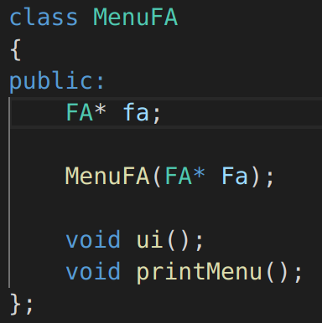

It takes a pointer to FA as it’s attribute.

It provides 2 methods:

printMenu() - prints the menu on the screen once
ui() - it is a loop that prints the menu on the screen, and calls the appropriate
functions from the FA class, depending on the user input

The FA class handles all operations on the finite automaton. It is defined as follows:

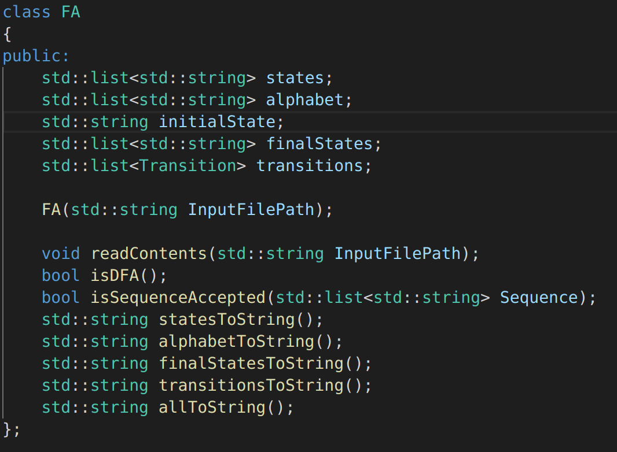

It contains all the states, alphabet, initial state, final states, and transitions.

Methods:
readContents(string InputFilePath) – reads the contents of a FA from an input file and
populates it’s attributes
isDFA() - returns true if the FA is deterministic
isSequenceAccepted(list<string> Sequence) – returns true if the provided sequence is
accepted by the FA
It also has some “toString” functions, for each attribute.

The Transition class is a simple structure that holds all information about one transition: starting state, action, and resulting state. It is defined as follows:

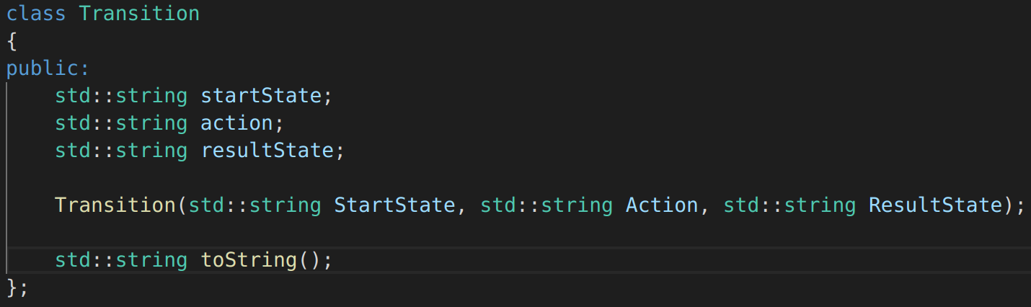

The form in which the FA.in file should be written:

form ::= “States” state{state} “Alphabet” {alphabet} “InitialState” state
“FinalStates” state{state} “Transitions” {transition}

state ::= “a” | “b” | … | “z”
alphabet ::= “1” | “2” | … | “9”
transition ::= “(“ state “, ” alphabet “) = ” state

Class diagram:

