Chis Sergiu
Claudiu Carare
gr: 932/1

Final lab parsing

Github link: https://github.com/SergiuChis/FLCD/tree/lab5
(The branch is named ‘lab5’ because this was the first lab for parsing. It contains labs from 5 to 7)

The parsing process is done by 3 classes: Grammar, ProductionRule and LL_ParsingTable.

The Grammar class is represented as follows:

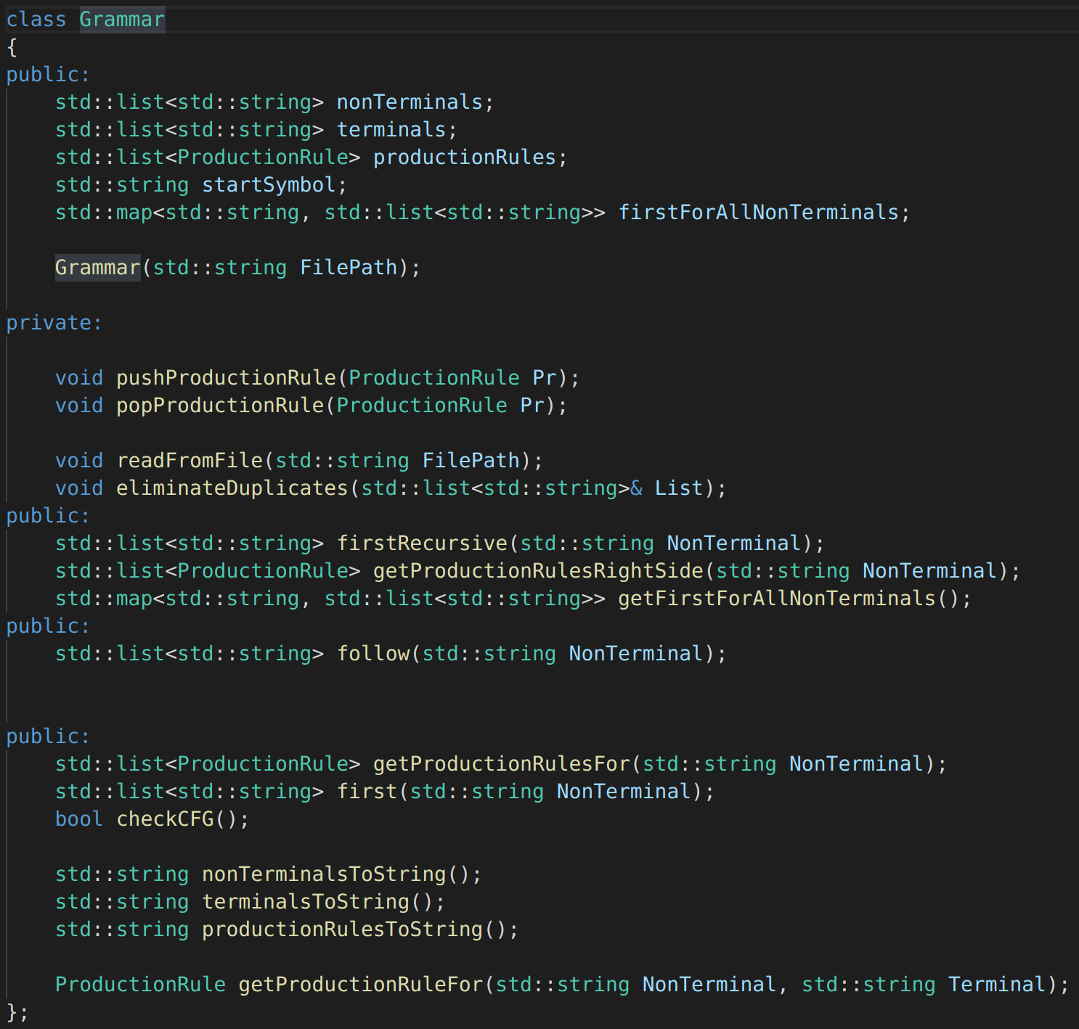

- class attributes:
- nonTerminals (a list of all the nonterminals)
- terminals (a list of all the terminals)
- productionRules (a list of all the production rules of the grammar)
- startSymbol (the start symbol of the grammar)
- firstForAllNonTerminals (a dictionary that maps the nonterminals to all their possible starting
terminals)

- class methods:
- pushProductionRule(ProductionRule Pr)
- adds a new production rule to the grammar
- popProductionRule(ProductionRule Pr)
- deletes the given production rule
- readFromFile(string FilePath)
- reads the grammar from the given file path
- eliminateDuplicates(list List)
- helper method to eliminate all duplicates from the given list
- firstRecursive(string NonTerminal)
- recursively search for all the terminals that the NonTerminal could start with
- getProductionRulesRightSide(string NonTerminal)
- get all production rules from the right side of the NonTerminal
- getFirstForAllNonTerminals()
- calculate first on all non terminals and return a map with the result
- follow(string NonTerminal)
- calculate the terminals that could appear after the given NonTerminal
- getProductionRulesFor(string NonTerminal)
- get all the production rules that have NonTerminal on the left side
- first(string NonTerminal)
- wrapper for the firstRecursive method
- checkCFG()
- returns true if the grammar is context free

The ProductionRule class is just a structure that represents one production rule. It is represented as folows:

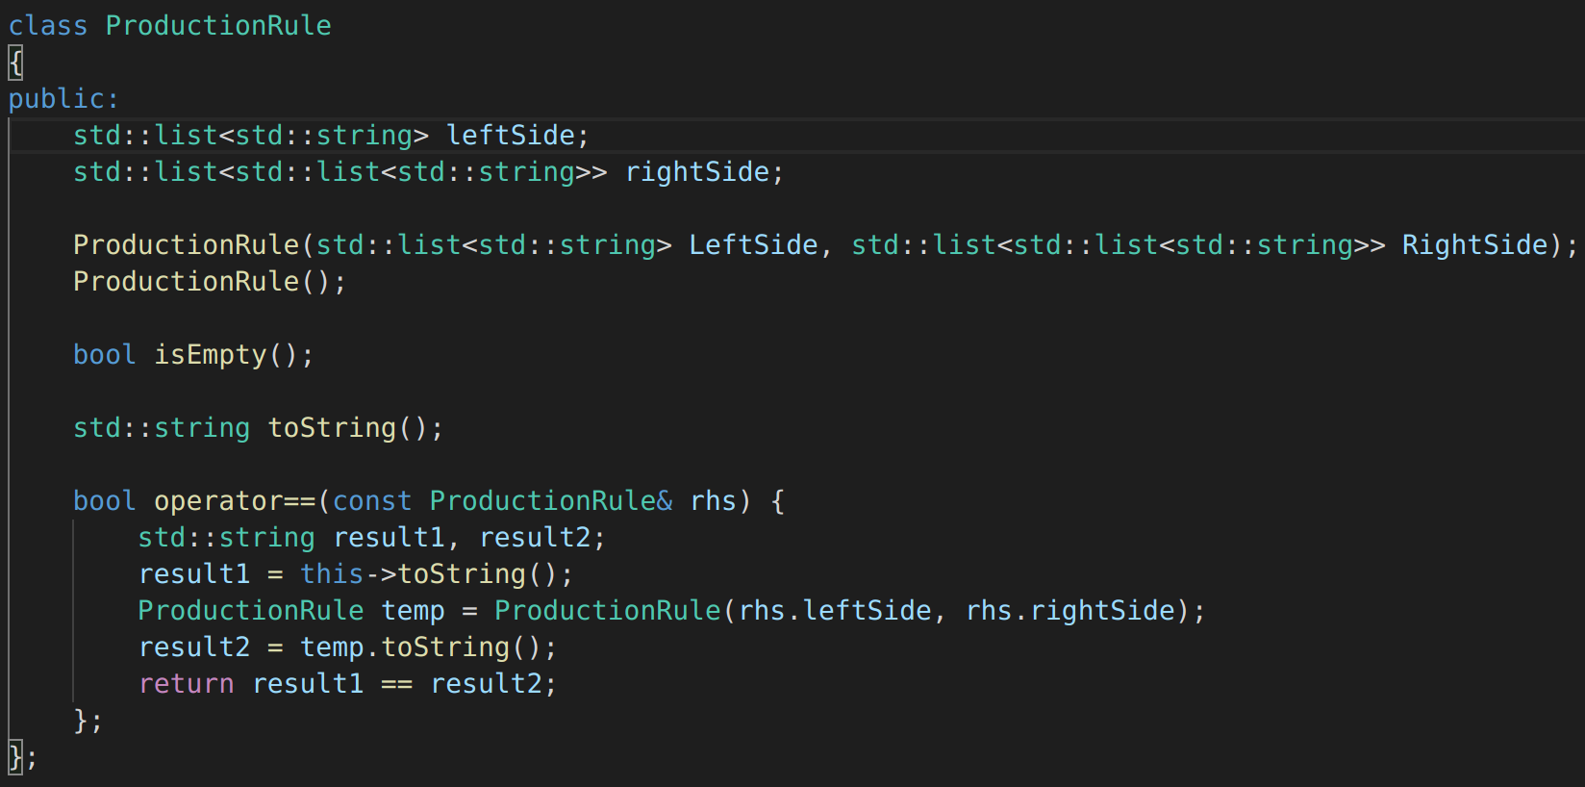

ProductionRule contains a list of symbols for the left side, and a list of lists of symbols for the right side.
Example: A - > B C | D
leftSide would be [A]
rightSide would be [[B, C], [D]]

The LL_ParsingTable class handles the creation of the parsing table. It is represented as follows:

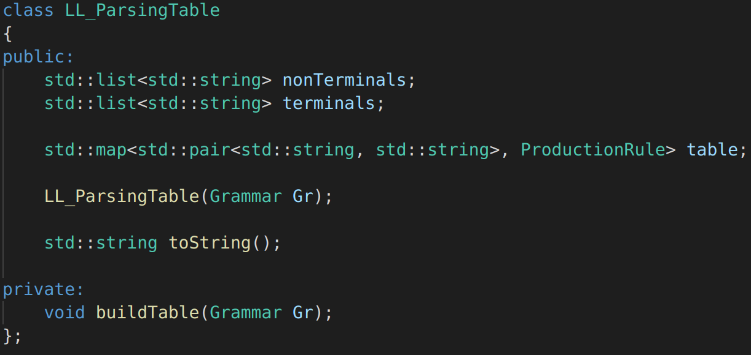

The most important method of this class is buildTable(Grammar Gr), which traverses all the possible pairs of NonTerminal – Terminal, and gets the proper ProductionRule for each pair.

