BIBLIOGRAFIE

Pe github avem proiectul impartit in mai multe parti:

CONDURACHE SERGIU 421Fa – am facut main-ul si part2

BARDASU EMILIAN ANDREI 421Fa – am facut part3

+imbunatatiri

Referinte:  
csv viewer with tk: <https://www.youtube.com/watch?v=Wq1MmAtp1oY&list=PLCQT7jmSF-LrwYppkB3Xdbe6QC81-ozmT&index=9>

tkinter introduction: <https://www.youtube.com/watch?v=YXPyB4XeYLA>

.astype(str): <https://www.w3schools.com/python/pandas/ref_df_astype.asp>

despre exceptii: <https://www.w3schools.com/python/python_try_except.asp>

.suffix din pathlib: <https://stackoverflow.com/questions/5899497/how-can-i-check-the-extension-of-a-file>

Ce am instalat:  
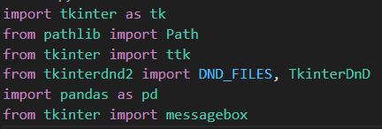

Folosim Visual Studio Code si simplu apasam butonul Run

In folderul in care lucram am adaugat si .csv - urile cu care am lucrat