**METU – EEE**

Middle East Technical University – Electrical Electronics Engineering Department

**PROJECT REPORT**

*by* Serhat ÖZKÜÇÜK

within the scope of the course

**EE568**

**SELECTED TOPICS ON ELECTRICAL MACHINES**

*by* Dr. Ozan KEYSAN

2019 – 2020 Spring Semester

**PROJECT REPORT NO** : 02

**PROJECT NAME** : Motor Winding Design & Analysis

**ASSIGN / DUE DATE** : 18.03.2020 / 31.03.2020 , 23:59

Introduction

In this report, we assume have a 20-pole, 120 slot, 3-phase machine for integral slot winding and for 20 or 22 pole number, we choose a slot number between 20 and 30 for fractional slot winding. Integral and fractional slot windings are investigated and designed. Also 2D FEA model of the fractional winding is simulated and analyzed. Winding diagrams are drawn. Distribution factor and pitch factor of the each winding are calculated. Also, 3rd and 5th harmonics winding factors are calculated.

1. Integral Slot Winding Design

We assume we have a 20-pole, 120 slot, 3-phase machine.

is the slot number per pole per phase:

is the electrical angle between two consecutive slot:

Assume each coil has 1 turns and full pitched. So, winding will be single layer.

|  |  |  |  |  |  |  |  |  |  |  |  |  |
| --- | --- | --- | --- | --- | --- | --- | --- | --- | --- | --- | --- | --- |
| slot | 1 | 2 | 3 | 4 | 5 | 6 | 7 | 8 | 9 | 10 | 11 | 12 |
| winding | A | A | -C | -C | B | B | -A | -A | C | C | -B | -B |

Fig. 1: Winding diagram of the given integral slot machine for one pole pair (12 slot)

**Winding Factor**

Winding factor () of a winding includes two main parts as known distribution factor () and pitch factor ().

Distribution factor: 🡪 for 1st fundamental component

Pitch factor: 🡪 for 1st fundamental component

Where is harmonic order, is pitch angle (for full pitch, ).

Winding factor for 1st fundamental component:

3rd and 5th harmonics winding factors

Distribution factor: 🡪 for 3rd harmonic component

Pitch factor: 🡪 for 3rd harmonic component

Winding factor:

Distribution factor: 🡪 for 5th harmonic component

Pitch factor: 🡪 for 5th harmonic component

Winding factor:

As a result of this part, for selected full pitch winding the fundamental component winding factor is obtained as 0.96, 3rd harmonic component is -0.7 and 5th one is 0.25. When we plot the magnetic loading distribution (B):

plot (0.96*sin(x)-0.7*sin(3*x)+0.25*sin(5*x))

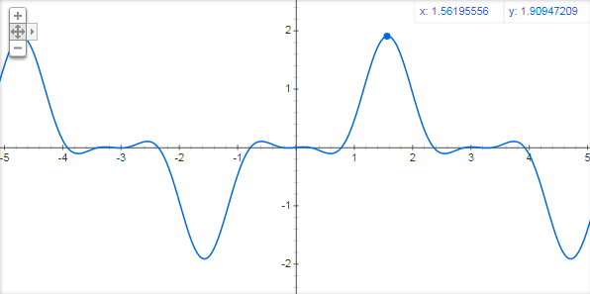

Fig. 2: Magnetic loading B of the selected integral slot winding

As seen from the figure 3rd harmonic negative winding factor causes sharpen the peaks of the total B. This effect creates long width zero crossing and smaller area under the curve that means smaller flux (φ) and energy. This type winding design creates nearly 70% 3rd harmonic component so it is inefficient design. Overcome this situation we can use fractional slot that is analyzed in next section.

2. Fractional-Slot Winding Design

In this part, we are going to analyze a 3-phase permanent-magnet synchronous machine with a fractional-slot winding.

**1st selection for design: 20 poles, 24 slots**

Using the Emetor Winding Design,

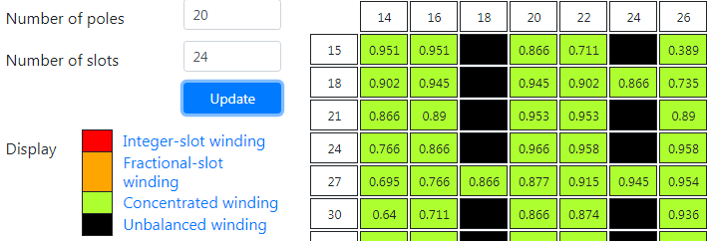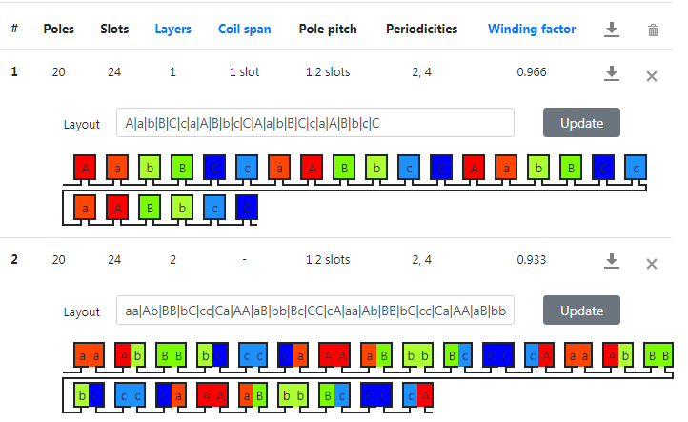

Fig. 3: Emetor Winding Design page, selected pole 20, slot 24 returns 1.2 slots pole pitch (5/6), 0.966 winding factor for 1 layer and 0.933 winding factor for 2 layer concentrated winding

is the slot number per pole per phase:

is the electrical angle between two consecutive slot:

Table 1: phase angle of the induced voltage in each slot

|  |  |  |  |  |  |  |  |  |  |  |  |
| --- | --- | --- | --- | --- | --- | --- | --- | --- | --- | --- | --- |
| 1st slot | 2 | 3 | 4 | 5 | 6 | 7 | 8 | 9 | 10 | 11 | 12 |
| 0o | 150o | 300o | 90o | 240o | 30o | 180o | 330o | 120o | 270o | 60o | 210o |

|  |  |  |  |  |  |  |  |  |  |  |  |
| --- | --- | --- | --- | --- | --- | --- | --- | --- | --- | --- | --- |
| 13 | 14 | 15 | 16 | 17 | 18 | 19 | 20 | 21 | 22 | 23 | 24th slot |
| 0o | 150o | 300o | 90o | 240o | 30o | 180o | 330o | 120o | 270o | 60o | 210o |

Then the phasor diagram for one phase is drawn by using Dolomites software:

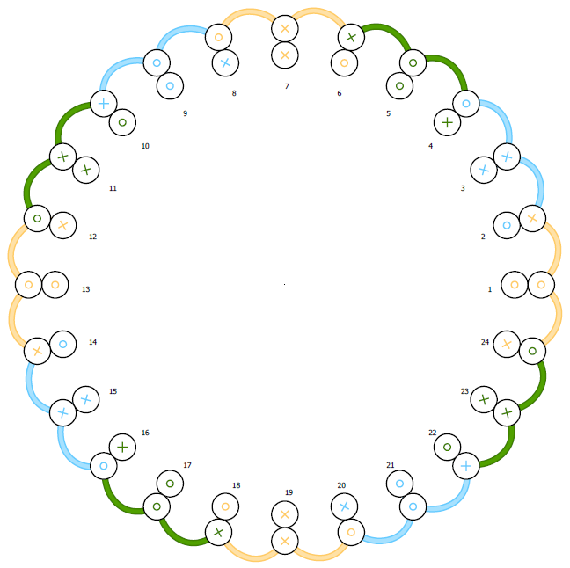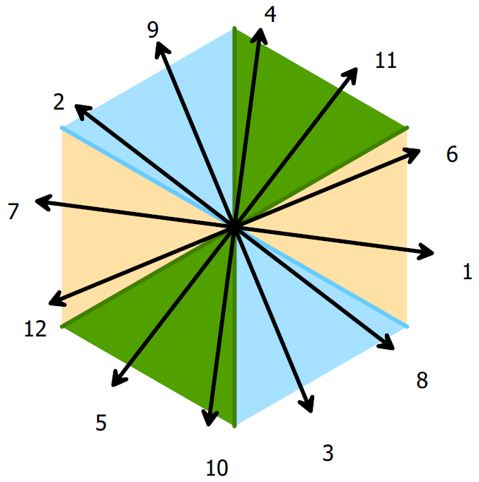

Fig. 4: Phasor diagram of 20 pole, 24 slot, 5/6 pitched winding

Winding Factor

Distribution factor: 🡪 for 1st fundamental component

\**For reducing the end winding, we can use phasor 1 and 6. In that way .*

Pitch factor: 🡪 for 1st fundamental component

Where is harmonic order, is pitch angle (for 5/6 pitch, ).

Winding factor for 1st fundamental component:

3rd and 5th harmonics winding factors

Distribution factor: 🡪 for 3rd harmonic component

Pitch factor: 🡪 for 3rd harmonic component

Winding factor:

Distribution factor: 🡪 for 5th harmonic component

Pitch factor: 🡪 for 5th harmonic component

Winding factor:

plot (0.97*sin(x)-0.77*sin(3*x)+0.33*sin(5*x))

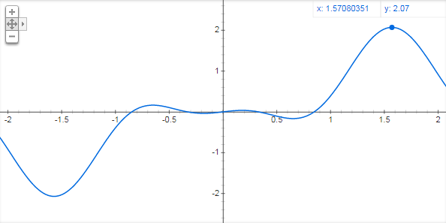

Fig. 5: Magnetic loading B of the selected fractional slot winding

Comments: 0.97 winding factor is obtained from 20 poles, 24 slots winding. It seems enough high for a design but, when we look the 3rd and 5th harmonic winding factors, we can see the 77% of 3rd effect and 33% of 5th harmonic effect. So, the total magnetic loading wave form of this type winding looks like in fig. 5. Because of the 3rd and 5th harmonics, total magnetic loading has not got pure sinusoidal shape and this causes less effective results in frame of harmonic contents.

**2nd selection for design: 20 poles, 30 slots**

Using the Emetor Winding Design,

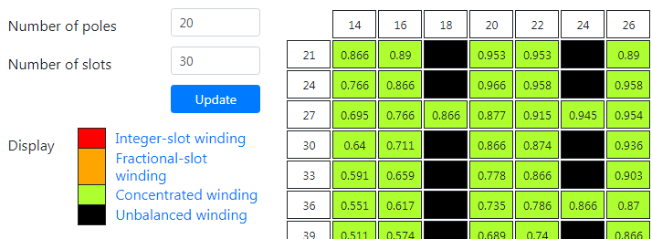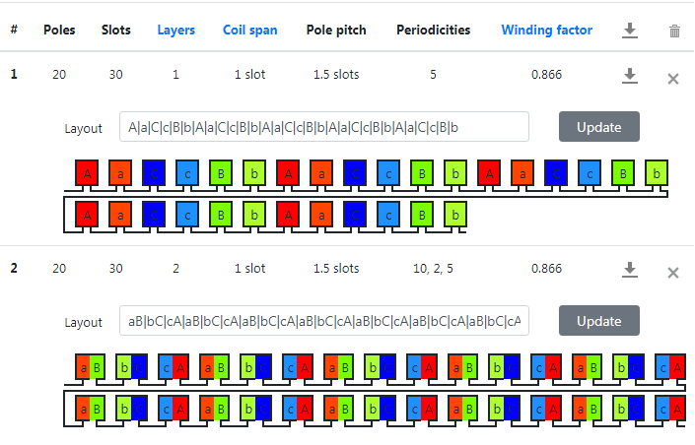

Fig. 6: Emetor Winding Design page, selected pole 20, slot 30 returns 1.5 slots pole pitch (2/3), 0.866 winding factor for 1 layer and 2 layer concentrated winding

is the slot number per pole per phase:

is the electrical angle between two consecutive slot:

Table 2: phase angle of the induced voltage in each slot

|  |  |  |  |  |  |  |  |  |  |  |  |
| --- | --- | --- | --- | --- | --- | --- | --- | --- | --- | --- | --- |
| 1st slot | 2 | 3 | 4 | 5 | 6 | 7 | 8 | 9 | 10 | 11 | 12 |
| 0o | 120o | 240o | 0o | 120o | 240o | 0o | 120o | 240o | 0o | 120o | 240o |

|  |  |  |  |  |  |  |  |  |  |  |  |
| --- | --- | --- | --- | --- | --- | --- | --- | --- | --- | --- | --- |
| 13 | 14 | 15 | 16 | 17 | 18 | 19 | 20 | 21 | 22 | 23 | 24th slot |
| 0o | 120o | 240o | 0o | 120o | 240o | 0o | 120o | 240o | 0o | 120o | 240o |

Then the phasor diagram for one phase is drawn by using Dolomites software:

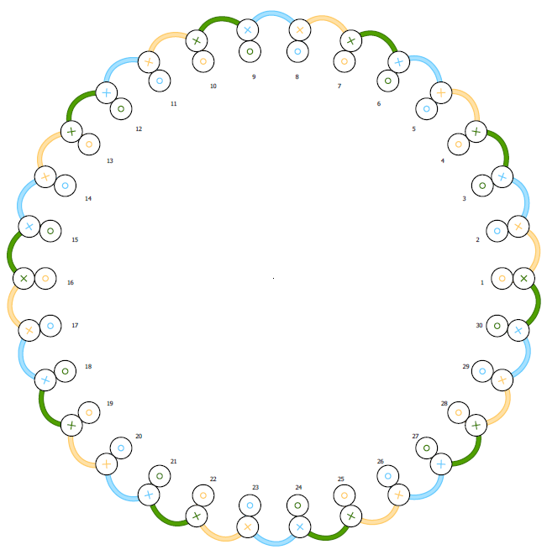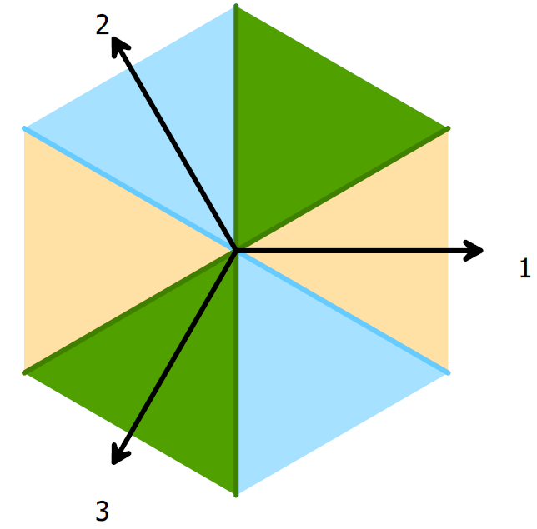

Fig. 7: Phasor diagram of 20 pole, 30 slot, 2/3 pitched winding

Winding Factor

Distribution factor: 🡪 for 1st fundamental component

Pitch factor: 🡪 for 1st fundamental component

Where is harmonic order, is pitch angle (for 2/3 pitch, ).

Winding factor for 1st fundamental component:

3rd and 5th harmonics winding factors

Distribution factor: 🡪 for 3rd harmonic component

Pitch factor: 🡪 for 3rd harmonic component

Winding factor:

Distribution factor: 🡪 for 5th harmonic component

Pitch factor: 🡪 for 5th harmonic component

Winding factor:

plot (0.86*sin(x)-0*sin(3*x)+0.86*sin(5*x))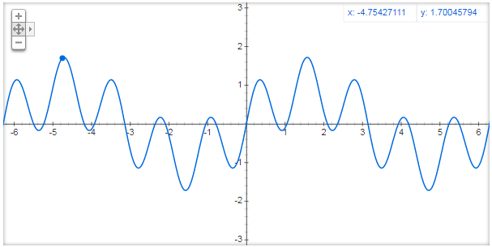

Fig. 8: Magnetic loading B of the selected fractional slot winding – 5th harmonic causes ripples

Comments: Comments: 0.86 winding factor is obtained from 20 poles, 30 slots winding. It seems little lower than previous one but still enough high for a design but, when we look the 3rd and 5th harmonic winding factors, we can see the 0% of 3rd harmonic effect (2/3 pitched coil – 120o/180o eliminates the 3rd harmonic) and 86% of 5th harmonic effect. So, the total magnetic loading wave form of this type winding looks like in fig. 8. Because of the 5th harmonic, total magnetic loading has not got pure sinusoidal shape and this causes less effective results in frame of harmonic contents.

3. FEA Modelling (2d) – fractional winding

# REFERENCES

1. <https://github.com/odtu/ee568>

2. <http://keysan.me/ee568/>