**METU – EEE**

Middle East Technical University – Electrical Electronics Engineering Department

**PROJECT REPORT**

*by* Serhat ÖZKÜÇÜK

within the scope of the course

**EE568**

**SELECTED TOPICS ON ELECTRICAL MACHINES**

*by* Dr. Ozan KEYSAN

2019 – 2020 Spring Semester

**PROJECT REPORT NO** : 03

**PROJECT NAME** : PM Motor Comparison Analysis

**ASSIGN / DUE DATE** : 19.04.2020 / 03.05.2020 , 23:59

Introduction

In this report, we examine the PM motor design. In the design process there are several design parameters that can be determined by designer with respect to some limitations such as machine dimensions, magnetic and electrical loading, cooling etc. The purpose of this project is design with considering these trades off and obtain the optimum design with respect to given specifications.

Constant specifications:

Number of phases: 3

Number of poles: 4

Motor Axial Length: 100 mm

Air-gap clearance: 1 mm

Magnet to Pole Pitch Ratio: 0.8

1. Magnetic Loading

In this part we are going to design a NdFeB magnet machine with the following parameters:

* Magnet Type: NdFeB N42 grade (ur=1.05), radial shaped
* Rotor Diameter: 100 mm
* Magnet Radial Thickness: 4 mm

**a) Magnetic equivalent circuit, load line and operating point on the B-H characteristics, peak air-gap flux density.**

The machine has 4 pole so it contains 2 permanent magnet as shown in fig.1. Also, equivalent magnetic circuit is given in fig.2.

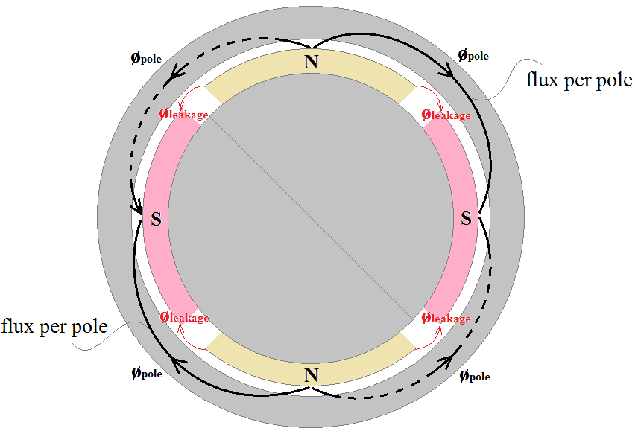

Fig.1: Solid stator machine representation

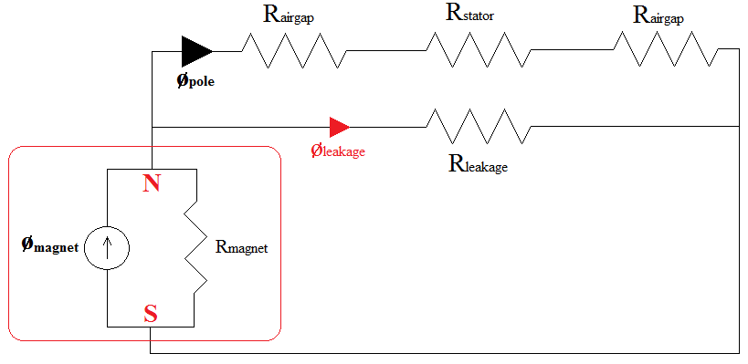

Fig.2: Equivalent magnetic circuit for one pole pairs

To calculate the peak air-gap flux density we have to know the load line and magnet operating point on the B-H characteristic. For this calculation, we determine the magnet geometry on the rotor as shown in figure 3.

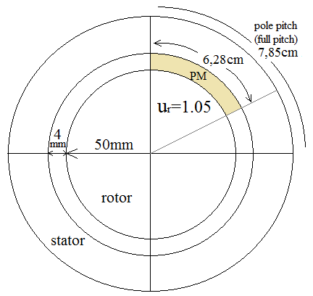

Fig.3: Magnet physical geometry on the rotor with respect to given specifications

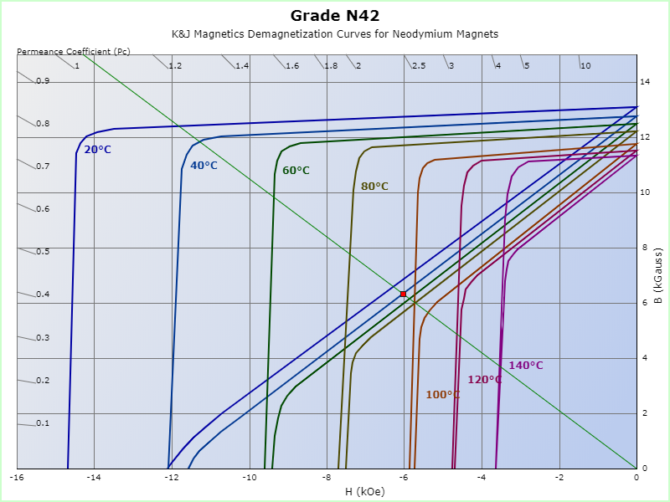

Fig. 4: Load line on the B-H characteristic of the given Neodymium magnet, Permeance Coefficient (Pc): 1.05, B: 6.34 kilogauss, H: -6.03 kilooersted, |BH|: 38.23 mega-gauss-oersted

According to specifications of the magnet, N42 grade magnet load line can obtained as shown in figure 4. If we select the operating temperature as 40’C, we can calculate the max. flux density in air gap using dimensions as shown in below equations:

Where is magnet magnetic flux, is magnet surface area. If we assume, rotor is surface mount permanent magnet machine, when we calculate the air gap flux density we can use the above equation.

Where, we assume that the magnet has a cylindrical shape in area calculation. 0.05m is radius of rotor, 0.004m is magnet thickness, 0.1m is axial length of the machine, 0.8 is magnet to pole pitch ratio.

b) Calculate the magnetic loading of the machine for this condition

c) Draw the radial air-gap flux density distribution in the middle of air-gap clearance for a one pole-pair using an FEA tool and compare it with your analytical calculations.

**Winding Factor**

Winding factor () of a winding includes two main parts as known distribution factor () and pitch factor ().

Distribution factor: 🡪 for 1st fundamental component

Pitch factor: 🡪 for 1st fundamental component

Where is harmonic order, is pitch angle (for full pitch, ).

Winding factor for 1st fundamental component:

3rd and 5th harmonics winding factors

Distribution factor: 🡪 for 3rd harmonic component

Pitch factor: 🡪 for 3rd harmonic component

Winding factor:

Distribution factor: 🡪 for 5th harmonic component

Pitch factor: 🡪 for 5th harmonic component

Winding factor:

As a result of this part, for selected full pitch winding the fundamental component winding factor is obtained as 0.96, 3rd harmonic component is -0.7 and 5th one is 0.25. When we plot the magnetic loading distribution (B):

plot (0.96*sin(x)-0.7*sin(3*x)+0.25*sin(5*x))

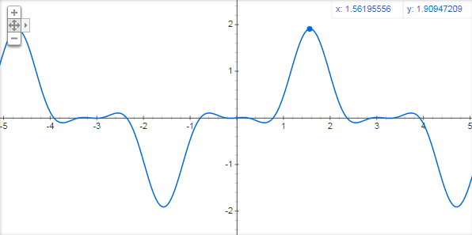

Fig. 2: Magnetic loading B of the selected integral slot winding

As seen from the figure 3rd harmonic negative winding factor causes sharpen the peaks of the total B. This effect creates long width zero crossing and smaller area under the curve that means smaller flux (φ) and energy. This type winding design creates nearly 70% 3rd harmonic component so it is inefficient design. Overcome this situation we can use fractional slot that is analyzed in next section.

2. Fractional-Slot Winding Design

In this part, we are going to analyze a 3-phase permanent-magnet synchronous machine with a fractional-slot winding.

**1st selection for design: 20 poles, 24 slots**

Using the Emetor Winding Design,

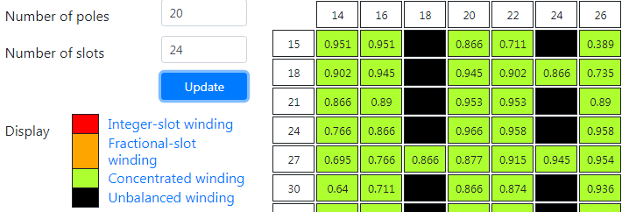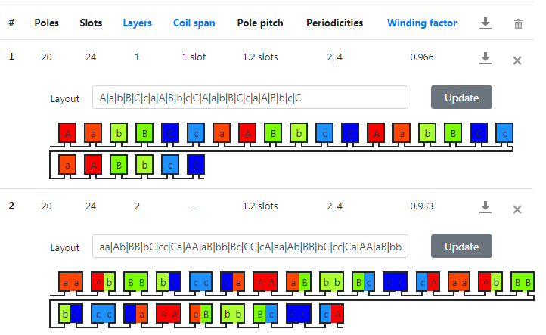

Fig. 3: Emetor Winding Design page, selected pole 20, slot 24 returns 1.2 slots pole pitch (5/6), 0.966 winding factor for 1 layer and 0.933 winding factor for 2 layer concentrated winding

is the slot number per pole per phase:

is the electrical angle between two consecutive slot:

Table 1: phase angle of the induced voltage in each slot

|  |  |  |  |  |  |  |  |  |  |  |  |
| --- | --- | --- | --- | --- | --- | --- | --- | --- | --- | --- | --- |
| 1st slot | 2 | 3 | 4 | 5 | 6 | 7 | 8 | 9 | 10 | 11 | 12 |
| 0o | 150o | 300o | 90o | 240o | 30o | 180o | 330o | 120o | 270o | 60o | 210o |

|  |  |  |  |  |  |  |  |  |  |  |  |
| --- | --- | --- | --- | --- | --- | --- | --- | --- | --- | --- | --- |
| 13 | 14 | 15 | 16 | 17 | 18 | 19 | 20 | 21 | 22 | 23 | 24th slot |
| 0o | 150o | 300o | 90o | 240o | 30o | 180o | 330o | 120o | 270o | 60o | 210o |

Then the phasor diagram for one phase is drawn by using Dolomites software:

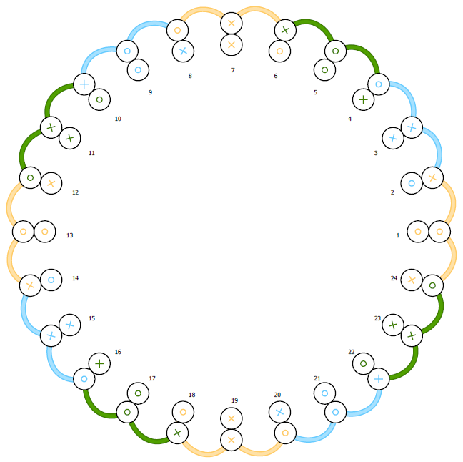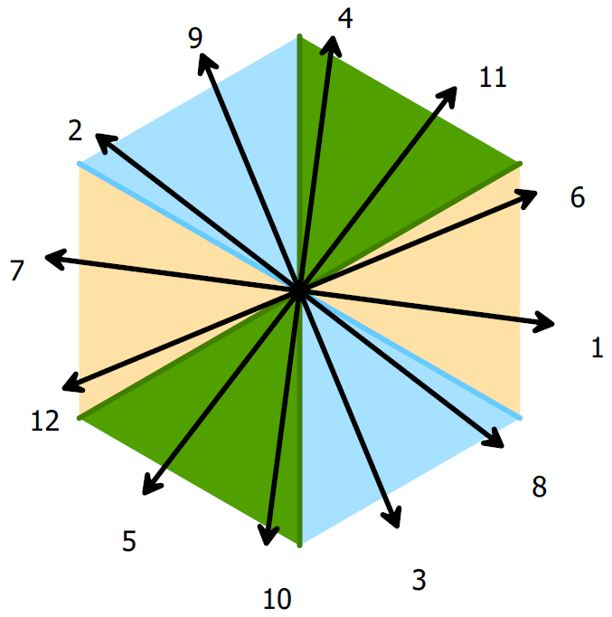

Fig. 4: Phasor diagram of 20 pole, 24 slot, 5/6 pitched winding

Winding Factor

Distribution factor: 🡪 for 1st fundamental component

\**For reducing the end winding, we can use phasor 1 and 6. In that way .*

Pitch factor: 🡪 for 1st fundamental component

Where is harmonic order, is pitch angle (for 5/6 pitch, ).

Winding factor for 1st fundamental component:

3rd and 5th harmonics winding factors

Distribution factor: 🡪 for 3rd harmonic component

Pitch factor: 🡪 for 3rd harmonic component

Winding factor:

Distribution factor: 🡪 for 5th harmonic component

Pitch factor: 🡪 for 5th harmonic component

Winding factor:

plot (0.97*sin(x)-0.77*sin(3*x)+0.33*sin(5*x))

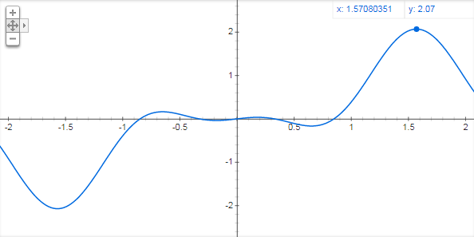

Fig. 5: Magnetic loading B of the selected fractional slot winding

Comments: 0.97 winding factor is obtained from 20 poles, 24 slots winding. It seems enough high for a design but, when we look the 3rd and 5th harmonic winding factors, we can see the 77% of 3rd effect and 33% of 5th harmonic effect. So, the total magnetic loading wave form of this type winding looks like in fig. 5. Because of the 3rd and 5th harmonics, total magnetic loading has not got pure sinusoidal shape and this causes less effective results in frame of harmonic contents.

**2nd selection for design: 20 poles, 30 slots**

Using the Emetor Winding Design,

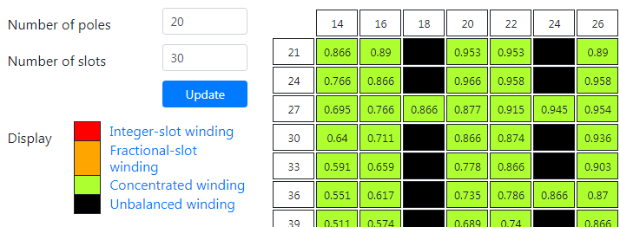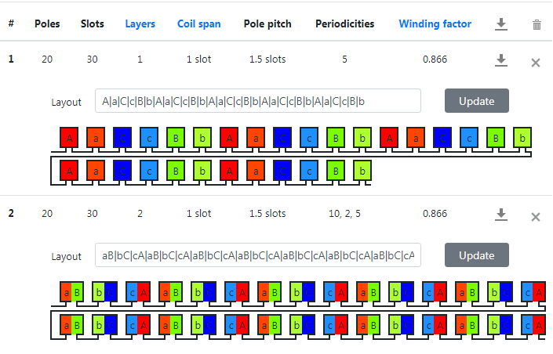

Fig. 6: Emetor Winding Design page, selected pole 20, slot 30 returns 1.5 slots pole pitch (2/3), 0.866 winding factor for 1 layer and 2 layer concentrated winding

is the slot number per pole per phase:

is the electrical angle between two consecutive slot:

Table 2: phase angle of the induced voltage in each slot

|  |  |  |  |  |  |  |  |  |  |  |  |
| --- | --- | --- | --- | --- | --- | --- | --- | --- | --- | --- | --- |
| 1st slot | 2 | 3 | 4 | 5 | 6 | 7 | 8 | 9 | 10 | 11 | 12 |
| 0o | 120o | 240o | 0o | 120o | 240o | 0o | 120o | 240o | 0o | 120o | 240o |

|  |  |  |  |  |  |  |  |  |  |  |  |
| --- | --- | --- | --- | --- | --- | --- | --- | --- | --- | --- | --- |
| 13 | 14 | 15 | 16 | 17 | 18 | 19 | 20 | 21 | 22 | 23 | 24th slot |
| 0o | 120o | 240o | 0o | 120o | 240o | 0o | 120o | 240o | 0o | 120o | 240o |

Then the phasor diagram for one phase is drawn by using Dolomites software:

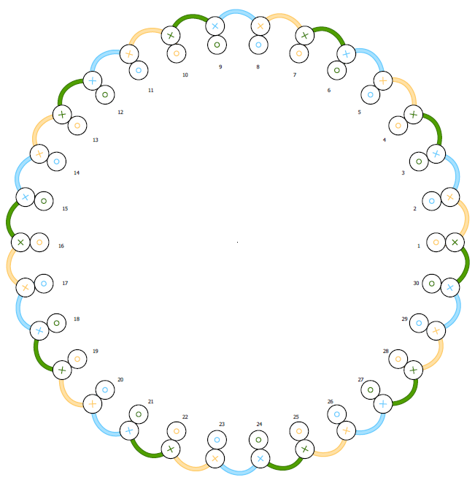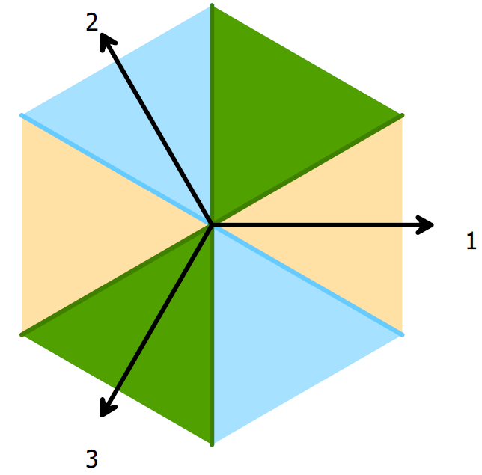

Fig. 7: Phasor diagram of 20 pole, 30 slot, 2/3 pitched winding

Winding Factor

Distribution factor: 🡪 for 1st fundamental component

Pitch factor: 🡪 for 1st fundamental component

Where is harmonic order, is pitch angle (for 2/3 pitch, ).

Winding factor for 1st fundamental component:

3rd and 5th harmonics winding factors

Distribution factor: 🡪 for 3rd harmonic component

Pitch factor: 🡪 for 3rd harmonic component

Winding factor:

Distribution factor: 🡪 for 5th harmonic component

Pitch factor: 🡪 for 5th harmonic component

Winding factor:

plot (0.86*sin(x)-0*sin(3*x)+0.86*sin(5*x))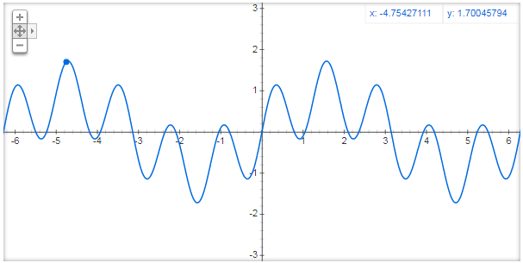

Fig. 8: Magnetic loading B of the selected fractional slot winding – 5th harmonic causes ripples

Comments: Comments: 0.86 winding factor is obtained from 20 poles, 30 slots winding. It seems little lower than previous one but still enough high for a design but, when we look the 3rd and 5th harmonic winding factors, we can see the 0% of 3rd harmonic effect (2/3 pitched coil – 120o/180o eliminates the 3rd harmonic) and 86% of 5th harmonic effect. So, the total magnetic loading wave form of this type winding looks like in fig. 8. Because of the 5th harmonic, total magnetic loading has not got pure sinusoidal shape and this causes less effective results in frame of harmonic contents.

3. FEA Modelling (2d) – fractional winding

In FEA (2d) model, we selected the 24 slots, 20 poles machine, which was analyzed in section 2. For the model, “Study of a Permanent Magnet Motor with MAXWELL 2D: Example of the 2004 Prius IPM Motor” document is used with some modifications (Optimizing is neglected, only suitable geometry considered). So, the designed geometry of FEA model is given in figure 9.

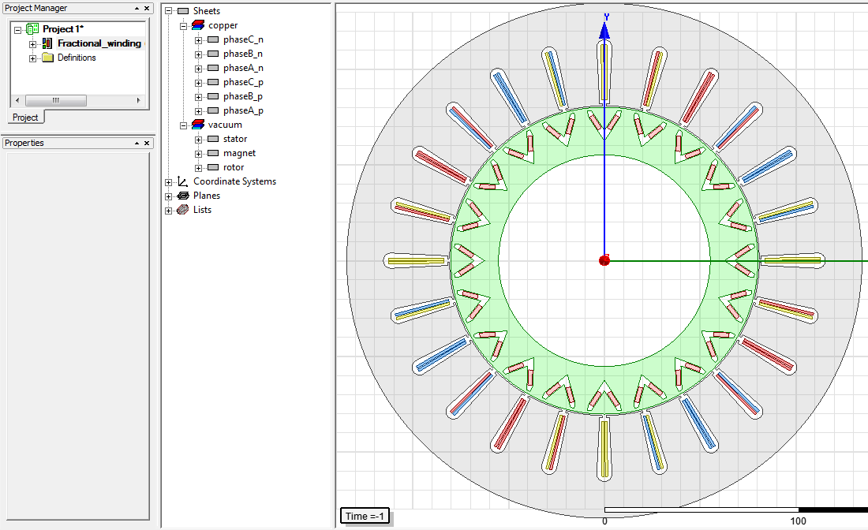

Fig. 9: Maxwell 2d FEA model of the 24 slots, 20 poles fractional winding machine.

After that, I created 1/4 model of the design (in figure 10) but I got mesh error that I can not found the solution of Maxwell error (I spent my 4.5-5h for handle it but I can not. (I selected coil pitch 0.4 but in Maxwell, I think it must set 5/2 instead of 2/5)).

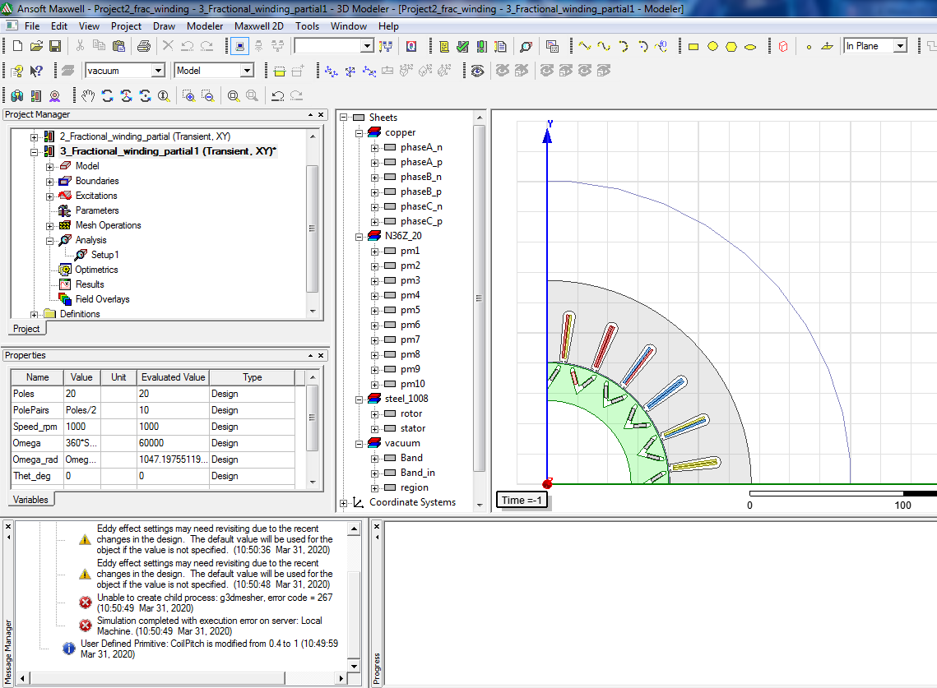

Fig. 10: Maxwell error

# REFERENCES

1. <https://github.com/odtu/ee568>

2. <http://keysan.me/ee568/>

3. ANSYS Maxwell 2D Field Simulator v15 User’s Guide 11.4, Study of a Permanent Magnet Motor with MAXWELL 2D: Example of the 2004 Prius IPM Motor

4. <https://www.kjmagnetics.com/bhcurves.asp>

5.