**METU – EEE**

Middle East Technical University – Electrical Electronics Engineering Department

**PROJECT REPORT**

*by* Serhat ÖZKÜÇÜK

within the scope of the course

**EE568**

**SELECTED TOPICS ON ELECTRICAL MACHINES**

*by* Dr. Ozan KEYSAN

2019 – 2020 Spring Semester

**PROJECT REPORT NO** : 04

**PROJECT NAME** : PM Motor Comparison Analysis

**ASSIGN / DUE DATE** : 03.06.2020 / 28.06.2020 , 23:59

Literature Review

In this study, 1kW permanent magnet synchronous machine (PMSM) type servo motor design aspects are discussed. In this concept, several comparative designs are modelled with FEA performance considerations. Servo motors are essential machines in industrial applications and have a basic specific property as high torque with low inertia (sausage type machine) for acceleration, speed, position accuracy and robust performance. Providing the basic properties depends on machine parameters such as diameter of the rotor-stator, pole-slot number, slot dimension, winding types, permanent magnet type etc. Design of these parameters effect the magnetic and electric load distribution, air gap flux density distribution (harmonic contents), flux leakages, cogging torque, end winding losses, thermal performance, machine dimension and cost [flieh].

The first critical consideration for designing AC PMSM servo is magnet type, location and shape in the rotor structure. There are two types PMSM servo known as internal permanent magnet synchronous machine (IPMSM), and surface mount permanent magnet synchronous machine (SMPMSM). The main difference between them the IPMSM can produce extra reluctance torque with hard manufacturing process. The detailed comparative performance analysis of the two type machines under identical conditions in terms of air gap flux density distribution, back EMF and current waveforms is critical for design process. IPMSM has more harmonics in its air gap flux density waveform than SMPMSM, which is caused by the rotor openings and the smaller air gap. Back EMF wave forms of the two type machines at the rated speed have nearly same amplitude. However, there are more harmonics components in the IPMSM, which are caused by the more harmonic air gap flux density components. The harmonic components of armature currents are slightly higher for the SPMSM with respect to IPMSM, which is due to the lower inductances. IPMSMs are superior in costs while SPMSMs are more robust, with higher overall efficiency and cooling performance. [dong].

Another important design issue about permanent magnets is shaping.

1. Analytical Calculations & Sizing

In this project, we design a AC PMSM type servo with respect to following specifications:

**The application:** Industrial servo systems

**The type of the machine:** Permanent magnet synchronous machines (PMSM), surface mount type.

**Power, voltage and current ratings:**  1kW, 220V - 4A (nominal for 1 phase), (3 phase inverter ratings: DC level of bulk is 310V (from 220V AC rms), 190Vph-ph, 3.1Aph, Y connected)

**Operating conditions:** 3000 rpm rated speed, 4Nm rated torque (12Nm max. torque), Duty type:S1 (Continuously), Natural cooling, IP 54 Enclosure (industrial applications), 0-55’C ambient temperature.

**Limitations (if there is any) such as mass, diameters, cost, efficiency:** max. mass 6kg, low inertia for obtaining dynamic response so the dimensions will not exceed the motor length L_max=250mm, outer diameter Do_max=125mm. (The smaller it can be designed, the better.)

**Design Procedure (Analytically)**

Machine constant:

Where, is output power, is represents the rotor volume, is synchronous frequency and machine constant is :

Where, is winding factor, is electric loading and is magnetic loading.

Where, is turn number per slot, is current flow through wire, is slot number, is inner diameter, is length of bore, is pole number, is flux per pole.

If we assume the iron core material for stator and rotor we can select the max magnetic loading as 1.8T (1.2T for average) which is saturation limit for selected material. Selection of electric loading depends on the required torque level.

Where, is tangential stress at x distance (will be rotor edge), is radius of the rotor.

According to specification of our motor the rated torque is 4Nm (12Nm max.) at rated output power 1kW. Also, max outer diameter is 125mm, so rough calculation (using table with respect to the worst case pole number 2) we can select the rotor diameter as nearly half of outer diameter 60mm (considering air gap, outer cover etc.). Determination of the axial length of the machine can be estimated by using again rough definition of aspect ratio for servo motors as (Torque-Aspect ratio graph from METU EE568 courses – Machine Design Basics, page 35), we can select the . At this time will be 250mm. The air gap can be selected as 1mm for providing mechanical reliability.

If we combine the known parameters up to now:

The average electrical loading will be 4715 A/m, (4.715 kA/m).

The air gap can be selected as 1mm for providing mechanical reliability. The slot and conductor number can be determined as (nominal current from spec is 4A):

According to these calculations we know that the total conductor number in the stator. So we can determine possible pole-slot combinations with respect to our winding factor result using the table 1.

**Table 1:** Winding factors for different combinations of pole and slot numbers and double layer winding (METU EE568 courses – Airgap & Mechanical constraints, page 42)

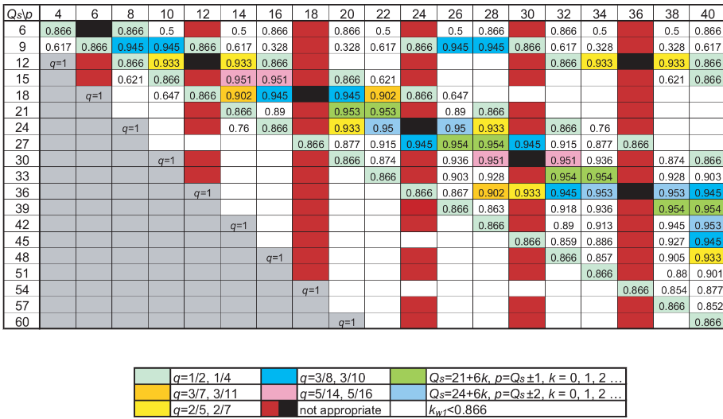

For determining the slot number , we can use the formula as follows and determine the value which is slot per pole per phase. Where the is phase number, is pole number. For improving the smooth torque performance we can select the as fractional.

If we select a suitable conductor which can carry 4A current from AWG table, the #20 conductor (area: 0.518mm2) is suitable for our design. But, the machine max torque will be 12Nm (3xNominal torque) so, we must select the conductor which is capable of carry 12A max. current. This is the #14 conductor for safe design (area: 2.08mm2). We can assume the slot fill factor 60%.

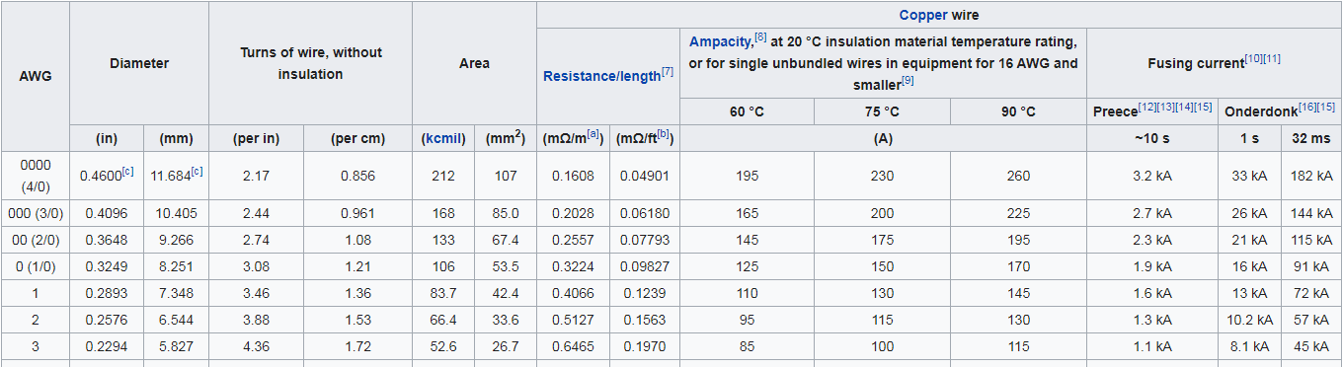



If we create a table which is shown the possibility of the design and mechanics with respect to figure 1, we can obtain table 2.

**Table 2:** Design mechanics control table for different pole slot selection.

|  |  |  |  |  |  |
| --- | --- | --- | --- | --- | --- |
| Pole number | Slot Number | Winding factor | N turn per slot | Slot area* mm2 | Possibility |
| 4 | 6 | 0.866 | 37 | 470 | OK – 135 turn/slot |
| 10 | 12 | 0.933 | 18.5 | 236 | OK-68 turn/slot |
| 16 | 18 | 0.945 | 12.33 | 157 | OK-45 turn/slot |
| 20 | 21 | 0.953 | 10.57 | 134 | OK-38 turn/slot |

*slot area is calculated roughly with respect to rectangular parallel teeth and slots. Slot height is assumed 20mm (back core 10mm). Slot number calculation is done with taking the mid-point of slots. Slot fill factor 60%. Single conductor area is 2.08mm2.

From the table 2, all possibilities are reliable when back core is 10mm. So according to flux density distribution and saturation we can increase the back core or if back core flux density is under the saturation level, we can increase the rotor diameter (preventing leakage) or decrease the machine dimension (decreasing slot height).

If the assume slots gets wider with diameter slots (rectangular teeth), the d ratio can be assume as 0.7. This means that the slot height is:

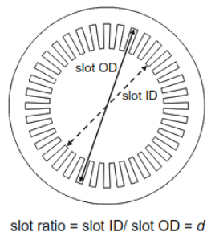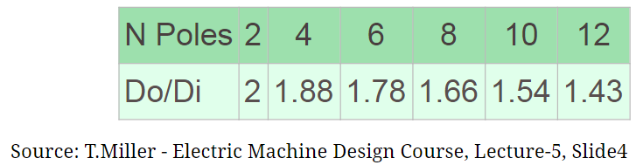

Fig. 9: d ratio on the machine

According to design table of T.Miller (fig. 9), the outer diameter Do is:

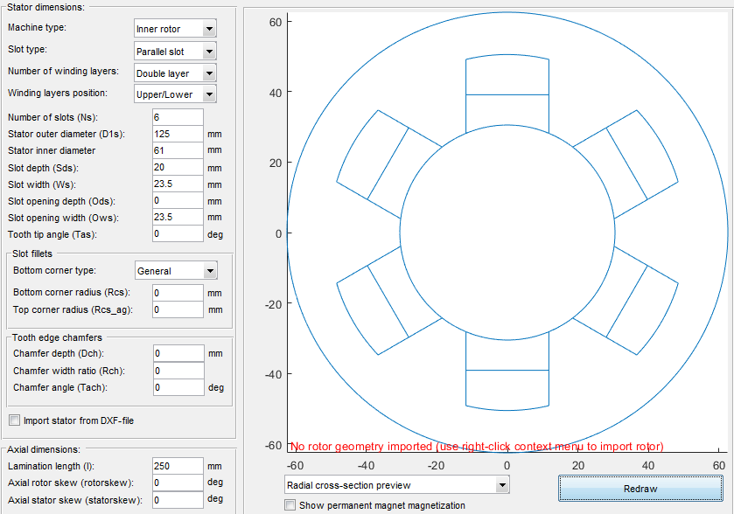 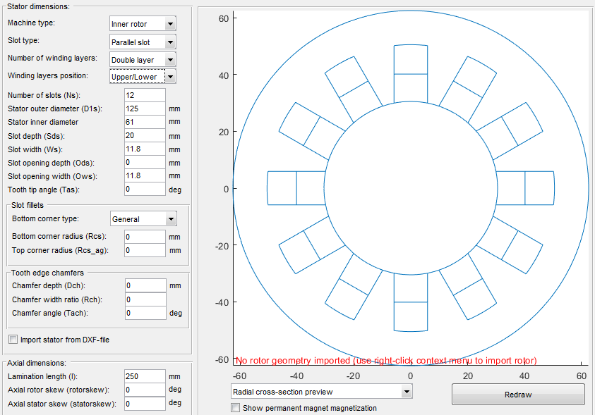

(a) 4 pole 6 slot, 0.866 winding factor (b) 10 pole 12 slot, 0.933 winding factor

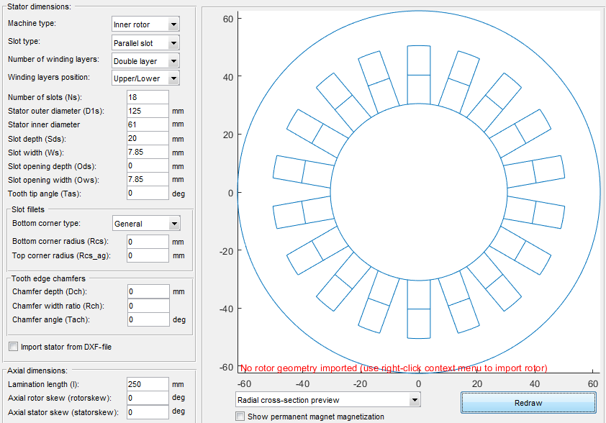 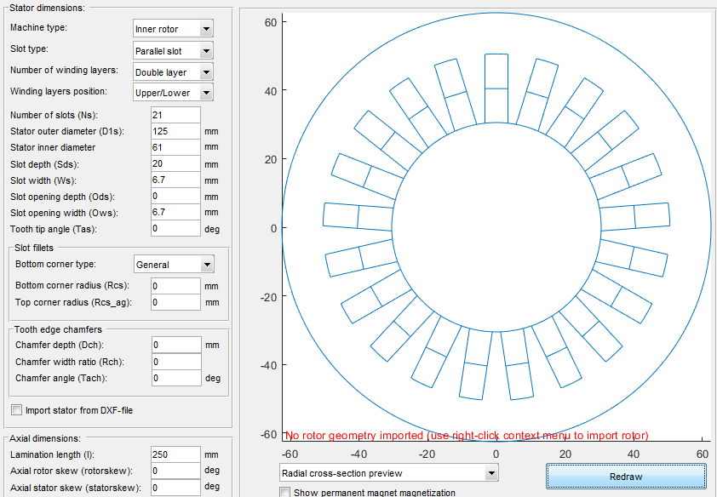

(c) 16 pole 18 slot, 0.945 winding factor (d) 20 pole 21 slot, 0.953 winding factor

**Figure 1:** Possible slot dimensions, back core thickness, stator slot design mechanics.

Material selection is another issue for design. If we calculate the flux density from the selected magnetic loading data as follows: (Assuming 10 pole machine)

We can determine the magnet flux density as follows:

Where is area of the magnets which is assumed the magnets are separated the rotor surface (magnet thickness is assumed as 5mm).

will be 1.02T. According to this value we can select the magnet as N42 neodymium, under 40oC operating temperature with permeance coefficient 4, as shown in figure 2.

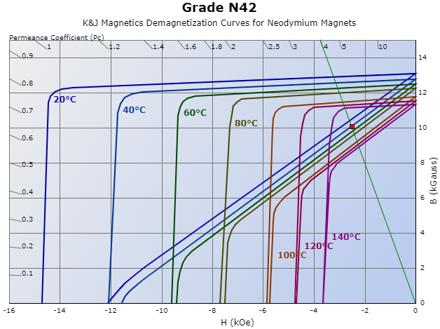

**Figure 2:** Load line on the B-H characteristic of the given Neodymium magnet, Permeance Coefficient (Pc): 4, B: 10.08 kilogauss, H: -2.52 kilooersted, |BH|: 25.39 mega-gauss-oersted

The electrical parameters of the design can be selected as 190Vph-ph, 3.1Aph for Y connected machine. Total conductor number was 222.18 that is calculated previously so total length of the conductor will be . The selected AWG14 conductor has 8.286mΩ/m resistance. So the phase resistance will be

Analytically designed machine:

|  |  |  |  |
| --- | --- | --- | --- |
| Pole number | 10 | Slot height | 12.85mm |
| Slot number | 12 | Slot width | 9.1mm |
| Winding factor | 0.933 | Back core | 3.7mm |
| Slot /phase/pole | 2/5 | Magnet | N42@40C, 1.008T |
| Outer diameter | 92.4mm | Flux per pole | 5.65x10-3 Wb/m2 |
| Inner diameter | 60mm | Phase Voltage,Current | 190V,3.1A |
| Air gap | 1mm | Phase resistance | 153mΩ |
| Axial length | 250mm | Power, Torque | 1kW, 4Nm(12Nm max) |

2. FEA Modelling

For the

**2a) Flux Density Vectors for Linear Materials (0, 45, 90 degree rotor)**

Flux density

**2b) Inductances and Stored Energy in the System**

Inductances

**2c) Torque Generation in the System**

Torque

3. Comparison & Discussion

In this section,

**3a) Flux Density Vectors for NonLinear Materials (0, 45, 90 degree rotor)**

curve) stator and rotor material

**3b) Inductances and Stored Energy in the Nonlinear System**

**3c) Torque Generation in the Nonlinear Material System**

As expected,

**3d) The effects of fringing and saturating effects with the linear and non-linear materials**

The difference

4. Conclusion

Beacuse

# REFERENCES