**METU – EEE**

Middle East Technical University – Electrical Electronics Engineering Department

**PROJECT REPORT**

*by* Serhat ÖZKÜÇÜK

within the scope of the course

**EE568**

**SELECTED TOPICS ON ELECTRICAL MACHINES**

*by* Dr. Ozan KEYSAN

2019 – 2020 Spring Semester

**PROJECT REPORT NO** : 01

**PROJECT NAME** : Torque in a Variable Reluctance Machine

**ASSIGN / DUE DATE** : 24.02.2020 / 08.03.2020 , 23:59

Introduction

In this report, a basic model of variable reluctance machine in fig.1 is examined. Analytical expression of torque, reluctance and inductance of the system is derived as a function of rotation of the variable reluctance rotor. 2D FEA model is created in ANSYS/Maxwell 2D and system is analyzed. Linear (constant µ) and non-linear (considering saturation) steel lamination effect is simulated. Also a XX control method is purposed to the model for acceleration with a certain torque.

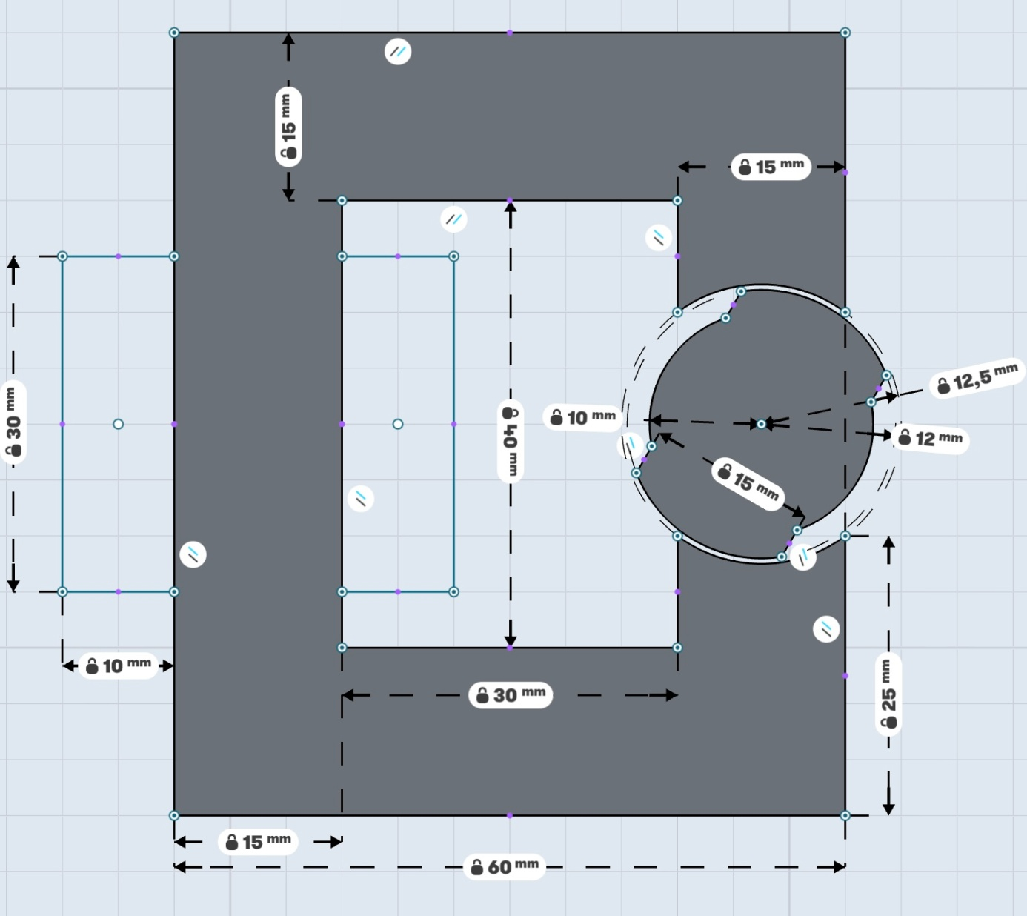

Fig. 1: Physical properties of the variable reluctance machine project model (*Coils are wound within 30mmx10mm rectangle areas, each airgap clearance is 0.5mm, depth of the core is 20mm, number of turns = 250, coil Current = 3 A DC*)

1. Analytical Modelling

There are two air-gaps in series in fig. 1 and these air gap lengths change with an angle (θ), which is between rotary part’s direct axis and stable part’s flux axis.

The maximum reluctance is observed when the angle is π/2 or 3π/2 radians (air gap is maximum). The minimum reluctance is observed when the angle is 0 or π radians (air gap is minimum).

So, total reluctance (and inductance) changes with respect to the angle θ. The maximum reluctance (minimum inductance) is calculated as () when the angle θ is equal to π/2 or 3π/2 shown in fig. 2. Steel permeability is assumed as infinite and fringing is neglected.

Where are air gap lengths, is permeability of air, are effective core areas that flux linking, is turn ratio.

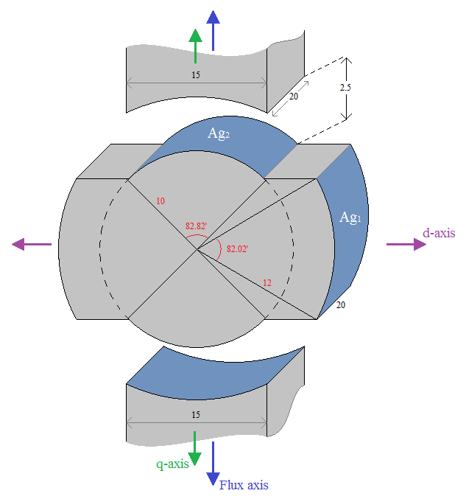

Fig. 2: Maximum reluctance case (The angle between d-axis and Flux axis is π/2, all lengths are in mm and angles are in degree)

Calculation of the max-min reluctances (or inductances) are done with respect to their effective core area that the flux is linking. So, the analyzed geometry is given in fig.3.

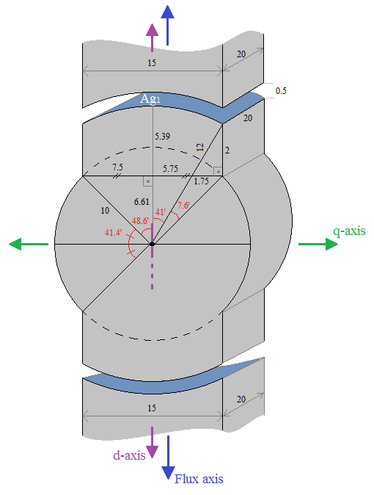

Fig. 3: Minimum reluctance case and geometry analysis (The angle between d-axis and Flux axis is 0 or π, all lengths are in mm and angles are in degree)

The minimum reluctance (maximum inductance) is calculated as () when the angle θ is equal to 0 or π shown in fig. 3. Steel permeability is assumed as infinite and fringing is neglected.

The total Reluctance and Inductance values are change with cos(2θ) character, because of mechanical symmetry, and they are multiplicative inverse each other with factor turn ratio square (N2), as shown in fig. 4.

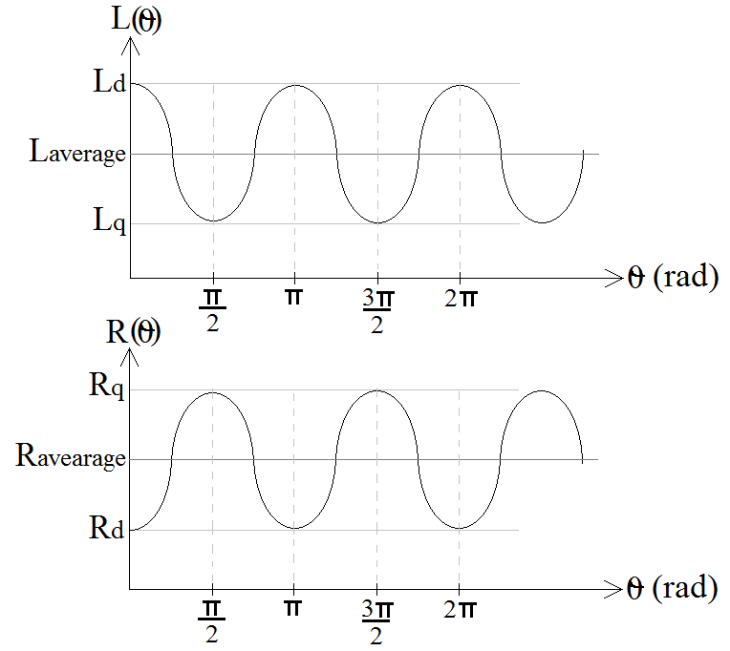

Fig. 4: Reluctance and Inductance changes with respect to the angle .

From the graphs in Fig. 4,

When we calculate the effective core areas () that are indicated in fig.2 as piece of cylinder surface,

For the case that shown in fig. 3, we can calculate and as shown below,

For the case that shown in fig. 2, we can calculate and as shown below,

The average and half of difference values of Inductances are calculated as shown below,

,

The Reluctance and Inductance as a function of are calculated as shown below,

**Torque Generation**

For DC current excitation,

Plot of the torque,

plot | -0.5×3^2×0.0224 sin(2 x)

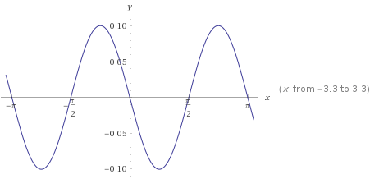

Fig. 5: Generated torque from analytical solution

Torque is maximum at the rotor angle

**Suggestions for Improving System**

The coils that carriying excitation current of the system can be distributed near position of the air gaps. In this way, leakage and fringing flux can be reduced as shown in figure below.

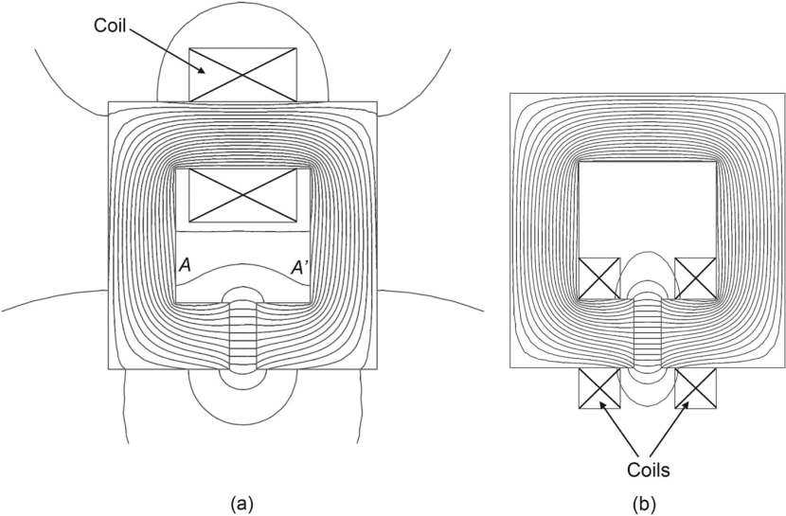

Fig. 6: Suggestion for winding distiribution

Air gap between rotor and stator can be reduced as possible as mechanical bearing allows as shown in figure below. So the fringing and leakage flux decreases torque and energy of the system increases (air gap reduces means reluctance decreases, inductance increases)

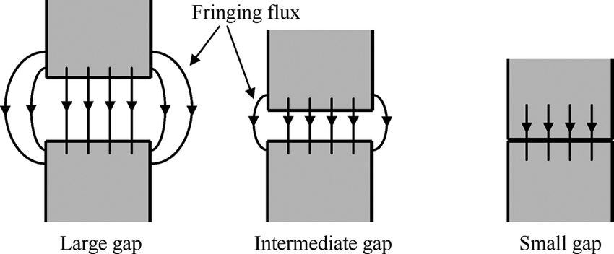

Fig. 7: Suggestion for air gap

Another suggestion may be increasing the core height (h) in y-axis direction. So, flux loss can be reduced this way shown in figure below.

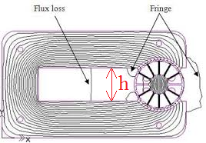

Fig. 8: Suggestion for core geometry

2. FEA Modelling (2d Linear Materials)

For the given geometry, the FEA model is constructed in Ansys/Maxwell (see fig.9). Stator and rotor materials are selected as steel_1008 in Ansys/Maxwell library. The material property is set as constant permeability as µ=902.6.

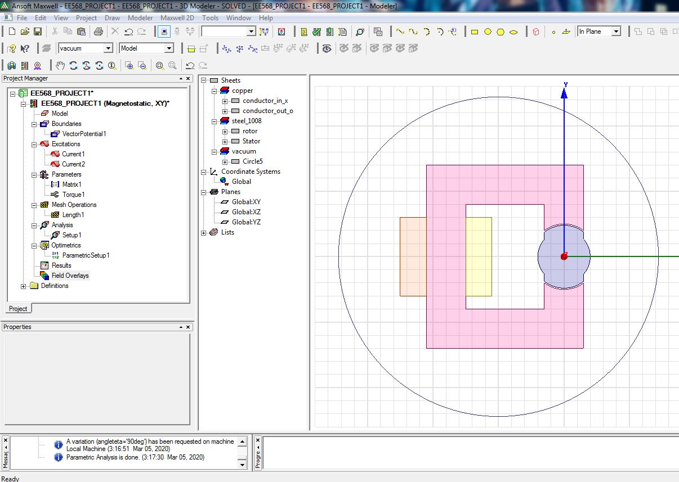

Fig. 9: FEA model of the given geometry in Ansys/Maxwell

System analysis is done for three positions as rotor angles are 0o, 45o and 90o. For these three position, the flux vectors, magnetic loading, inductances and energies are calculated.

**2a) Flux Density Vectors for Linear Materials (0, 45, 90 degree rotor)**

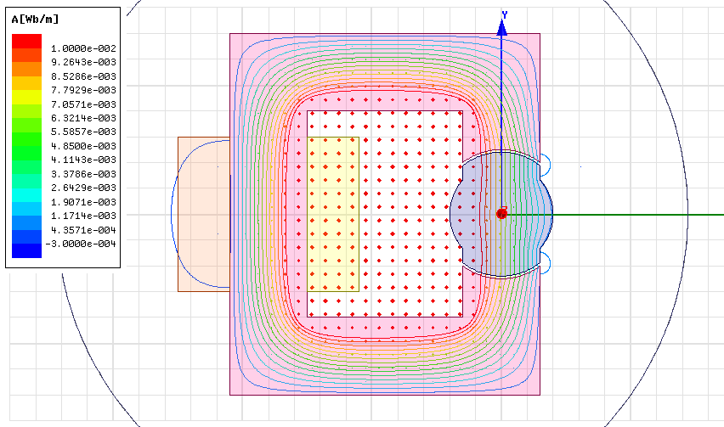(a) 0o position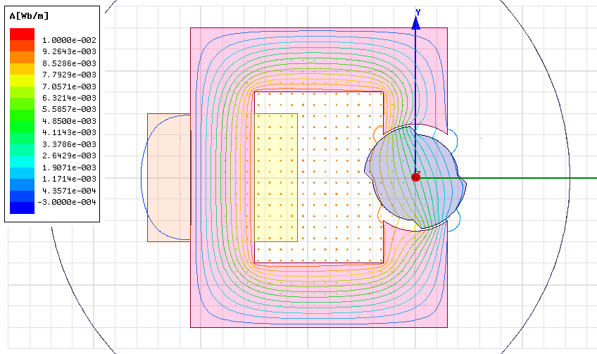(b) 45o position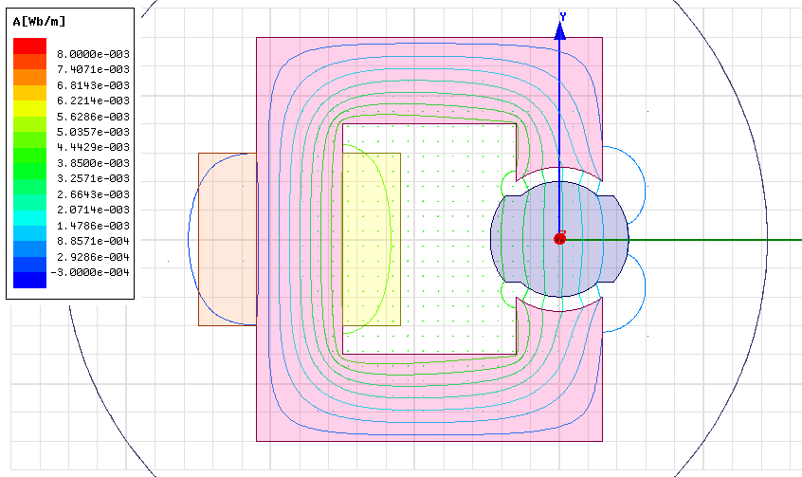(c) 90o position

Fig. 10: Flux lines and vectors for linear (µ=902.6) stator and rotor material

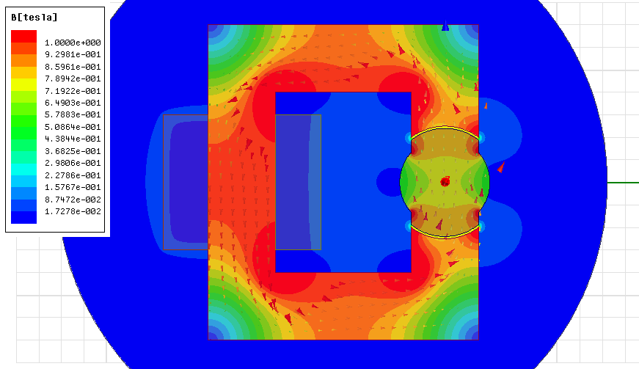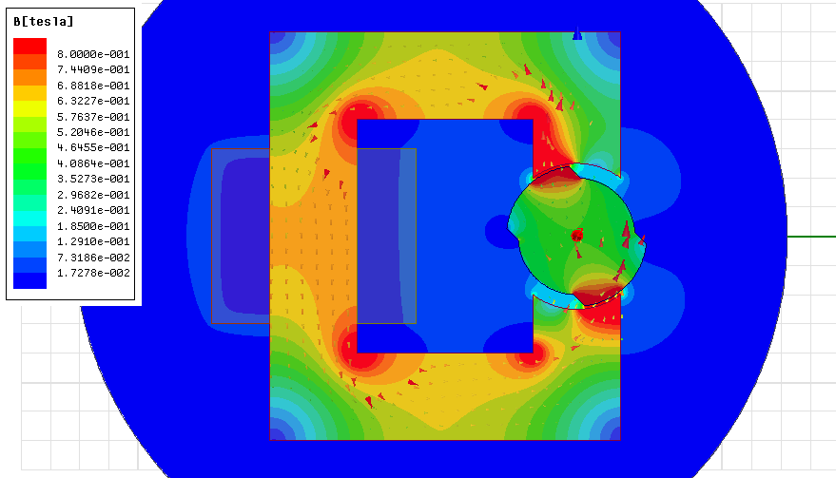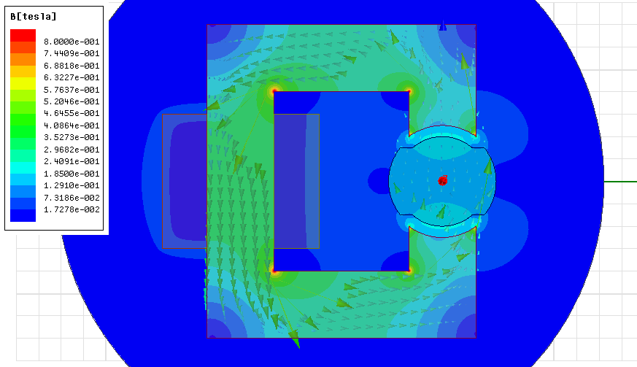

Fig. 11: Magnetic loading (B) distribution of the system with linear (µ=902.6) stator and rotor material

**2b) Inductances and Stored Energy in the System**

Inductances in the system is obtained as shown below. These values are too low with respect to analytical calculations maybe because of material depth is assumed as too low in 2D analysis.

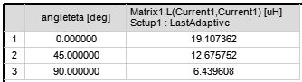

CoEnergies of the system for 0, 45 and 90 degree positions,

0o position 🡪

45o position 🡪

90o position 🡪

These values are meaningless for to compare with analytical solution but we can compare the linear and non-linear material difference. We expect that for linear material coenergy and energy of the system are equal each other but for non-linear material (non linear BH curve) coenergy is slightly smaller than energy.

**2c) Torque Generation in the System**

Torque data of the system is recorded for three specific angle (0, 45 and 90 degree). So the torque graph is looks like triangular but actual form must be sinussoidal. Max torque is generated at 45o angle position.

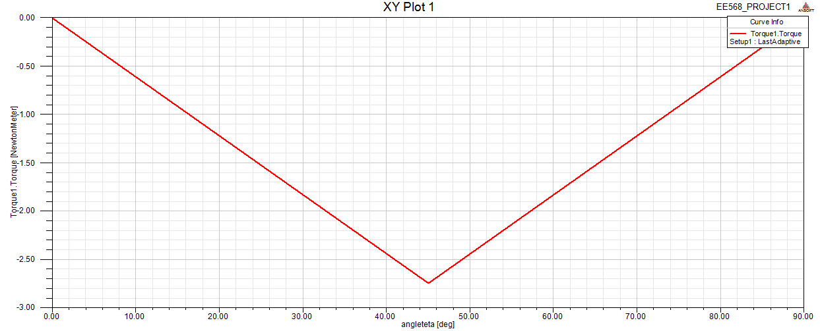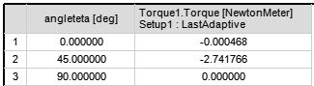

Fig. 12: Torque – position graph and actual values for linear material

3. FEA Modelling (2d Nonlinear Materials)

In this section, stator and rotor materials are selected as again steel_1008 in Ansys/Maxwell library. But, the material property is set as nonlinear characteristic as nonlinear B-H curve that is given in Ansys/Maxwell library.

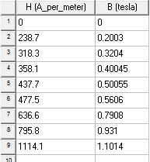

Fig. 13: Non-linear B-H curve of steel_1008 material in Maxwell

**3a) Flux Density Vectors for NonLinear Materials (0, 45, 90 degree rotor)**

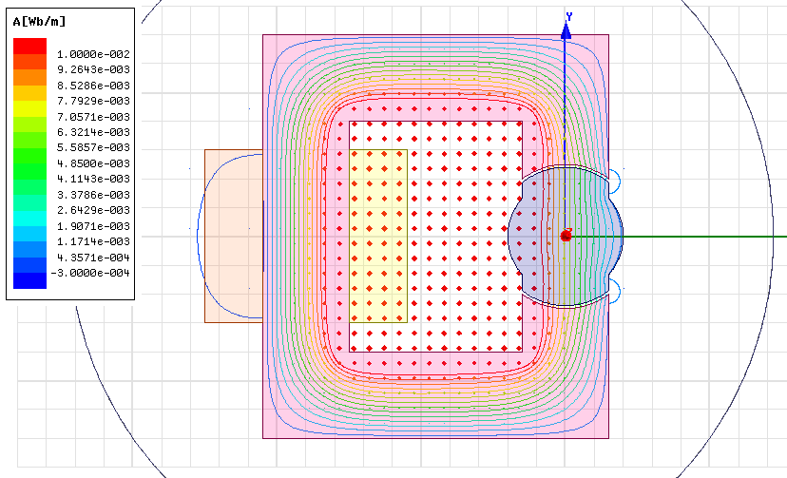(a) 0o position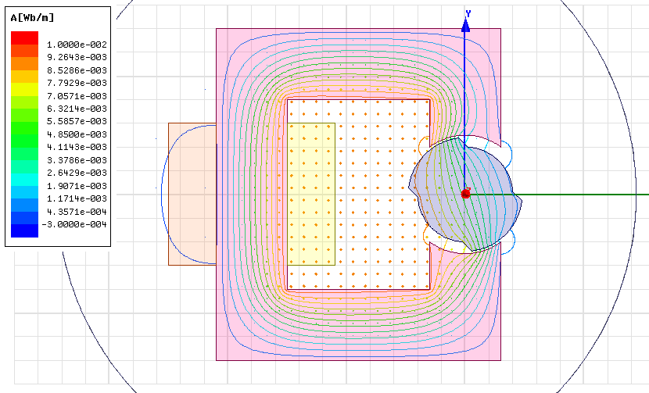(b) 45o position 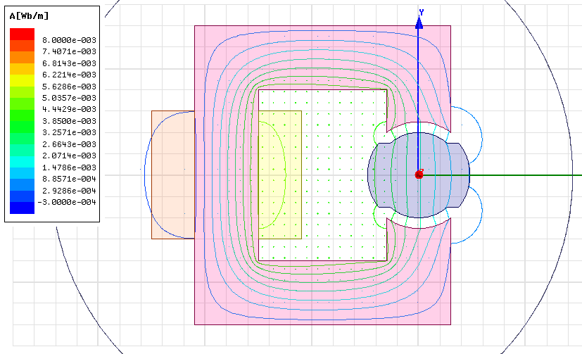(c) 90o position

Fig. 14: Flux lines and vectors for no- linear (steel_1008 nonlinear BH curve) stator and rotor material

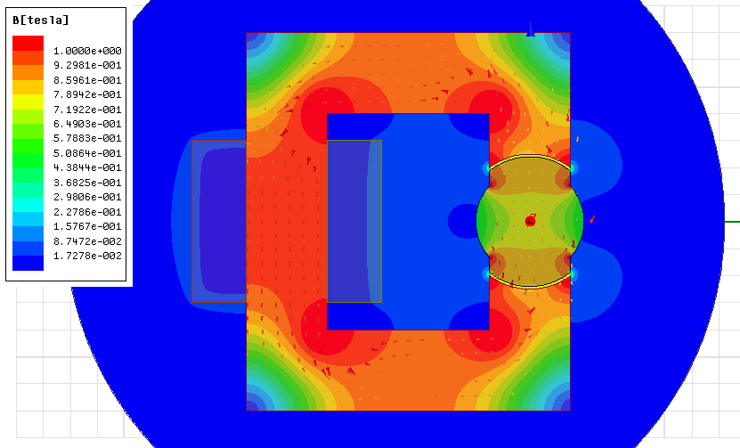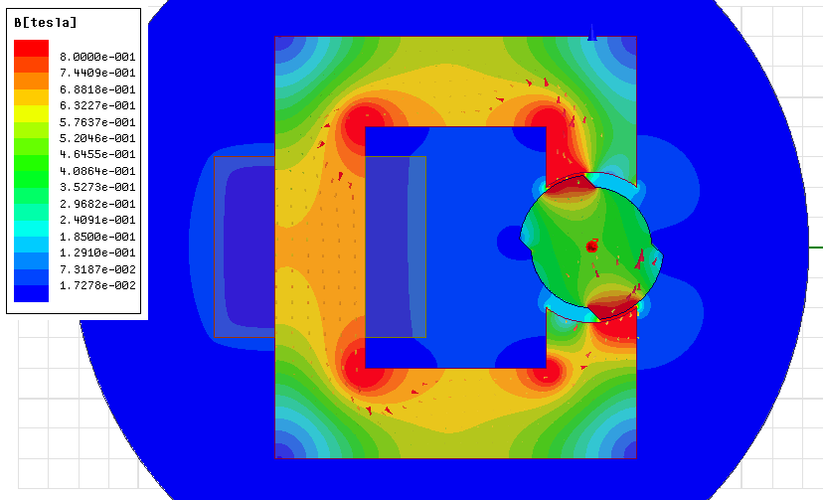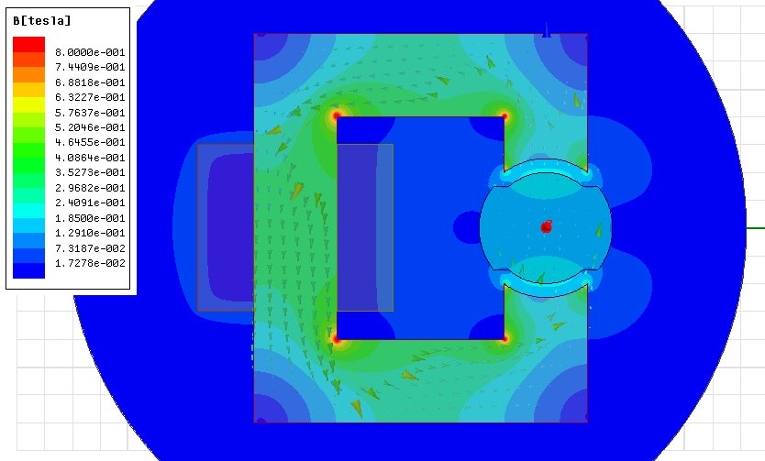

Fig. 15: Magnetic loading (B) distribution of the system with non-linear (steel_1008 nonlinear BH curve) stator and rotor material

**3b) Inductances and Stored Energy in the Nonlinear System**

Inductances in the nonlinear material used system is obtained as shown below. These values are too low with respect to analytical calculations maybe because of material depth is assumed as too low in 2D analysis.

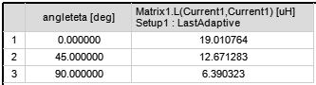

CoEnergies of the system for 0, 45 and 90 degree positions,

0o position 🡪

45o position 🡪

90o position 🡪

When we compare these result with respect to linear material used result, we can see the coenergy of the system decreases slightly because of the nonlinear characteristic of BH curve. For energy comparison, the situation is vice versa.

**3c) Torque Generation in the Nonlinear Material System**

As expected, maximum torque value at 45o position is slightly smaller than linear material based system because of the inductances. Inductances of the nonlinear based system are obtained slightly smaller than linear based system. Torque expression contains Ld-Lq statement. So, for nonlinear based system, this difference is slightly bigger than linear system.

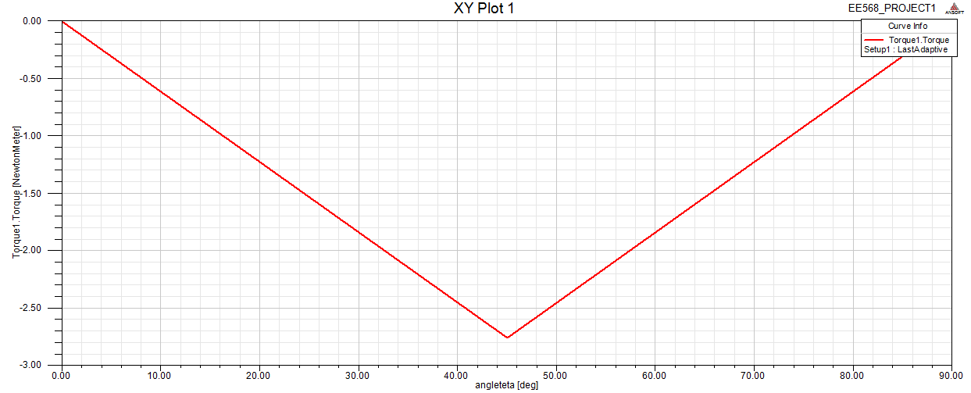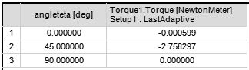

Fig. 16: Torque – position graph and actual values for non-linear material

**3d) The effects of fringing and saturating effects with the linear and non-linear materials**

The difference between linear and nonlinear materials based system can be seen from given figure below that shows the magnetic loading (B) distributions in same scale for 0o position.



(a) Linear stator and rotor material (b) Non-linear stator and rotor material

Fig. 17: Magnetic loading distributions at 0o position for linear and non-linear BH curve materials

For linear material, the magnetic permeability of the material is constant all location on the geometry. So, magnetic loading increases at the inner corners of the stator because of the small length of flux paths. But, the material tries to distribute this loading to homogeneous. In non-linear material, magnetic permeability is constant up to 1.4T, after that value nonlinear region starts and permeability decreases. So, inner corners of the stator expose this non-linear region and permeability is low in these areas and magnetic loading saturates.

4. Control Method

Beacuse of the saliency of the rotor, rotor tries to come to position 0o (180o) position (figxx-b3) for minimizing the reluctance. So, in that position there will not any excitation (avoiding the locking rotor). In this manner, we have to excite the system with maximum energy at near of 90o (270o) position of the rotor. After this excitation rotor gains speed and tries to keep it with its inertia up to next maximum excitation at 270o (90o) position. The excitation wave form with respect to rotor position angle θ is given in figure below.

plot | sin(x) - 0.33 sin(3 x) + 0.2 sin(5 x) - 0.14 sin(7 x)

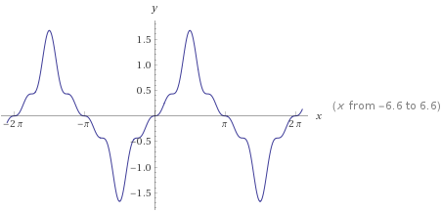

(a)

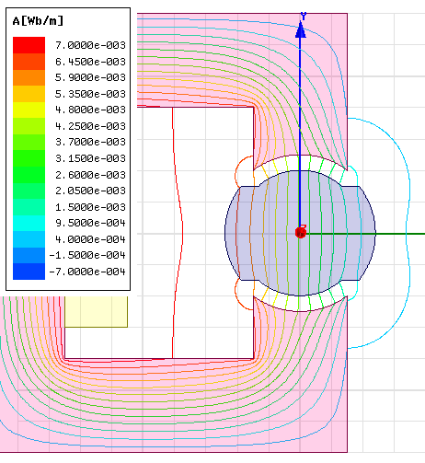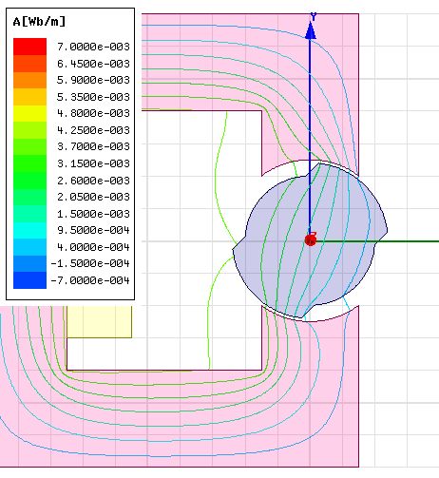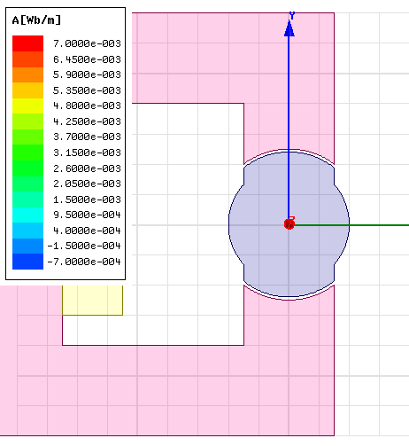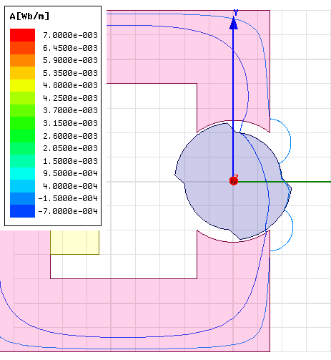

(b)

Fig. 18: (a) Stator excitation signal for control the rotor (b) Rotation motions with flux lines of the control method

With this logic, we can design a basic speed controller for this machine with PID controller as shown below. There is no ready to use motor model exactly same as our model, So, I used the this general model with torque input. Driver function controls the two seperated switch that can also connect the DC source for creating single phase signal as we designed. So the stator excited when the rotor at position every 90o and 270o position.

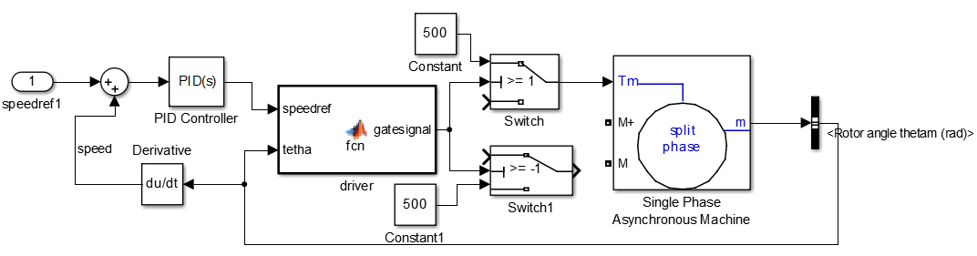

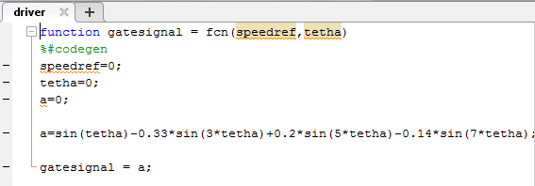

Fig. 19: Designed control system in MATLAB/Simulink

The generated torque is shown in figure below that obtained by Maxwell with designed excitation. As expected, maximum torques are obtained at 135o (also continues periodically at 45o 135o 225o 315o).

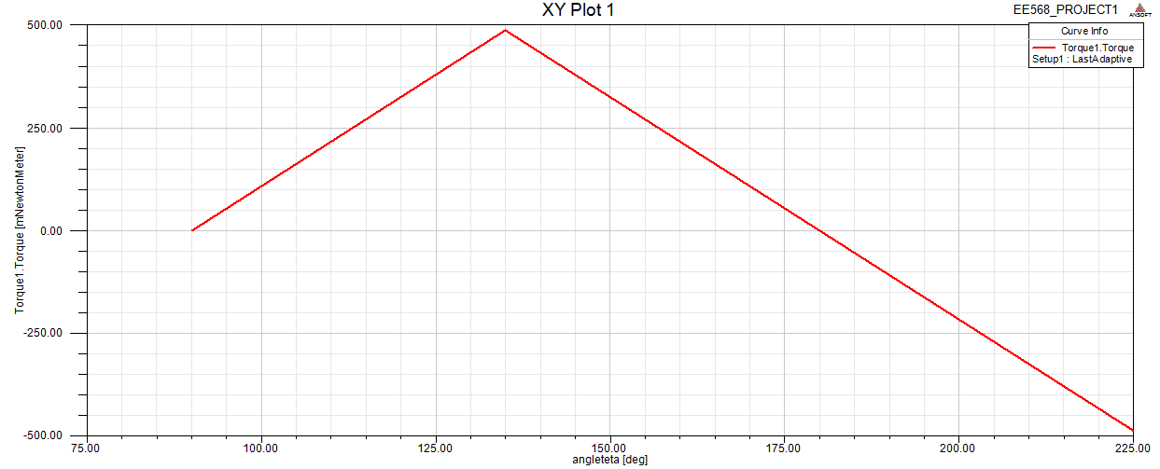

Fig. 20: Generated torque from FEA analysis when the excitation is derived from designed control system

5. Motion Animation

Animation videos are added on github.

<https://github.com/SerhatOzkucuk/EE568-Selected-Topics-on-Electrical-Machines/blob/master/ee568_ozkucuk_control_method_animated.avi>

<https://github.com/SerhatOzkucuk/EE568-Selected-Topics-on-Electrical-Machines/blob/master/ee568_ozkucuk_dcexcitation_animated.avi>

# REFERENCES

1. <https://github.com/odtu/ee568>

2. <http://keysan.me/ee568/>