**Serhat TATAŞ 201005063**

**LIBRARY DATABASE MANAGEMENT SYSTEM**

This project includes fundamental entities related to the library system such as books, authors, categories, customers, and borrowed books. It illustrates the basic relationships among these entities.

|  |  |
| --- | --- |
| **1.Book Table:**  • ISBN (Primary Key)  • Title  • AuthorID (Foreign Key)  • CategoryID (Foreign Key)  • Publisher  • Publication Year  • Page Count  • Shelf Number | **2. Authors Table:**  • AuthorID (Primary Key)  • First Name  • Last Name  • Date of Birth  • Country |
| **3.Categories Table:**  • CategoryID (Primary Key)  • Category Name | **4.Customers Table:**  • CustomerID  • First Name  • Last Name  • Email  • Phone Number  • Address |
| **5. Borrowed Books Table:**  • BorrowID (Primary Key)  • BookID (Foreign Key)  • CustomerID (Foreign Key)  • Borrow Date  • Return Date (It can be null if the book has not been returned yet) |

This project represents the basic data structure of a library management system. Below, you can find fundamental operations that can be implemented on this data model:

|  |
| --- |
| **1-) Adding and Removing Books:** |
| * Adding a new book or removing an existing one. |
| **2-) Adding and Removing Authors:** |
| * Adding a new author or removing an existing one. |
| **3-) Adding and Removing Categories:** |
| * Adding a new category or removing an existing one. |
| **4-) Adding and Removing Customers:** |
| * Adding a new customer or removing an existing one. |
| **5-) Borrowing and Returning Books:** |
| * Managing customers borrowing and returning books. |
| **6-) Viewing Inventory:** |
| * Viewing current books, authors, categories, and customers. |

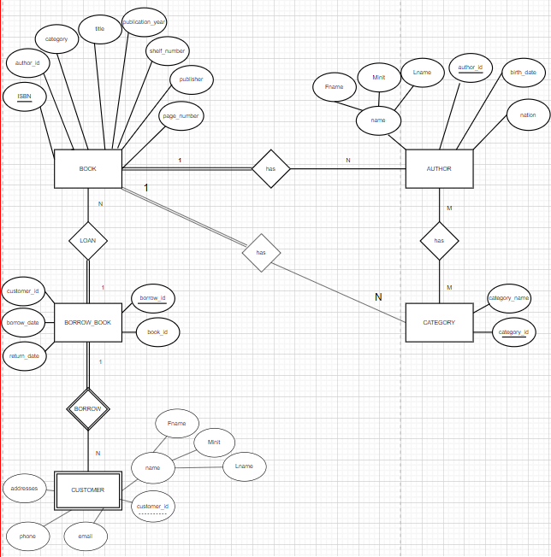

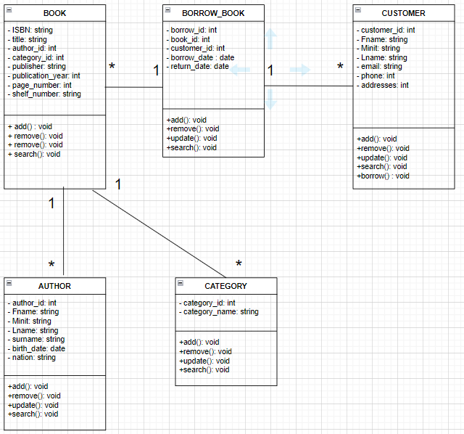

**CODES IN MY SQL**

create database library_management;

USE LIBRARY_MANAGEMENT_SYSTEM;

CREATE TABLE CUSTOMERS(

customer_id INT AUTO_INCREMENT PRIMARY KEY,

customer_name VARCHAR(50),

email VARCHAR(50),

address VARCHAR(100),

phone VARCHAR(15)

);

CREATE TABLE AUTHORS(

author_id INT AUTO_INCREMENT PRIMARY KEY,

author_name VARCHAR(50),

birth_date DATE,

nation VARCHAR(50)

);

CREATE TABLE CATEGORIES(

category_id INT AUTO_INCREMENT PRIMARY KEY,

category_name VARCHAR(50)

);

CREATE TABLE BOOKS(

ISBN VARCHAR(20) PRIMARY KEY,

title VARCHAR(100),

publication_year INT,

shelf_number VARCHAR(20),

author_id INT,

category_id INT,

FOREIGN KEY (author_id) REFERENCES AUTHORS(author_id),

FOREIGN KEY (category_id) REFERENCES CATEGORIES(category_id)

);

CREATE TABLE BORROW_BOOKS(

borrow_id INT AUTO_INCREMENT PRIMARY KEY,

borrow_date DATE,

return_date DATE,

customer_id INT,

book_id VARCHAR(20),

FOREIGN KEY (customer_id) REFERENCES CUSTOMERS(customer_id),

FOREIGN KEY (book_id) REFERENCES BOOKS(ISBN)

);