1 | You perform an ad-hoc review of the model of a process that realizes the following business requirement: “User can send any file of size at most 1 GB through a webform. If the file size exceeds this bound, the system should reject the file, clear the form, and return to the initial state. Otherwise, the system accepts the file.” The model under review is presented in "A model of business flow" What defect in the model can you uncover during the review? Describe the uncovered defect in one sentence. This sentence might be as short as possible but informative  A model of business flow  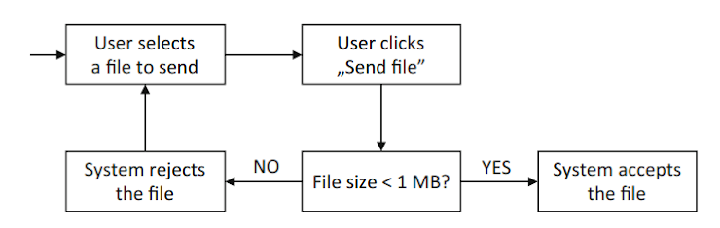
 | Contradiction Between Business Requirements (1GB) And Business Flow Model (1MB)
2 | The degree to which a component or system can be used by people with the widest range of characteristics and capabilities to achieve a specified goal in a specified context of use is...
 | Accessibility
3 | The degree to which a component or system satisfies the stated and implied needs of its various stakeholders is
 | Quality
4 | A user or business requirement consisting of one sentence expressed in the everyday or business language which is capturing the functionality a user needs, the reason behind it, any non-functional criteria, and also including acceptance criteria is...
 | User story
5 | A large user story that cannot be delivered as defined within a single iteration or is large enough that it can be split into smaller user stories is...
 | Epic
6 | The degree to which a component or system can exchange information with other components or systems, and/or perform its required functions while sharing the same hardware or software environment is...
 | Compatibility
7 | Find a Jokek pair https://learningapps.org/watch?v=ptrao5qij21
 | I will be a Great Quality Engineer
8 | Уявімо, що ви прийшли на проєкт і ваша задача на сьогодні - виконати огляд правил (малюнок1). Постав уточнювальні питання Юрі - бізнес-аналітик на проєкт. Став питання ввічливо та починай з привітання  малюнок 1  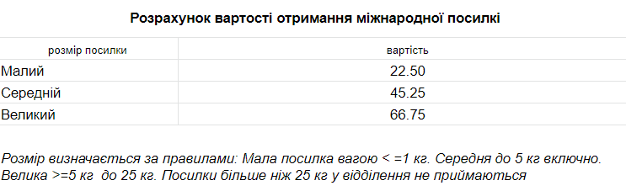
 | Привіт Юра, хотів запитати стосовно малюнка 1: "Чи маєш ти перелік країн з яких надходять посилки? Які розміри посилки в одиницях виміру довжини? У яких грошових одиницях зазначена вартість?
9 | Перевір свої знання та отримай 1 000 000 в КУА карму  https://learningapps.org/watch?v=p4pygjpnt21
 | Я отримала(в) 1 000 000 в куа карму
10 | В статті про статичне тестування не вистачає слів. Спробуй знайти відповідні слова. https://learningapps.org/watch?v=p4vnp3enj21
 | Так, знайшла(ов) всі слова
11 | What is not a benefit of static testing  1) Reducing testing cost and time  2) Increasing development cost and time  3) Reducing development productivity  4) Improving communication between team members  5) Preventing defects in design  6) Identifying failures which are not easily found by dynamic testing

