LABORATORY ASSIGNMENT №3
Partial Views. Navigation. Filtering. Sessions

Goal: Gain skills in working with partial views, learn to work with query string parameters, and acquire skills in working with sessions.

Workflow:

Task 1. Create Partial View

First I’ve created partial view, I it looks like event card.

@model TicketBookingWebsite.Models.Event

<div class="card mb-3 shadow-sm">
<div class="card-body">
<h5 class="card-title">@Model.Name</h5>
<p class="card-text text-muted">
<i class="bi bi-calendar-event"></i> @Model.Date.ToString("dd MMMM, yyyy") <br>
<i class="bi bi-geo-alt"></i> @Model.Location
</p>
<p class="card-text">@Model.Description</p>
<p class="card-text fw-bold text-success">
<i class="bi bi-ticket"></i> @Model.AvailableTickets tickets available
</p>
<p class="card-text">
<span class="badge bg-primary fs-6">$@Model.Price</span>
</p>
</div>
</div>

Next step was importing it to page, so I can display it. Here is how I modified my Index.cshtml:
@model TicketBookingWebsite.ViewModels.EventListViewModel
@using System.Globalization

<div class="row row-cols-1 row-cols-md-2 row-cols-lg-3 g-4">
@foreach (var e in Model.Events)
{
<div class="flex-grow-1" style="min-width: 300px; max-width: 400px;">
<partial name="EventSummary" model="e" />
</div>

}
</div>

<!-- Pagination Controls -->
<nav class="mt-4">
<ul class="pagination justify-content-center">
@for (int i = 1; i <= Model.PagingInfo.TotalPages; i++)
{
<li class="page-item @(i == Model.PagingInfo.CurrentPage ? "active" : "")">
<a class="page-link" asp-action="Index" asp-route-page="@i">@i</a>
</li>
}
</ul>
</nav>

Task 2. Category Navigation
First I’ve created NavigationMenuViewComponent.cs:

using Microsoft.AspNetCore.Mvc;
using TicketBookingWebsite.Data;
using System.Linq;

namespace TicketBookingWebsite.Components
{
public class NavigationMenuViewComponent : ViewComponent
{
private readonly WebsiteDbContext _context;

public NavigationMenuViewComponent(WebsiteDbContext context)
{
_context = context;
}

public IViewComponentResult Invoke()
{
var categories = _context.Events
.Select(e => e.Location)
.Distinct()
.OrderBy(c => c)
.ToList();

return View(categories);
}
}
}

Then I’ve created the component is Views/Shared/Components/NavigationMenu/Default.cshtml:

<div class="sidebar-sticky">
<h4 class="text-primary">Categories</h4>
<ul class="nav flex-column">
<li class="nav-item">
<a class="nav-link text-dark fw-bold" asp-controller="Home" asp-action="Index" asp-route-category="">
All Events
</a>
</li>
@foreach (var category in Model)
{
<li class="nav-item">
<a class="nav-link text-dark" asp-controller="Home" asp-action="Index" asp-route-category="@category">
@category
</a>
</li>
}
</ul>
</div>

Added it to _Layout.chtml and modified the controllers Index method:

public IActionResult Index(string? category, int page = 1)
{
var filteredEvents = string.IsNullOrEmpty(category)
? repository.Events
: repository.Events.Where(e => e.Location == category);

var totalEvents = filteredEvents.Count();

var events = filteredEvents
.OrderBy(e => e.Date)
.Skip((page - 1) * PageSize)
.Take(PageSize);

var viewModel = new EventListViewModel
{
Events = events,
PagingInfo = new PagingInfo
{
CurrentPage = page,
TotalItems = totalEvents,
ItemsPerPage = PageSize
},
CurrentCategory = category
};

return View(viewModel);
}

Here is the result:

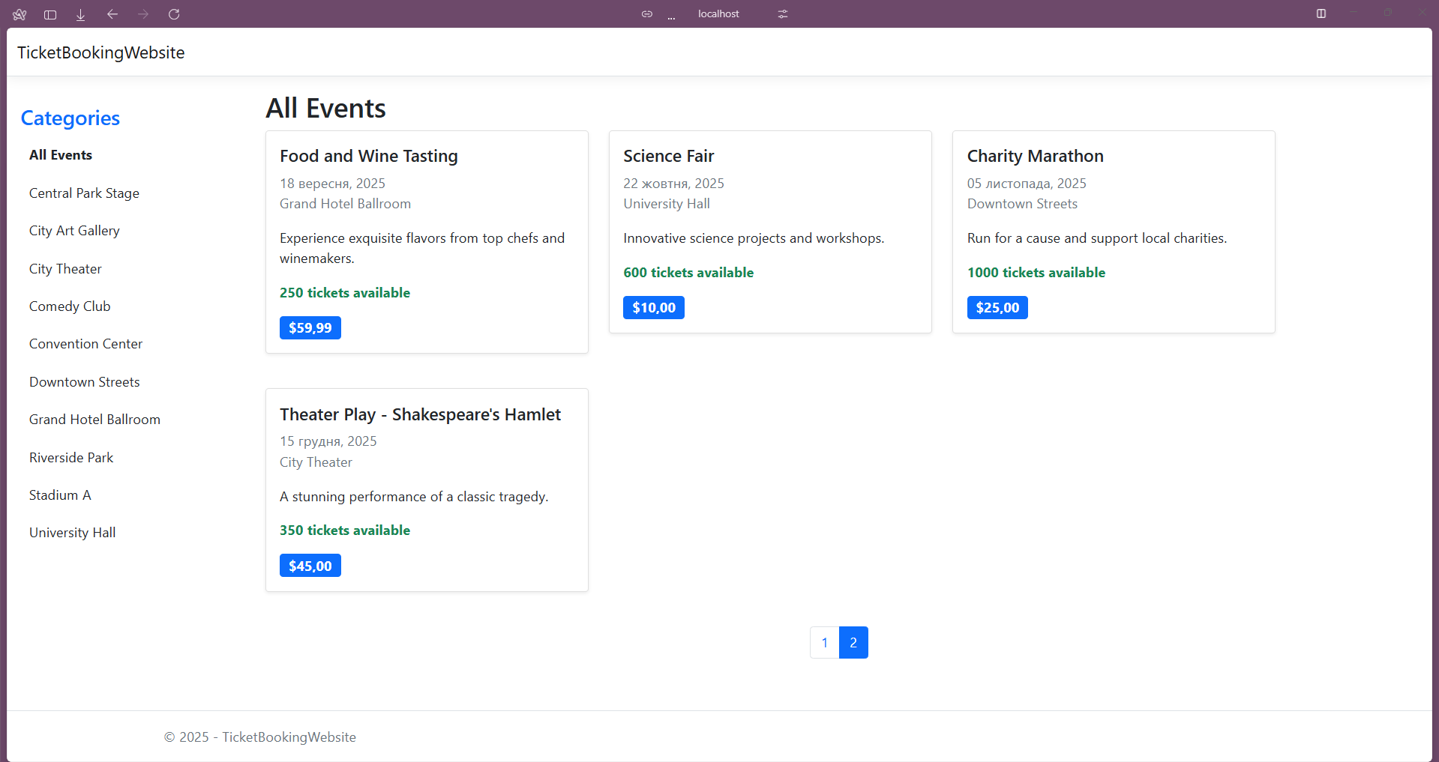

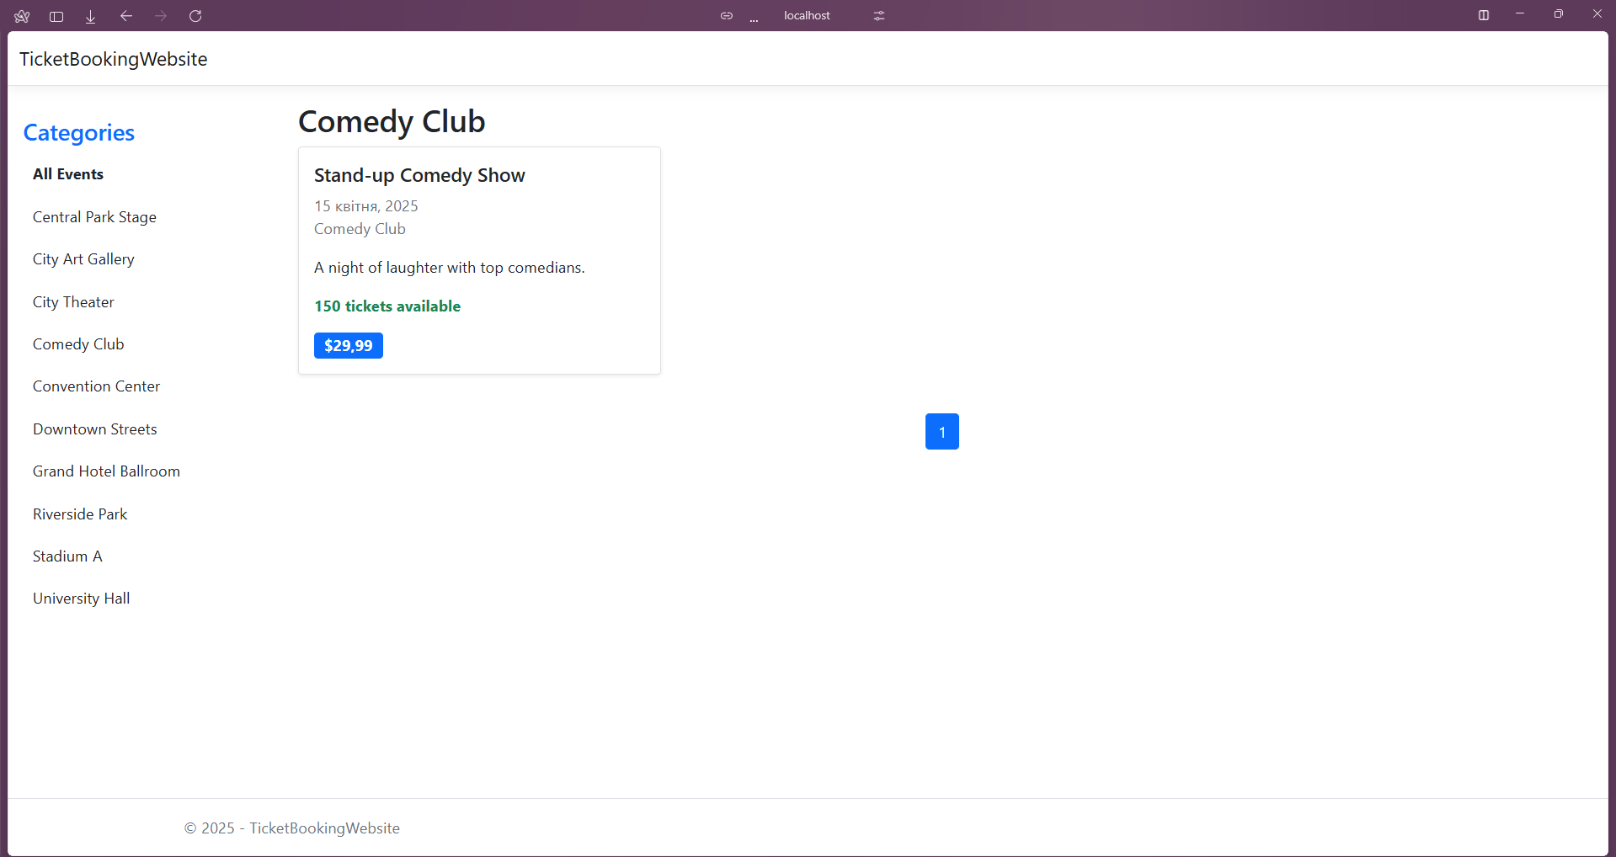
Task 3. Sessions
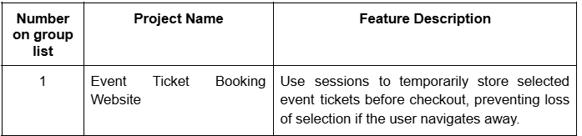

Firstly I added this lines to Program.cs to include sessions:

builder.Services.AddDistributedMemoryCache();
builder.Services.AddSession(options =>
{
options.IdleTimeout = TimeSpan.FromMinutes(30);
options.Cookie.HttpOnly = true;
options.Cookie.IsEssential = true;
});

app.UseSession();

Then I created SessionHelper:

using Microsoft.AspNetCore.Http;
using Newtonsoft.Json;

public static class SessionHelper
{
public static void SetObjectAsJson(this ISession session, string key, object value)
{
session.SetString(key, JsonConvert.SerializeObject(value));
}

public static T GetObjectFromJson<T>(this ISession session, string key)
{
var value = session.GetString(key);
return value == null ? default(T) : JsonConvert.DeserializeObject<T>(value);
}
}
To save something in session, firstly I need to create thing that I will save. So I decided to create Cart, where all selected event tickets will be stored before checkout.

To start I’ve created CartViewModel and cart page:

using TicketBookingWebsite.Models;

namespace TicketBookingWebsite.ViewModels
{
public class CartViewModel
{
public List<Event> Events { get; set; }
public decimal TotalPrice { get; set; }
}

}

@model TicketBookingWebsite.ViewModels.CartViewModel

<h2>Your Cart</h2>

@if (Model.Events != null && Model.Events.Count > 0)
{
<table class="table">
<thead>
<tr>
<th>Event</th>
<th>Price</th>
</tr>
</thead>
<tbody>
@foreach (var item in Model.Events)
{
<tr>
<td>@item.Name</td>
<td>@item.Price.ToString("C")</td>
</tr>
}
</tbody>
</table>

<h3>Total: @Model.TotalPrice.ToString("C")</h3>

<a href="@Url.Action("ClearCart")" class="btn btn-danger">Clear Cart</a>
<a href="@Url.Action("Checkout")" class="btn btn-primary">Proceed to Checkout</a>
}
else
{
<p>Your cart is empty.</p>
}

Added Add to Cart button in event summary:

<a href="@Url.Action("AddToCart", "Home", new { eventId = Model.Id })" class="btn btn-primary">
Add to Cart
</a>

Modified HomeController, added handlers for Cart:

public IActionResult AddToCart(int eventId)
{
var selectedEvent = repository.Events.FirstOrDefault(e => e.Id == eventId);
if (selectedEvent != null)
{
var cart = HttpContext.Session.GetObjectFromJson<List<Event>>("Cart") ?? new List<Event>();
cart.Add(selectedEvent);
HttpContext.Session.SetObjectAsJson("Cart", cart);
}

return RedirectToAction("Index");
}

public IActionResult Cart()
{
var cart = HttpContext.Session.GetObjectFromJson<List<Event>>("Cart");
var viewModel = new CartViewModel
{
Events = cart,
TotalPrice = cart?.Sum(e => e.Price) ?? 0
};

return View(viewModel);
}

public IActionResult ClearCart()
{
HttpContext.Session.Remove("Cart");
return RedirectToAction("Cart");
}

Result:

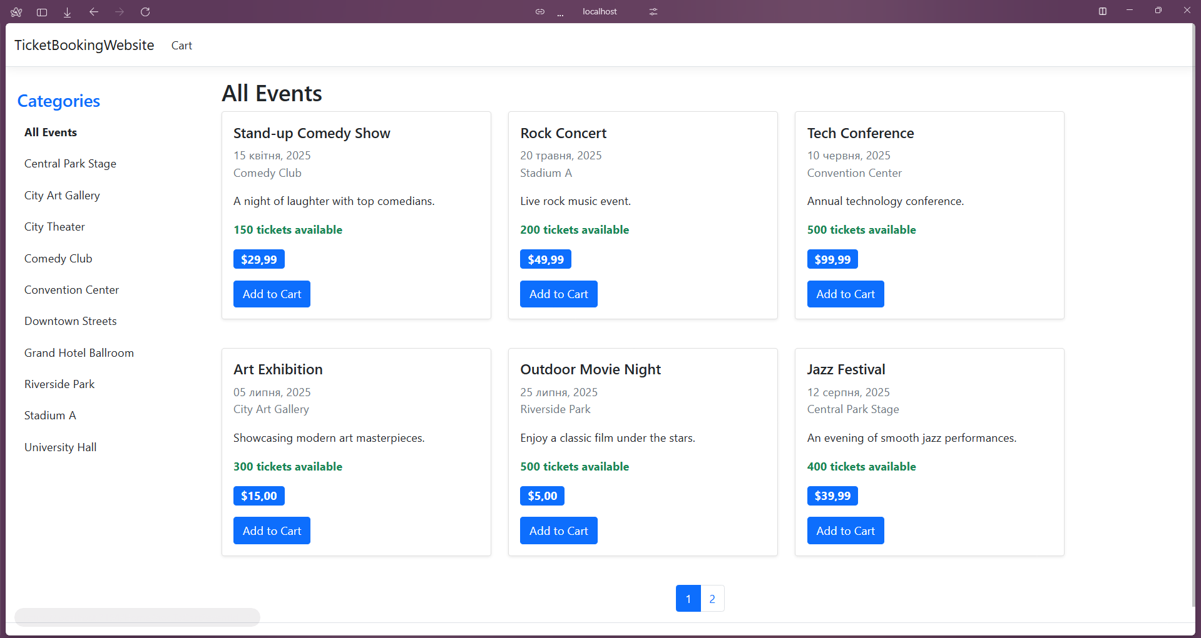

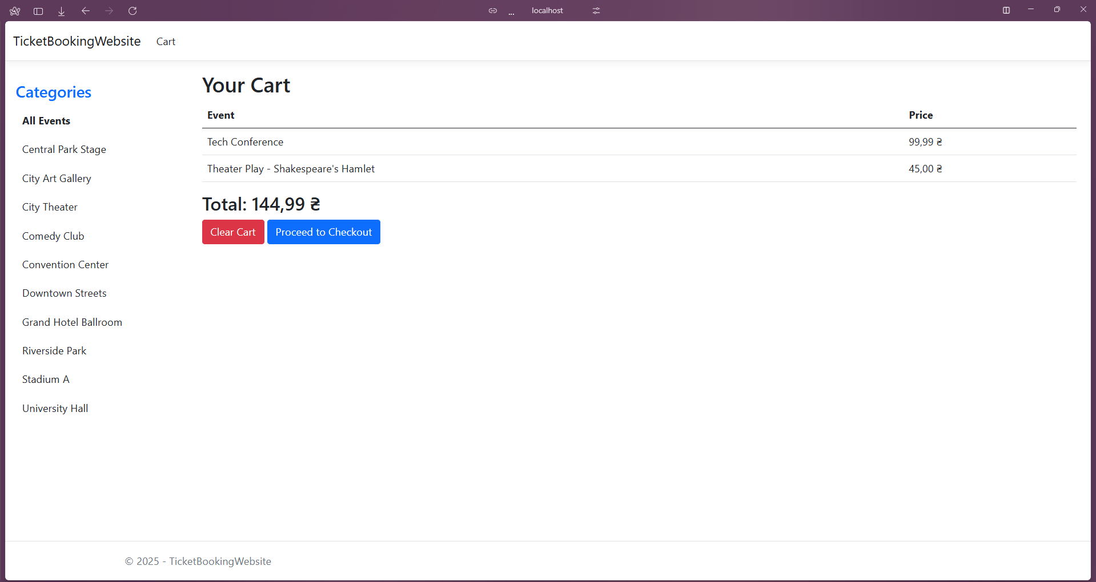

Conclusion: I gained skills in working with partial views, learned how to work with query string parameters, and acquired skills in working with sessions.

