LABORATORY ASSIGNMENT №5
Authentication and authorization. Web API. JSON Web Token.

Goal: acquire skills with authorization authentication mechanisms in ASP.NET, get skills working with Web API.

Workflow:

Task 1. Implement user registration, authentication and authorization using Microsoft Identity package.

First, I’ve installed identity and configured identity:

public class WebsiteIdentityDbContext : IdentityDbContext<IdentityUser>
{
public WebsiteIdentityDbContext(DbContextOptions<WebsiteIdentityDbContext> options)
: base(options) { }
}

builder.Services.AddDbContext<WebsiteIdentityDbContext>(options =>
options.UseSqlServer(builder.Configuration["ConnectionStrings:IdentityConnection"]));

"ConnectionStrings": {
"DefaultConnection": "Server=(localdb)\\mssqllocaldb;Database=TicketBookingWebsite;MultipleActiveResultSets=true",
"IdentityConnection": "Server=(localdb)\\mssqllocaldb;Database=TicketBookingWebsiteIdentity;MultipleActiveResultSets=true"
}

After configuring Identity, implement the following functionalities:
- User registration
  - Set a requirement for the uniqueness of the user's email address
  - Set password requirements: no shorter than 8 characters, contains numbers and letters, must contain at least one uppercase letter
  - Implement a field for confirming the entered password (you can add client side equality check using JS and get additional points)
- User authentication (Login)
- User logout (Logout)
- User's personal account, where he will be able to view or change his own data. (you can add password recovery with email for additional points)

1. User registration
a. Set a requirement for the uniqueness of the user's email address
b. Set password requirements: no shorter than 8 characters, contains numbers and letters, must contain at least one uppercase letter

I’ve added configuration into Program.cs to match requirements.

builder.Services.AddIdentity<IdentityUser, IdentityRole>(options =>
{
options.User.RequireUniqueEmail = true;

options.Password.RequireDigit = true;
options.Password.RequiredLength = 8;
options.Password.RequireNonAlphanumeric = false;
options.Password.RequireUppercase = true;
options.Password.RequireLowercase = true;
})

c. Implement a field for confirming the entered password (you can add client side equality check using JS and get additional points)

public class RegisterModel
{
[Required]
[EmailAddress]
public string Email { get; set; }

[Required]
[DataType(DataType.Password)]
[MinLength(8, ErrorMessage = "Password must be at least 8 characters long")]
[RegularExpression(@"^(?=.*[A-Z])(?=.*\d)(?=.*[a-z]).{8,}$", ErrorMessage = "Password must contain at least one uppercase letter, one lowercase letter, and one number.")]
public string Password { get; set; }

[Required]
[DataType(DataType.Password)]
[Compare("Password", ErrorMessage = "Passwords do not match.")]
public string ConfirmPassword { get; set; }
}

In fact it was implemented using JS, cause it was using DataAnnotations, which equality checks data using jquery validation scripts. Script is included at the end of view.

@model TicketBookingWebsite.ViewModels.RegisterModel

<div class="d-flex justify-content-center align-items-center" style="min-height: 80vh;">
<div class="card p-4 shadow" style="min-width: 300px; max-width: 500px; width: 100%;">
<h2 class="text-center mb-4">Register</h2>

<form asp-action="Register" method="post">
<div class="form-group mb-3">
<label for="Email">Email</label>
<input asp-for="Email" class="form-control" />
<span asp-validation-for="Email" class="text-danger"></span>
</div>

<div class="form-group mb-3">
<label for="Password">Password</label>
<input asp-for="Password" class="form-control" />
<span asp-validation-for="Password" class="text-danger"></span>
</div>

<div class="form-group mb-4">
<label for="ConfirmPassword">Confirm Password</label>
<input asp-for="ConfirmPassword" class="form-control" />
<span asp-validation-for="ConfirmPassword" class="text-danger"></span>
</div>

<button type="submit" class="btn btn-primary w-100">Register</button>

<div class="form-group mb-2 mt-2">
<p>Already have an account? <a asp-action="Login">Log in</a></p>
</div>
</form>
</div>
</div>

@section Scripts {
<partial name="_ValidationScriptsPartial" />
}

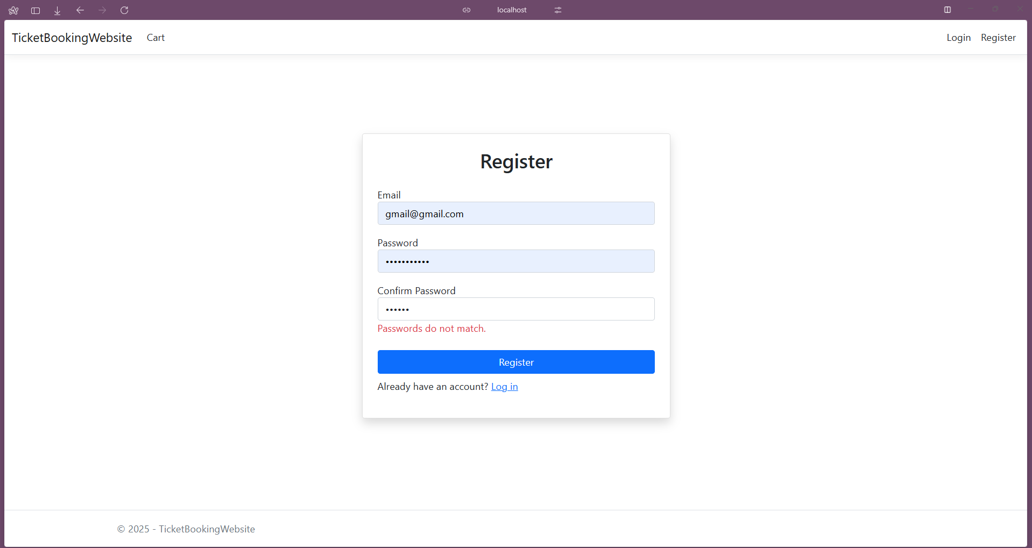

2. User authentication (Login):

public IActionResult Login(string returnUrl) =>
View(new LoginModel { ReturnUrl = returnUrl });

[HttpPost]
[ValidateAntiForgeryToken]
public async Task<IActionResult> Login(LoginModel loginModel)
{
if (ModelState.IsValid)
{
var user = await _userManager.FindByEmailAsync(loginModel.Email);
if (user != null)
{
var result = await _signInManager.PasswordSignInAsync(user, loginModel.Password, false, false);
if (result.Succeeded)
{
return Redirect(loginModel.ReturnUrl ?? "/");
}
}
ModelState.AddModelError("", "Invalid name or password");
}
return View(loginModel);
}

@model TicketBookingWebsite.ViewModels.LoginModel

<div class="d-flex justify-content-center align-items-center" style="height: 80vh;">
<div class="card p-4 shadow" style="min-width: 300px; max-width: 400px; width: 100%;">
<h2 class="text-center mb-4">Login</h2>

<form asp-action="Login" method="post">
<div class="form-group mb-3">
<label asp-for="Email"></label>
<input asp-for="Email" class="form-control" />
<span asp-validation-for="Email" class="text-danger"></span>
</div>

<div class="form-group mb-4">
<label asp-for="Password"></label>
<input asp-for="Password" class="form-control" type="password" />
<span asp-validation-for="Password" class="text-danger"></span>
</div>

<button type="submit" class="btn btn-primary w-100">Login</button>

<div class="form-group mb-2 mt-2">
<p>Not registered? <a asp-action="Register">Create an account</a></p>
</div>

<div class="form-group">
<a href="#" onclick="redirectToForgotPassword()" id="forgotPasswordLink">Forgot your password?</a>
</div>
</form>
</div>
</div>

@section Scripts {
<partial name="_ValidationScriptsPartial" />
<script>
function redirectToForgotPassword() {
const email = document.querySelector('input[name="Email"]').value;
const url = `/Account/ForgotPassword${email ? '?email=' + encodeURIComponent(email) : ''}`;
window.location.href = url;
}
</script>
}

I’ve also added password recovery here, which was mentioned in subtask 4:

User's personal account, where he will be able to view or change his own data. (you can add password recovery with email for additional points)
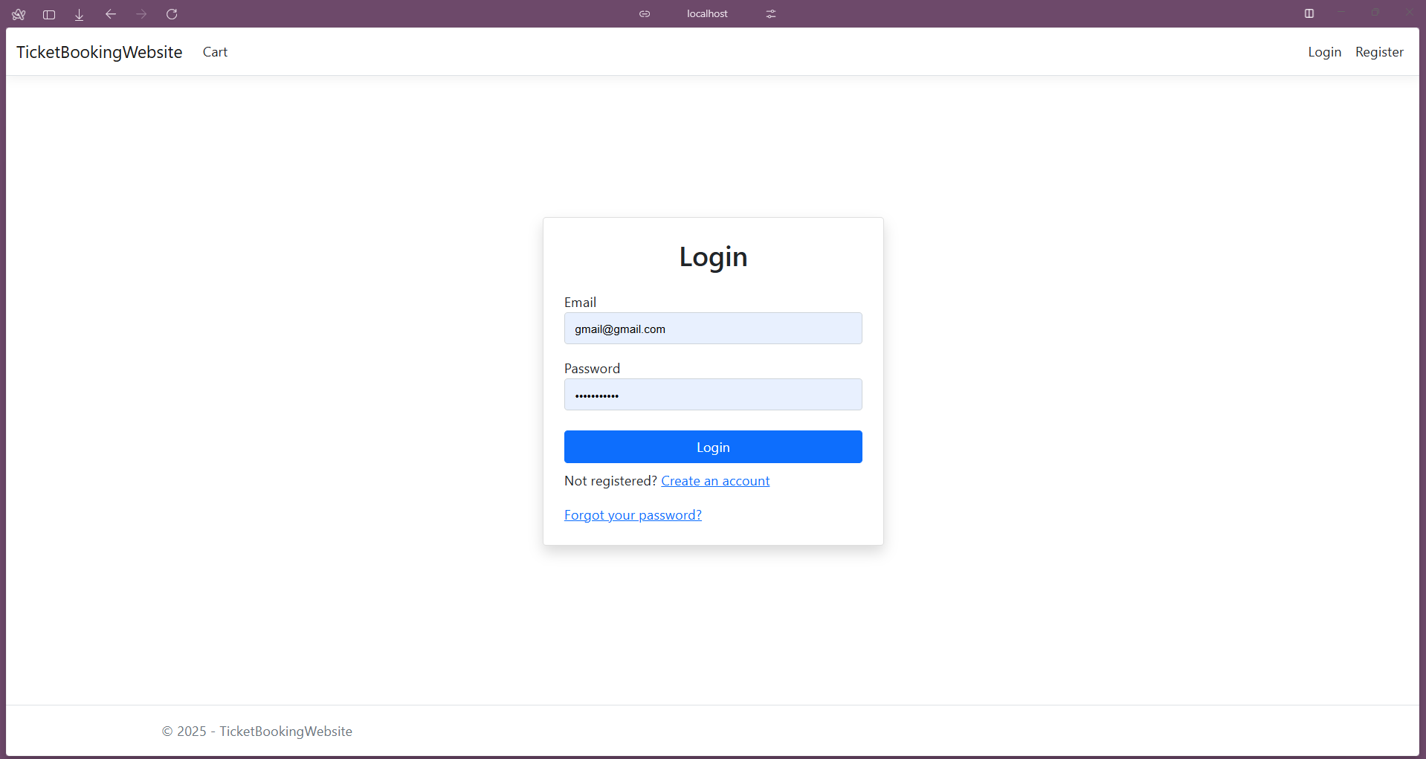

3. User logout (Logout)

[Authorize]
public async Task<IActionResult> Logout()
{
await _signInManager.SignOutAsync();
return RedirectToAction("Index", "Home");
}

Logout button is placed on _Layout:

@if (User.Identity?.IsAuthenticated ?? false)
{
<li class="nav-item">
<a class="nav-link text-dark" asp-controller="Account" asp-action="Manage">Hello, @User.Identity.Name!</a>
</li>
<li class="nav-item">
<form class="form-inline" asp-area="" asp-controller="Account" asp-action="Logout" method="post">
<button type="submit" class="nav-link btn btn-link text-dark">Logout</button>
</form>
</li>
}

4. User's personal account, where he will be able to view or change his own data. (you can add password recovery with email for additional points)

Here is all controlled methods related to account management:

[Authorize]
[HttpGet]
public async Task<IActionResult> Manage()
{
var user = await _userManager.GetUserAsync(User);
if (user == null) return RedirectToAction("Login");

var model = new UserProfileModel
{
Email = user.Email,
Name = user.UserName,
PhoneNumber = user.PhoneNumber
};

return View(model);
}

[HttpPost]
[Authorize]
[ValidateAntiForgeryToken]
public async Task<IActionResult> UpdateProfile(UserProfileModel model)
{
var user = await _userManager.GetUserAsync(User);
if (user == null) return RedirectToAction("Login");

if (ModelState.IsValid)
{
user.UserName = model.Name;
user.PhoneNumber = model.PhoneNumber;
var result = await _userManager.UpdateAsync(user);

if (result.Succeeded)
{
ViewBag.StatusMessage = "Profile updated successfully!";
}
else
{
foreach (var error in result.Errors)
ModelState.AddModelError("", error.Description);
}
}
return View("Manage", model);
}

[HttpGet]
[AllowAnonymous]
public IActionResult ForgotPassword(string email = "")
{
var model = new ForgotPasswordModel { Email = email };
return View(model);
}

[HttpPost]
[AllowAnonymous]
[ValidateAntiForgeryToken]
public async Task<IActionResult> ForgotPassword(ForgotPasswordModel model, [FromServices] IEmailSender emailSender)
{
if (!ModelState.IsValid) return View(model);

InfoPageModel infoPageModel = new InfoPageModel
{
Message = "Password reset mail has been sent. Check your email."
};

var user = await _userManager.FindByEmailAsync(model.Email);
if (user == null)
{
return View("InfoPage", infoPageModel);
}

var token = await _userManager.GeneratePasswordResetTokenAsync(user);
var callbackUrl = Url.Action("ResetPassword", "Account",
new { token, email = model.Email }, Request.Scheme);

await emailSender.SendEmailAsync(model.Email, "Reset Password",
$"Please reset your password by clicking <a href='{callbackUrl}'>here</a>.");

return View("InfoPage", infoPageModel);
}

[HttpGet]
[AllowAnonymous]
public IActionResult InfoPage() =>
View();

[HttpGet]
[AllowAnonymous]
public IActionResult ResetPassword(string token, string email) =>
View(new ResetPasswordModel { Token = token, Email = email });

[HttpPost]
[AllowAnonymous]
[ValidateAntiForgeryToken]
public async Task<IActionResult> ResetPassword(ResetPasswordModel model)
{
if (!ModelState.IsValid) return View(model);

InfoPageModel infoPageModel = new InfoPageModel
{
Message = "Password has been reset."
};

var user = await _userManager.FindByEmailAsync(model.Email);
if (user == null)
{
return View("InfoPage", infoPageModel);
}

var result = await _userManager.ResetPasswordAsync(user, model.Token, model.Password);
if (result.Succeeded)
{
return View("InfoPage", infoPageModel);
}

foreach (var error in result.Errors)
{
ModelState.AddModelError("", error.Description);
}

return View(model);
}

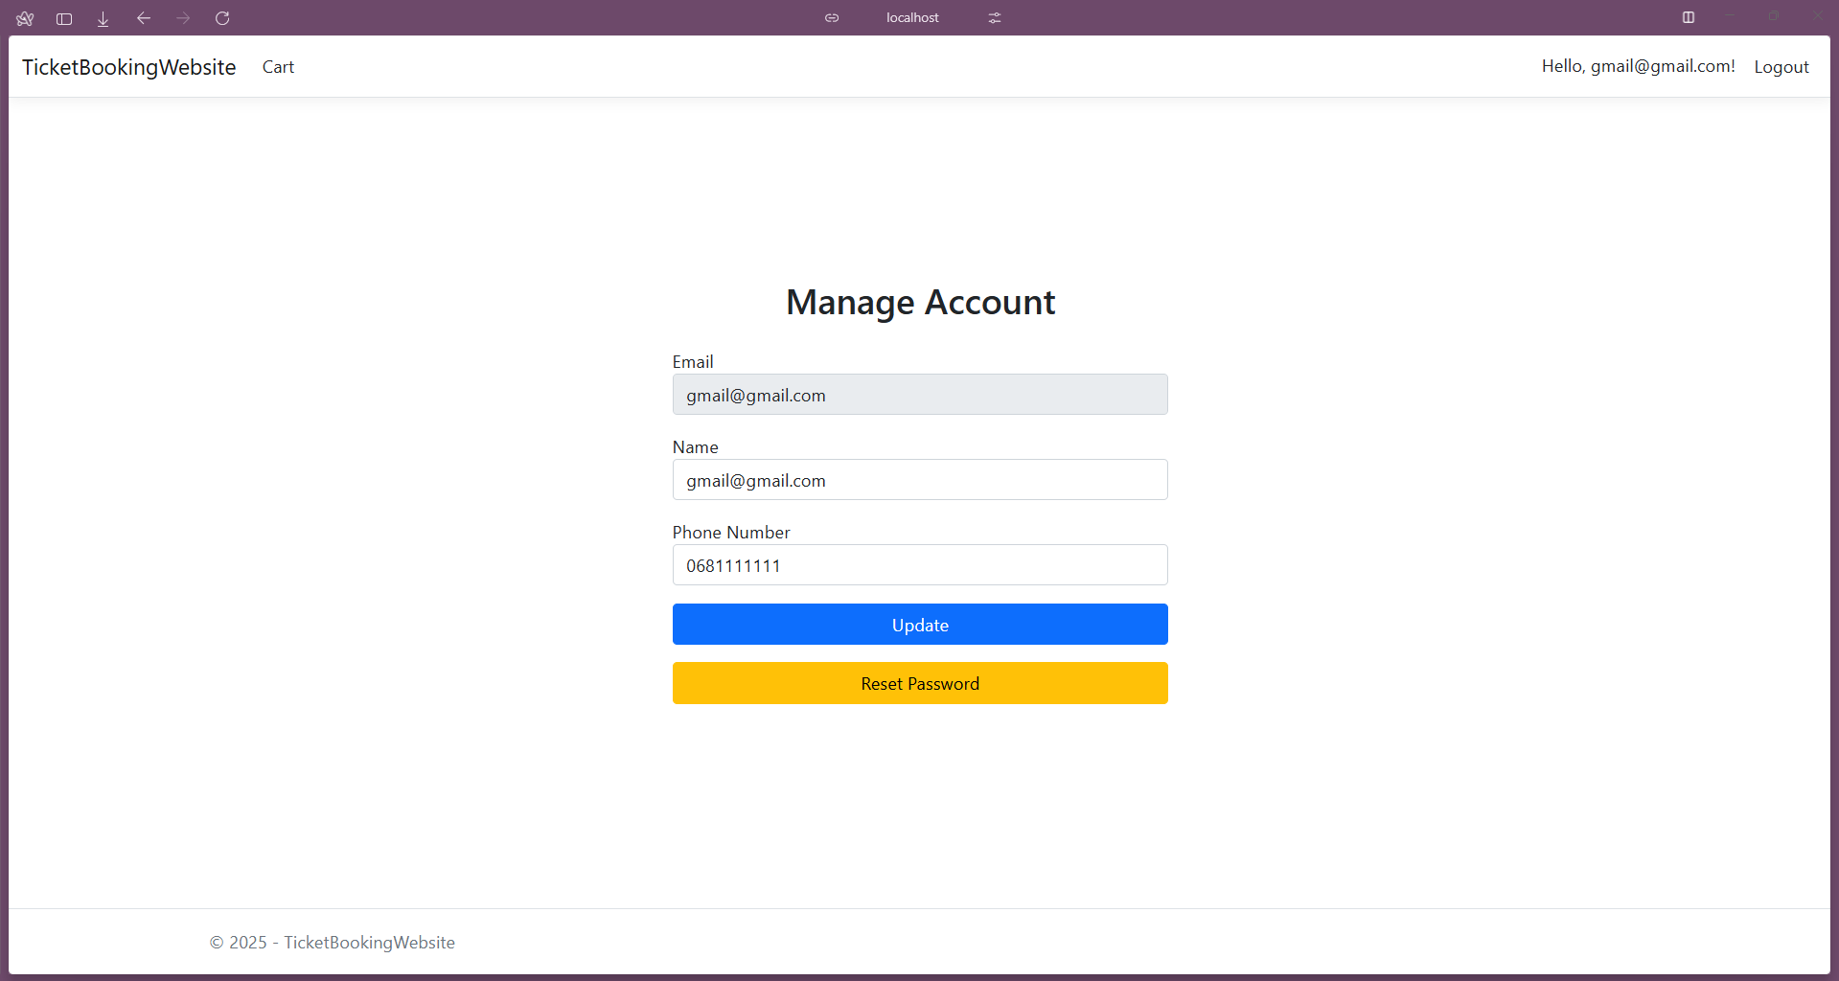

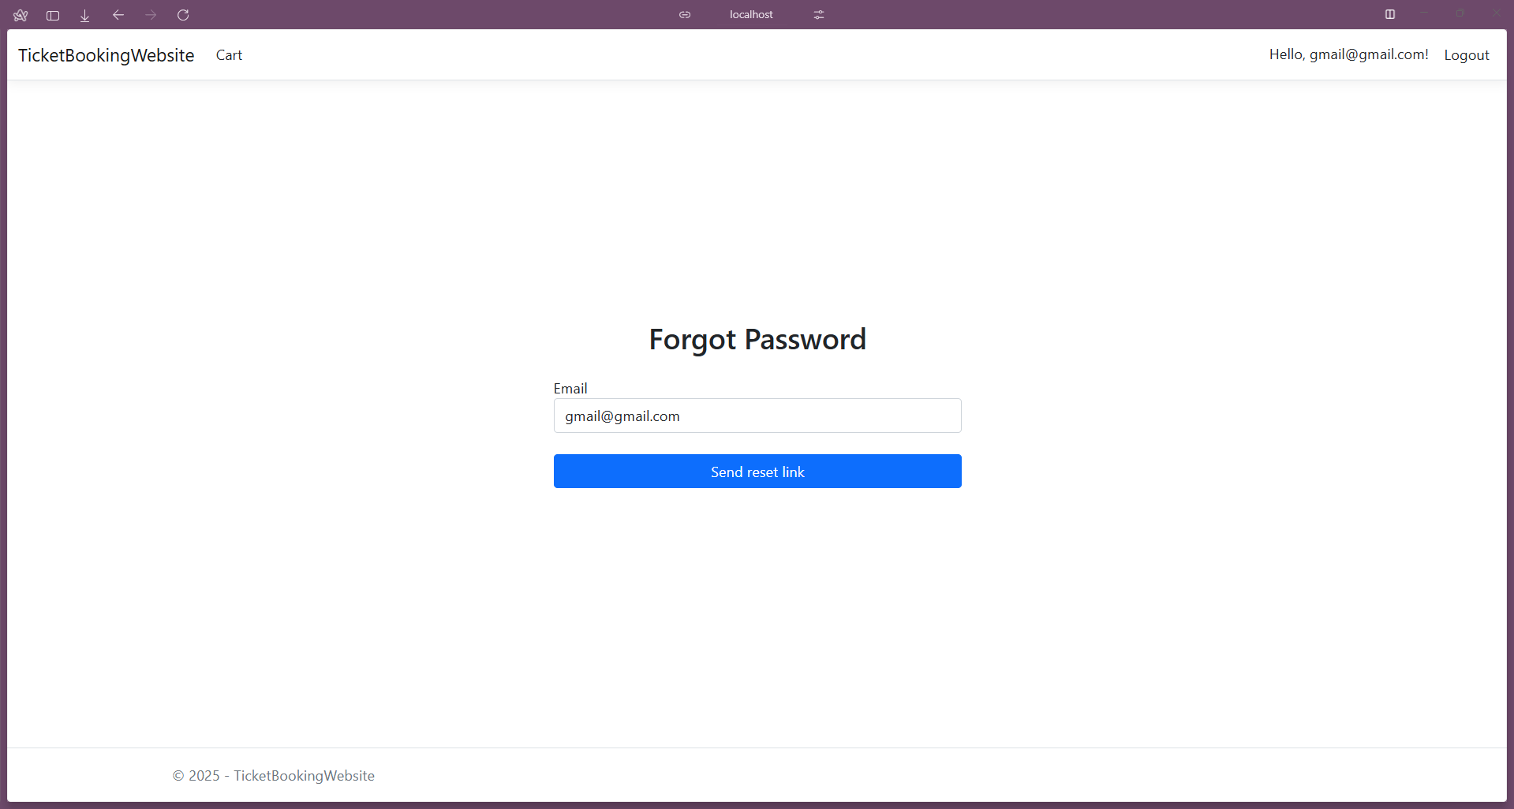

Password recovery is emplemented using Email sender:

using System.Diagnostics;
using Microsoft.AspNetCore.Identity.UI.Services;
using Microsoft.Extensions.Options;
using System.Net.Mail;
using System.Net;
using System.Threading.Tasks;

namespace TicketBookingWebsite.Helpers
{
public class EmailSettings
{
public string SmtpServer { get; set; }
public int SmtpPort { get; set; }
public string SmtpUser { get; set; }
public string SmtpPass { get; set; }
}

public class EmailSender : IEmailSender
{
private readonly EmailSettings _settings;

public EmailSender(IOptions<EmailSettings> settings)
{
_settings = settings.Value;
}

public Task SendEmailAsync(string email, string subject, string htmlMessage)
{
try
{
var mail = new MailMessage
{
From = new MailAddress(_settings.SmtpUser),
Subject = subject,
Body = htmlMessage,
IsBodyHtml = true
};
mail.To.Add(email);

var client = new SmtpClient(_settings.SmtpServer, _settings.SmtpPort)
{
Credentials = new NetworkCredential(_settings.SmtpUser, _settings.SmtpPass),
EnableSsl = true
};

return client.SendMailAsync(mail);
}
catch (Exception ex)
{
Console.WriteLine($"[ERROR] Email sending failed: {ex.Message}");
throw;
}
}
}
}

builder.Services.Configure<EmailSettings>(builder.Configuration.GetSection("EmailSettings"));
builder.Services.AddTransient<IEmailSender, EmailSender>();

Additional points task (5 points): implement work with user roles.
Provide the possibility of registering two types of users in the project, for example, a patient and a doctor. If the project topic does not involve working with several types of users, then implement the roles of a regular user and an administrator.

builder.Services.AddIdentity<IdentityUser, IdentityRole>(

I’ve added IdentityRole to Identity service then seeded database with roles:

private static async Task SeedRoles(RoleManager<IdentityRole> roleManager)
{
string[] roleNames = { "Admin", "User" };

foreach (var roleName in roleNames)
{
var roleExist = await roleManager.RoleExistsAsync(roleName);
if (!roleExist)
{
await roleManager.CreateAsync(new IdentityRole(roleName));
}
}
}

Also added default admin and user seeding:

private static async Task SeedUsers(UserManager<IdentityUser> userManager)
{
var adminUser = await userManager.FindByEmailAsync("admin@ticketbooking.com");

if (adminUser == null)
{
adminUser = new IdentityUser
{
UserName = "admin@ticketbooking.com",
Email = "admin@ticketbooking.com"
};
var result = await userManager.CreateAsync(adminUser, "AdminPassword123!");

if (result.Succeeded)
{
await userManager.AddToRoleAsync(adminUser, "Admin");
}
}

var regularUser = await userManager.FindByEmailAsync("user@ticketbooking.com");

if (regularUser == null)
{
regularUser = new IdentityUser
{
UserName = "user@ticketbooking.com",
Email = "user@ticketbooking.com"
};
var result = await userManager.CreateAsync(regularUser, "UserPassword123!");

if (result.Succeeded)
{
await userManager.AddToRoleAsync(regularUser, "User");
}
}
}

I’ve implemented 2 roles: User and Admin. User is just basic without additional permissions. Admin is user, who can control all events and bookings.

[Authorize(Roles= "Admin")]
public class BookingController : Controller

[Authorize(Roles = "Admin")]
public class EventController : Controller

