LABORATORY ASSIGNMENT №7
Building real-time web applications with SignalR

Goal: to gain hands-on experience integrating SignalR into a web application to enable real-time data exchange using SignalR.

Workflow:

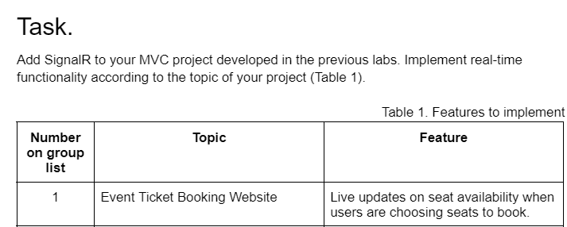

First, I’ve added Seat model:

using System;
using System.Collections.Generic;
using System.Linq;
using System.Text;
using System.Threading.Tasks;

namespace TicketBookingWebsite.Models
{
public class Seat
{
public string Id { get; set; }
public bool IsAvailable { get; set; } = true;
}

}
Then, I’ve created SeatHub, which handles sending seat update to all clients:
using Microsoft.AspNetCore.SignalR;
using System.Threading.Tasks;

namespace TicketBookingWebsite.Hubs
{
public class SeatHub : Hub
{
public async Task NotifySeatUpdate(string seatId, bool isAvailable)
{
await Clients.All.SendAsync("ReceiveSeatUpdate", seatId, isAvailable);
}
}
}

Added Controller and View:

using Microsoft.AspNetCore.Authorization;
using Microsoft.AspNetCore.Mvc;
using System.Collections.Generic;
using System.Linq;
using TicketBookingWebsite.Models;

namespace TicketBookingWebsite.Controllers
{
[Authorize]
public class SeatsController : Controller
{
private static List<Seat> Seats = new List<Seat>
{
new Seat { Id = "A1", IsAvailable = true },
new Seat { Id = "A2", IsAvailable = true },
new Seat { Id = "A3", IsAvailable = true },
new Seat { Id = "B1", IsAvailable = true },
new Seat { Id = "B2", IsAvailable = true }
};

public IActionResult Index()
{
return View(Seats);
}

[HttpPost]
public IActionResult Book(string id)
{
var seat = Seats.FirstOrDefault(s => s.Id == id);
if (seat != null && seat.IsAvailable)
{
seat.IsAvailable = false;
}

return RedirectToAction("Index");
}
}

}

@model List<Seat>

@{
ViewData["Title"] = "Select Seats";
}

<h2>Select Your Seats</h2>

<div id="seat-container">
@foreach (var seat in Model)
{
<button id="@seat.Id"
class="seat @(seat.IsAvailable ? "available" : "unavailable")"
onclick="selectSeat('@seat.Id')">
@seat.Id
</button>
}
</div>

<script src="https://cdnjs.cloudflare.com/ajax/libs/microsoft-signalr/7.0.5/signalr.min.js"></script>

<script>
const connection = new signalR.HubConnectionBuilder()
.withUrl("/seathub")
.build();

connection.on("ReceiveSeatUpdate", (seatId, isAvailable) => {
const seat = document.getElementById(seatId);
seat.classList.remove("available", "unavailable");
seat.classList.add(isAvailable ? "available" : "unavailable");
seat.disabled = !isAvailable;
});

connection.start().catch(err => console.error(err.toString()));

function selectSeat(seatId) {
fetch(`/Seats/Book?id=${seatId}`, { method: 'POST' })
.then(() => connection.invoke("NotifySeatUpdate", seatId, false))
.catch(err => console.error(err));
}
</script>

<style>
.seat {
margin: 5px;
padding: 10px 20px;
}

.available {
background-color: green;
color: white;
}

.unavailable {
background-color: red;
color: white;
}
</style>

And added this lines to Program.cs:

builder.Services.AddSignalR();

app.MapHub<SeatHub>("/seathub");

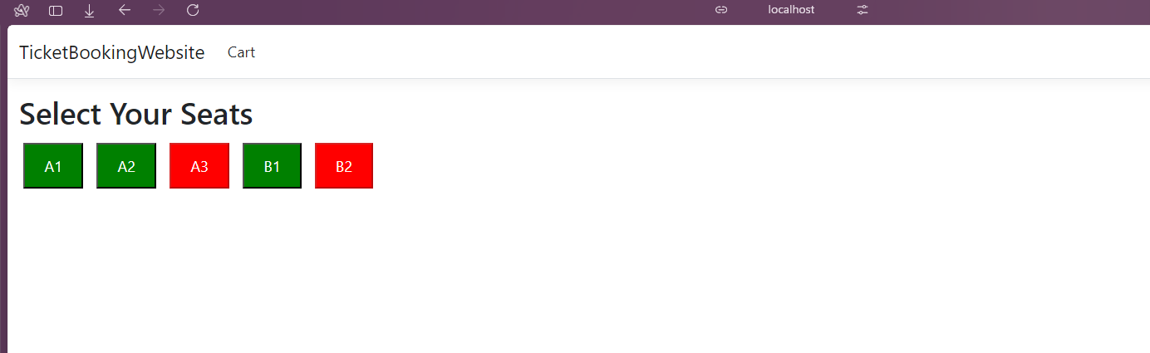

Conclusion: I’ve gained experience integrating SignalR into a web application to enable real-time data exchange using SignalR.

