**PART 1. HYPERVISORS1.**

1 What are the most popular hypervisors for infrastructure virtualization?

1. VMware ESXi/vSphere 2.**)** Microsoft Hyper-V3.)Oracle VirtualBox.

**2 Briefly describe the main differences of the most popular hypervisors**

VirtualBox - The performance is reasonable for those working on a budget, and it shares many features with its more costly rivals. VirtualBox is also notable for running on a wide number of operating systems, including those outside the usual triad of Mac, Linux and Windows.

Microsoft Hyper-V - Though it is available as standalone software, one of the key advantages of Hyper-V is that it can be integrated into a Windows Server package.

VMware ESXi/vSphere - Available as a free product and in various commercial iterations, the vSphere suite features an exhaustive array of features for optimising network services, storage and automatio.

**PART 2. WORK WITH VIRTUALBOX.**

1.1 Get acquainted with the structure of the user manual VirtualBox

1.2 Downloaded and installed VirtualBox

1.3 Download the latest stable version of Ubuntu Desktop

1.4 Create VM1 and install Ubuntu using the instructions

1.5 Get acquainted with the possibilities of VM1 control

1.6

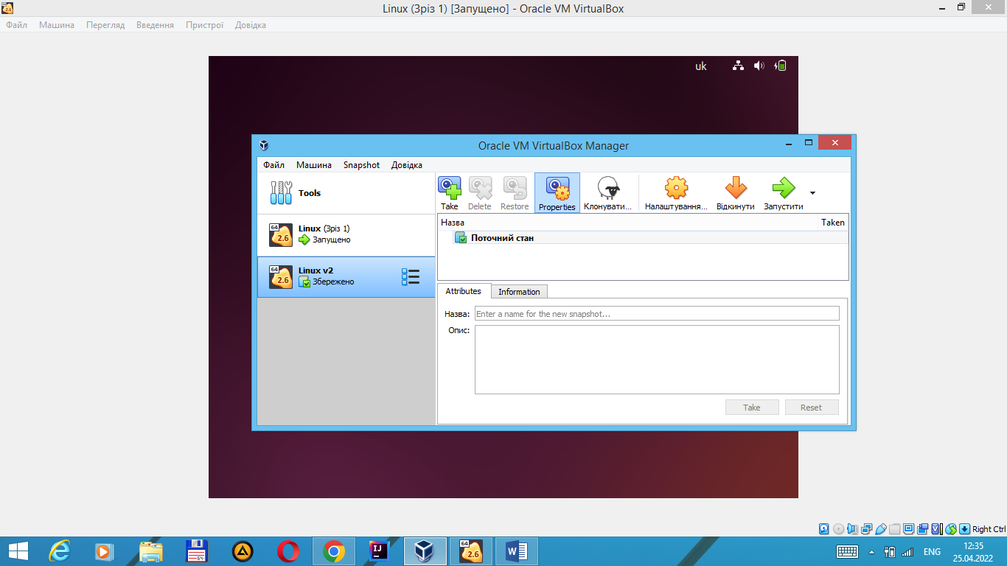

1.7

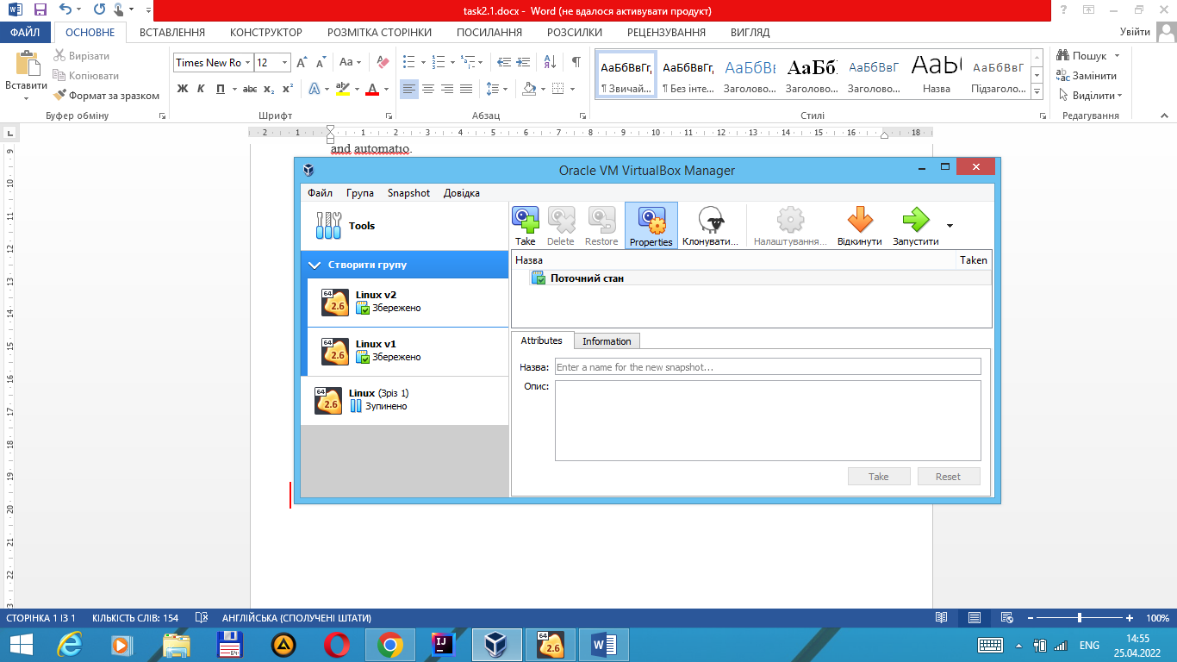

2.2 USB connect.

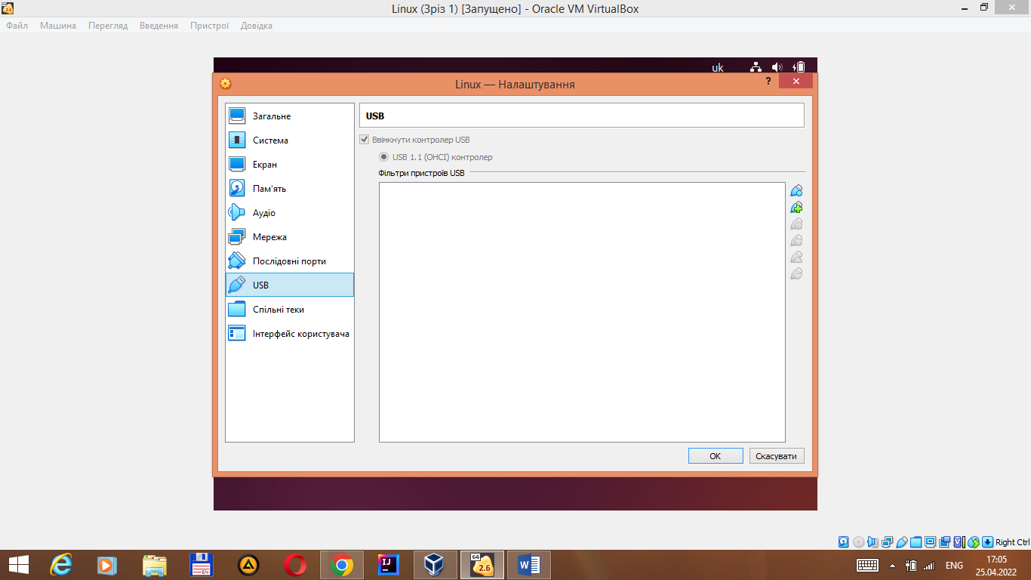

2.3 Configure a shared folder to exchange data.

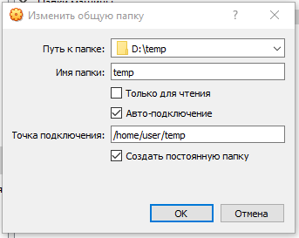

2.4 Some difrerent network modes.

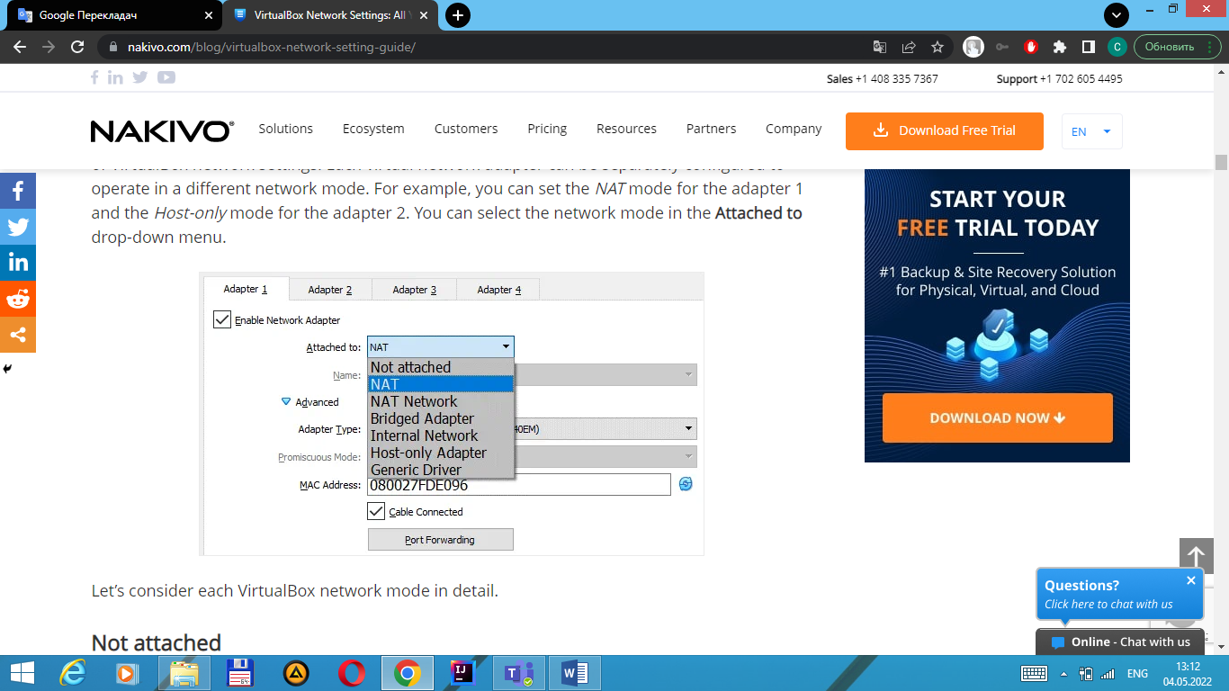

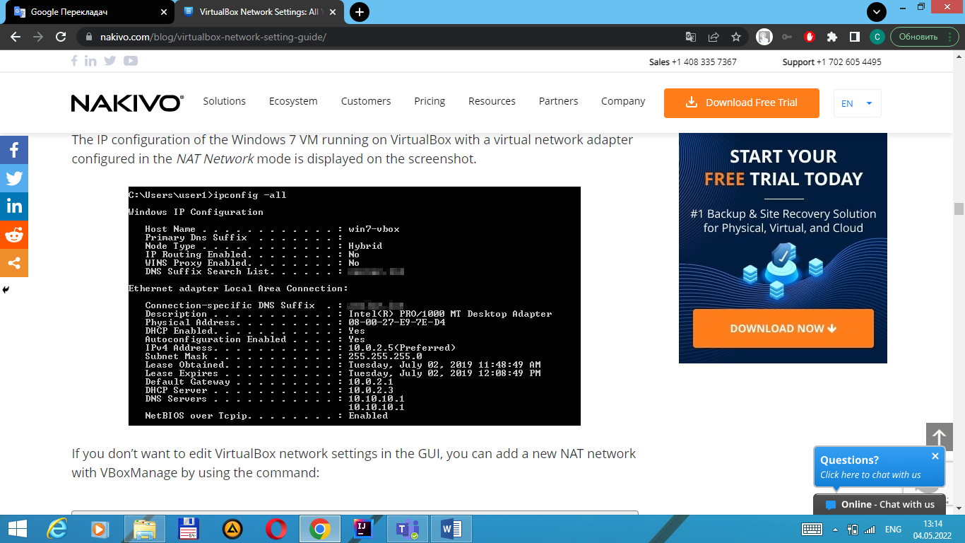

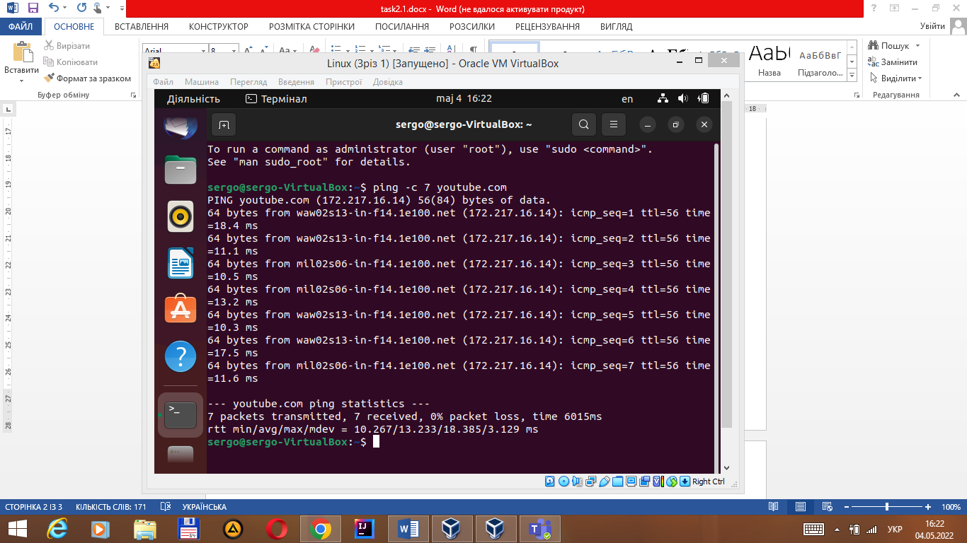

3.1 Run the cmd.exe command line

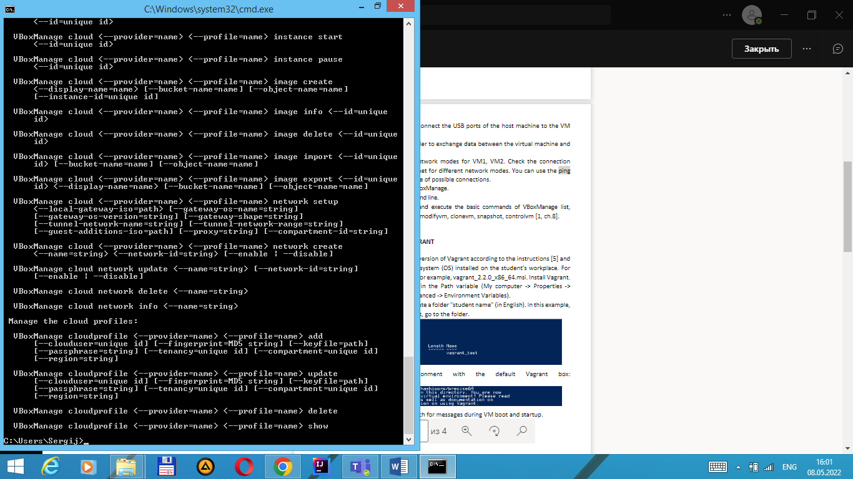

3.2 Basic commands of VBoxManage.

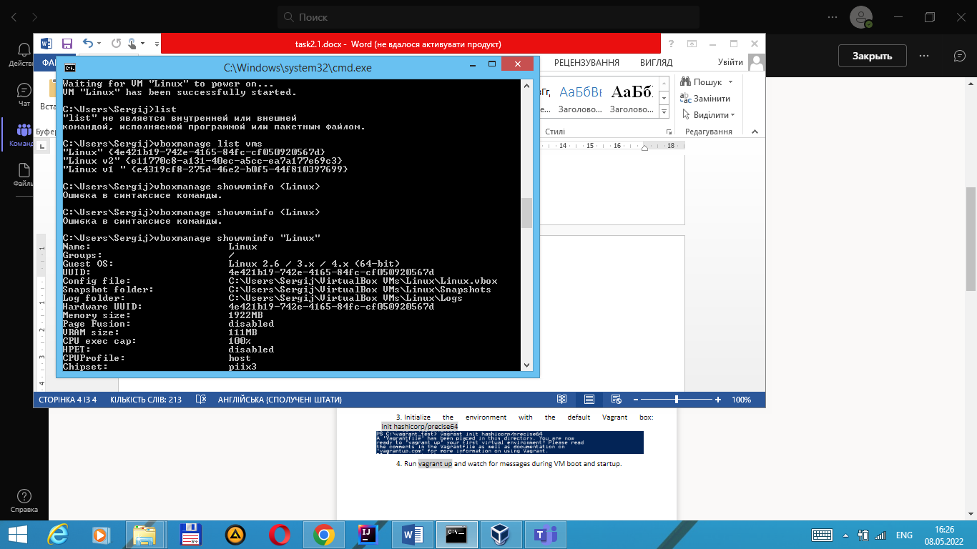



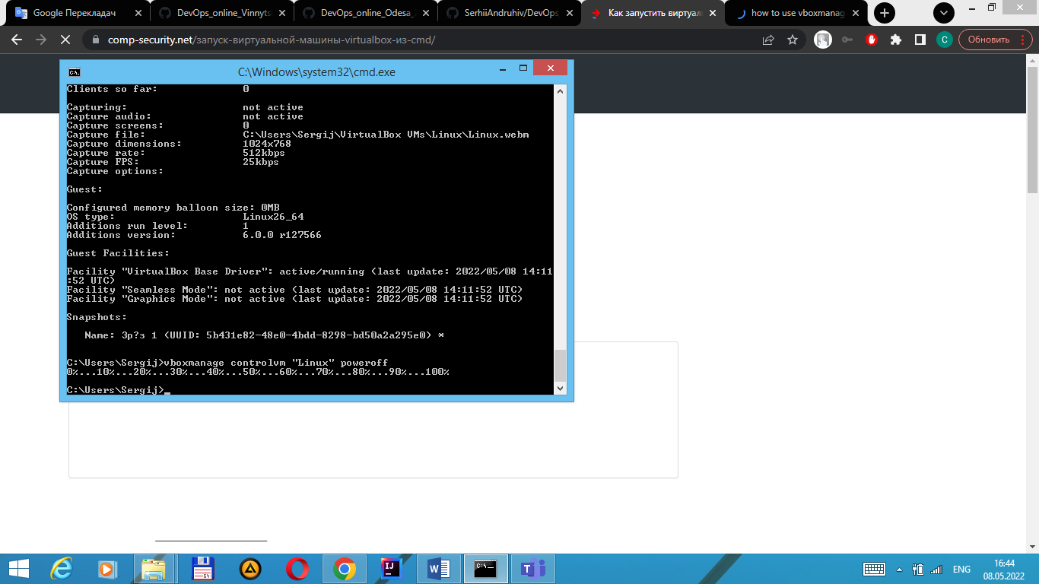

Use next commands too - createvm, startvm, modifyvm, clonevm, snapshot, controlvm.

PART 3. WORK WITH VAGRANT

1.Download the required version of Vagran – done)

3

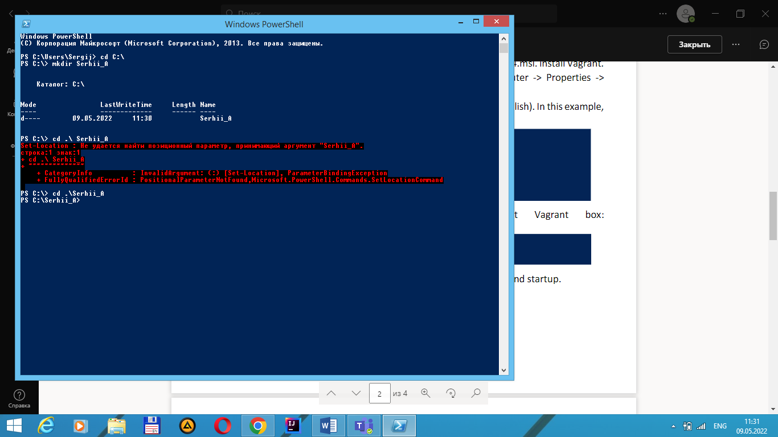

5. Connect to the VM using the program MobaXterm

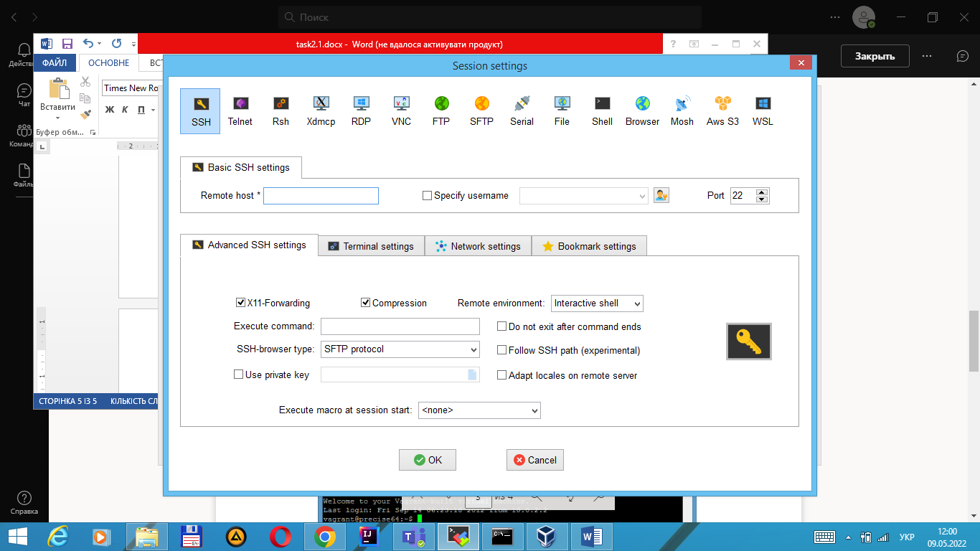

6. Record the date and time by executing the datecommand

7. Stop and delete the created VM