1. Read the terms of Using the AWS Free Tierand the ability to control their own costs

done

2. Register with AWS

done

3. Explore list of step-by-step tutorials for deferent category

done

4.ReviewGetting Started with Amazon EC2. Log Into Your AWS Account, Launch, Configure, Connect and Terminate Your Instance.Do not use Amazon Lightsail. It is recommended to use the t2or t3.micro instance and the CentOS operating system

Done

5.Create a snapshot of your instance to keep as a backup.

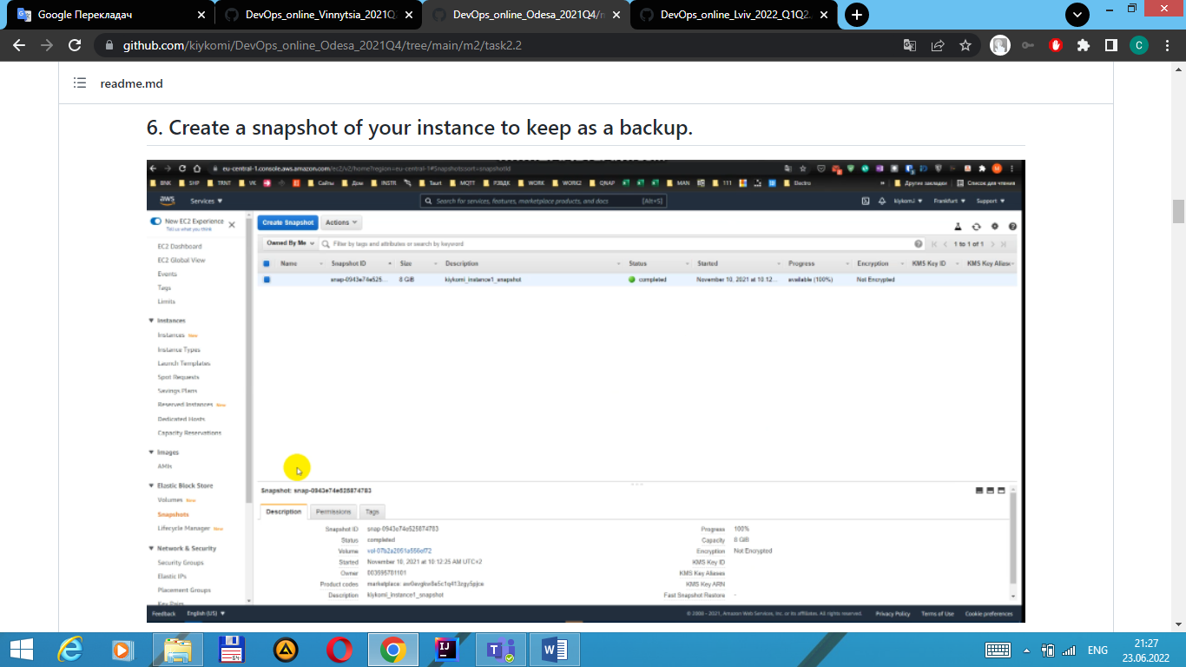

6.Create and attach a Disk_D (EBS)to your instance to add more storage space.Create and save some file on Disk_D

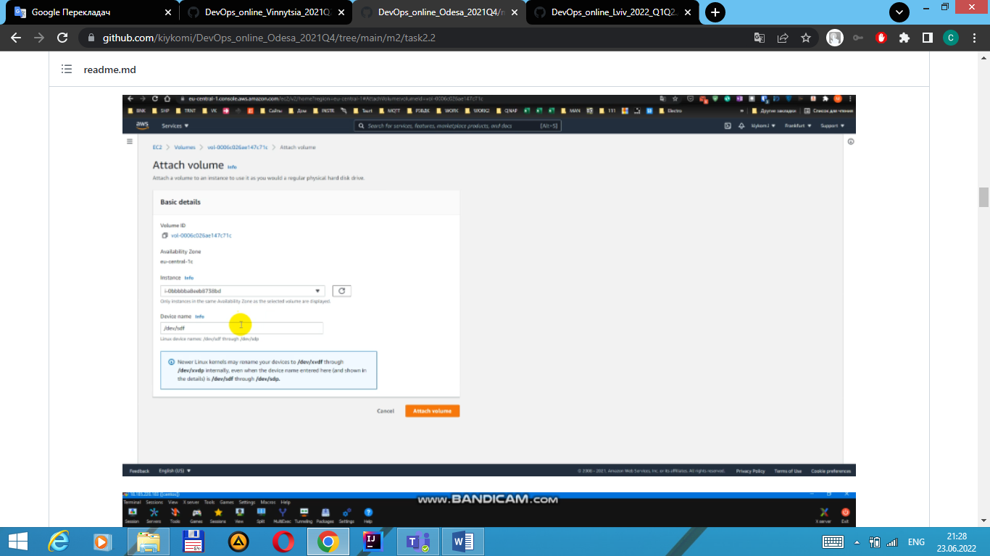

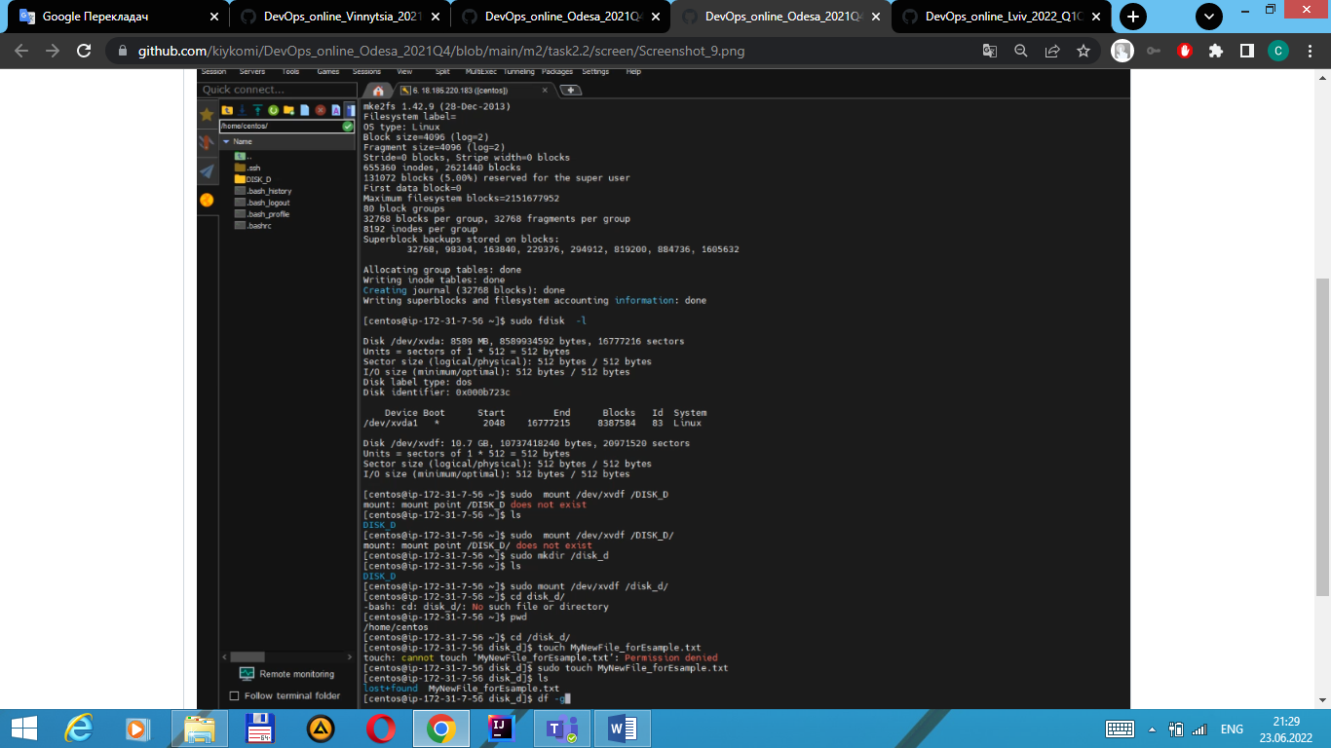

7.Launch the secondinstance from backup

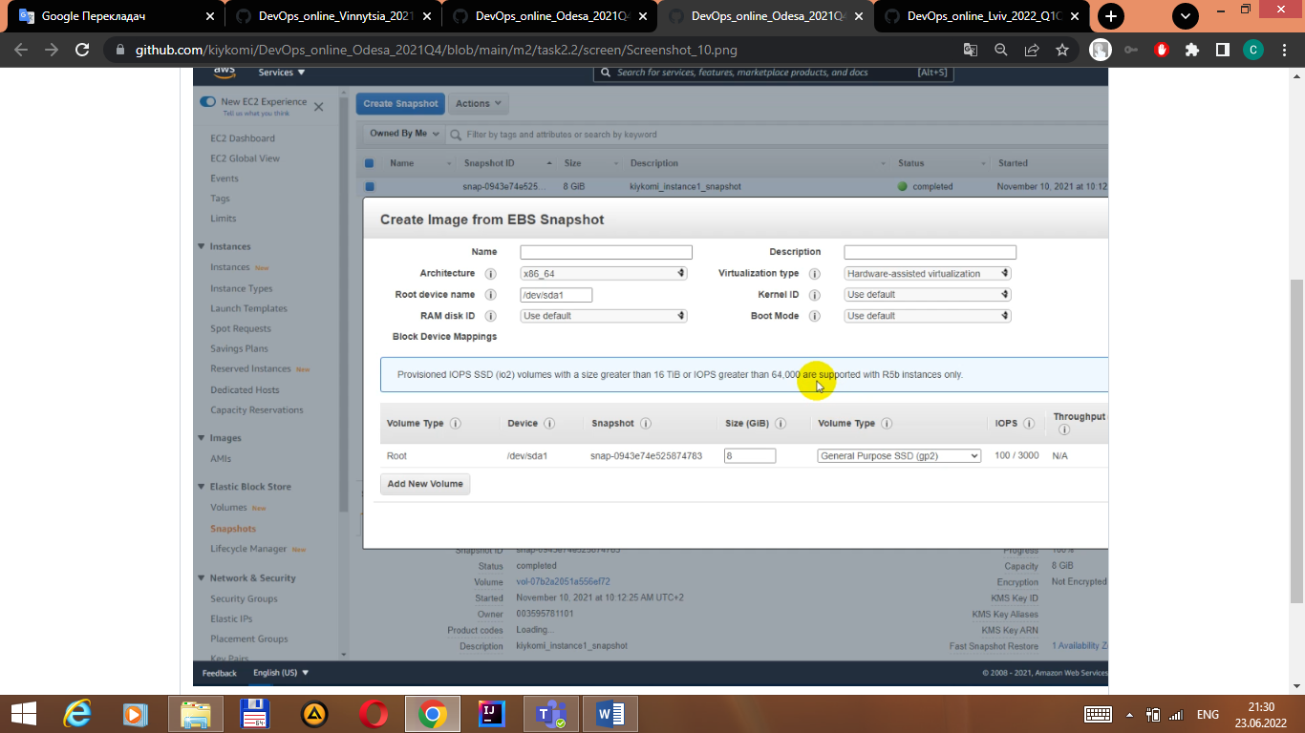

8.Detach Disk_D from the 1stinstance and attach disk_D to the new instance.

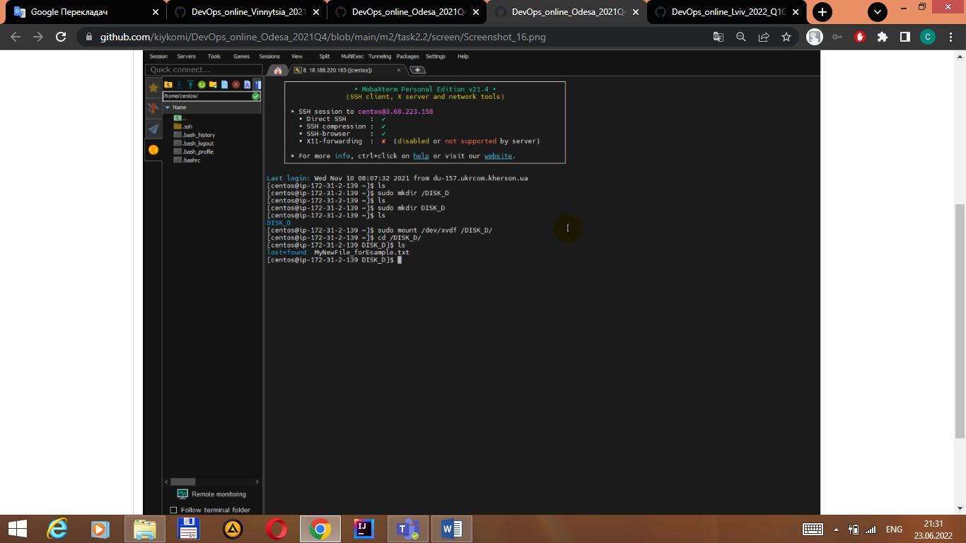

9.Review the 10-minute example.Explore the possibilities of creating your own domain and domain name for your site.Note, that Route 53 not free service. Alternativelyyou can free register thedomainname*.PP.UA and use it.

