A. Create a script that uses the following keys:

1. When starting without parameters, it will display a list of possible keys and their description.

**#!/bin/bash**

**man bash | grep "(.-.*)$" -A1**

**echo "What do yo want to scan: subnet(--all)/port (--target)"  
read use  
echo subnet**

**if [[ "$use" == "--all" ]]; then  
nmap -sn 10.10.10.1/24  
fi**

**echo "What do yo want to scan: subnet(--all)/port (--target)"  
read use  
echo ports  
if [[ "$use" == "--target" ]]; then  
sudo nmap -PE localhost  
fi**

2. The --all key displays the IP addresses and symbolic names of all hosts in the current subnet

**#!/bin/bash  
file_out=out_script2  
awk '{ print $1}' $1 | sort | uniq -c | sort -nr > $file_out  
{  
read line1  
}<$file_out  
echo $line1**

3. The --target key displays a list of open system TCP ports.

**#!/bin/bash  
file_out=out_script3  
awk '{ print $1}' $1 | sort | uniq -c | sort -nr | head -n20  
echo $1**

B. Using Apache log example create a script to answer the following questions:

1. From which ip were the most requests?

**#!/bin/bash  
file_out=out_script6  
awk '{print $1,$4,$5}' apache_logs.txt | sort | uniq -c | sort -fr | head -n 30  
echo END**

2. What is the most requested page?

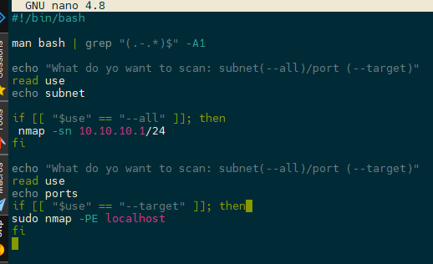

3. How many requests were there from each ip?

**#!/bin/bash  
file_out=out_script3  
awk '{ print $1}' $1 | sort | uniq -c | sort -nr | head -n20  
echo $1**

4. What non-existent pages were clients referred to?

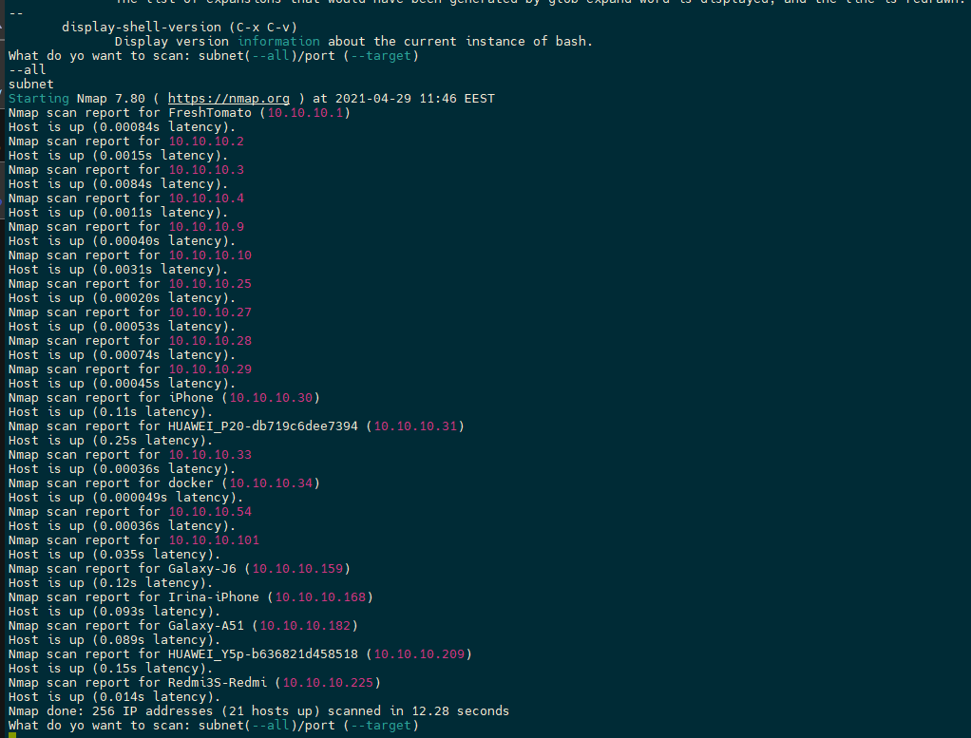

5. What time did site get the most requests?

**#!/bin/bash  
file_out=out_script6  
awk '{print $1,$4,$5}' apache_logs.txt | sort | uniq -c | sort -fr | head -n 30  
echo END**

6. What search bots have accessed the site? (UA + IP)

**#!/bin/bash  
file_out=out_script7  
awk -F" '{print $1 $6}' $1 | sort | uniq -c | sort -fr  
echo END**

C. Create a data backup script that takes the following data as parameters:

1. Path to the syncing directory. 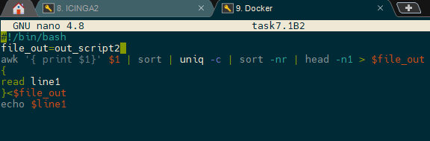

2. The path to the directory where the copies of the files will be stored.

