Business Requirements Document(BRD) Template
Project/Initiative
Month 20YY
Version X.XX

Company Information

Document Revisions
Date | Version Number | Document Changes
05/02/20xx | 0.1 | Initial Draft

Approvals
Role | Name | Title | Signature | Date

Introduction

Project Summary

Objectives
Reduce revenue losses caused by booking cancellations by 30% within 6 months of implementation. Enable customers to independently cancel bookings, modify stay dates and access booking documents through self-service functionality, reducing customer service workload by 40-50%.
Overview
This project introduces a self-service booking management feature within the hotel booking platform. The feature will enable authenticated users to independently manage their bookings through a personal account, including booking cancellation, booking date modification, invoice download, and booking history tracking. The solution is intended to improve customer experience by providing greater flexibility while reducing the operational workload on the customer service team.

Background
[Provide a brief history of how the project came to be proposed and initiated, including the business issues/problems identified, and expected benefit of implementing the project/developing the product.]

Business Drivers
[List the business drivers that make development of this product important. These can be financial, operational, market or environmental.]

Project Scope
- Booking cancellation through a self-service portal
- Booking date modification through a self-service portal
- Invoice download
- Booking price comparison during date modification
- Booking history categorization and status tracking
- Automatic cancellation fee calculation
- Hotel notification of booking changes

In Scope Functionality

Out of Scope Functionality
- Processing of additional payments resulting from booking modifications.
- Processing of refunds from booking modifications or booking cancellation .
- Integration with payment gateways for payment collection or refund execution.
- Payment transaction management and reconciliation.
- Automated refund approval workflows.

System Perspective
[Provide a complete description of the factors that could prevent successful implementation or accelerate the projects, particularly factors related to legal and regulatory compliance, existing technical or operational limitations in the environment, and budget/resource constraints.]

Assumptions

Constraints

Risks

- .

Issues

Business Process Overview
[Describe how the current process(es) work, including the interactions between systems and various business units. Include visual process flow diagrams to further illustrate the processes the new product will replace or enhance.
Use case documentation and accompanying activity or process flow diagrams can be used to create the description(s) of the proposed or “To-Be” processes.]

Current Business Process (As-Is)
At any point during or after deployment of web apps or web sites (internal or external) to support business activities, development/support teams may create and deploy widgets.
- CMS / database administrators for the employee portal use the CMS tool to create widgets. They can test widgets in the designated staging environment, then register them and deploy to production.
- Development teams may deploy widgets to development and testing environments set up for their development projects. They must check widget code into and out of the source code repository according to their projects’ development schedule.
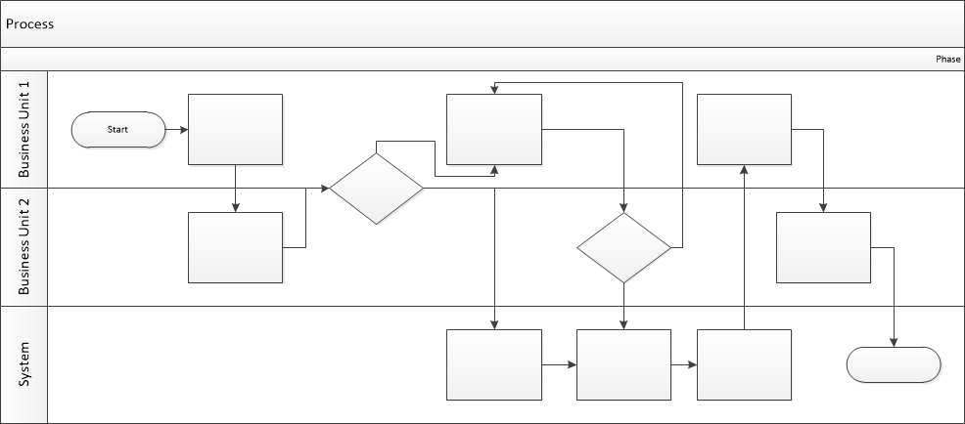

Proposed Business Process (To-Be)
- Technical Lead searches repository
- If widget is not found, user creates a new widget name record.
- WINS validates that all fields have been completed.
- WINS confirms that no similar widgets exist
- User confirms record to be created.

- User searches repository to locate existing widget description.
- WINS displays record
- User selects Edit to open and modify record
- WINS validates all fields completed correctly
- User confirms changes.
- WINS confirms changes and updates Audit table.


Stakeholder Requirements
SR-010- As an authenticated user I
WANT to cancel my booking without contacting Customer service
SO THAT i can save time and manage my reservation independently.

SR-020- As an authenticated user I
WANT to modify my booking dates without Customer service
SO THAT i can save time and manage my reservation independently.

SR-030- As an authenticated user I
WANT to download my booking invoices
SO THAT i can keep them for my records and access them whenever needed.

SR-040- As an authenticated user I
WANT to view the price difference before confirming a booking date change
SO THAT i can make informed decisions and manage my travel budget effectively.

SR-050- As an authenticated user I
WANT to view the current status of my bookings (Active, Completed, Cancelled)
SO THAT i can track my reservations and plan my trip accordingly.

SR-060- As an authenticated user I
WANT to view my additional payment, refund amount, or cancellation fee before confirming changes to my booking
SO THAT i can understand the financial impact of my actions.

The requirements in this document are prioritized as follows:
Value | Rating | Description
1 | Critical | This requirement is critical to the success of the project. The project will not be possible without this requirement.
2 | High | This requirement is high priority, but the project can be implemented at a bare minimum without this requirement.
3 | Medium | This requirement is somewhat important, as it provides some value but the project can proceed without it.
4 | Low | This is a low priority requirement, or a “nice to have” feature, if time and cost allow it.
5 | Future | This requirement is out of scope for this project, and has been included here for a possible future release.

Functional Requirements
Req# | Priority | Description | Rationale | Use Case Reference | Impacted Stakeholders
General / Base Functionality
FR-G-010 | 1 | When an authenticated user selects a booking, the system shall provide an option to cancel the booking. | Allows users to cancel bookings independently without customer service. |  | authenticated user,  Hotel,  Customer service representative
FR-G-011 | 1 | When an authenticated user selects a booking cancel option, the system shall display a confirmation modal containing a “confirm cancellation button”. | Allows users to cancel bookings independently without customer service. |  | authenticated user,  Hotel,  Customer service representative
FR-G-012 | 1 | When an authenticated user confirms booking cancellation, the system shall cancel the booking. | Helps prevent accidental booking cancellation by requiring user confirmation. |  | authenticated user,  Hotel,  Customer service representative.
FR-G-020 | 1 | When an authenticated user selects a booking, the system shall provide an option to modify booking dates. | Allows users to change booking dates through self service functionality. |  | authenticated user,  Hotel,  Customer service representative.
FR-G-021 | 1 | When an authenticated user initiates change booking dates, the system shall display a selectable list of available date options. | Allows users to change booking dates through self service functionality. |  | authenticated user,  Hotel,  Customer service representative.
FR-G-022 | 1 | When an authenticated user selects new booking dates, the system shall display a confirmation modal with “change confirmation button”. | Allows users to change booking dates through self service functionality. |  | authenticated user,  Hotel,  Customer service representative.
FR-G-022 | 1 | When an authenticated user confirms a booking date change, the system shall update the booking dates with selected dates. | Helps prevent accidental booking modifications by requiring user confirmation. |  | authenticated user  Hotel,  Customer service representative.
FR-G-003 | 1 | When an authenticated user views a booking, the system shall provide the invoice associated with that booking as a separate downloadable file for download. | Allows users to access and retain booking invoices for their records. |  | authenticated user.
FR-G-004 | 1 | When an authenticated user selects new booking dates, the system shall display the original booking price, the updated booking price, and the price difference before the user confirms the change. | Provides users with pricing transparency before confirming booking modifications and reduces disputes related to booking price changes. |  | authenticated user,  Business owner
FR-G-005 | 1 | The system shall display the current status of each booking as active, completed or cancelled. | Allows users to track the current state of their bookings. |  | authenticated user
FR-G-060 | 1 | When an authenticated user initiates booking cancellation, the system shall display the applicable cancellation fee before the user confirms the cancellation. | Provides users with pricing transparency before booking cancellation and reduces disputes related to cancellation charges. |  | authenticated user,  Business owner
FR-G-061 | 1 | When an authenticated user selects new booking dates, the system shall calculate and display any additional payment required before the user confirms the change | Allows users to understand the additional cost associated with a booking modification before confirming the change. |  | authenticated user,  Business owner
FR-G-062 | 1 | When an authenticated user selects new booking dates resulting in a lower booking price, the system shall calculate and display the refund amount before the user confirms the change | Allows users to understand the refund amount associated with a booking modification before confirming the change. |  | authenticated user,  Business owner
Security Requirements
FR-S-001 | 1
Reporting Requirements
FR-R-070 | 1 | When the booking is cancelled, the system shall notify the hotel about the cancellation via email. | Allows the hotel to maintain up-to-date information about booking cancellation. |  | Hotel
FR-R-080 | 1 | When the booking dates are modified, the system shall notify the hotel about the dates changing via email. | Allows hotel to maintain up-to-date information about booking modification. |  | Hotel
Usability Requirements
FR-U-001 | 1
Audit Requirements
FR-A-001 | 1

Non-Functional Requirements
[Include technical and operational requirements that are not specific to a function. This typically includes requirements such as processing time, concurrent users, availability, etc.]
ID | Requirement
NFR-001 | The system shall complete booking cancellation requests within 2 seconds in 95% of cases.
NFR-002 | The system shall complete booking date change requests within 2 seconds in 95% of cases.
NFR-003 | The system shall retain invoice download audit records for a minimum of 12 months.
NFR-004 | The system shall display all user interface elements with a minimum color contrast ratio of 4.5:1 in accordance with WCAG 2.1 AA accessibility guidelines.
NFR-005 | The system shall provide all in-scope functionality on Android, iOS, Windows and macOS platforms without loss of functionality.
NFR-006 | The system shall calculate cancellation fees, additional payments and refund amounts with 100% accuracy based on the configured hotel policies.

Appendices

List of Acronyms
[If needed, create a list of acronyms used throughout the BRD document to aid in comprehension.]

Glossary of Terms
[If needed, identify and define any terms that may be unfamiliar to readers, including terms that are unique to the organization, the technology to be employed, or the standards in use.]

Related Documents
[Provide a list of documents or web pages, including links, which are referenced in the BRD.]

