**ITASE Payroll Instructions**

When starting the ITASE Payroll application, you may see all blank fields or fields populated from a previous payroll file. The picture below has not been populated.

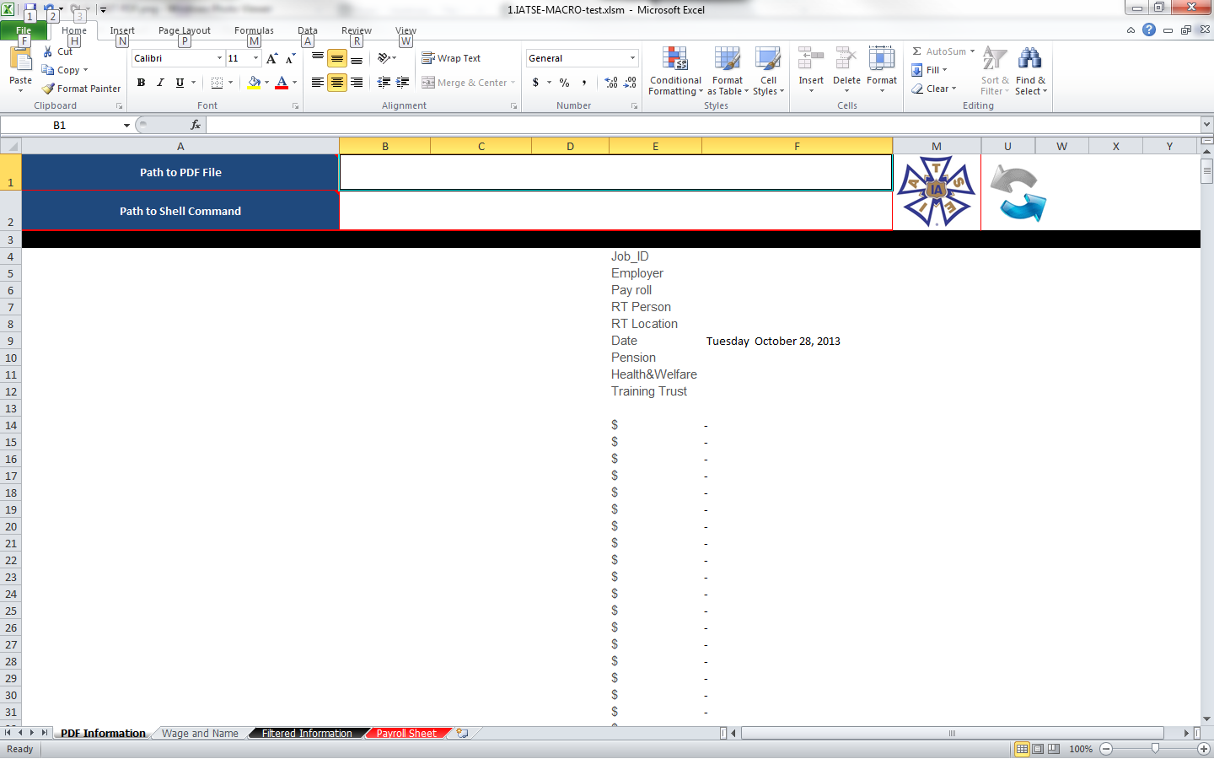

Next to the box next to the blue cell labeled “Path to PDF File” you will need to insert the path to the payroll file you are working on. If you know the path then simply type it in. If not, there is an easier way.

You must first locate your payroll PDF files. Once your files are located, you can simply right click the file you will be working with. This should create a menu of options. Select the properties option.

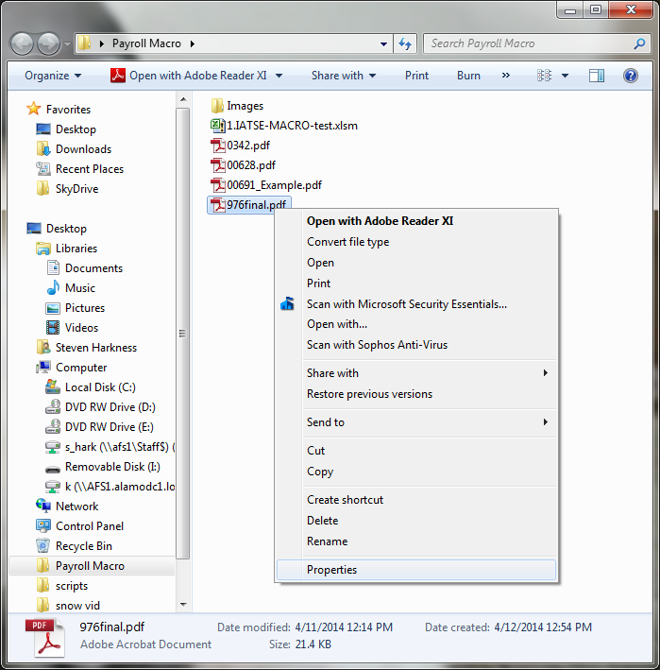

Within the properties dialog box, you should see a Security tab. If your files are on a flash drive, you may not have the security tab. In that case just copy from location in the General tab. However, you will need to add the file name manually.

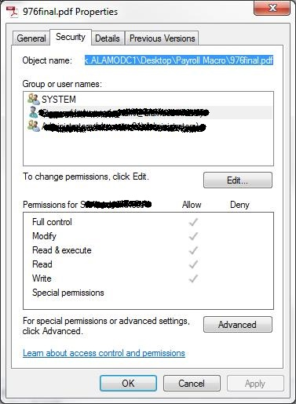

Double click in the box to the right of the blue box labeled “Path to PDF File” then right click and select paste or CTRL+V to paste.

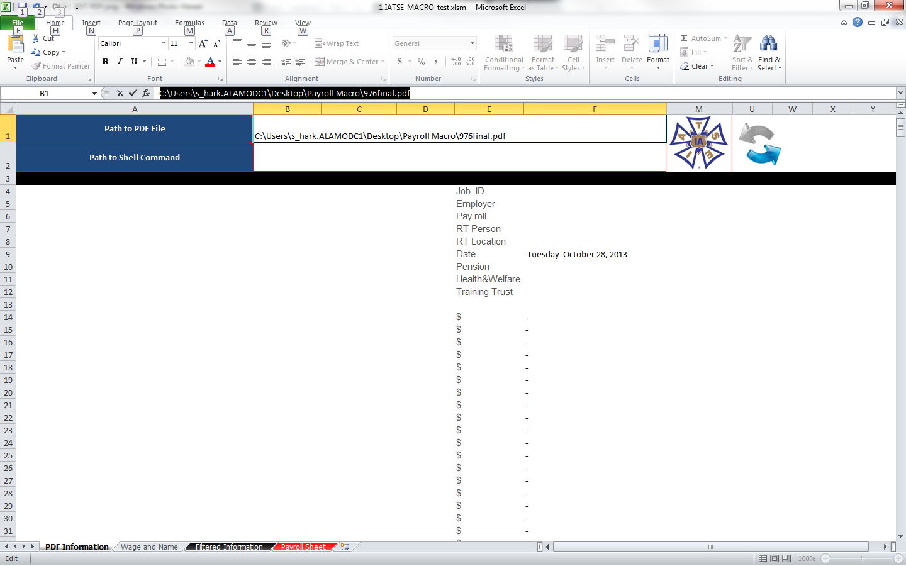

The next step is very similar to the previous one. You will need to add the path to Adobe Reader. The most simple way is to click on your start menu and right click the Adobe Reader icon then select Properties from the pop up menu. From the Shortcut tab highlight the path next to Target. Right click and copy or CTRL+C

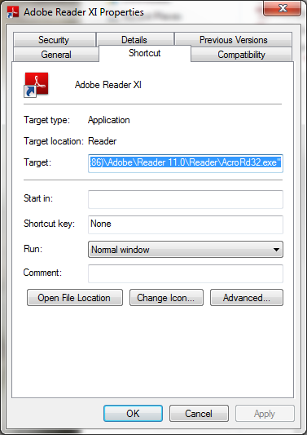

Double click in the box to the right of the blue box labeled “Path to Shell Command” then right click and select paste or CTRL+V to paste. Be sure to remove any quotation marks in the path. Then click the IATSE icon to the right of the paths you just entered.

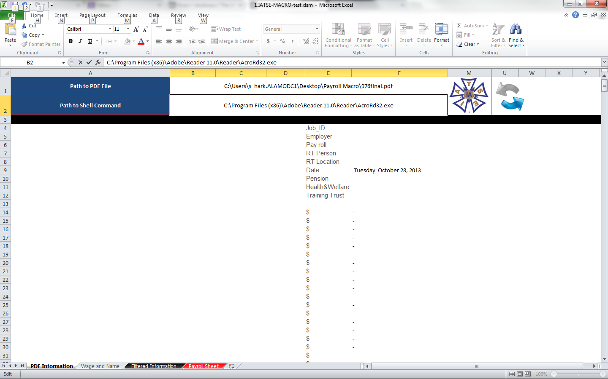

You will see the PDF file open briefly while the information is being extracted. Then you will be taken to the Filtered Information tab in your excel program.

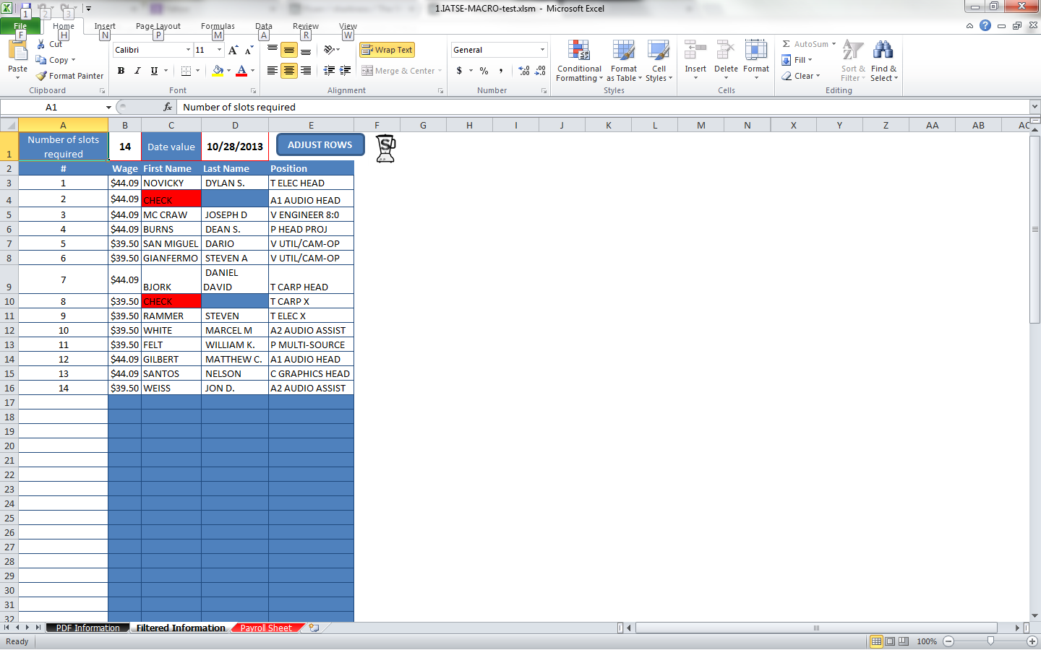

You may see red cells that have CHECK printed. If this is the case then the PDF file has the individual’s name on two lines rather than one. You can easily look at the PDF file and simply type the names in the correct cells.

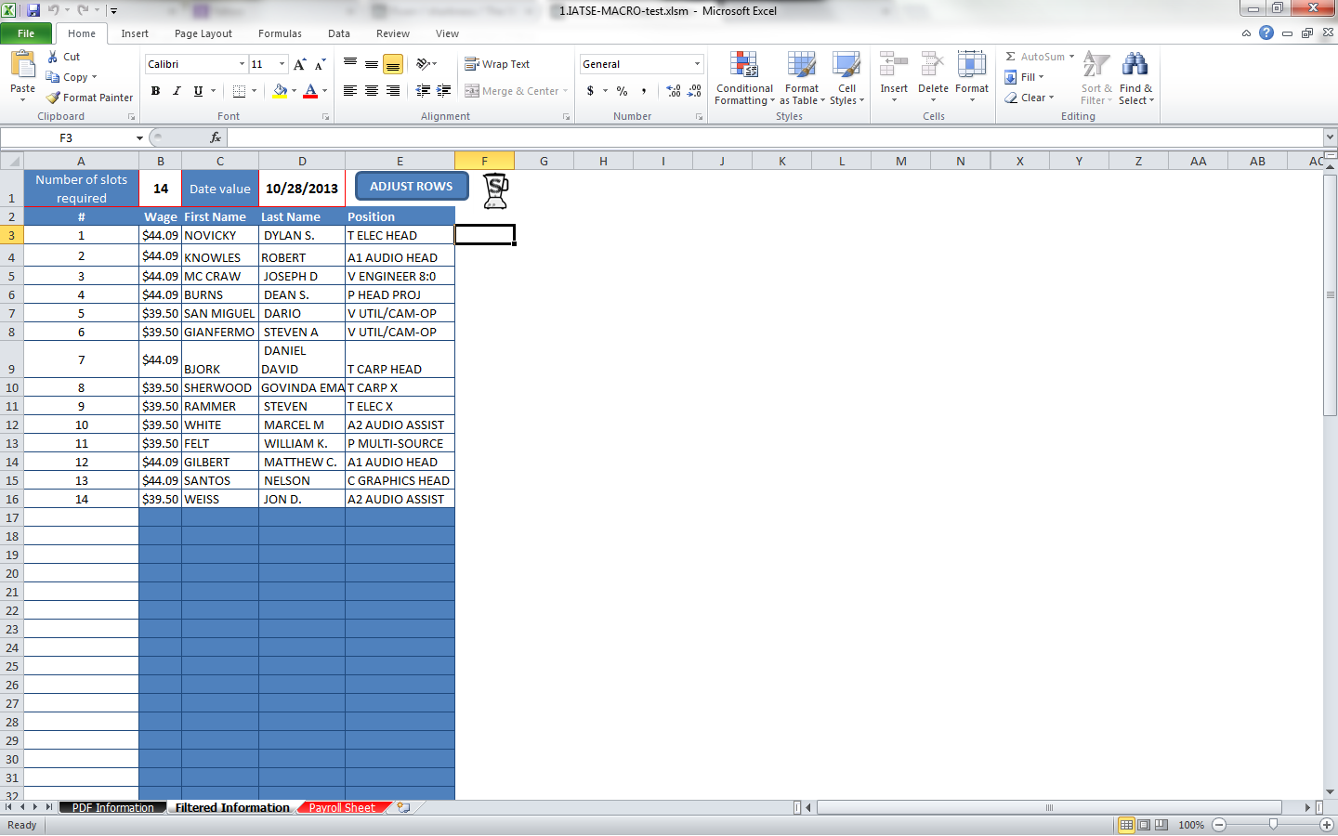

Once the information is correct under the Filtered Information tab then you are ready to select the payroll sheet. Once there you can fill in each individual’s daily hours to calculate the totals.

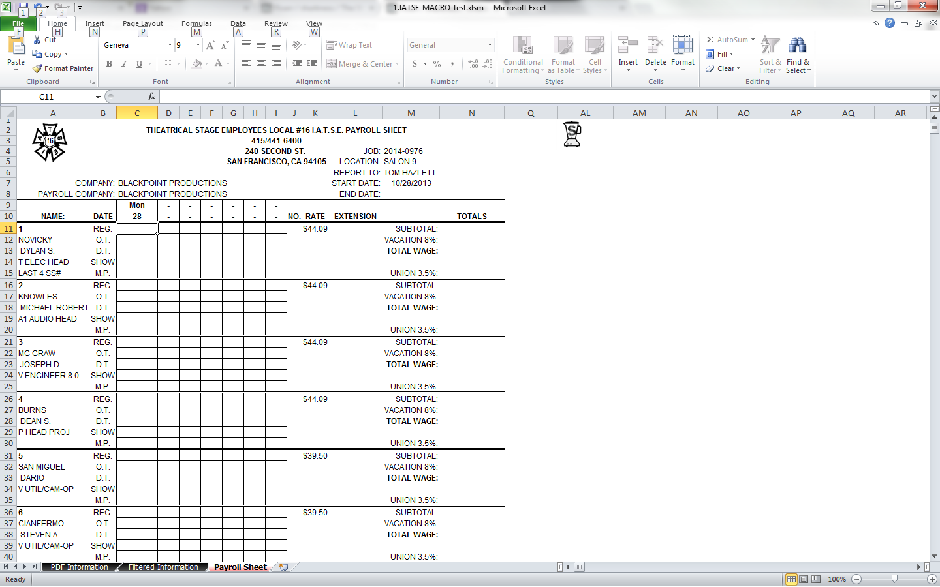

On the left at the bottom you have an itemized list of other fees to be paid. Just to the right is a list of calculations based on your percentage criteria.

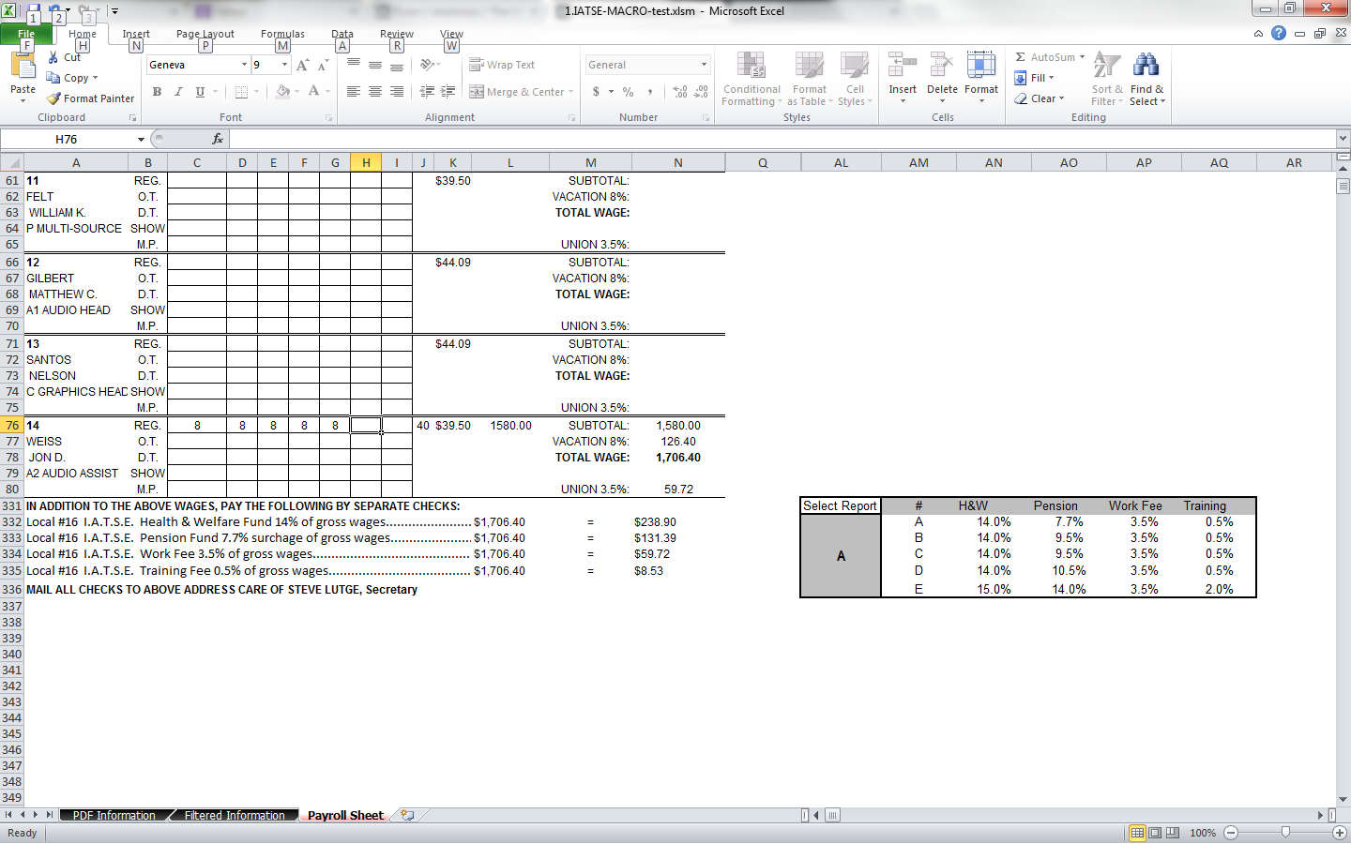

When you select the box below “Special Report” you will see a menu of the calculations to choose from for the line items to the left.

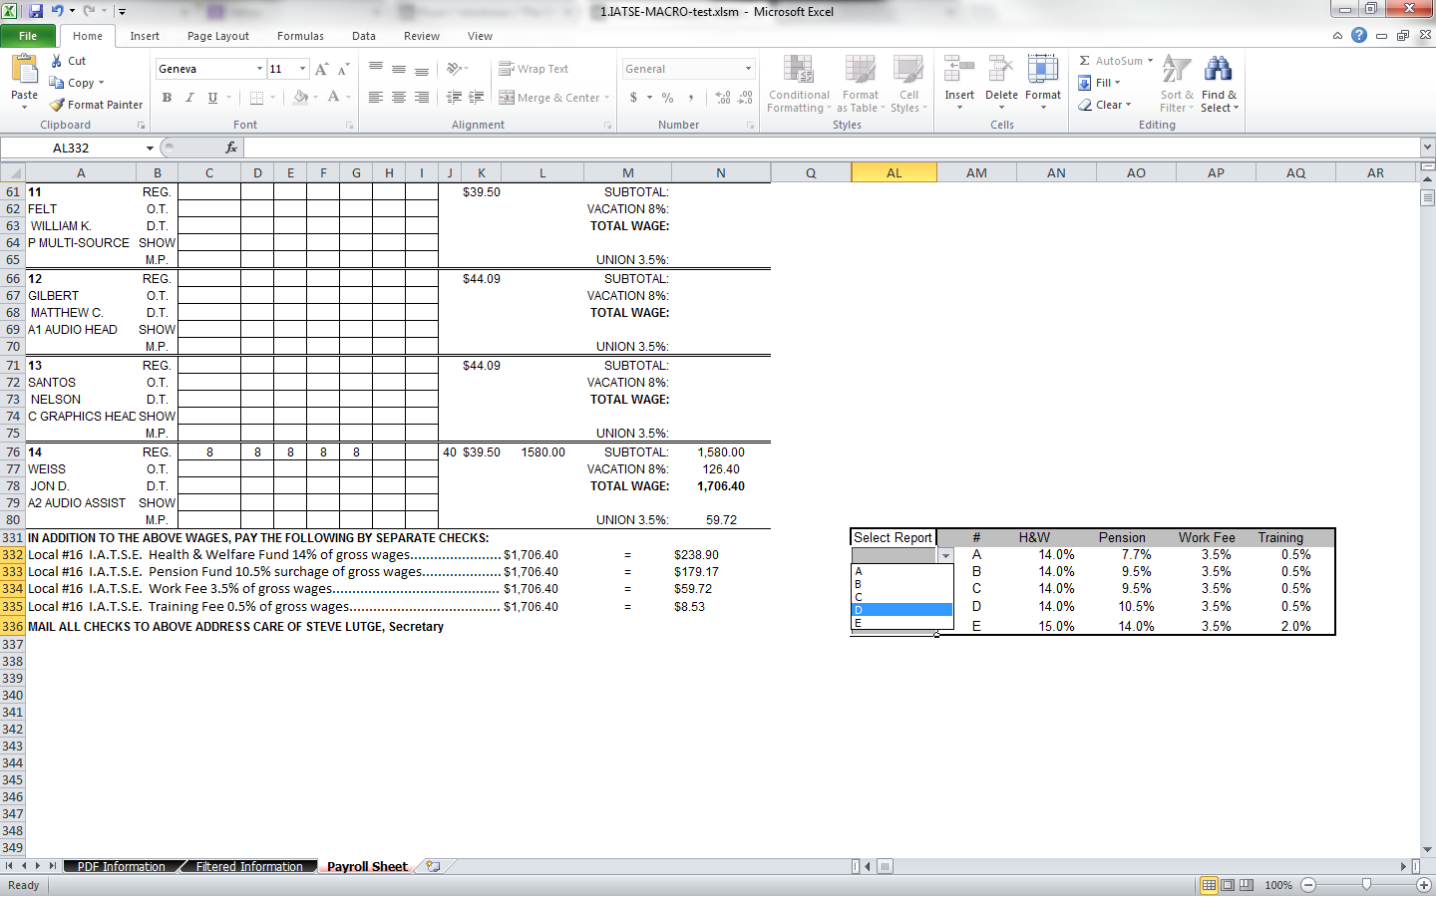

Although it may seem like a lot, once you have done it you will see that it is a great time saver.