**FINAL PROJECT**

**Project Kickoff & Requirements Gathering**

TEAM ASSET

MEMBERS:

**MARNELSON LANOT – PROJECT LEAD/PROGRAMMER**

**ARJOHN PAUL OCAMPO – DOCUMENTER/RESEARCHER**

**MARK ANGELO OLICIA - DIAGRAMMER**

**TERENCE JOHN SARABIA – PRESENTER**

OBJECTIVES

The main objective of the Inventory Asset Tracking System for Mindoro State University Main Campus is to provide the Supply and Property Services Office with a centralized, automated platform to accurately track, monitor, and manage all physical assets—including equipment, furniture, electronics, vehicles, and supplies—throughout their lifecycle, ensuring enhanced asset accountability, maintenance efficiency, and compliance with institutional policies.

This objective aligns directly with the scope of covering all physical assets managed by the university’s Supply and Property Services Office, enabling them to maintain real-time visibility and control over inventory, reduce losses, facilitate timely maintenance, and support audit and reporting requirements effectively.

SCOPE

The system will cover all physical assets owned or managed by Mindoro State University - Main Campus, including equipment, furniture, electronics, vehicles, and supplies.

STAKEHOLDER

Our stakeholder will be the **Supply and Property Services Office** because they are responsible for tracking, maintenance, and custody of inventories and other university assets—this is likely the system's primary user.

STAKEHOLDER INTERVIEW

1. What are your biggest problems with tracking items right now?
2. What items do you need to track, and what information is most important for each?
3. **What specific improvements or benefits do you hope to see in your daily tasks or overall operations once this new inventory asset tracking system is in place?**
4. Who will use this system, and what will they need to do with it?
5. Are there any existing systems or programs this new one needs to work with?
6. What kind of reports or information do you want the system to show you?
7. How do you plan to put information into the system (e.g., scanning, typing)?

FUNCTIONAL AND NON-FUNCTIONAL REQUIREMENTS

|  |  |  |  |
| --- | --- | --- | --- |
| Functional Requirements | | | |
| **ID** | **Requirement** | **Description** | **Verification Method** |
| FR-01 | User Authentication | The system shall allow users to register, log in, and log out securely. | Test login/logout using valid and invalid credentials. |
| FR-02 | Role-Based Access Control | The system shall provide different access levels (e.g., Admin, Manager, Staff, Viewer). | Verify that each role only has access to authorized features. |
| FR-03 | Asset Registration | The system shall allow users to add new assets with details (name, type, category, purchase date, supplier, cost, serial number, etc.). | Enter new asset data and verify it is stored and retrievable. |
| FR-04 | Asset Tagging | The system shall support unique asset identifiers (e.g., barcode/QR code) for tracking. | Scan QR/barcode to confirm correct asset retrieval. |
| FR-05 | Asset Assignment | The system shall allow assignment of assets to employees, departments, or locations. | Assign an asset and check assignment logs. |
| FR-06 | Asset Tracking | The system shall track asset status (available, in use, under maintenance, retired, disposed). | Update status and verify reflected changes in system. |
| FR-07 | Asset Movement Logging | The system shall log all asset transfers between locations or users. | Perform asset transfer and validate audit log entry. |
| FR-08 | Inventory Management | The system shall maintain real-time inventory levels of assets. | Check that adding/removing assets updates inventory count. |
| FR-09 | Maintenance Scheduling | The system shall allow scheduling of maintenance tasks and send notifications. | Schedule maintenance and verify notification delivery. |
| FR-10 | Audit Trail | The system shall maintain a detailed log of user actions (create, update, delete, transfer). | Inspect audit logs for recorded actions. |
| FR-11 | Reporting | The system shall generate reports (e.g., asset summary, usage, depreciation, maintenance history). | Generate sample reports and validate correctness. |
| FR-12 | Search & Filter | The system shall allow users to search and filter assets by category, status, user, or location. | Test queries and verify search/filter results. |
| FR-13 | Notifications & Alerts | The system shall notify users about upcoming maintenance, low stock, or expired warranties. | Trigger events and validate alerts. |

|  |  |  |  |
| --- | --- | --- | --- |
| Non-Functional Requirements | | | |
| **ID** | **Requirement** | **Description** | **Verification Method** |
| NFR-01 | Performance | The system shall support at least 200 concurrent users without degradation. | Load testing with simulated users. |
| NFR-02 | Availability | The system shall be available 99.5% of the time per month. | Monitor uptime via server logs. |
| NFR-03 | Scalability | The system shall be able to scale to handle 100,000+ assets. | Stress test with large dataset. |
| NFR-04 | Security | The system shall enforce HTTPS, password encryption (bcrypt), and CSRF protection. | Security testing with penetration tests. |
| NFR-05 | Usability | The system shall provide a responsive and user-friendly UI accessible on desktop, tablet, and mobile. | User testing across devices. |
| NFR-06 | Maintainability | The system shall follow Laravel best practices (MVC, migrations, RESTful API). | Code review and compliance check. |
| NFR-07 | Reliability | The system shall ensure no data loss during asset update or transfer operations. | Test with simulated power/network failure. |
| NFR-08 | Data Backup & Recovery | The system shall perform daily automated backups and allow recovery within 2 hours. | Test backup restore procedure. |
| NFR-09 | Compliance | The system shall comply with relevant data protection regulations (e.g., GDPR, Philippine Data Privacy Act). | Audit compliance documentation. |
| NFR-10 | Localization | The system shall support multi-language and multi-currency configuration. | Switch language/currency and verify translations. |
| NFR-11 | Portability | The system shall be deployable on Linux-based web servers with MySQL/PostgreSQL database. | Deploy to test environment. |
| NFR-12 | Interoperability | The system shall integrate with third-party APIs (e.g., HR, Finance). | Test API integration with mock systems. |
| NFR-13 | Response Time | The system shall load pages within 3 seconds under normal load. | Performance benchmarking. |

CONTEXT DIAGRAM

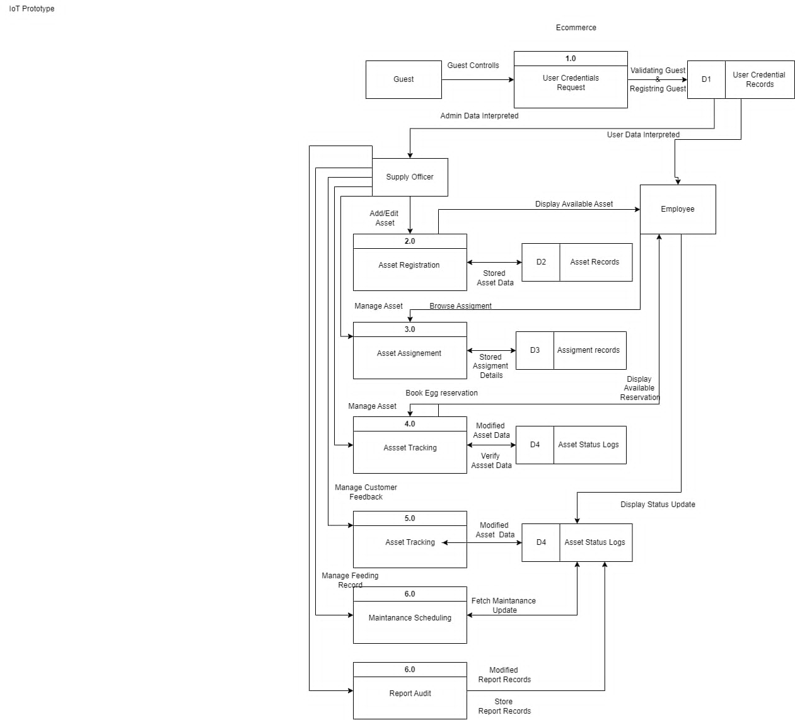

HIGH-LEVEL SYSTEM OVERVIEW

The **Inventory Asset Tracking System** is designed as a centralized digital platform to efficiently monitor, manage, and control inventory assets throughout their lifecycle.

This Inventory Asset Tracking System aims to streamline the oversight of physical and digital assets within an organization, providing accurate, up-to-date information on asset locations, conditions, and usage. The primary users include warehouse managers, procurement officers, maintenance teams, and auditors who need reliable asset visibility to optimize operations and reduce losses. By leveraging automation and real-time data, the system is expected to enhance asset utilization, minimize manual errors, improve compliance with audit requirements, and enable proactive maintenance, ultimately leading to cost savings and operational efficiency improvements for the organization.