**Software Requirements Document for LLP “Asjan” web-site**

Author: Dream team

Zholdasbekov Aibek

Khamza Ayan

Akhmetbekov Chingiz

Kenzhegalin Serik

|  |  |  |  |
| --- | --- | --- | --- |
| Version | Date | Author | Change |
| 0.1 | 01.03.2014 | Dream team | Initial document |
|  |  |  |  |
|  |  |  |  |
|  |  |  |  |
|  |  |  |  |

Table of content

**1 Introduction**…………………………………………………………………………………….3

1.1 Purpose………………………………………………………………………………………...3

1.2 Scope…………………………………………………………………………………………..3

1.3 Definitions, acronyms, abbreviations…………………………………………………………3

1.4 References…………………………………………………………………………………….3

1.5 Overview……………………………………………………………………………………...3

2 **Overall Description**……………………………..……………………………………………..4

2.1 Product Perspective…………………………………………………………………………...4

2.2 Product functions……………………………………………………………………………..6

2.3 User characteristics…………………………………………………………………………...7

2.4 Constraints……………………………………………………………………………………8

2.5 Assumptions and Dependencies……………………………………………………………...8

3 **Specific Requirements**………………………………..……………………………………….9

3.1 External Interface Requirements……………………………………………………………...9

3.2 FEATURES…………………………………………………………………………………..9

3.3 Performance requirements…………………………………………………………………….9

3.4 Design Constraints…………………………………………………………………………….9

3.5 Software System Attributes……………………………………………………………….......9

3.6 Other Requirements……………………….…………………………………………………..9

**1Introduction**

* 1. ***Purpose***

The purpose of this document is to provide detailed requirements information about the

LLP “Asjan” web-site

* 1. ***SCOPE***

This document will describe the use cases and features of the LLP “Asjan” web-site.

* 1. ***Definitions, acronyms, abbreviations***

|  |  |
| --- | --- |
| admin | Person who controls the website |
| Catering services | Catering is the business of providing food service at a remote site |
| Asjan | Specialty of the house of LLP “Asjan” which consists beef, mushrooms and rice |
| Viola | A dish which consists chicken with vegetables |
| Lentil soup | refers to a variety of vegetarian and meat soups made with lentils |
| Arlekino | A dish which consists French fries and chicken under cheese. |
| Pizza “Zhan” | A pizza which contains sauce, cheese, French fries, sausages, salty cucumber |
| Pizza “Asjan” | A pizza which contains kazi, cheese, tomatoes, sauce, pepper, onion |

* 1. ***References***
  2. ***Overview***

**[OMIT]**

***2Overall Description***

The “Asjan” site is for clients of LLP “Asjan”. The site allow clients to see all products and order pizza.

***2.1Product Perspective***

It is unique, though, in that it allow to know more about this pizzeria. Our target audience is public.

***2.1.1Concept of Operations***

Our website will run in global area network.

***2.1.2Major User Interfaces***

We make user interface for our website easy to use, efficient and enjoyable.

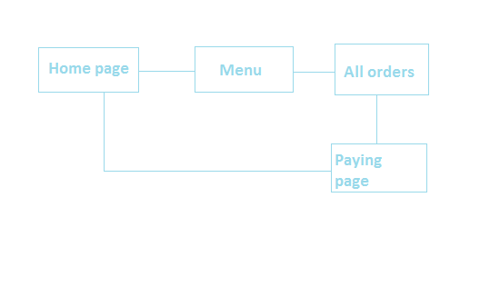

***2.1.2.1 Example Screenshot and description***

See web-site____

***2.1.3 Hardware Interfaces***

This software requires no more than standard personal computer peripherals.

***2.1.4 Software Interfaces***

// example: CGI-URL or function signatures etc (OMIT for now).

***2.1.5 Communication Interfaces***

// example: modem etc (OMIT for now)

***2.1.6 Memory Constraints***

// RAM, and other storage constraints (OMIT for now)

***2.1.7 Operations***

// special operations (if any) (OMIT for now)

***2.1.8 Site Adaptation Requirements***

//ex: Japanese language etc (OMIT for now)

***2.2 Product functions***

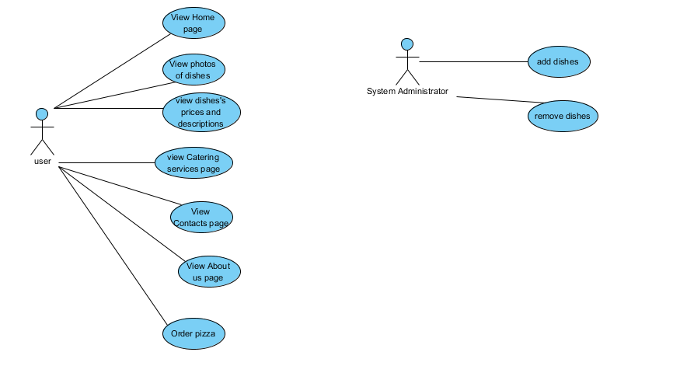

***2.2.1 Pizza app (SM)***

Description: Allows to serve pizza.

Actors: clients

2.2.1.1. The client has to write name, surname and address to serve and also card details.

2.2.1.2. If happened successfully served pizza will come to that address.

2.2.1.3. If happened unsuccessfully in that page show incorrect fillings

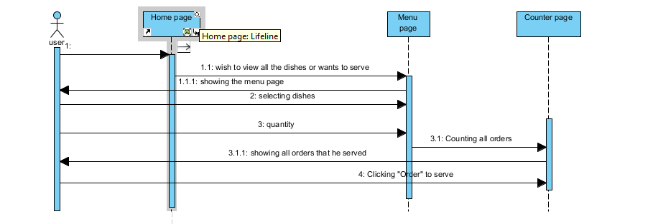

2.2.2 Add dishes

Actor: admin only

2.2.2.1 Admin clicks add button

2.2.2.2 Admin full-fills name, description, adds photos

2.2.2.3 Clicks save button

Pre-condition: Admin has to click “Add” button

Post-condition: The system shows all dishes including that one he added

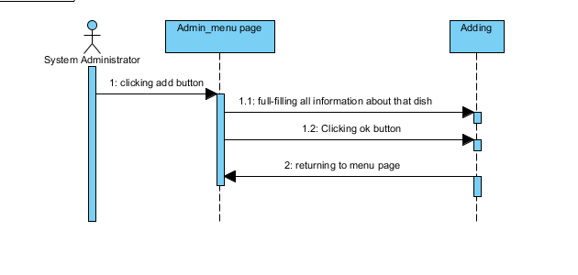

2.2.3 Remove dishes

Actor: admin only

2.2.2.1 Admin clicks remove button in right side of that dish

2.2.2.2 That dish is removed from list

Pre-condition: The delete is located on the top right side of each dish

Post-condition: No possibility to retrieve that dish information

***2.3 USER CHARACTERISTICS***

|  |  |  |
| --- | --- | --- |
| Types | Characteristics | Frequency of usage |
| Admin | Controls the website, adds, removes dishes | Medium |
| Client | See all the dishes  order pizza | High  Medium |

***2.4Constraints***

1. This site is designed to be used for all the people who lives in Almaty and must be easy for all of them to use

2. This site for “Asjan” pizzeria

3. Used for watching all the dishes of that pizzeria and to order pizza

4. We are restricted to using HTML, CSS, Java EE, Database mysql

***2.5Assumptions and Dependencies (JH)***

1. It is assumed that ordering will be from Halyk Bank

2. This site also depends on information of cooker of “Asjan” pizzeria