Design and Evaluation of a Risk Aware Screening and Matching System for Dog and Cat Rehoming in Japan
Final report draft
Serika Kawano | CSM500 | 29 September 2026
Red text indicates additions or revisions to Proposal. Brackets mark evidence or final assets still to be supplied.

Abstract
This study develops and evaluates a risk-aware review interface for dog and cat rehoming in Japan. The prototype links animal-specific care requirements to applicant plans, verification states and a staged human decision. A scenario comparison between Application information only and With PawMatch review support examines recognition of important risks, quality of written reasons, information clarity, perceived usefulness and possible over-reliance on scores. Elapsed screen time is retained only as a secondary contextual observation because a prototype task cannot reproduce follow-up communication and document checks in a real adoption review. The current software and synthetic cases establish feasibility; participant results and real-world adoption outcomes have not yet been obtained. The report preserves the original problem, design and evaluation proposal while distinguishing implemented functions from hypotheses awaiting evaluation. The operating model preserves direct communication between the adopter and the rehomer, while PawMatch reviewers and administrators manage the more burdensome screening, evidence and workflow tasks.

1 Background and problem
This project proposes the design and evaluation of a proof-of-concept prototype for a risk-aware screening and matching system to support safer and more transparent peer-to-peer rehoming of rescue dogs and cats in Japan.
The problem is not simply the absence of an online animal noticeboard or a matching application. In peer-to-peer rehoming, current carers and rescuers must assess prospective adopters’ housing suitability, financial readiness, availability, animal care knowledge, existing pets, understanding of lifelong care, and compatibility with the needs of each animal. These judgements often rely on individual experience, which can make applicant comparison burdensome, inconsistent, and difficult to explain.
The difficulty is increased because each animal may require different conditions. A senior cat with chronic medical needs, an indoor-only cat, a young active dog, or an animal that is sensitive to environmental change may each require a different form of adopter review. The key issue is therefore not merely to increase adoption numbers, but to reduce the risk of abandonment, neglect, repeated rehoming, and animal hoarding after adoption.
In Japan, the number of dogs and cats taken in by local authorities and the number euthanised have declined substantially. In FY2024, 39,409 dogs and cats were taken in by local authorities; 6,855 were returned to owners, 25,651 were rehomed, and 6,830 were euthanised (Ministry of the Environment, 2025).
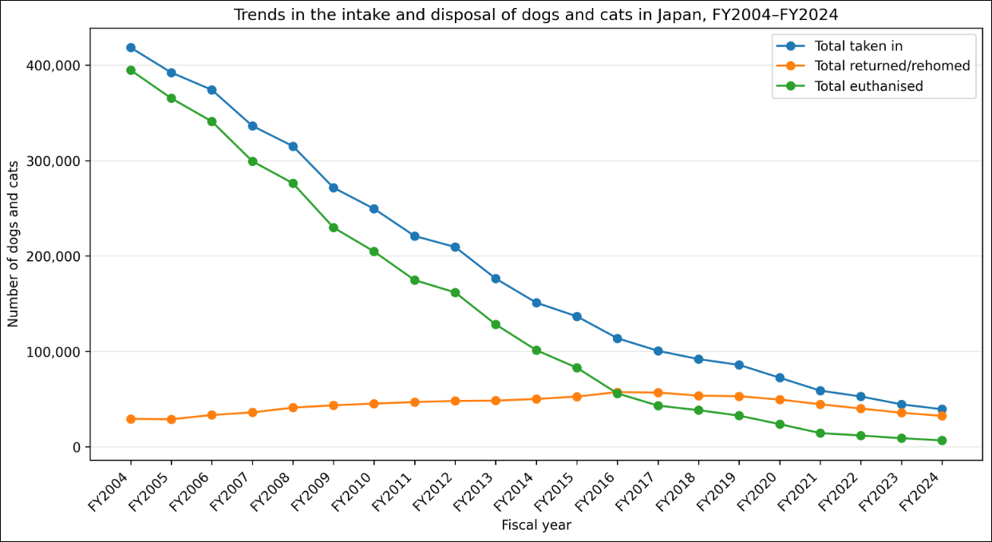
Figure 1 Trends in the intake and disposition of dogs and cats in Japan from FY2004 to FY2024. Source: author's figure based on Ministry of the Environment (2025).
[Before submission: replace the original figure with a high-resolution, legible version. The complete source series is retained in Appendix A.]
The administrative series describes public intake and disposition, not the quality of individual peer-to-peer screening. A decline in intake or euthanasia cannot be attributed to this prototype. The analytical outcome here is the quality and efficiency of a review decision.
Improved public statistics do not mean that rescue and rehoming needs have disappeared. Animal welfare organisations, volunteers, rescue cat cafes, and individual rescuers still deal with abandonment, abuse, medical care, adopter recruitment, post-adoption follow-up, and animal hoarding. Hoarding may involve deteriorating animal health, unhygienic conditions, neighbourhood conflict, and social isolation (Ministry of the Environment, 2022).
Ministry guidance identifies factors to check in prospective adopters, including family consent, lifelong care, time away from home, housing conditions, and the burden of caring for ill or elderly animals. It also states that people living in accommodation where animal keeping is prohibited should be excluded, and that proof may be requested where animals are permitted in apartment housing (Ministry of the Environment, 2006). At the same time, stricter checks create privacy risks, especially when identity documents, facial images, addresses, home photographs, or income-related information are involved. A safer rehoming system must therefore balance verification with data minimisation.
In a follow-up questionnaire of 29 cat adopters from one Japanese animal hospital, Onodera, Uchida and Kakuma (2014) found differences between ideal and later perceived activity and aggression, and an association between house soiling and lower satisfaction. The small single-site study does not establish a general failure rate, but it motivates documenting expectations and the needs of each animal.

2 Related work and research gap

2.1 Animal and adopter evidence
The following studies inform which circumstances to ask about; none supplies a validated Japanese scoring threshold.
• Onodera et al. (2014): Among 29 cat adopters at one Japanese animal hospital, perceived activity and aggression exceeded the owners' ideal images, while house soiling correlated with lower satisfaction. This supports checking expectations against an individual cat's behaviour, not treating appearance as a proxy for fit.
• Lord et al. (2008): In US shelter-adopter surveys, 51.9% of animals with one-week responses had a reported health problem, falling to 10.3% among those with one-month responses; respiratory disease was most common. The different response groups and observational design do not prove that screening prevents illness. They justify making medical history, likely care and follow-up plans visible.
• Powell et al. (2022): Of 132 dog adopters at one US shelter, 29 returned a dog within three months. Returners had higher prior expectations of desirable dog behaviour, health and the human–dog bond, whereas expectations about ownership duties did not differ significantly. This suggests pre-adoption discussion of realistic behaviour and adjustment, without assuming that expectations alone cause returns.
• Griffin et al. (2020): Responses from 82 UK organisations described varied screening practices; published literature supported only eight of 37 adopter characteristics they deemed most important. Much support concerned associations, not causal proof. Therefore this prototype exposes the reasons and missing evidence for each check, and does not exclude people categorically by age, income or household form.

2.2 Adoption journeys and operational software
Two directly relevant examples show different emphases. A research prototype and a deployed service should not be treated as equivalent evidence of effectiveness.
• Agapet (Chang and Cañarte, 2023): After four months of work with an Ecuadorian rescue organisation, the authors proposed a mobile app with a timeline, milestones, short learning activities and rewards to make the adoption journey easier to understand. They report positive early design results, but the accessible abstract does not establish a measured reduction in review time, missed risks or post-adoption returns. PawMatch does not reproduce its reward mechanism; it tests the reviewer's case-level decision support.
• Shelterluv (n.d.): Its published feature list includes digital applications, animal medical records, automatic tasks and reporting, supporting the shelter's end-to-end operations. This is a vendor feature description, not a peer-reviewed outcome evaluation. It does not show how the evidence-aware display itself changes recognition of a particular animal's critical care requirements. PawMatch narrows its evaluation to that question rather than claiming broader operational coverage.

2.3 What this study will test
Existing work helps adopters understand the journey and organisations manage cases. This study asks a narrower unanswered question: when animal needs, applicant plans and pending checks appear together, can a reviewer identify important risks and explain the next action without relying only on the score? The study does not claim superiority over existing products or an increase in real adoptions.

3 Research aim and questions
The research questions (RQs) organise three observable differences when the same case is reviewed with Application information only and With PawMatch review support:
• RQ1 — Noticing important checks: Can participants connect the animal's care needs with the applicant's plan and identify the predefined important risks, missing evidence and appropriate next checks?
• RQ2 — Explaining the decision: Can participants explain why they selected a candidate and what must be checked next? Researcher coding of written answers is combined with task-level 1–5 ratings of usefulness, information clarity and confidence in explaining the decision.
• RQ3 — Avoiding over-reliance: When a provisional score is high but housing or care evidence is still missing, do participants notice the pending check rather than advancing solely because of the number? Critical misses are considered together with self-reported reliance on screen conclusions and scores.

4 Proposed system
The following design specification is retained from Proposal; the implementation status and the revisions to its initial diagrams are stated immediately afterwards.
The proposed system is a risk-aware decision-support prototype for reviewing prospective adopters in peer-to-peer dog and cat rehoming. It is intended to support, rather than replace, human judgement. The system will not automatically approve or reject any applicant. Instead, it will structure relevant information and present review support in a way that helps human reviewers make more transparent and consistent decisions.
The basic operating unit of the system consists of four roles: (1) adopter, (2) rehomer, (3) reviewer and (4) administrator. Roles 3 and 4 are grouped as the service-side PawMatch operations team. The adopter asks questions and submits required information. The rehomer, who actually cares for the animal, answers questions about behaviour, health, daily care and adoption conditions. PawMatch operations organises and manages suitability review, documents, identity checks, workflow stages, decision rationale and audit records.
The enquiry history is a shared thread in which all three parties can participate. Pet-specific facts can be asked directly of the rehomer, whereas movement into formal screening, requests for additional evidence, identity checks and workflow updates are handled by PawMatch operations. The administrator is not normally the primary correspondent, but manages permissions, settings, accounts and audit access and may inspect records as part of operations. This division preserves the rehomer's knowledge and participation in the decision while transferring burdensome screening, procedure and verification work to the service provider.
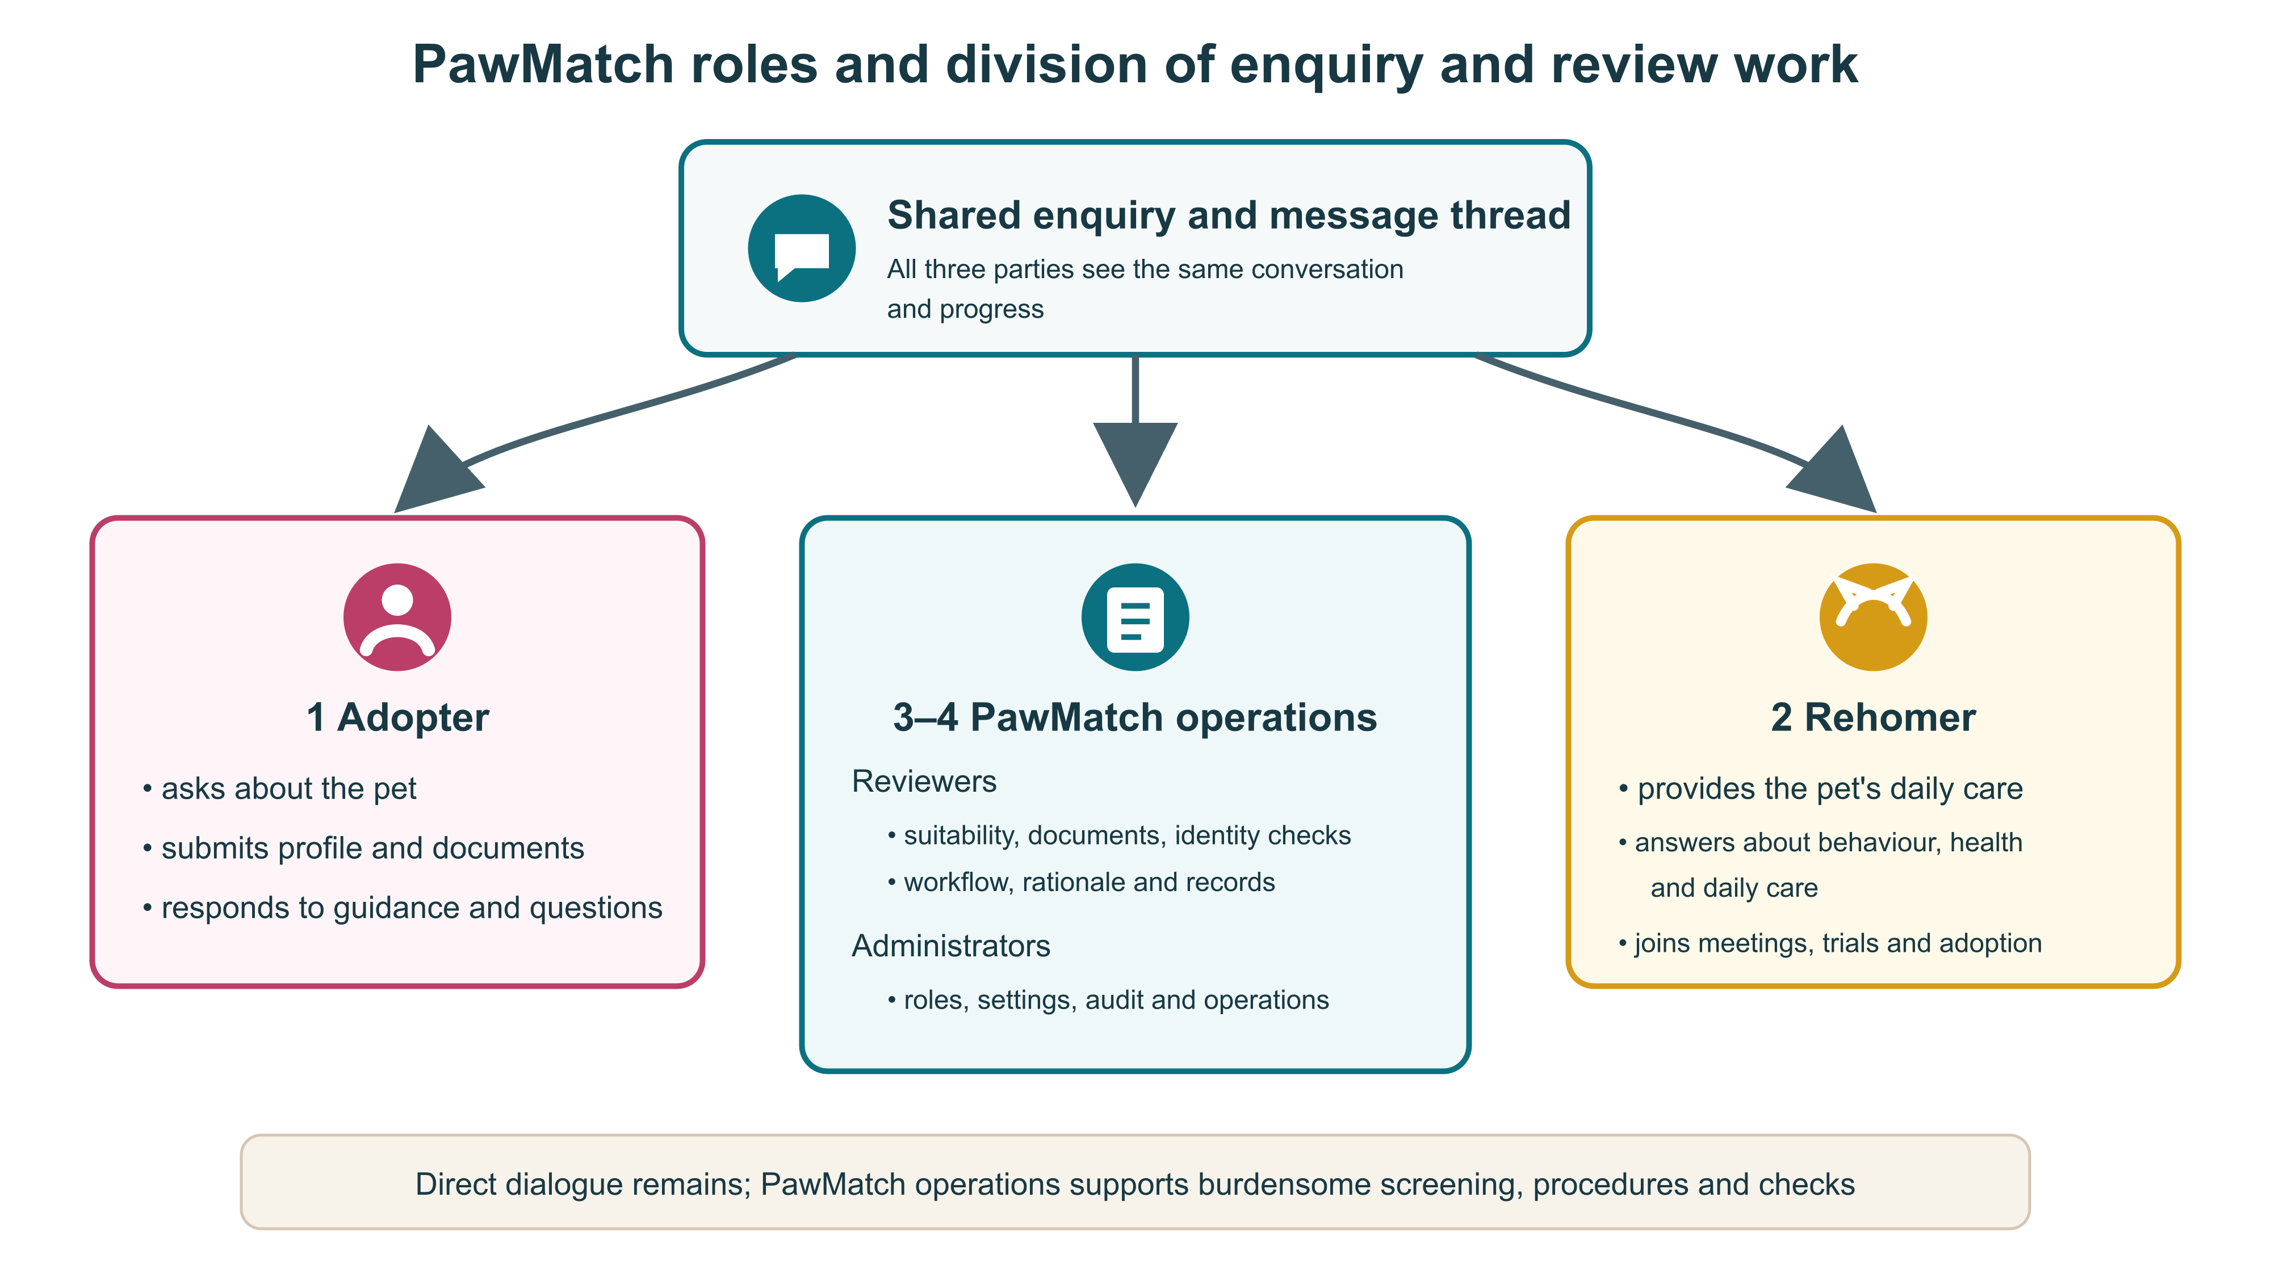
Figure 2a PawMatch responsibility model: direct adopter-rehomer dialogue is retained while PawMatch operations supports screening, procedures and verification. Source: author.
The prototype will use synthetic data representing realistic rehoming scenarios. It will structure animal profiles, including age, health condition, care needs, temperament, compatibility with children or other animals, indoor-only requirements, and environmental sensitivity. It will also structure adopter profiles, including housing, cohabitant consent, previous experience, availability, financial readiness, medical cost awareness, existing pets, veterinary access, lifelong care agreement, and willingness to accept follow-up.
Adopter preferences, such as species, age, temperament, willingness to adopt senior animals, or appearance preferences, will be recorded. However, preferences will not override welfare-related suitability factors. Economic and occupational information will be treated cautiously as care-related context, not as simple attribute-based judgement.
In a live system, identity verification, housing confirmation, home environment review, and adoption agreements may be important. In this project, actual documents, tenancy agreements, home photographs, facial images, employer information, and proof of income will not be processed directly. Instead, these checks will be represented as abstract verification statuses, such as identity verified, housing verified, and follow-up agreement accepted.
The system will present initial screening results, weighted suitability scores, risk flags, verification statuses, and recommended next checks. For example, it may show that an applicant is broadly suitable but still requires housing evidence, or that a household with several existing animals requires further review because of a possible multi-animal household risk.
Figure 2 Planned current system overview: animal and adopter profiles, case-specific checks, human review and feedback. The original Proposal design is preserved in Appendix B. [INSERT UPDATED LEGIBLE DIAGRAM]
The evaluation uses two review screens. Application information only presents the same animal and applicant facts and verification states. With PawMatch review support adds the suitability score, reasons for the score, risks and suggested next checks. Candidate order and source facts remain identical, allowing the study to compare decisions and explanations when review support is added.
Figure 3 Planned six-stage review: initial screening → risk review → evidence verification → meeting → trial → final human decision. The original Proposal workflow is preserved in Appendix B. [INSERT UPDATED LEGIBLE DIAGRAM]
The current prototype uses a responsive interface, a REST API described by OpenAPI and optional MongoDB persistence with a synthetic-data fallback. Eight animal scenarios and 32 applicant records exercise the review workflow. Role-specific demo accounts separate adopters, rehomers, reviewers and administrators. A one-application-per-row progress view, case history and administrator analytics make the state of each review inspectable. These features demonstrate scope but are not themselves the evaluated research outcome.
Table 1 separates the basis for selecting review categories from the provisional numerical weights. The Ministry's rehoming guidance and the empirical studies identify relevant questions, but none estimates a Japanese causal effect or establishes that housing should receive exactly 25 points. The initial ordering gives more weight to conditions that directly determine whether the animal can be kept safely and cared for daily. This is an explicit design hypothesis, to be reviewed with domain experts and sensitivity analysis rather than presented as a validated risk model.
Table 1 Provisional review categories, checks and evidence basis
Category / points | Case-specific checks | Why included; source
Housing / 25 | Pet-permitted residence; indoor/outdoor conditions; safe space and escape prevention. | Direct keeping condition in Ministry of the Environment (2006); housing issues also appeared among returns in Powell et al. (2022).
Care time / 20 | Daily absence, feeding/exercise, medication schedule; named substitute carer. | Time and care arrangements in Ministry of the Environment (2006); owner circumstances discussed by Powell et al. (2022).
Care understanding / 15 | Knowledge of this animal's behaviour, training and adjustment; realistic expectations. | Expectation–behaviour gaps in Onodera et al. (2014) and Powell et al. (2022).
Medical readiness / 15 | Known conditions, vaccines, veterinary access and a feasible care/expense plan. | Post-adoption health problems in Lord et al. (2008); illness and ageing in Ministry of the Environment (2006).
Household integration / 15 | Cohabitant agreement; children and resident animals; a safe introduction plan. | Family/household questions in Ministry of the Environment (2006); caution about weak categorical rules in Griffin et al. (2020).
Continuity / 10 | Lifelong care, changes in circumstances, emergency arrangements and follow-up cooperation. | Lifelong-care guidance in Ministry of the Environment (2006); return-related expectations in Powell et al. (2022).

The six categories are assessed at category level: a concrete, documented plan receives the full category weight; a partial plan receives half; and unknown or conflicting evidence receives zero. The sub-checks in Table 1 guide the reviewer but are not independently point-scored. Unknown is labelled 'needs information', not 'unsuitable'. Identity, housing verification and critical animal-specific conflicts remain separate flags; no score alone approves, rejects or ranks a person. An administrator can change the six weights in the research settings (total 100 and a recorded rationale). The current configuration is also used for ordinary review displays; saved research sessions keep the version and weights issued to them. Operational scores are recalculated under the active version, whereas previously recorded human decisions are not rewritten. Before participant testing, freeze the weights and check alternative plausible allocations.
Figure 5 Planned implementation architecture: role-based web interface → REST API and review services → MongoDB or synthetic case store; research sessions and export are separate from demo activity. [INSERT VERIFIED DIAGRAM]
Figure 6 provides dated implementation evidence for the two operational views used to inspect the review workflow. The screenshots show the Japanese-language prototype; the same interface provides an English display option.
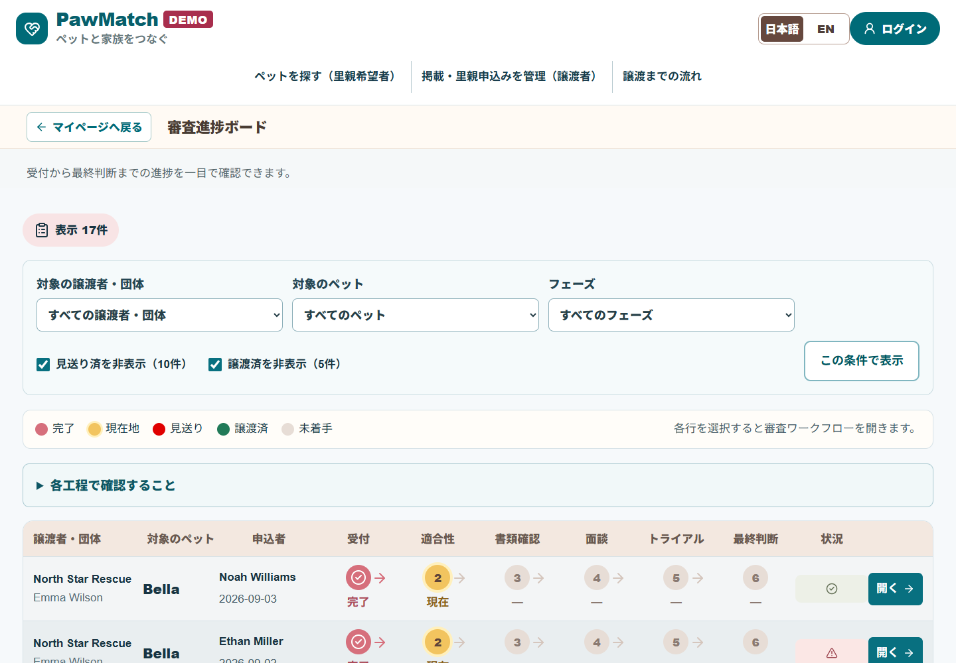
Figure 6a Review progress board showing one application per row, dated 29 September 2026. Source: author.
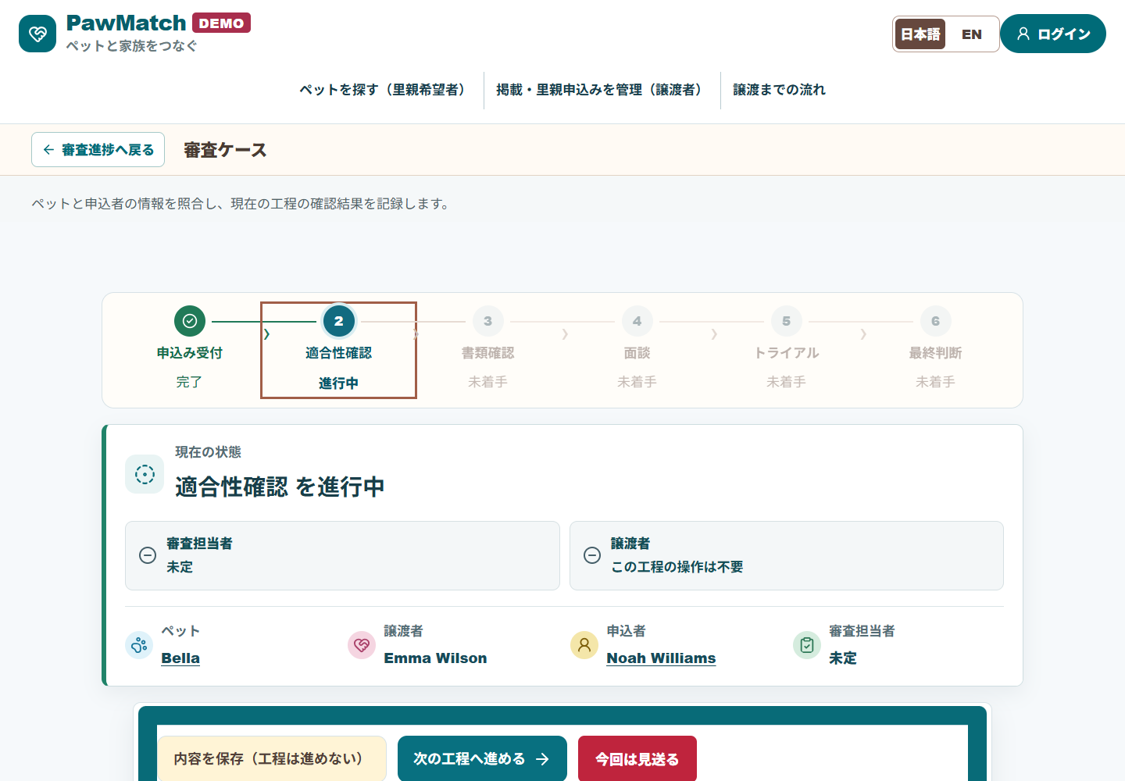
Figure 6b Case-level suitability review showing stage, role responsibilities and human-controlled actions, dated 29 September 2026. Source: author.

5 Decision support and critical considerations
This project is framed not primarily as a CRUD-style web application or a noticeboard service, but rather as a decision-support and review-support system. The central concern is not only whether information can be stored and displayed, but whether structured information, risk visibility, explanation, and evaluation can improve the way adopter applications are reviewed.
A simple noticeboard or matching service can publish animal profiles and connect applicants with carers. However, this approach may not adequately support comparison between applicants, identification of hidden risks, explanation of review decisions, or consistent use of review criteria. In dog and cat rehoming, a match is not only a matter of applicant preference. The animal’s age, health condition, temperament, care needs, housing requirements, and compatibility with the adopter’s household all have to be considered together.
Decision Support Systems are relevant because the prototype organises information and assists judgement rather than automating it. PawMatch operations organises and records the evidence and next action, but final adoption requires agreement between the adopter and rehomer. Because adoption decisions affect animal welfare, applicant responsibility and personal information, fully automatic approval or rejection would be inappropriate in this context.
The project is also connected to human-in-the-loop design. The system can highlight risk factors and provide suitability scores, but the reviewer should still interpret the evidence, request additional checks where necessary, and make the final judgement. This design reduces the risk of treating the software output as a definitive decision.
Explainability is another important concern. A numerical suitability score alone is insufficient because it does not explain why an applicant appears suitable or why further checks are required. The prototype will therefore combine scores with risk flags, verification statuses, and recommended follow-up actions. These explanations should help reviewers justify their decisions and identify unresolved concerns.
At the same time, the use of scores and flags introduces a risk of automation bias. Reviewers may over-trust the score and overlook important profile details. For this reason, the evaluation will not only ask whether the interface is useful, but also whether participants continue to use profile evidence and risk explanations rather than relying solely on the numerical score.
Feedback from animal welfare organisations is valuable, but it also has limitations. Many Japanese animal welfare non-profit organisations, rescue groups, and rescue cat cafes are likely to be operated by a small number of staff or volunteers. They may have strong practical knowledge of rescue and adoption, but may not be able to provide detailed professional comments on application UX or software design. Their feedback will therefore be used mainly to assess domain relevance, realism of scenarios, and practical concerns. Usability and interface clarity can also be evaluated by pet owners, IT professionals, and adult users using controlled synthetic scenarios.
This is decision support, not a substitute for a rehoming worker. Griffin et al. (2020) show that many familiar adopter criteria have limited research support, so each check should have an explicit reason rather than being applied as an unquestioned rule. Parasuraman and Manzey (2010) explain why people can over-trust automated advice. PawMatch therefore displays the evidence behind each provisional point and keeps unresolved checks visible even when the total is high. The evaluation will test whether reviewers actually notice these warnings. Expert review of the case rubric and alternative weight settings are still needed before use with real applicants.

6 Evaluation method
The evaluation uses scenario-based tasks with synthetic animal and applicant profiles. Its purpose is not only to demonstrate technical operation, but to examine whether the prototype helps participants understand and explain information needed for review. Participants consider the same rehoming cases using Application information only and With PawMatch review support.
Application information only presents applicant facts and verification states in a simple profile. With PawMatch review support adds a weighted suitability score, its explanation, risks and suggested next checks. For each candidate, participants record an action, select a priority candidate, identify risks, explain their decision and propose next checks.
The test scenarios will include a senior cat with continuing medical needs, an indoor-only cat requiring stable housing conditions, a young active dog requiring time and training, an applicant with incomplete housing verification, an applicant with several existing pets, a case where adopter preferences conflict with animal welfare needs, and a case where an applicant appears suitable overall but has one important unresolved risk.
Primary measures are recall of predefined important risks, clarity of the written decision, appropriate next checks, perceived usefulness, information clarity, confidence in explaining the decision and possible over-reliance on screen conclusions or scores. Task-level 1–5 ratings and written answers are compared within the same participant and case. Elapsed screen time is also recorded, but is secondary because it excludes the follow-up communication and document checks required in real rehoming.
Figure 4 shows the evaluation design. Participants consider the same synthetic case using Application information only and With PawMatch review support. Important-risk recall, written reasons, next checks and task-level ratings are compared. Display order alternates AB/BA; elapsed time is retained as contextual information.
Figure 4 Planned comparison design: AB/BA order, repeated-case learning caveat, important-risk recall, written reasons and task-level ratings. The original Proposal comparison figure is preserved in Appendix B. [INSERT UPDATED LEGIBLE DIAGRAM]
Once the prototype reaches a stage where it can be reasonably demonstrated, feedback will be requested from several Japanese animal welfare non-profit organisations, animal rescue groups, and rescue cat cafes where possible. If sufficient feedback cannot be obtained from these organisations, alternative adult participants will be used, including IT professionals, pet-owning family members, friends, and people with experience of caring for dogs or cats. If most participants are not animal welfare professionals, this limitation will be explicitly discussed in the final report. The project will avoid claiming that the prototype has been validated for real-world adoption decisions unless sufficient domain feedback is obtained.
This formative evaluation targets five consenting adult participants. The Office for Health Improvement and Disparities (2020) recommends five to six people for qualitative usability testing intended to identify problems in tasks. By contrast, the GOV.UK User Research Community (2018) advises recruiting 30 to 60 actual or likely users for service-wide usability benchmarking. Five participants are a pragmatic choice for this individual project, not a powered sample or a service benchmark. Participant-level observations of important risks, written reasons and task ratings will be primary. The study will not claim statistical significance, population performance or a real-world reduction in review time.
Each participant will see two selected synthetic cases in both modes, making four tasks. AB and BA display orders will be alternated; with five people the split is necessarily three versus two, and repeating cases may teach participants what to look for. Within each participant, the study compares important-risk recall, concrete usability problems, appropriate next checks, written reasons, usefulness, clarity, confidence and reliance on the screen. Free text will be coded against a predefined rubric, with denominators, missing data, order and relevant experience disclosed. Elapsed time will be reported only as contextual information alongside interruptions. The study will look for design problems and promising signals, not estimate an average treatment effect. If no animal-welfare practitioner participates, the findings cannot validate use by rehoming organisations.

6.1 Five-participant session procedure
Each participant completes one moderated session of approximately 35–45 minutes. The participant acts as a reviewer for the experimental tasks; the researcher-led all-role journey remains a technical verification and is not mixed with the participant outcome measures.
1. Recruit five consenting adults using pragmatic purposive sampling: where possible, include two current or previous pet carers, one person with rescue or rehoming experience, and two adults without specialist experience. Record relevant experience, but do not present the group as representative.
2. Send a short information sheet in advance and record oral or email consent. Assign participant codes P01–P05; do not collect identity documents, addresses or real adoption records.
3. Run the study on the researcher's computer or a prepared hosted instance. Start a fresh research session for each participant so that saved answers and workflow changes do not carry across participants.
4. Give a five-minute neutral orientation to the four roles and the meaning of scores, warnings and verification states. Do not explain the case risks that form the coding rubric.
5. Ask each participant to complete four tasks: two synthetic cases in both Application information only and With PawMatch review support. Alternate AB/BA order across participants (three in one order and two in the other). For every task, record the selected action, important risks, written reason and next checks.
6. Immediately after each task, collect 1–5 ratings for usefulness, information clarity, confidence in explaining the decision and reliance on the screen conclusion or score. The moderator records assistance, navigation errors, omitted critical risks and interruptions. Elapsed time is contextual only.
7. Finish with a short interview on confusing information, trust, missing evidence and role clarity. Code written answers against the frozen rubric before viewing aggregate ratings, then report participant-level denominators, medians, ranges, counterexamples and missing data without inferential significance claims.
[PENDING VALIDATION: prepare participant information and record oral or email consent before participation; also retain the in-application consent confirmation. Document recruitment, eligibility, participant count, dates, ethics approval if required, the frozen risk rubric and scoring weights. Do not substitute simulated participants or invented times.]

7 Work plan and submitted artefacts
The plan of work covers research, design, implementation, evaluation, analysis, reporting, GitHub code submission, and the final three-minute demonstration video. It is therefore not only a development schedule, but a plan for completing the project as a research-informed software artefact.
Table 2 Proposal development phases
Phase | Work | Output
Phase 1: Literature review and requirement refinement | Review literature on animal rehoming, Decision Support Systems, human-in-the-loop design, HCI, explainability, and automation bias. Refine the research question and evaluation criteria. | Critical review, refined research question, evaluation criteria
Phase 2: Scenario and data design | Design synthetic animal profiles, adopter profiles, verification statuses, and scenario-based test cases. | Synthetic dataset and test scenarios
Phase 3: Prototype and interface design | Design the baseline screen, risk-aware interface, review screen, risk flag display, and recommended action display. | Wireframes, UI design, system overview
Phase 4: Implementation | Implement the MVP, including profile display, scoring, risk flags, verification statuses, and applicant review views. | Working prototype and GitHub code artefacts
Phase 5: Evaluation | Request feedback from relevant organisations where possible and conduct alternative participant testing if needed. | Evaluation data and user feedback
Phase 6: Analysis and final reporting | Analyse results, discuss limitations, prepare the final report, organise GitHub artefacts, and create the three-minute demo video. | Final report, code artefacts, demo video

The MVP scope will be deliberately limited. It will include synthetic animal and adopter profile display, verification status display, suitability scoring, risk flagging, recommended next checks, and applicant review screens. It will not include real identity verification, facial image processing, address verification, payments, real user registration, or legal adoption contract processing.
For the final submission, the report, GitHub artefacts and three-minute video will be structured around one or two representative scenarios. The demonstration should show how risks that are difficult to organise from application information alone become easier to inspect through score explanations, warnings, verification states and suggested actions.

8 Ethics and data handling
The project will use synthetic data and fictional rehoming scenarios. It will not collect or process real personal data from prospective adopters, rescuers, animal welfare organisations, or real animals. The prototype will not process identity documents, facial images, home photographs, addresses, employment information, proof of income, or real animal records.
If human participants are involved in evaluating the prototype, they will review only synthetic animal and adopter profiles. They will not be asked to make real adoption decisions. Feedback will focus on clarity, usability, perceived usefulness, visibility of risks, and the value of the decision-support interface.
Participant feedback will be anonymised or summarised in the report. Individual names and organisation names will not be reported unless explicit permission is obtained. The system will not automatically approve or reject applicants. It will also avoid discriminatory or overly simplified exclusion based solely on broad attributes such as being unmarried, living alone, occupation, or income level. Instead, it will focus on care-related risk factors such as housing, availability, medical cost awareness, emergency readiness, previous experience, existing pets, lifelong care agreement, and willingness to accept follow-up.
External adult testers must receive clear participant information and provide oral or email consent before participating. The application also records their confirmation of the study conditions. Research records use participant codes, support withdrawal and apply documented access, retention and deletion rules. The demo login is not production-grade identity verification; this study does not collect real identity documents, facial images or income evidence.

9 Implementation and technical verification
The source repository and the implemented technology are shown below. The application is a research prototype with role-specific screens and a human-controlled review workflow. The repository URL identifies the configured project, while the exact submitted commit should be checked against the final test run.
In the enquiry thread, only the adopter who opened the enquiry, the rehomer responsible for the listed pet and PawMatch operations can read and send messages. Role labels distinguish pet-specific answers from operational guidance. Unrelated rehomers cannot access another person's enquiry, while authority to advance formal screening stages remains restricted to reviewers and administrators.
Source repository: https://github.com/SerikaKawano/PawMatch
Table 3 Implemented technology stack
Layer | Technology | Use in the prototype
Interface | React, Next.js, TypeScript | Role-specific screens for adopters, rehomers, reviewers and administrators.
API | Next.js REST routes, OpenAPI | Pet and application data, review operations and a machine-readable API description.
Persistence | MongoDB via Mongoose; local JSON fallback | Optional database storage; a local mode supports the synthetic-data demonstration.
Verification | Node.js test runner, ESLint, Next.js build | Automated behaviour checks, static linting, TypeScript and production compilation.

Table 4 reports checks run on the local working tree on 29 September 2026. All 50 automated tests passed. They cover role boundaries, listing ownership, consultation ownership, synthetic-case consistency, separation of scores from verification, propagation of administrator weights, consent and withdrawal in study sessions, prepared decline and completed-adoption outcomes, and human-gated final review. A complete Bella scenario begins with the rehomer's published listing and opaque listing number, then checks the adopter's enquiry, replies by the rehomer and PawMatch operations, suitability and document review, joint meeting, trial and final sign-off, adoption approval, and chronological dates for every completed stage. Seven additional HTTP suites passed against an isolated production build; these included 151 role/page/API boundary checks plus login, consultation, document, navigation, persistence, research-session and withdrawal journeys. These checks establish selected software behaviour; they do not establish usability, fairness, animal-welfare impact or adoption outcomes.
Table 4 Local automated verification on 29 September 2026
Check | Observed result | Scope
npm test | 50 passed; 0 failed | Listings, roles, ownership, research sessions, scoring, prepared outcomes and an all-role completed adoption journey.
npm run lint | Passed | ESLint reported no errors.
Next.js production build (webpack) | Passed | Compilation, TypeScript check and page generation completed.

10 Participant results to complete
[PENDING RESULTS: report invited, consented, started, completed and withdrawn counts; important-risk recall; appropriate next checks; coded explanations; usefulness; information clarity; confidence in explaining decisions; screen reliance; missing data; and paired case-level comparisons. Report elapsed time only as a secondary value excluding interrupted tasks. Quote participants only with consent. No participant outcome is claimed at this stage.]
Outcome | Application information only | With PawMatch review support
Completed tasks | [n / planned tasks] | [n / planned tasks]
Important-risk recall | [detected / opportunities] | [detected / opportunities]
Clarity of written reasons | [mean 0–3; coded n] | [mean 0–3; coded n]
Usefulness, clarity and confidence | [each mean 1–5] | [each mean 1–5]
Reliance on screen conclusions or scores | [mean 1–5] | [mean 1–5]

Figure 7 Planned results figure: within-participant, same-case differences in important-risk recall, usefulness, information clarity, confidence and screen reliance, with denominators and missing data shown. Elapsed time will appear only in a secondary figure or note. [INSERT ONLY AFTER REAL PARTICIPANT DATA ARE COLLECTED]

11 Discussion and limitations
The anticipated methodological contribution is an inspectable comparison of two review screens on the same synthetic cases. With five self-selected participants, researcher-written cases and scoring rules, learning between repeated tasks and differences in domain experience can strongly influence every observation. Even a unanimous pattern would be a finding about these tasks and people, not a precise estimate for rehoming organisations. Improved risk recall or explanations would not by itself establish operational effectiveness. If scores encourage unjustified advancement or greater reliance on the screen, the design should be revised. Elapsed time excludes real follow-up and is not primary evidence of efficiency. Real placement success, return and animal welfare require field follow-up and are outside this short evaluation.

12 Expected contribution
The expected contribution of this project is a structured prototype and evaluation approach for supporting adopter review in peer-to-peer dog and cat rehoming. Rather than treating the problem as a simple noticeboard or matching service, the project models it as a risk-aware review process involving structured data, verification statuses, suitability scoring, risk flags, and human judgement.
Synthetic data and scenarios also provide an ethically lower-risk evaluation design. If, compared with Application information only, review support shows a consistent improvement in important-risk recall, written reasons, next checks, information clarity or perceived usefulness without increasing critical misses or screen reliance, the findings can provide evidence of potential value for safer and more transparent rehoming workflows. They will not directly establish real adoption outcomes.
Three distinct claims require separate evidence: a working software artefact, a reproducible comparison and an effect on reviewers. Only the first is technically evidenced so far. Synthetic cases and the three-minute video cannot establish a change in real adoption rates.

13 Provisional conclusion
This study advances a specific design hypothesis: rehoming review may be simplified not by omitting checks, but by bringing each animal's care needs, the applicant's plan, outstanding evidence and the next human action into one traceable decision. The prototype implements that workflow. All 50 automated tests and seven isolated production HTTP suites passed, including an all-role journey that begins with a published listing and completes enquiry, review and adoption approval while preserving permissions and chronological dates. These results establish technical feasibility and internal consistency, but do not show that people make better decisions with the interface.
The testable prediction is that, compared with Application information only, With PawMatch review support will help participants identify at least as many predefined important risks and next checks, provide more specific reasons, and rate usefulness, clarity and confidence more highly. At the same time, high-scoring cases with unresolved housing or care evidence test whether critical misses or screen reliance increase. If improvement appears only for some people or cases, the report will state those conditions and counterexamples. Elapsed time is a secondary value and will not be interpreted as real-world review-time reduction. [After participant testing: insert differences, denominators, missing data and counterexamples, and state which parts of the prediction were supported.]
Until that comparison is completed, the defensible finding is that a reviewable, human-controlled workflow can be built and technically checked, not that it increases adoptions or improves animal welfare. Five qualitative sessions may identify design problems or suggest a direction for later research, but cannot validate a general efficiency gain. Field research with rescue organisations and post-placement follow-up would be needed for those longer-term outcomes. The three-minute video will demonstrate the software and research question, not replace participant evidence.

References
Chang, M. and Cañarte, G. (2023) 'Agapet: Supporting a responsible adoption process for stray and abandoned pets in urban areas', Extended Abstracts of the 2023 CHI Conference on Human Factors in Computing Systems, pp. 1–5. doi: 10.1145/3544549.3583845.
GOV.UK User Research Community (2018) 'Usability benchmarking a website or whole service', Service Manual. Available at: https://www.gov.uk/service-manual/measuring-success/usability-benchmarking-a-website-or-whole-service (Accessed: 27 September 2026).
Griffin, K.E., John, E., Pike, T. and Mills, D.S. (2020) 'Can This Dog Be Rehomed to You?', Frontiers in Veterinary Science, 7, 617525. doi: 10.3389/fvets.2020.617525.
Lord, L.K., Reider, L., Herron, M.E. and Graszak, K. (2008) 'Health and behavior problems in dogs and cats one week and one month after adoption from animal shelters', Journal of the American Veterinary Medical Association, 233(11), pp. 1715–1722. doi: 10.2460/javma.233.11.1715.
Ministry of the Environment (2006) Guidelines for finding a new owner [in Japanese]. Available at: https://www.env.go.jp/nature/dobutsu/aigo/2_data/pamph/support/02.pdf (Accessed: 24 September 2026).
Ministry of the Environment (2022) Guidelines on measures to address animal hoarding [in Japanese]. Available at: https://www.env.go.jp/nature/dobutsu/aigo/2_data/pamph/r0409/guideline.pdf (Accessed: 24 September 2026).
Ministry of the Environment (2025) Intake and disposition of dogs and cats [in Japanese]. Available at: https://www.env.go.jp/nature/dobutsu/aigo/2_data/statistics/dog-cat.html (Accessed: 24 September 2026).
Office for Health Improvement and Disparities (2020) 'Usability testing: qualitative studies', GOV.UK. Available at: https://www.gov.uk/guidance/usability-testing-qualitative-studies (Accessed: 27 September 2026).
Onodera, N., Uchida, K. and Kakuma, Y. (2014) 'Association between characteristics of cats and satisfaction of owners who adopted cats from an animal hospital in Japan', Journal of Veterinary Medical Science, 76(5), pp. 729–733. doi: 10.1292/jvms.12-0569.
Parasuraman, R. and Manzey, D.H. (2010) 'Complacency and bias in human use of automation', Human Factors, 52(3), pp. 381–410. doi: 10.1177/0018720810376055.
Powell, L. et al. (2022) 'Returning a Shelter Dog: The Role of Owner Expectations and Dog Behavior', Animals, 12(9), 1053. doi: 10.3390/ani12091053.
Shelterluv (n.d.) Features. Available at: https://www.shelterluv.com/product/features/ (Accessed: 24 September 2026).

Appendix A Complete source data for Figure 1
All 2004–2024 rows and all ten fields from Proposal Table 1 are retained below, divided into three readable tables. 'Returned/rehomed' follows the source table's combined label; the series should be checked against the Ministry's original definitions before final submission.

Table A1 Dogs
Year | Dogs taken in | Dogs returned/rehomed | Dogs euthanised
2004 | 181,167 | 25,297 | 155,870
2005 | 163,578 | 24,979 | 138,599
2006 | 142,110 | 28,942 | 112,690
2007 | 129,937 | 29,942 | 98,556
2008 | 113,488 | 32,774 | 82,464
2009 | 93,807 | 32,944 | 64,061
2010 | 85,166 | 33,464 | 51,964
2011 | 77,805 | 34,282 | 43,606
2012 | 71,643 | 33,269 | 38,447
2013 | 60,811 | 32,092 | 28,570
2014 | 53,173 | 31,625 | 21,593
2015 | 46,649 | 29,637 | 15,811
2016 | 41,175 | 30,500 | 10,424
2017 | 38,511 | 29,955 | 8,362
2018 | 35,535 | 28,032 | 7,687
2019 | 32,561 | 27,126 | 5,635
2020 | 27,635 | 24,199 | 4,059
2021 | 24,102 | 21,518 | 2,739
2022 | 22,392 | 19,658 | 2,434
2023 | 19,352 | 17,338 | 2,118
2024 | 17,399 | 15,427 | 1,964

Table A2 Cats
Year | Cats taken in | Cats returned/rehomed | Cats euthanised
2004 | 237,246 | 4,026 | 238,929
2005 | 228,654 | 3,936 | 226,702
2006 | 232,050 | 4,427 | 228,373
2007 | 206,412 | 6,179 | 200,760
2008 | 201,619 | 8,311 | 193,748
2009 | 177,785 | 10,621 | 165,771
2010 | 164,308 | 11,876 | 152,729
2011 | 143,195 | 12,680 | 131,136
2012 | 137,745 | 14,858 | 123,400
2013 | 115,484 | 16,320 | 99,671
2014 | 97,922 | 18,592 | 79,745
2015 | 90,075 | 23,037 | 67,091
2016 | 72,624 | 26,886 | 45,574
2017 | 62,137 | 26,967 | 34,854
2018 | 56,404 | 25,634 | 30,757
2019 | 53,342 | 25,936 | 27,107
2020 | 44,798 | 25,385 | 19,705
2021 | 34,805 | 23,112 | 11,718
2022 | 30,401 | 20,471 | 9,472
2023 | 25,224 | 18,426 | 6,899
2024 | 22,010 | 17,079 | 4,866

Table A3 Combined totals
Year | Total taken in | Total returned/rehomed | Total euthanised
2004 | 418,413 | 29,323 | 394,799
2005 | 392,232 | 28,915 | 365,301
2006 | 374,160 | 33,369 | 341,063
2007 | 336,349 | 36,121 | 299,316
2008 | 315,107 | 41,085 | 276,212
2009 | 271,592 | 43,565 | 229,832
2010 | 249,474 | 45,340 | 204,693
2011 | 221,000 | 46,962 | 174,742
2012 | 209,388 | 48,127 | 161,847
2013 | 176,295 | 48,412 | 128,241
2014 | 151,095 | 50,217 | 101,338
2015 | 136,724 | 52,674 | 82,902
2016 | 113,799 | 57,386 | 55,998
2017 | 100,648 | 56,922 | 43,216
2018 | 91,939 | 53,666 | 38,444
2019 | 85,903 | 53,062 | 32,742
2020 | 72,433 | 49,584 | 23,764
2021 | 58,907 | 44,630 | 14,457
2022 | 52,793 | 40,129 | 11,906
2023 | 44,576 | 35,764 | 9,017
2024 | 39,409 | 32,506 | 6,830

Appendix B Original Proposal design figures
The following three figures are retained as a record of the initial design, not as diagrams of the current implementation. In particular, the original applicant-ranking label and ten-step workflow have been superseded by an evidence-aware, six-stage process with no automatic acceptance, rejection or score-based ranking. Updated Figures 2–4 must be inserted before final submission.
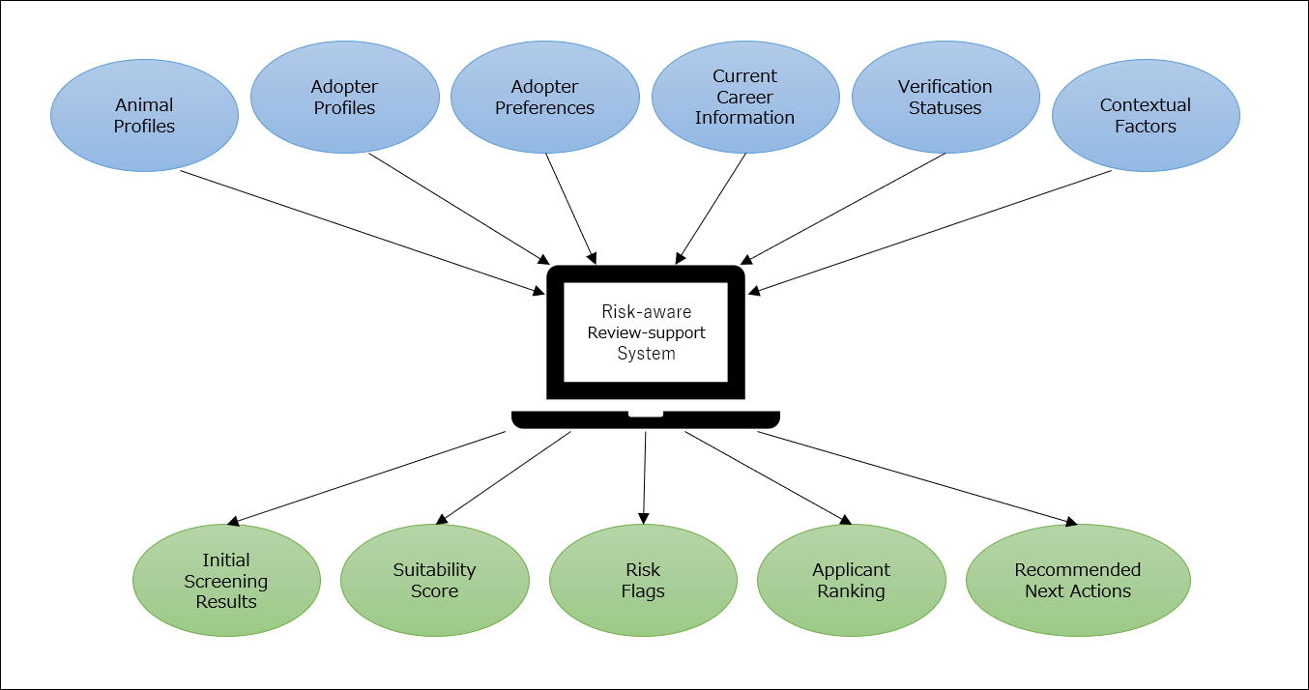
Figure B1 Original Proposal system overview (superseded design). Source: author's own work.
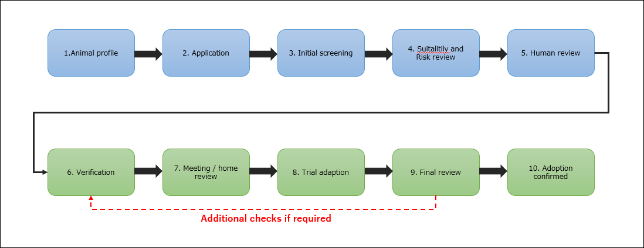
Figure B2 Original Proposal review workflow (superseded design). Source: author's own work.
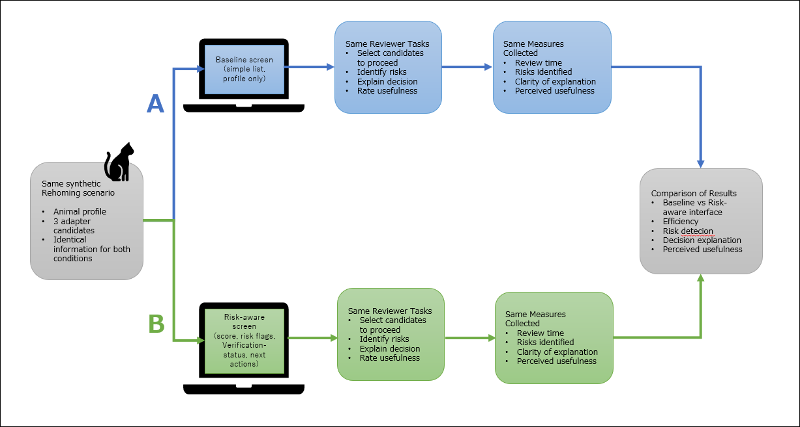
Figure B3 Original Proposal comparison design (superseded design). Source: author's own work.

