Logistics Incident Report
Purpose: This document is used to record and report any accidents, damages, or unexpected incidents that occur during the transportation or handling of goods. It ensures accurate tracking, accountability, and helps with investigating and resolving logistics issues.

Incident Overview
Report Number: INC-20261101-5
Date of Incident: 01 November 2026
Time of Incident: 14:03:10 (UTC+08:00)
Location: NSE High-Risk Stretch (GPS 1.9952, 103.0808). Vehicle WXY 9913 (Hino 500 Reefer), route Shah Alam, Selangor to Johor Bahru, Johor.

Personnel Involved
Name | Role | Contact Info
Marcus Lee (DRV-20418) | Driver | marcus.lee@coldtrust.example | +60 12-555 0202

Incident Details
Description:
The system recorded a light level of 70.5 percent for 5 seconds while the vehicle traveled at a speed of 90.0 kilometers per hour in the zone NSE High-Risk Stretch. The transport was outside an authorised stop at latitude 1.99522 and longitude 103.08076. A person was detected in the frame during this sequence. The system assigned a risk score of 90 and quarantined the shipment.
Type of Incident: Suspected theft or unauthorised access to the cargo hold
Cargo Affected: 10 packages, 13,010 kg: Fresh berries (SHP-1248), Fresh salmon fillets (SHP-2364), Insulin pens (SHP-4574), Ready meals (SHP-5678), Sliced deli meats (SHP-7801) and 5 more. Status now: 10 quarantined.

Impact Assessment
Was there cargo damage? Not determined: the system cannot see the cargo, so a physical inspection is needed.
Description of Cargo Damage:
No package has spent any time outside its temperature limits according to the sensor readings. Quarantined or exposed packages must be inspected before release.
Was there vehicle damage? Not assessed by the system; the reviewer completes this.
Were there injuries? Not assessed by the system; the reviewer completes this.

Cause of Incident
There is a possible indication of unauthorized cargo access during transit. It is suspected that environmental lighting entered the compartment due to a temporary breach.

Immediate Actions Taken
14:03:10 Driver and admin notified (dashboard alarm and Telegram).
14:03:10 System: 10 package status changes (QUARANTINED - DO NOT ACCEPT)

Reported By
Name: ColdTrust system (automatic draft)
Position: Automatic report, not yet reviewed by a person
Contact: not applicable

Additional Notes
Alert #5 (THEFT_SUSPECTED), risk score 90 of 100. Status decided by rules: QUARANTINED - DO NOT ACCEPT.
Data check (Seal agent): no integrity problems found.
GS1 EPCIS event hash IDs linked to this alert: 4fc40e7e5ee9b5ab…, 905015a40e470ed0….
The description and cause wording was drafted by Gemini · Incident agent (every figure checked against the data).
Prepared automatically when the alert was raised. An admin has not reviewed it yet.
AI-assisted draft: a person must review it before it is signed or sent. The system cannot see the cargo, so damage is not assessed.

Photo Evidence

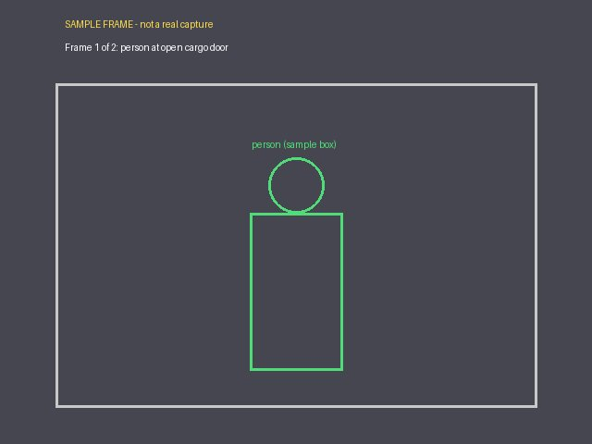
- 14:03:10 · person · file 1793512990_034b9f958fa4.jpg · SHA-256 034b9f958fa40efb…
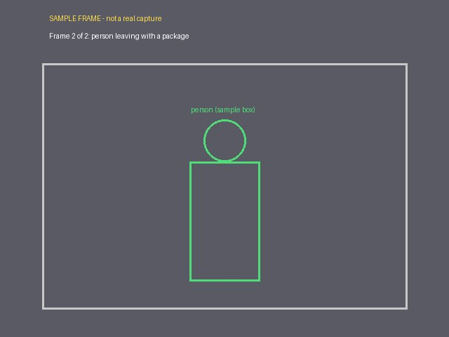
- 14:03:10 · person · file 1793512990_97208c56ad14.jpg · SHA-256 97208c56ad14588c…

Signatures
Person | Role | Signature | Date
Marcus Lee (DRV-20418) | Driver

