Group 103
WONG Shing Chak (13881205)
FAN Hang Lok (14257260)
Li Vincent (13494788)
OOP-based Ticket Selling System
User Guide
Table of Contents
Ticket Selling System User interface installations 2
GUI-Event Ticket Selling System 3
1.Login Page 3
2.HomePage 4
3.Event Details 5
5.Check balance 6
6.Check tickets 6
Ticket Booking Procedure 7
1.Add balance 7
2.Select Events 7
3.Check your ticket 8

Ticket Selling System User interface installations
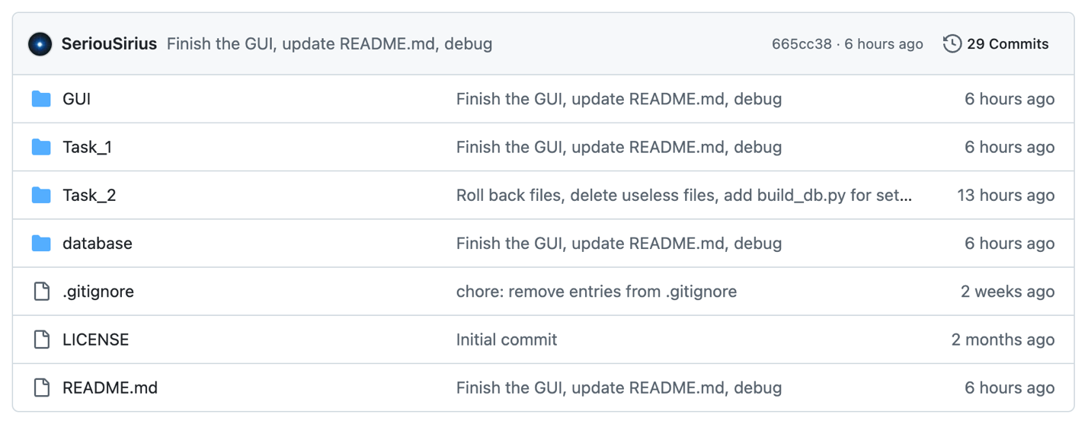
1.download all the files needed
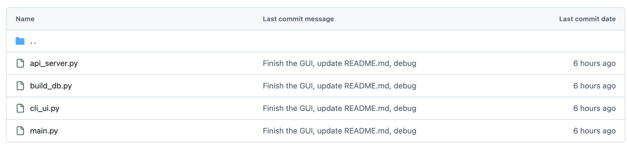
2.Run: python Task_1/main.py
3.Install dependencies through command line interface: python -m pip install flask pytest
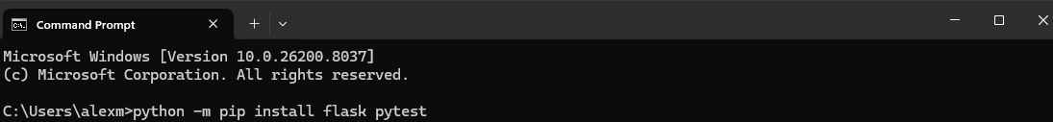
4. build or refresh database: python Task_1/build_db.py
5.Start Flask server (serves API and GUI): python Task_1/api_server.py
6. Open in browser: http://127.0.0.1:5000/

GUI-Event Ticket Selling System

1.Login Page
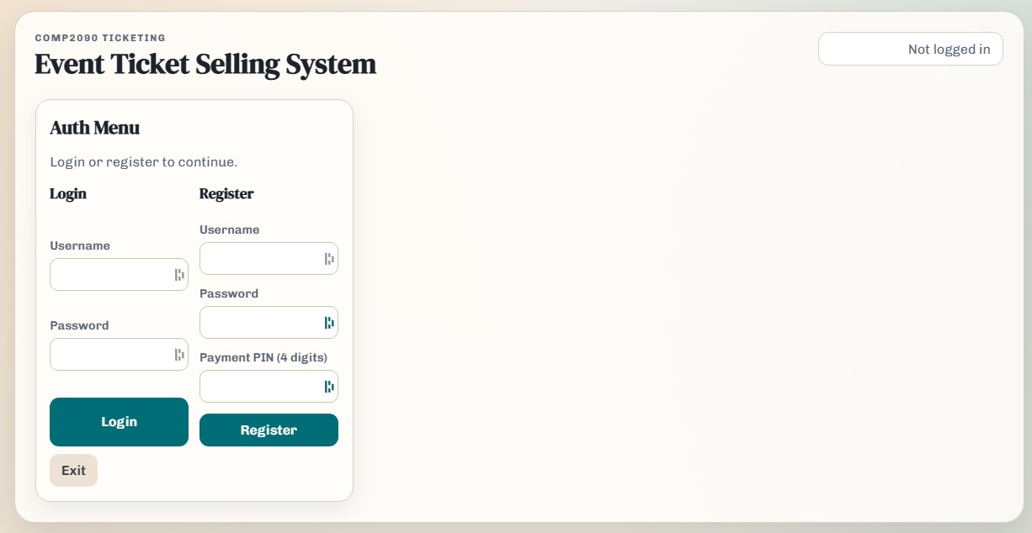
“The GUI interface”
- Login -> Enter your registered Username and Password to login
- Register -> Create your account by setting a username, password, and a 4-digit payment PIN.
- Exit -> Exit the System
- “Not Logged in” -> Your login status

2.HomePage
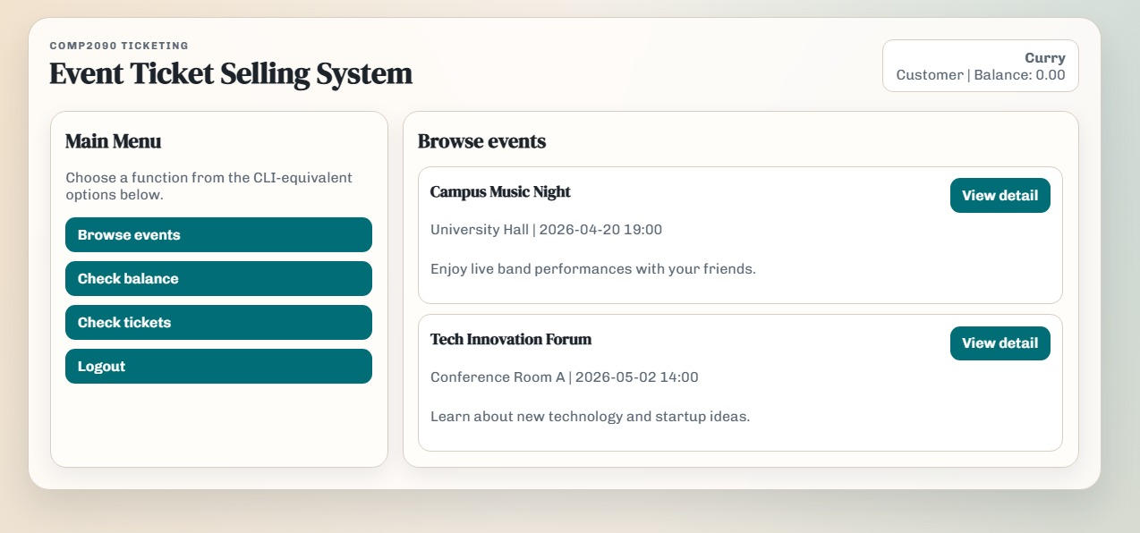
“Main Menu”
- Browse Events → Displays all available events with relevant details that can be purchased.
- Check Balance → Shows your current account balance and allows you to top up your balance.
- Check Tickets → Displays a list of all tickets you have successfully purchased.
- Logout → Logs you out of the system.

3.Event Details
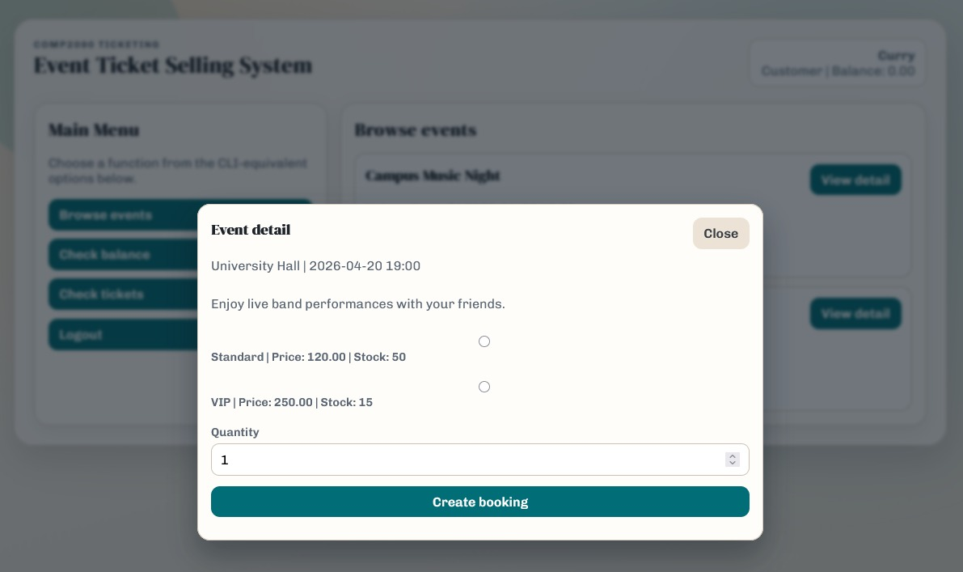
View detail -> It displays the venue, date, time and the price of different tickets
- You can select your ticket types
Quantity -> It allows you to select how many tickets you want
Create booking -> A booking will be made

5.Check balance
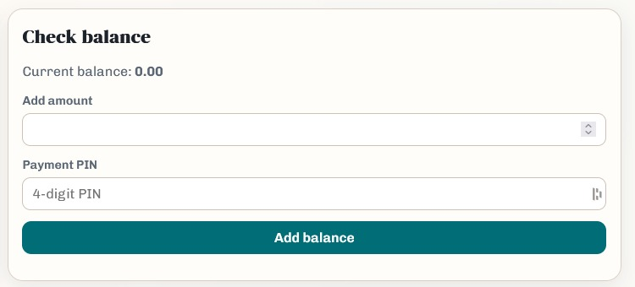
Current balance -> Remaining balance that can be used to purchase tickets
Add amount -> Enter the amount to top-up your account
Payment PIN -> Enter the 4 digits code created when registering account to add balance

6.Check tickets
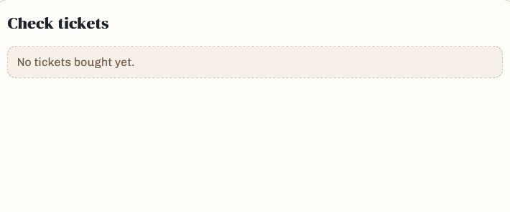
Check tickets -> Displays a list of all successfully purchased tickets, along with detailed ticket information.

Ticket Booking Procedure

1.Add balance
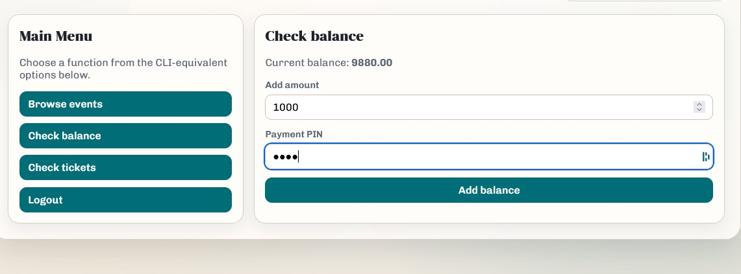

- Navigate to Check Balance from the main menu.
- Enter the required amount in the Add Amount field.
- Input your 4-digit Payment PIN to confirm and complete the balance top-up.

2.Select Events
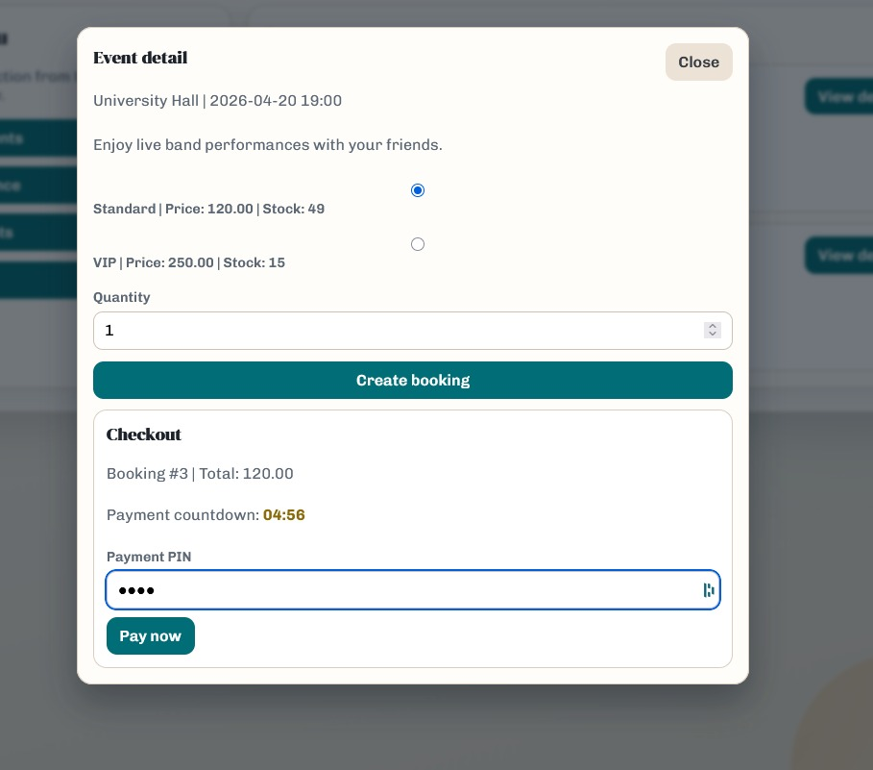
- Select Ticket Type
Choose your preferred ticket type from the available options.
- Enter Quantity
Specify the number of tickets you wish to purchase.
- Enter Payment PIN
Input your 4-digit payment PIN to authorize the transaction.
- Confirm Payment
Review the total price and proceed with payment to complete the purchase.

3.Check your ticket
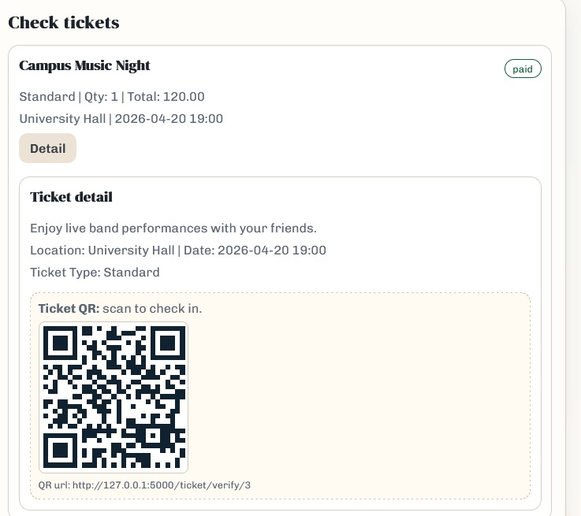
- Click Details to display the QR code.
- Use the QR code for event check-in.

**A successful purchase will display a “Paid” status in the top-right corner of the ticket.
If the purchase is unsuccessful, the ticket will be marked as “Unpaid”. Payment can be completed later through the Check Tickets page.

