Running the server (PowerShell Terminal / T1):

Making a “curl” GET Request (Command Prompt Terminal / T2):

T1 proxy terminal parses and displays request:
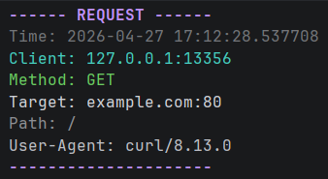

Cache checks and returns MISS:
Since MISS occurred, retrieve response from target server and return to client:
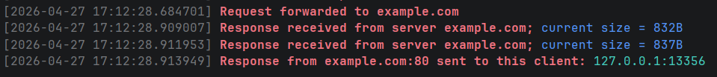
Display basic response parameters:
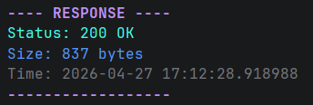
Curl (T2) logs:
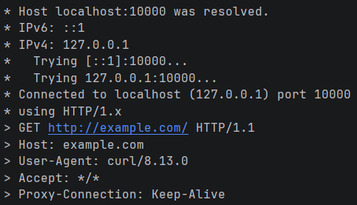
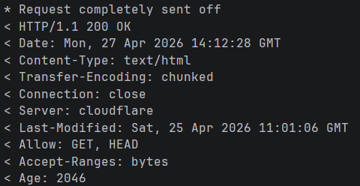

Then display the actual response body:
<!doctype html><html lang="en"><head><title>Example Domain</title><meta name="viewport" content="width=device-width, initial-scale=1"><style>body{background:#eee;width:60vw;margin:15vh auto;font-family:system-ui,sans-serif}h1{font-size:1.5em}div{opacity:0.8}a:link,a:visited{color:#348}</style></head><body><div><h1>Example Domain</h1><p>This domain is for use in documentation examples without needing permission. Avoid use in operations.</p><p><a href="https://iana.org/domains/example">Learn more</a></p></div></body></html>

Connection then shuts down (curl specific behavior):

Proxy (T1) terminal then displays cache statistics:
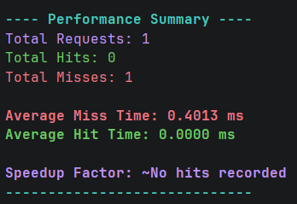
Calling the same request again after 60 seconds results in the expiration logs:
Then it’s fetched again from the target server with the same behavior as a cache MISS.

In case of HIT, simply logs it and doesn’t fetch it from target server:

Finally, display performance summary:
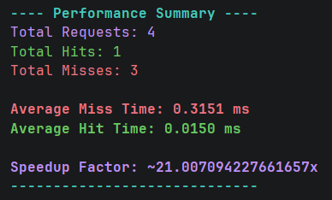

In case of blocked IP Address:
In case of blocked Host name:
In case of blocked Port:

Curl command for HTTPS CONNECT method call:
Logs for a CONNECT request:
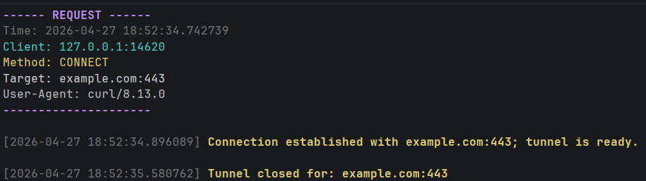
No response is logged since the proxy received it as encrypted and cannot access it, acts just as a tunnel for the data.

In case the cache was full, LRU algorithm is used, removes least used entry (first in ordered dictionary), and logs:

