Testing Methodologies
Testing the program can be done in two ways, either:
- Using curl in command prompt or terminal
- Configuring browser’s settings to use the running proxy server

Before proceeding, ensure that you are running the proxy.py file from the Main Project > basic_proxy folder. By default, it runs the proxy server on port 10000.

curl
To use curl, open another command prompt or a terminal window, and use this command:
curl -v –proxy http://localhost:10000 http://example.com/index.html

You can replace the URL “http://example.com/index.html” with another, but in level 1 only HTTP pages are allowed. Another web page that could be tested with retrieves a JSON file:
curl -v –proxy http://localhost:10000 http://httpbin.org/get

This is used to retrieve the URL specified at the end using the proxy server running at localhost port 10000.

Browser
To test through a browser, first you need to configure the browser to use our proxy server. For example, in Firefox, you can do this by:
- Open the application menu and click on Settings
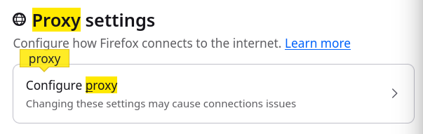
- Search (in Find in Settings) for the keyword: proxy
- Click on the “Configure proxy” section under Proxy settings
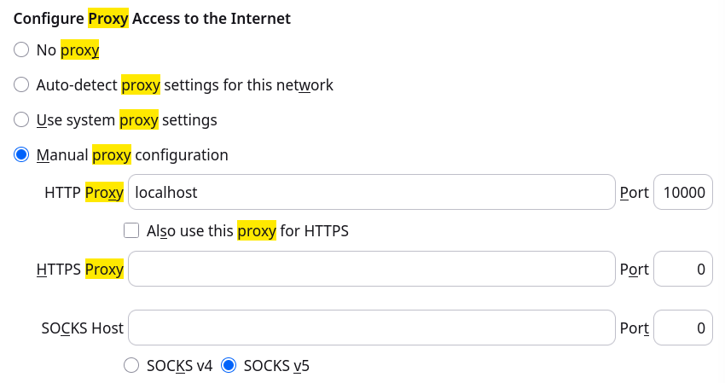
- Click on “Manual proxy configuration” and set the HTTP Proxy to “localhost” and the Port at “10000”.
- Click Save.

Now, whenever you try to access an HTTP website it will use our running proxy server.

Level 1
For our level 1 testing, we used two web pages for simplicity:
- http://example.com
- http://httpbin.org/get

When connecting to a web page, our proxy server logs in the terminal the following information:
Request | Response
Client’s IP address and port number | The time when the proxy server received the response (in level 1, from the target server only)
The request line (method, path, and HTTP version)
The Host the client is trying to connect to
The User-Agent information of the client (browser version)
The time when the proxy server received the HTTP Request
