

НАЦІОНАЛЬНИЙ ТЕХНІЧНИЙ УНІВЕРСИТЕТ УКРАЇНИ

«КИЇВСЬКИЙ ПОЛІТЕХНІЧНИЙ ІНСТИТУТ»

ФАКУЛЬТЕТ ПРИКЛАДНОЇ МАТЕМАТИКИ

**Кафедра системного програмування і спеціалізованих комп’ютерних систем**

**Лабораторна робота №2.4.**

з дисципліни

**«Структури даних та алгоритми»**

Тема: **«Модулі»**

Виконав: студент І курсу

ФПМ групи КВ-61

Бідяк М.А.

Перевірила:_________________

Київ – 2017

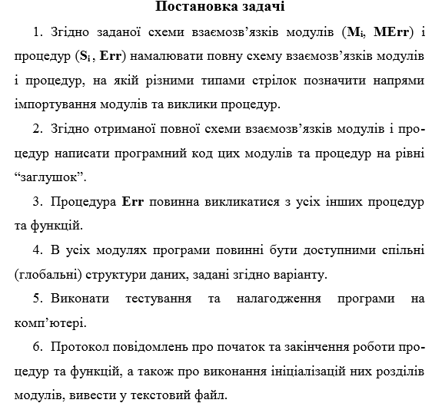

**1.Завдання варіанту**

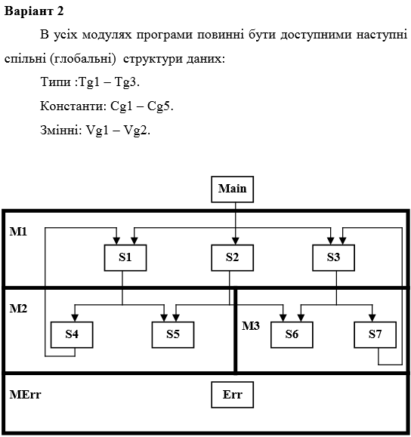

**2.Текст програми**

**Main.c**

#include "Common.h"

#include "M2.h"

#include "M3.h"

int main()

{

common_init();

printf("Main is started\n");

fprintf(f,"Main is started\n");

Cg2 = 0;

printf ("Cg2 = %d\n",Cg2);

fprintf (f,"Cg = %d\n",Cg2);

s1();

s2();

s3();

printf("Main is finished\n");

fprintf(f,"Main is finished\n");

return 0;

}

**Сommon.h**

#ifndef __Common_H__

#define __Common_H__

#include <stdio.h>

#include <stdlib.h>

typedef char Tg1;

typedef int Tg2;

typedef float Tg3;

char Cg1;

int Cg2;

float Cg3;

double Cg4;

long double Cg5;

int Vg1;

float Vg2;

FILE* f;

void common_init(void);

#endif // __Common_H__

**Сommon.c**

#include "Common.h"

void common_init(void)

{

printf("common init started and finished\n");

f = fopen("f.txt","a");

fprintf(f, "common init started and finished\n");

}

**M1.h**

#ifndef __M1_H__

#define __M1_H__

void s1();

void s2();

void s3();

#endif

**M1.c**

#include "Common.h"

#include "M2.h"

#include "M1.h"

void s1()

{

printf("S1 is started\n");

fprintf(f,"S1 is started\n");

Cg2 = 1;

printf ("Cg2 = %d\n",Cg2);

fprintf (f,"Cg = %d\n",Cg2);

s4();

s5();

printf("S1 is finished\n");

fprintf(f,"S1 is finished\n");

}

void s2()

{

printf("S2 is started\n");

fprintf(f,"S2 is started\n");

s5();

s6();

printf("S2 is finished\n");

fprintf(f,"S2 is finished\n");

}

void s3()

{

printf("S3 is started\n");

fprintf(f,"S3 is started\n");

s6();

s7();

printf("S3 is finished\n");

fprintf(f,"S3 is finished\n");

}

**M2.h**

#ifndef _M2_h

#define _M2_h

void s4();

void s5();

#endif // _M2_h

**M2.c**

#include "M1.h"

#include "M2.h"

#include "M3.h"

#include "Common.h"

void s4()

{

printf("s4 is started\n");

fprintf(f,"s4 is started\n");

Cg2 = 2;

printf ("Cg2 = %d\n",Cg2);

fprintf (f,"Cg = %d\n",Cg2);

printf("S4 -> S1 Err\n");

fprintf(f,"S4 -> S1 Err\n");

printf("s4 is finished\n");

fprintf(f,"s4 is finished\n");

}

void s5()

{

printf("s5 is started\n");

fprintf(f,"s5 is started\n");

Erring();

printf("s5 is finished\n");

fprintf(f,"s5 is finished\n");

}

**M3.h**

#ifndef __M3_H__

#define __M3_H__

void s6();

void s7();

#endif

**M3.c**

#include "Common.h"

#include "M3.h"

void s6()

{

printf("s6 is started\n");

fprintf(f,"s6 is started\n");

Erring();

printf("s6 is finished\n");

fprintf(f,"s6 is finished\n");

}

void s7()

{

printf("s7 is started\n");

fprintf(f,"s7 is started\n");

Cg2 = 3;

printf ("Cg2 = %d\n",Cg2);

fprintf (f,"Cg = %d\n",Cg2);

printf("s7 -> s3 Err\n");

fprintf(f,"s7 -> s3 Err\n");

printf("s7 is finished\n");

fprintf(f,"s7 is finished\n");

}

**ERR.h**

#ifndef _ERR_H

#define _ERR_H

void Erring();

#endif // _ERR_H

**ERR.c**

#include "Err.h"

#include "Common.h"

void Erring(){

printf("Err\n");

fprintf(f,"Err\n");

}

**3.Тестування програми**

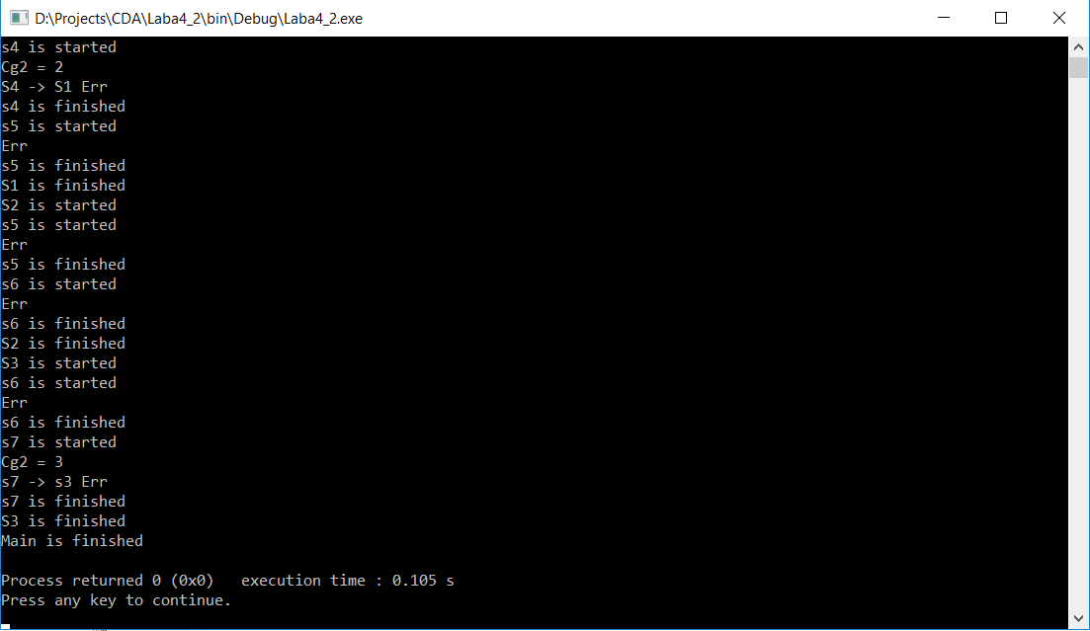

**4.Вміст текстового файла**

