Using jaaslounge within websphere 6.0
The use of jaaslounge on a websphere server is done in three steps:
- add a new jaas configuration in the websphere “Application login configuration” mechanism, with desired jaaslounge login module;
- set the custom registry to the supplied JaasloungeRegistry adapter class, and configure it to use the previously declared application login configuration;
- notify websphere to use the custom registry

New application login configuration
Launch Websphere server and run the administrative console – usually located at http://yourServer:9060/ibm/console (you may have to log on with the previously defined authentication scheme).
On the Security  Global security pane, access the JAAS configuration  Application logins screen.
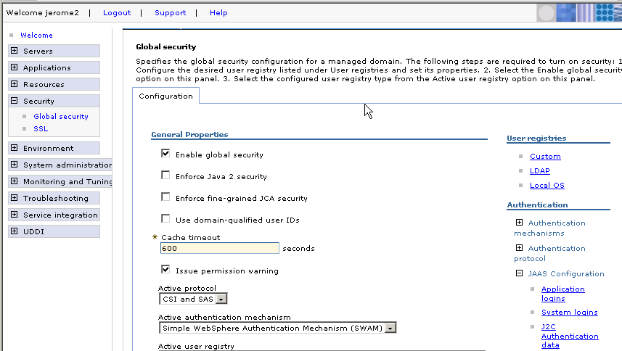
Create a new configuration:
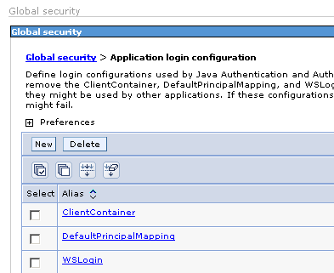
Give an explicit alias to your configuration, click on Apply, and then access the JAAS login modules screen.
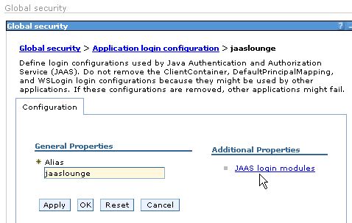
On the JAAS login modules screen, click on New button. The module window opens. On this form, specify the jaaslounge login module class you want to use, for instance org.jaaslounge.ntlm.NtlmLoginModule or org.jaaslounge.ldaplm.LDAPLoginModule.
Select the “Use login module proxy” checkbox.
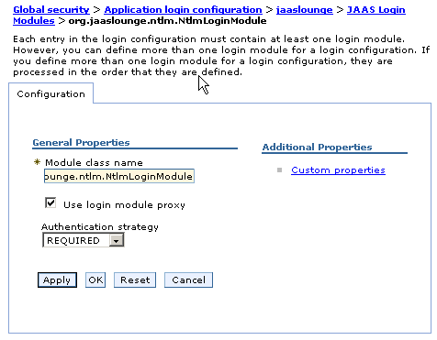
Click on Apply, and then open the Custom properties screen to set necessary properties.
(Refer to the specific documentation of the jaaslounge module you want to use).
The mode property, common to all jaaslounge modules, must be set to “websphere”.
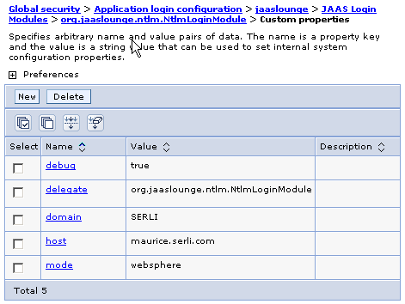

Configure the custom registry
Now go back to the Security  Global security pane, and access the User registries  Custom screen.
Set the class name for the user registry to :
org.jaaslounge.adapters.websphere.JaasloungeRegistry
This class will allow to call the application login configuration previously defined.

Note: Be careful that the values you give for Server user Id / Server user password actually exist in the target authentication system, because these values will be used to log on the administrative console once your new registry will be taken in acount.
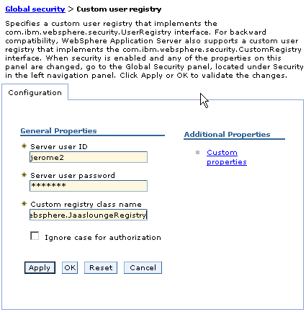
Open now the custom properties window for the custom registry. Three properties can be defined to use this class:
- moduleName (mandatory) must contain the alias you gave to your Application Login Configuration.
- realmName (mandatory) is the name of the custom realm you intend to receive. (this name is prefixed to the user and group names in the returned Principal and Credential occurences, it will be seen only by developers. It has no special impact)
- debug (optional) might be set to “true” to have some execution trace in the server’s log file.
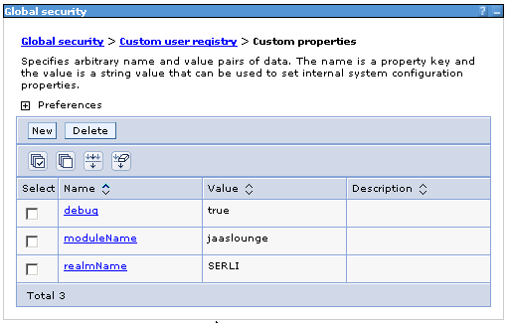

Use the custom registry
Last step of our installation is to notify websphere to use the custom registry. Go back to the Security  Global security main window.
- set the Active User Registry listbox to “Custom user registry”
- set the Active authentication mechanism listbox to SWAM
- select the Enable global security checkbox
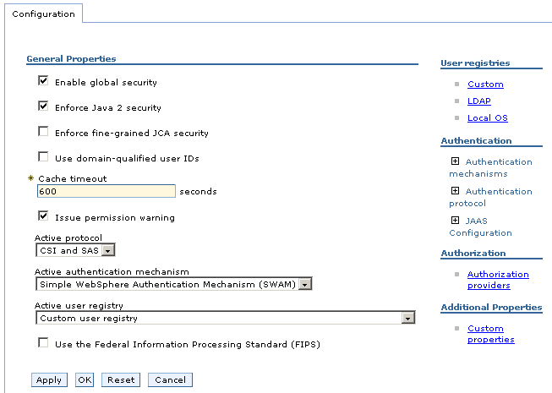
Copy the jar files to your websphere server libraries directory:
ServerBaseDirectory/lib/ext
Copy into this directory jaaslounge.jar and the additional jar files depending on chosen module (jcifs.jar / jcifs-ext.jar for instance, for NtlmLoginModule)
Restart the server.

Note
Up to know, we set up a simple case, using one jaaslounge login module. But by mixing the power of websphere application login configuration mechanism with the flexibility of jaaslounge module, you can imagine to add different jaaslounge modules to your configuration.
In that case, the different modules will be called in sequence, depending on their result and the “authentication stategy” chosen for each one (Required / Requisite / Sufficient / Optional – see websphere documentation).
The different groups returned by all succesful modules are then merged in the list of groups of the final Subject.
You could for instance imagine to implement
- a very strict control that accepts the user only if it is registered with different authentication systems (many modules with REQUISITE option)
- a system that accepts a user if it is registered with at least one system (many modules with SUFFICIENT or OPTIONAL option)
- a system that authenticate the users from a fist REQUISITE module, and then enriches the groups list of the user from many OPTIONAL modules.
The only constraint is to use only jaaslounge login modules, because they return information in a form expected by the JaasloungeRegistry adapter.

