**Creating Kafka Topics**

1. View Kafka related scripts in Kafka "Bin" directory

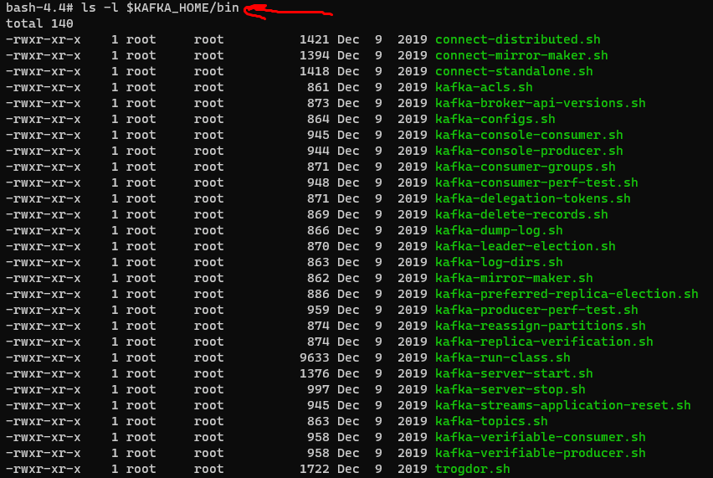

1. The value of KAFKA_HOME



1. Check for any configured topics



Текущих топиков нет

1. Create topic kafka-tst-01 and check for existing topics

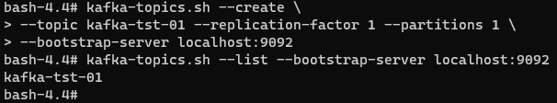

**Writing and reading Kafka topics**

1. Write a command to read data from a Kafka topic and writes it to the standard output



1. Write a command which reads data from the standard input and writes it to your Kafka topic. Write “Hello world! This is Kafka” in the stdin.

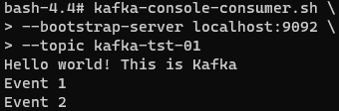

1. Create another producer writing to the same topic

Консьюмер принимает сообщения одновременно от двух продюсеров.



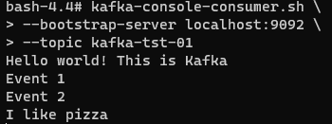

1. Create another consumer that reads all messages from the beginning

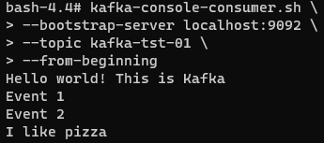

1. Check which consumer will get the next message.

Сообщения получили все консьюмеры. По умолчанию, сообщения, поступающие в топик распределяются равномерно по всем консьюмерам.

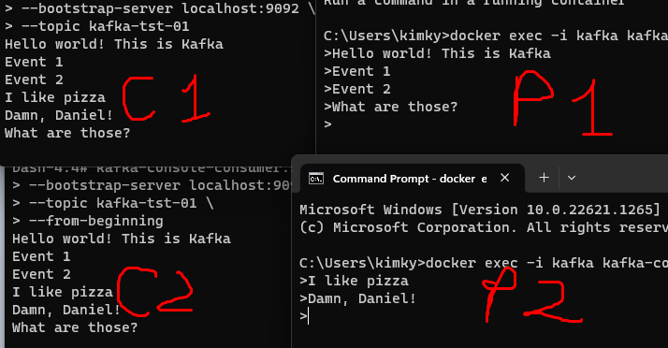

1. Delete kafka-tst-01 topic

Установка свойства delete.topic.enable=true в свойствах сервера (server.properties)



Удаление топика kafka-tst-01





**Using Kafka Connect to read from a source file**

1. Create and verify confFiles,srcFiles,sinkFiles

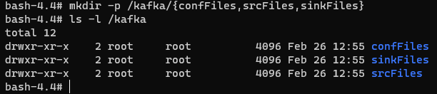

1. Create connect-file-source.properties file and fill it up



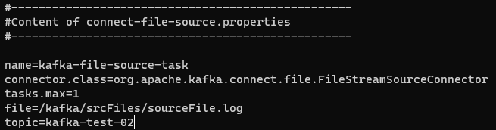

1. Insert a few records to the source file and verify the contents



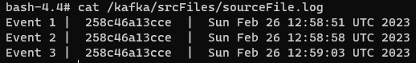

1. Issue the Kafka Connect Standalone script



1. Create consumer that reads data from the topic



1. Add more messages to the source file and verify, that the consumer receives them

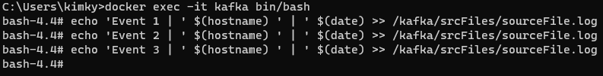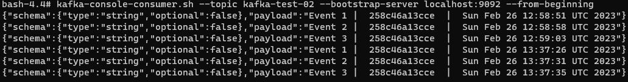

1. Checking topics list

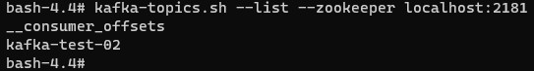

**Using Kafka Connect to write to a destination file**

1. Rewriting source properties file

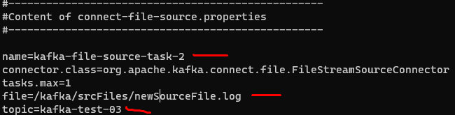

1. Creating sink properties file

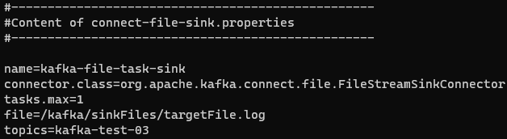

1. Sending few messages to the source file and creating the target file

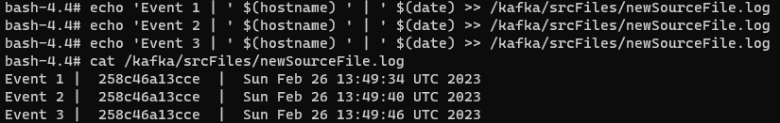

\

1. Issuing the Kafka Connect script

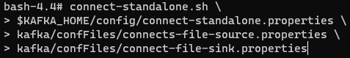

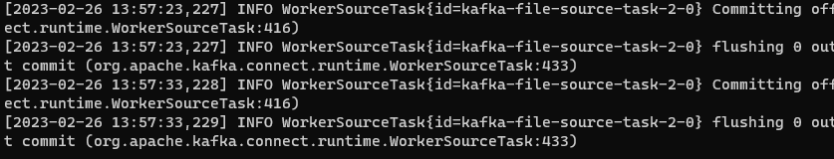

1. Verifying contents of the targetFile.log file

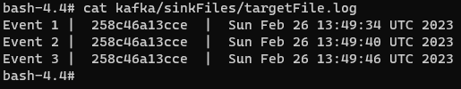

1. New consumer, reading messages from the same topic, and the list of existing consumers

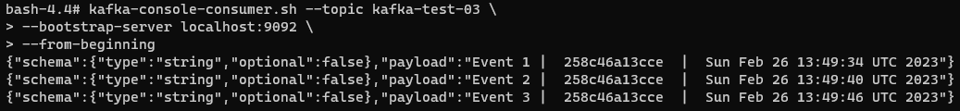

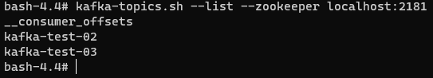

1. Generating 30 messages every second. Checking the consumer and the target file if they receive messages.



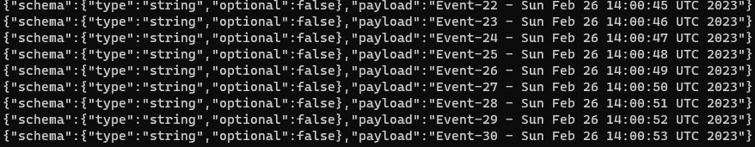

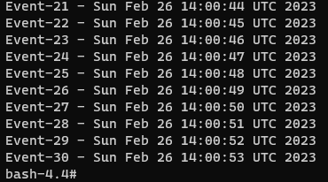

**Kafka Administration**

1. Listing existing consumer groups and consumers offsets



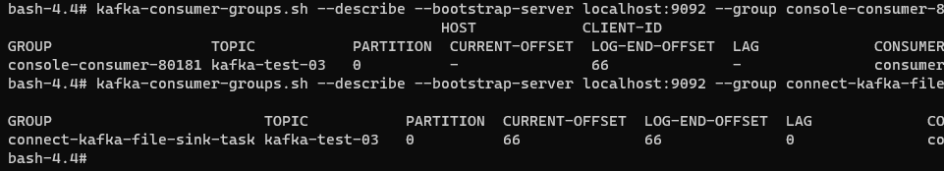

1. Listing all current connectors

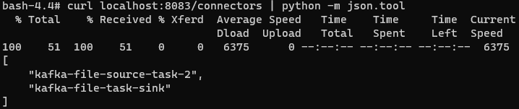

1. Checking tasks/status, and configurations of a connector kafka-file-source-task-2

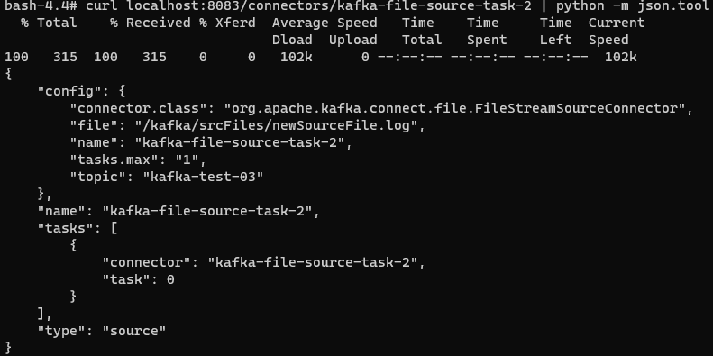

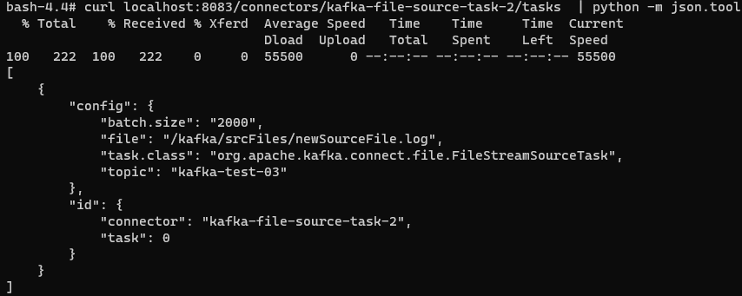

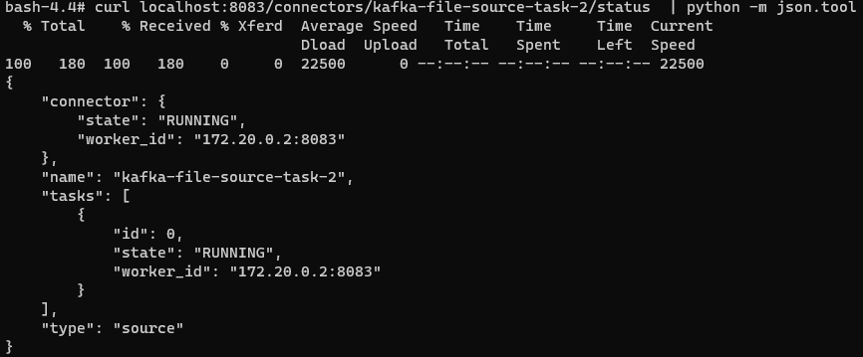

1. Restarting kafka-file-source-task-2 connector



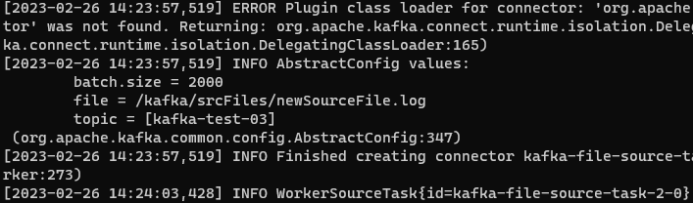

1. Pause connectors and reset offsets for kafka-consumer-gorups.sh

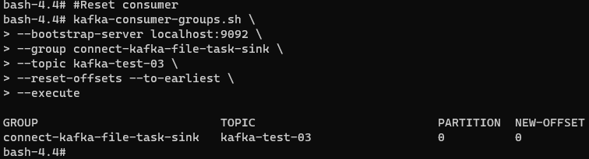

Нельзя корректировать оффсеты консьюмера пока он задействован.

1. Activate consumer again, and verify the rewritten contents

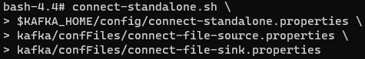

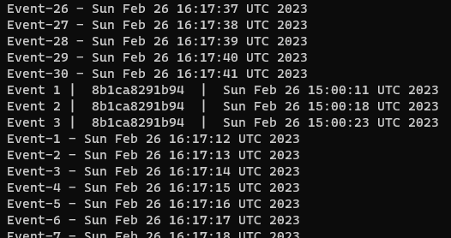

1. Reactivate script and verify no new content in the target file



Две записи по 30 сообщений от скрипта генерировавшего по сообщению в секунду и две записи по 3 сообщения введенных в сорс файл вручную. Третьей записи не обнаружено.

**Using Kafka Connect to read from a database (MySQL)**

1. Create Database srcdb, and tables src_events and web_logins inside of the db

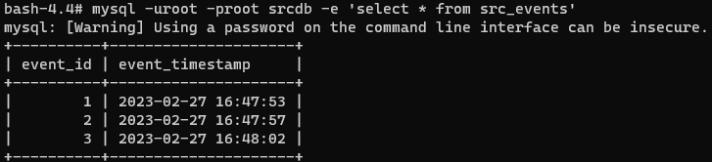

1. Create and fill up connect-jdbc-source.properties file in kafka/confFiles directory

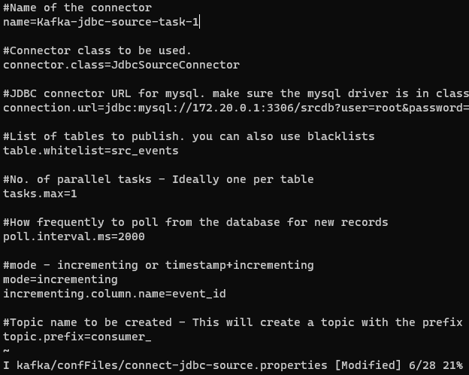

1. Issue the script



1. Create a consumer that reads data from the topic

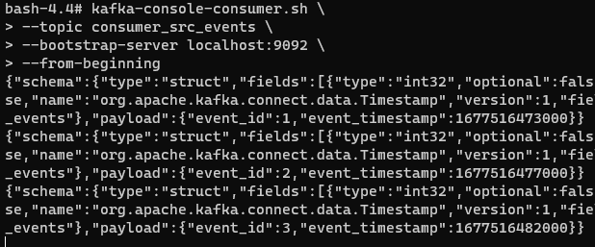

1. Insert more records to the table



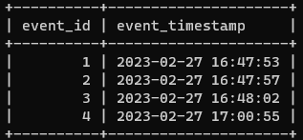



1. List topics

