**Report**

My database is created for a Car Shop. It is aimed at the staff and management of the store. It has 7 tables. They are: **Cars**, **Customers_c, Employees_c, Orders_c, Orders_consult, Orders_status** and **Income tables.**

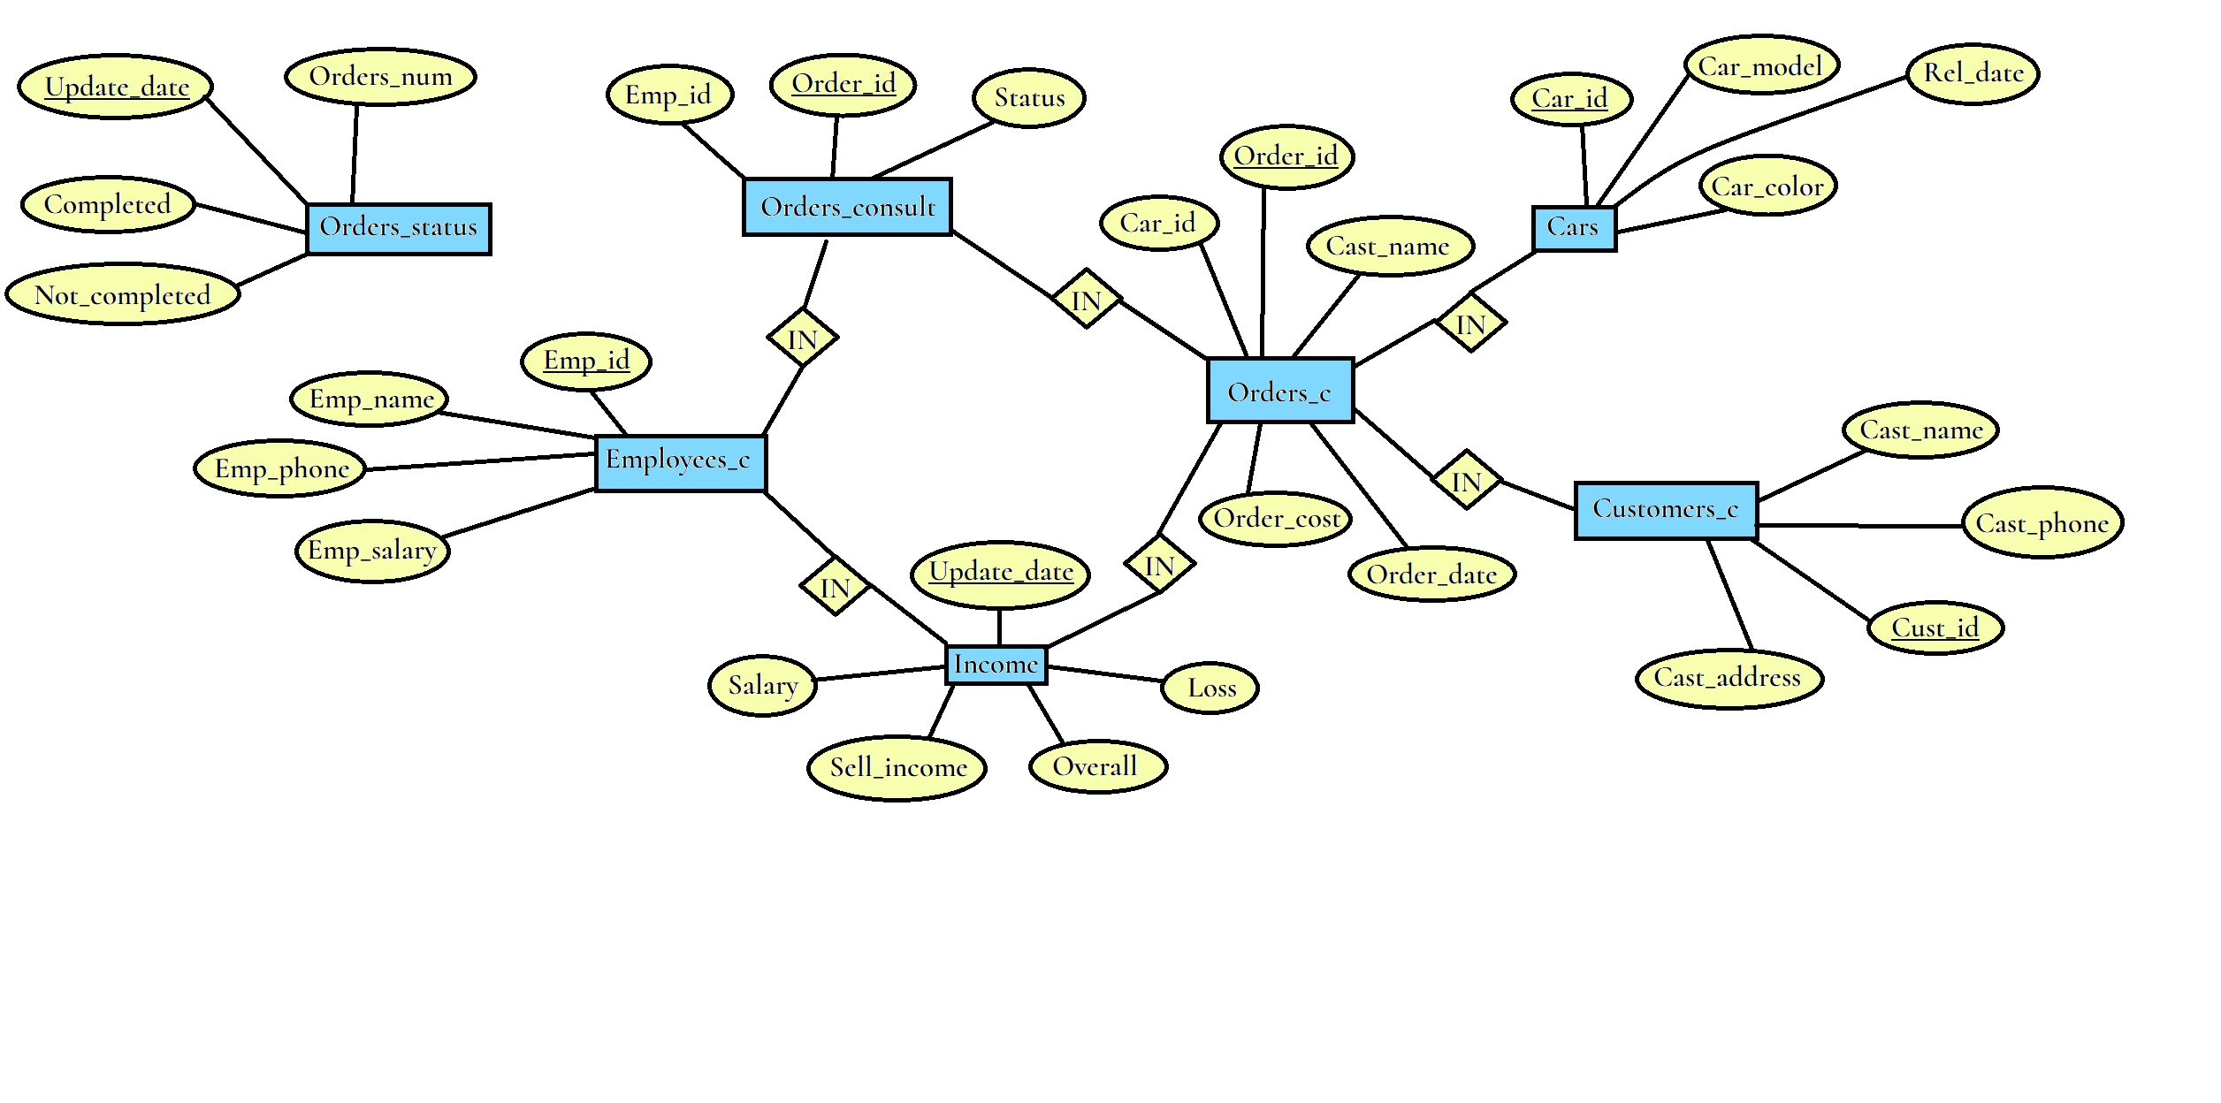

**First table Cars:**

There are four columns in Cars table: Car_id, Car_model, Car_color, Rel_date. This table about cars. Car_id – unique identifier number of cars. All cars in this table is unique and there are no storages for cars, so there is no quantity of cars. Because after order cars will be imported from other countries. Car_id – primary key of this table.

Car_model – is model of car. Car_color – is color of car, Rel_date – is release date of this model of car. It is very simple.

**Normalization:**

1-norm: All fields in this table contain maximum one data or element;

2-norm: There is only one key column. So partial dependency is impossible.

3-norm: All non-key columns of this table depend on Car_id key column.

**So, it is time to explain my triggers in this table. There is only one trigger. Same triggers will be used in other tables.**

AUTOID trigger just put the new inserting row with the right Car_id. First, declares number type Max_n value. And when insert row doesn’t have Car_id column (What is right, because it is too long to check last Car_id manually.) it is automatically look for last Car_id, add 1 to this number and give it to Max_n. Then just give max_n value to new inserted row’s Car_id field.

**Table Customers_c:**

There are also four columns in this table. Cust_id (Cust is from customer), Cast_name (I miss clicked, so it’s should be cust_name…), Cast_phone and Cast_address. This table contain info about clients of Car Shop. The address of customers will not be used in midterm. It is oriented to future.

Cust_id - primary key of this table.

**Normalization:**

1-norm: All fields in this table contain maximum one data or element;

2-norm: There is only one key column. So partial dependency is impossible.

3-norm: All non-key columns of this table depend on Cust_id key column.

**TIME OF TRIGGERS!**

**There is only one trigger and it is as same as in the Cars table’s AUTOID trigger. So pass it.**

**Table Employees_c:**

There are four columns in this table. Emp_id (Emp is from employee), Emp_name, Cast_phone and Emp_salary. This table contain info about staff of Car Shop. I think that name of this columns help to understand aim of columns very easy.

Emp_id - primary key of this table.

**Normalization:**

1-norm: All fields in this table contain maximum one data or element;

2-norm: There is only one key column. So partial dependency is impossible.

3-norm: All non-key columns of this table depend on Emp_id key column.

**TIME OF TRIGGERS!**

**Oh, there are two triggers now! First trigger as same as AUTOID in the Cars table. So, pass and go to second one.**

**It is – Salary_Report trigger! We declare three more values for our comfort. First – “sal” number type value. Sal takes the SUM of all employees’s salary. Second – “inc” number type value. It takes the Income of all orders, that have been done, and just SUM it. Simple, right? Third value is “ove”. It just take 40% of all Income value add minus from it “sal” and some value of wastes.**

**Table Orders_c:**

In this table I have 5 columns: Order_id, Cust_id, Car_id, Order_cost, Order_date. This is main table of my DB and its aim is to collect info about all customer’s orders. Order_id – is primary key. Cust_id is Foreign key referencing itself from Customers_c table. Car_id is Foreign key referencing itself from Cars table. Order_cost is cash, that Customer paid or should pay for the car. Yes, there is no fixed price of cars. Order_date is just date of inserting the order into table.

This table more complicated than other.

**Normalization:**

1-norm: All fields in this table contain maximum one data or element;

2-norm: There is only one key column. So partial dependency is impossible.

3-norm: All non-key columns of this table depend on Order_id key column.

**TIME OF TRIGGERS!**

**There are two triggers also. One of the triggers is like AUTOID from the first table of my report. Second trigger is AUTO_CONSULTING. When some customer ordering, there should be employee that can help to Customer with his different questions.**

**Firstly, we declare 6 (!) additional values. All of them is number type. There are: n_id, no_id, emdn_id, sal, inc and ove. We know about last three numbers and their aim from Employees_c table’s trigger. N_id value that contain the maximum number of Order_id from Orders_c table. No_id contain last number of Order_id from Orders_consult table. Emp_id contain random Emp_id from Employees_c table. Then we just insert into Orders_consult these three values if n_id doesn’t equal no_id. That’s mean, that if there in Orders_c just some Update of order, it does the report for Income table but doesn’t make new insert into Orders_consult.**

**Table Orders_consult:**

It is very simple table with tree columns: Order_id, Emp_id and status. When some order inserted in the table Orders_c, there also will be inserted new row with Order_id of report and random Emp_id. Order_id – primary and Foreign key of the table. Emp_id – Foreign key that reference itself from Employees_c table. Status – is status of order. If it is 1 – order have been completed, if it is 0 – it is not completed.

**Normalization:**

1-norm: All fields in this table contain maximum one data or element;

2-norm: There is only one key column. So partial dependency is impossible.

3-norm: All non-key columns of this table depend on Order_id key column.

**TIME OF TRIGGERS!**

There is only one trigger Orders_report. It does the report for Orders_status table. Firstly, as usual, we declare three values. All is number: all_o, comp_o, n_comp_o. All_o contains counted number of all orders from Orders_consult. Comp_o contains counted number of all orders with status 1. And n_comp_o contains counted number of all orders with status 0. Then it takes all these values and just insert into Orders_status with actual time.

**Table Orders_status:**

Simple table with four columns: Update_date, Orders_num, Completed, Not_completed. Update date id primary key and it is time of updating the status of all orders. Orders_num – number of orders in Orders_c. Completed – number of completed orders of it and not_completed – number of not completed orders. Very easy.

**Normalization:**

1-norm: All fields in this table contain maximum one data or element;

2-norm: There is only one key column. So partial dependency is impossible.

3-norm: All non-key columns of this table depend on Update_date key column.

**TIME OF TRIGGERS!**

It has no triggers.

**Table Income:**

My last table have 5 columns: Update_date, Salary, Sell_income, Loss and Overall. Update_date is Primary key and like in previous table it shows the time of income status updating. Salary displays loss of money for salary of employees. Sell_income – 40% of Order_cost price, Car Shop resell the cars so it takes only 40% of all price. Loss – money for service computers, servers, office and so on. Overall – clear income of Car Shop!

**Normalization:**

1-norm: All fields in this table contain maximum one data or element;

2-norm: There is only one key column. So partial dependency is impossible.

3-norm: All non-key columns of this table depend on Update_date key column.

**TIME OF TRIGGERS!**

It has no triggers.

**SO, that’s all about my tables and triggers! Let’s do some functions, procedures and other operations!**