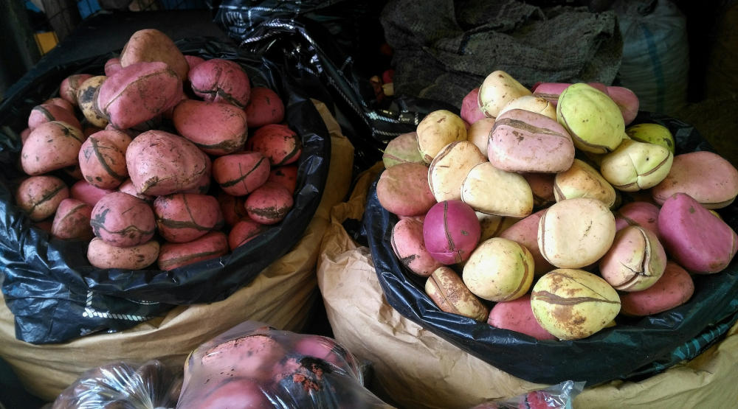

Welcome to Bese Saka Store

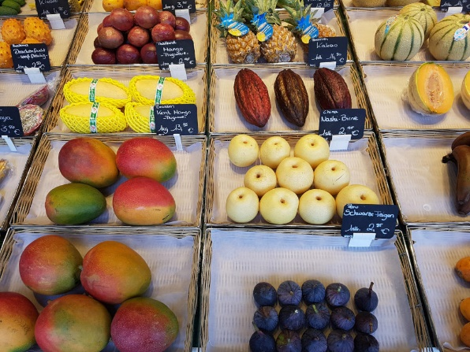Bese Saka Store is an exotic store, unlike any other, because we put on a new level what an exotic store is!

Bese Saka Store has an attractive and modern look in a friendly and clean environment. At Bese Saka Store, we give to our customers the best experience possible and top-of-the-art services. And last, but not least, at Bese Saka Store you will only find well-chosen, fresh, labeled, and quality products.

Bese Saka literally means "sack of cola nuts" and for the Akans, a group of West-African peoples, it is a symbol of affluence, abundance, togetherness and unity.

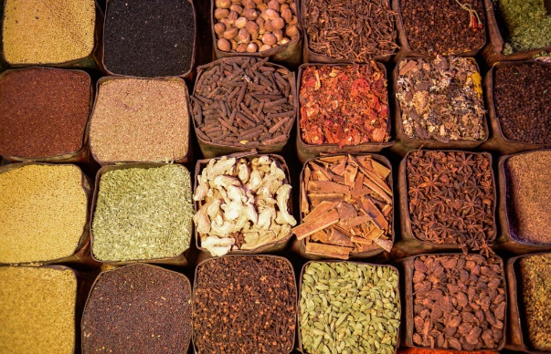Why did we choose this symbol for our exotic store? Because we believe that food is an essential part of life and that discovering new culinary horizons and others’ cuisines helps bound together and unite people. Bese Saka Store is a place where there is an abundance of greatness and a unity of everyone involved to propose and give only the best.

Whether you are a novice in exotic cuisine or an expert in exotic supplies, you are the welcome to come to Bese Saka Store like you are.

Every member of the Bese Saka Store’s team is willing to share her or his knowledge of food and her or his competent and wise advices. With pleasure we will help you to find the right ingredients for the dish you dream to cook.

Going to Bese Saka Store is an invitation to discover, to travel and to cook! Come to visit and meet us.

Services

At Bese Saka Store, we offer many services to our customers in order to meet everybody’s needs. Bese Saka’s team is always ready and glad to help each and everyone.

Advice

Everyone at Bese Saka Store is committed to give strong, competent and wise advice to anyone who asks, all of that with a big smile!

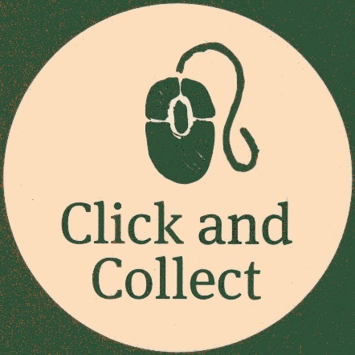Click and Collect

Give us your shopping list and within 2 hours just come to Bese Saka Store, and your groceries will be ready!

Home delivery

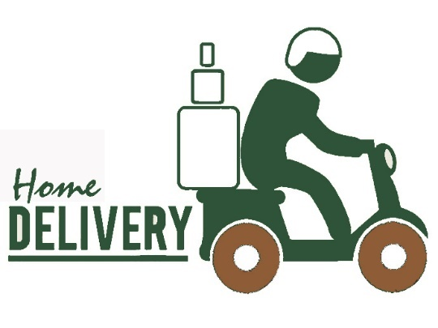You cannot come to Bese Saka Store but really need that particular item? No panic! Just give us your shopping list and within 4 hours, your groceries will be delivered right into your kitchen!  
Keep in mind that additional fees will be charged, depending on the delivering location ad that we will not be able to deliver outside a area bigger than 20 kilometers around Bese Saka Store.

Contact us  
You want to know how and where to find Bese Saka Store? Nothing easier than exploring the map bellow.

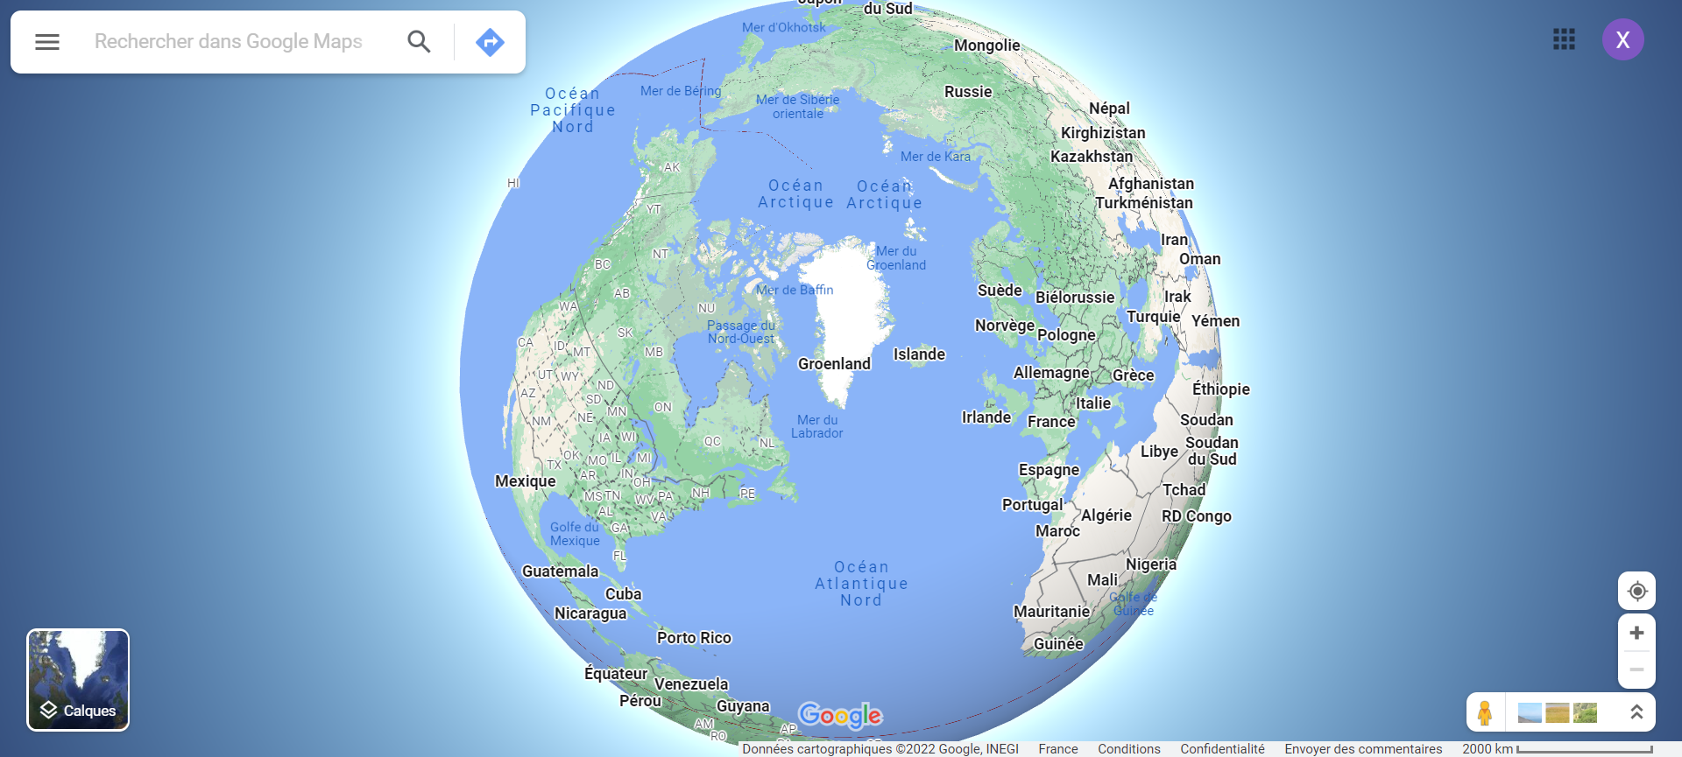

You have a question, a remark or just want to share with us your experience at Bese Saka Store or your last recipe?  
Call us or write us by filling out the form bellow. We will answer as soon as possible.



+1 (234) 567-8901



Write your message

Select a topic

Your e-mail