macOS special characters with Hungarian keyboard v1.0.12 by Serrin

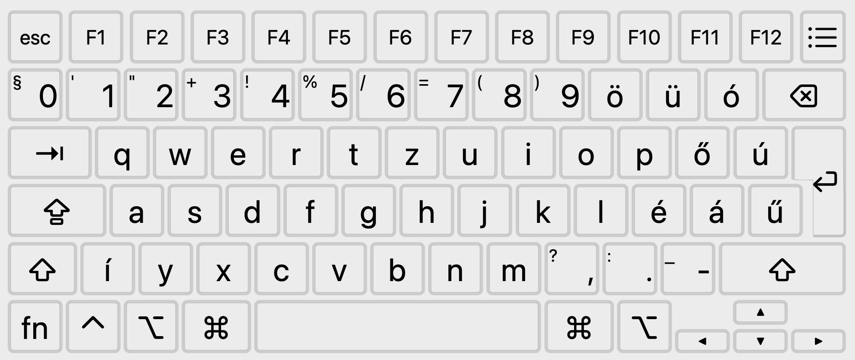
RED: OPTION+KEY BLUE: OPTION+SHIFT+KEY
;
<
>
{ [ ] }
&
|
*
$
^
^
~
#
\
`
~

Non-visible characters on HU keyboard |  |  |  | Visible characters on HU keyboard
Char | HU keyboard |  | EN keyboard | Char | HU keyboard | EN keyboard
; | OPTION .: |  | É | @ | OPTION Q | SHIFT 2
< | OPTION SHIFT Y |  | SHIFT ,? | ' | SHIFT 1 | Á
> | OPTION SHIFT X |  | SHIFT .: | " | SHIFT 2 | SHIFT Á
{ | OPTION 7 |  | SHIFT Ő | + | SHIFT 3 | SHIFT Ó
} | OPTION Ö |  | SHIFT Ú | ! | SHIFT 4 | SHIFT 1
[ | OPTION 8 |  | Ő | % | SHIFT 5 | SHIFT 5
] | OPTION 9 |  | Ú | / | SHIFT 6 | -_
& | OPTION 1 |  | SHIFT 7 | = | SHIFT 7 | Ó
| | OPTION Í (AltTab conflict) |  | SHIFT Ű | ( | SHIFT 8 | SHIFT 9
\ | OPTION Ü |  | Ű | ) | SHIFT 9 | SHIFT Ö
* | OPTION SHIFT ,? |  | SHIFT 8 | , | ,? | ,?
` | OPTION Ű |  | Í | ? | SHIFT ,? | SHIFT -_
$ | OPTION 4 |  | SHIFT 4 | . | .: | .:
^ | OPTION Á | OPTION I | SHIFT 6 | : | SHIFT .: | SHIFT É
~ | OPTION Ú | OPTION N | SHIFT Í | - | -_ | Ü
# | OPTION SHIFT 3 |  | SHIFT 3 | _ | SHIFT -_ | SHIFT Ü

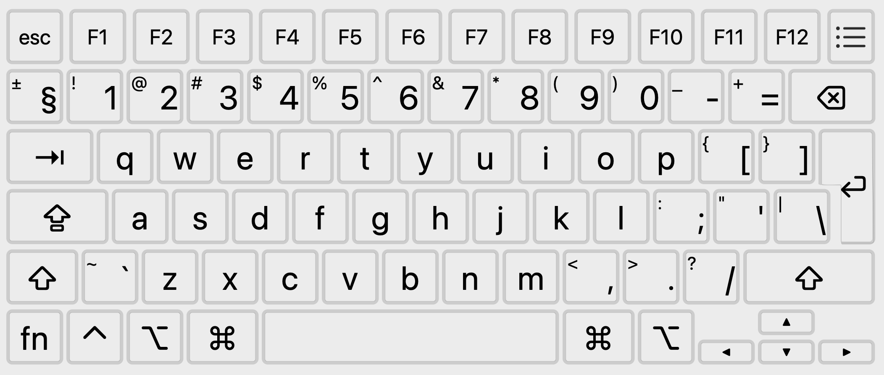
PC key | macOS Key | Details | PC key | macOS Key
PrtScr | SHIFT CMD 3 | Full screenshot to file | PAGEUP | 4FN UP
PrtScr | SHIFT CMD 4 | Select area to file | PAGEDOWN | FN DOWN
PrtScr | CTRL SHIFT CMD 3 | Full screenshot to clipboard | HOME | FN LEFT
PrtScr | CTRL SHIFT CMD 4 | Select area to clipboard | END | FN RIGHT
CTRL ALT DEL | OPTION CMD ESC | Force quit applicatons | ALT F4 | CMD Q (app)
CTRL ALT DEL | CTRL CMD POWER | Force restart | ALT F4 | CMD W (tab/window)
CTRL B/C/I/N/O/P/S/T/U/V/X/Y/Z | CMD  B/C/I/N/O/P/S/T/U/V/X/Y/Z | Same as PC shortcuts. | WIN M  WIN D | F11 (show desktop)
ALT ENTER | CMD I | Get info in Finder (properties) | WIN L | CTRL CMD Q (lock)
WIN S | CMD SPACE | Spotlight search | DEL | FN BACKSPACE  (delete from right)
WIN S | CMD OPTION SPACE | Finder search window | DEL | FN BACKSPACE  (delete from right)

Action | Shortcuts / Details
"insert" key in MC | CTRL T | Midnight Commander: select a file/folder under cursor
Minimize window | CMD M | Minimize current window.
Minimize window | CMD OPTION and click on desktop | Minimize all open windows.
Minimize window | CMD OPTION M | Minimize all windows on the current application.
Minimize window | CMD H OR CMD OPTION H | Minimize all windows except for the active ones on the top.
Force shutdown | POWER (hold 5 sec) | CTRL OPTION CMD POWER
Finder: move files and folders | 1. Select the files/folders and press CTRL C (copy)  2. Open the target folder and press CMD OPTION V
Log out | CMD SHIFT Q
Toggle fullscreen | CTRL CMD F
Recovery Mode | Hold POWER until “Loading startup options” appears, then select Options.
Startup Manager | Hold POWER until “Loading startup options” appears.
Safe Mode | Hold UP while clicking the startup disk in Startup Manager.
Apple Diagnostics | Hold POWER, then press CMD D when startup options appear.
DFU Mode | Specific button sequence (varies by model, used for firmware recovery)

