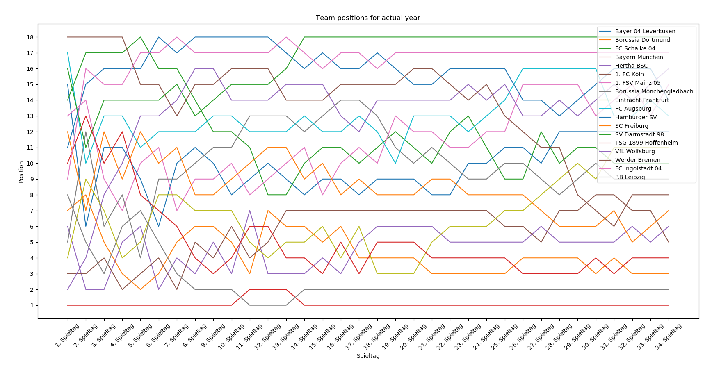

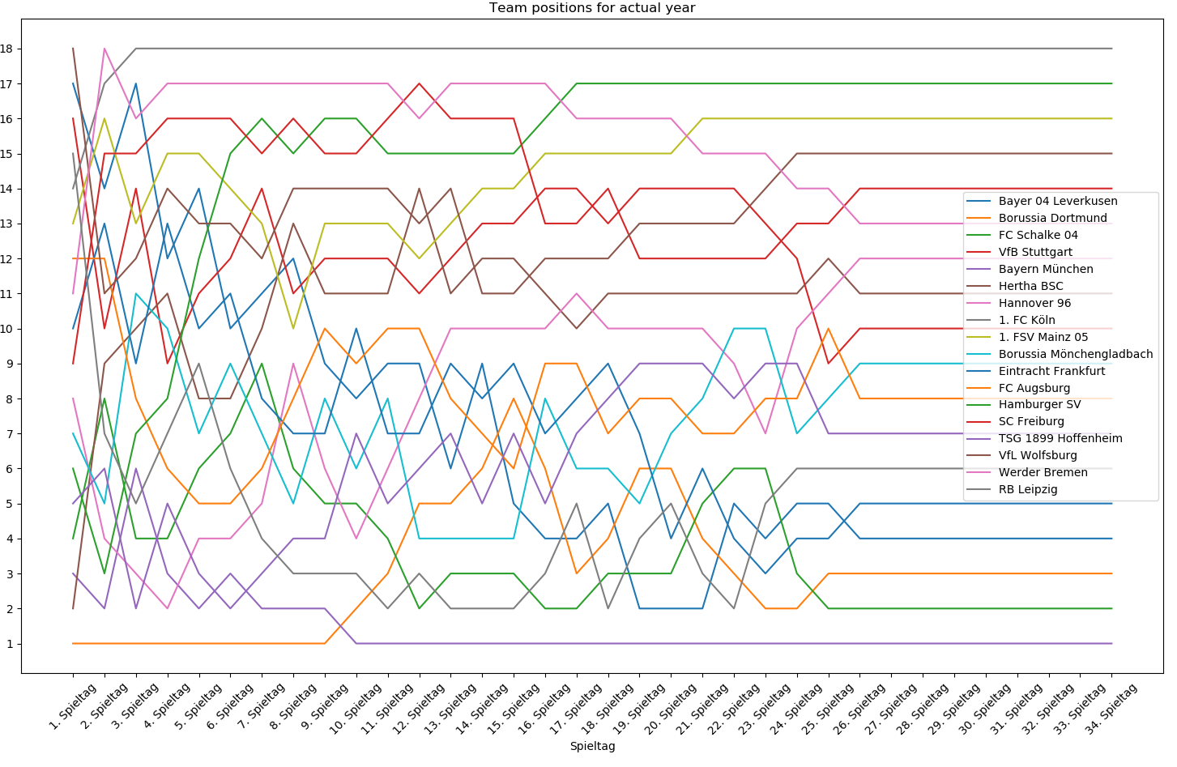

C:\Users\josef\AppData\Local\Programs\Python\Python36\python.exe C:/Users/josef/OneDrive/GitHub/PycharmProjects/Gaming/Soccer/SQLSoccerForcastByNNW.py

[ 1 2 3 4 5 6 7 8 9 10 11 12 13 14 15 16 17 18 19 20 21 22 23 24

25 26 27 28 29 30 31 32 33 34]

[ 1 2 3 4 5 6 7 8 9 10 11 12 13 14 15 16 17 18 19 20 21 22 23 24

25 26 27 28 29 30 31 32 33 34]

Last position for 9 FC Schalke 04: previous_last=[10], actual_last=[2]

Position for week 1 for 9 FC Schalke 04: previous=[14], actual=[4]

Position for week 5 for 9 FC Schalke 04: previous=[17], actual=[4]

Position for week 26 for 9 FC Schalke 04: previous=[9], actual=[2]

Last position for 55 Hannover 96: previous_last=[], actual_last=[12]

Position for week 1 for 55 Hannover 96: previous=[], actual=[8]

Position for week 5 for 55 Hannover 96: previous=[], actual=[2]

Position for week 26 for 55 Hannover 96: previous=[], actual=[11]

Last position for 118 SV Darmstadt 98: previous_last=[18], actual_last=[]

Position for week 1 for 118 SV Darmstadt 98: previous=[16], actual=[]

Position for week 5 for 118 SV Darmstadt 98: previous=[14], actual=[]

Position for week 26 for 118 SV Darmstadt 98: previous=[18], actual=[]

team_list=[ 6 7 9 40 54 65 81 87 91 95 100 112 118 123

131 134 171 1635]

team_list_actual =[ 6 7 9 16 40 54 55 65 81 87 91 95 100 112

123 131 134 1635]

9= [ 4 8 4 4 6 7 9 6 5 5 4 2 3 3 3 2 2 3 3 3 5 6 6 3 2 2 2 2 2 2 2 2 2 2]

55=[ 8 4 3 2 4 4 5 9 6 4 6 8 10 10 10 10 11 10 10 10 10 9 7 10 11 12 12 12 12 12 12 12 12 12]