

Egypt University of Informatics

Computer and Information Systems

Data Analysis Course

Semester Projects' Effect on Students' Sleep

Submitted by: Laila Khaled Mohamed (22-101078)

9/3/2023

# Introduction

It’s common to lose some sleep during projects but to what degree? Is it related to their normal sleep schedule? or the number of projects they have?

This study investigates how academic projects impact students' sleep patterns. By comparing how many hours they slept with and without projects.

# Research Question

# What is the impact of academic projects on students' sleep patterns?

# Hypothesis

Students have shorter sleep durations during academic projects compared to their normal routines.

# Population of Interest:

The population is all undergraduates who have projects every semester

# Sampling Method:

The sampling method used is convenience sampling, it was effective and got fast results

# Bias Identification

The source of bias was that most samples were from my university, so I tried to send the form to other groups in WhatsApp and Facebook and friends to get as much diversity as possible.

# Survey Questions

* Gender
* Age
* Major
* Academic Year
* CGPA
* On average, how many hours do you sleep daily?
* Does the time change whenever there are projects or quizzes?
* How many projects do you have per semester?
* How many hours you sleep when you have projects/quizzes to do?
* How many hours is your phone screen time?

Number of samples collected: 45

# Data preparation and cleaning

During collecting data, there were some values that had to be rewritten (example “6 hours” instead of 6) so I prepared them in the needed format.

# Analysis

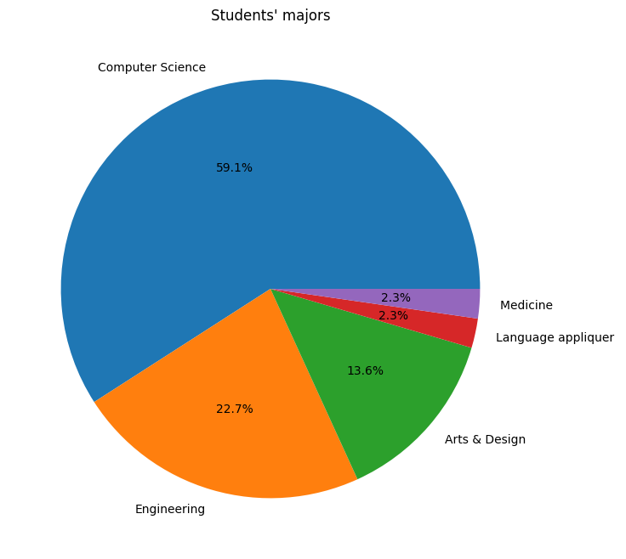 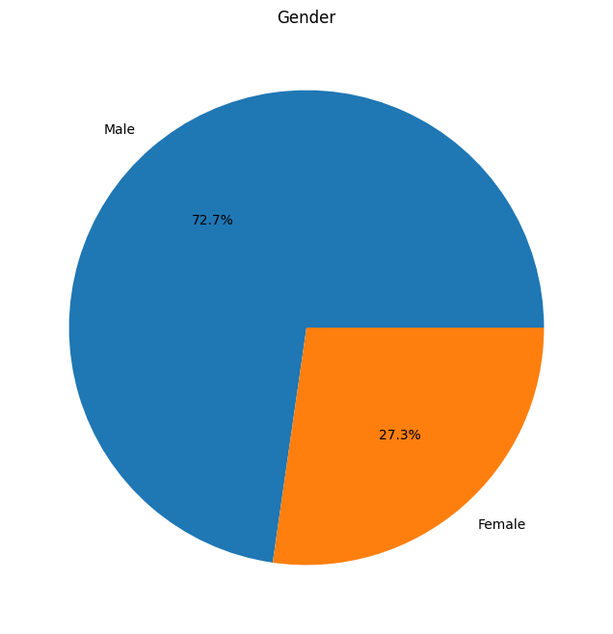

Pie chart of student’s majors (most is computer science students thus can create a bias)

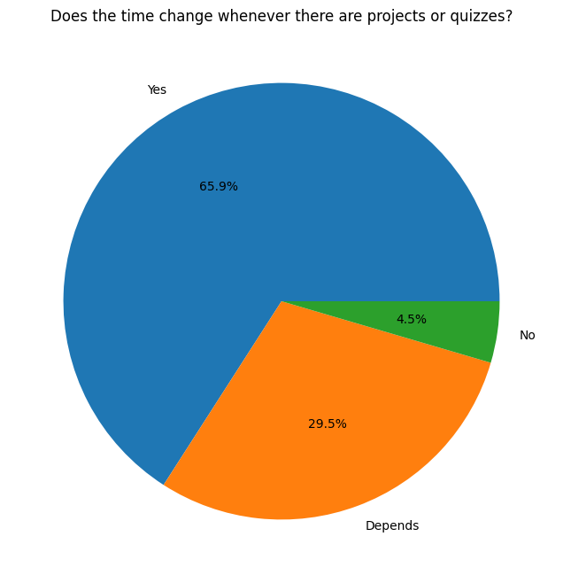

Pie chart of asking whether or not projects affect their hours of sleep

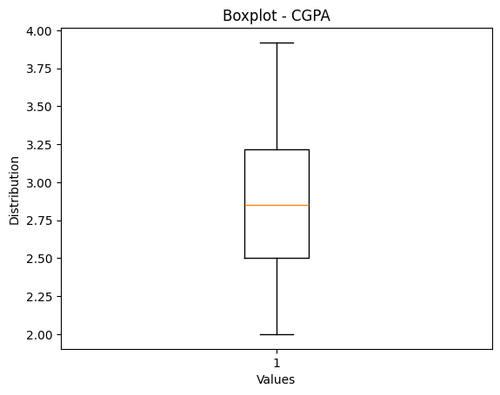

A box plot of all participants’ CGPA

Comparison between the hours of sleep:

|  |  |
| --- | --- |
| Sleep hours without projects | Sleep hours during projects |
|  |  |
| It doesn’t seem very symmetrical  Mean: 6.69  Median: 7  Mode: 7  Standard error: 1.45 | It’s more symmetrical here  Mean: 4.69  Median: 5  Mode: 5  Standard error: 1.87 |
|  |  |

Correlations:

Hours of sleep during projects and the number of projects: -0.079 (very weak)

Hours of sleep without projects and during projects: 0.529 (moderate)

Hours of sleep and CGPA: 0.12 (very weak)

# Conclusion

Although there was no correlation between the number projects and the hours of sleep, there was a moderate to high correlation between the normal hours of sleep and the hours of sleep during projects. This means for example that if a student sleeps more than the average will still have more sleep during projects than the average as well.

The conclusion is it’s not the number of projects that affect the student’s sleep but rather their sleep patterns and how long they usually sleep.

# Any potential issues

I should have been more accurate with the form (make people only write numbers for quantitative questions) and the question about screen time should have been divided to 2 parts (the usual screen time and screen time during projects) to see if there’s truly an affect.