**CS3354 Software Engineering**

**Final Project Deliverable 1**

**Pure Eats**

**By**

**Taha Arshad, Mahjoobah Billah, Bushra Hameed, Yongda Li, Anjali Prabhala, and Servando Luviano**

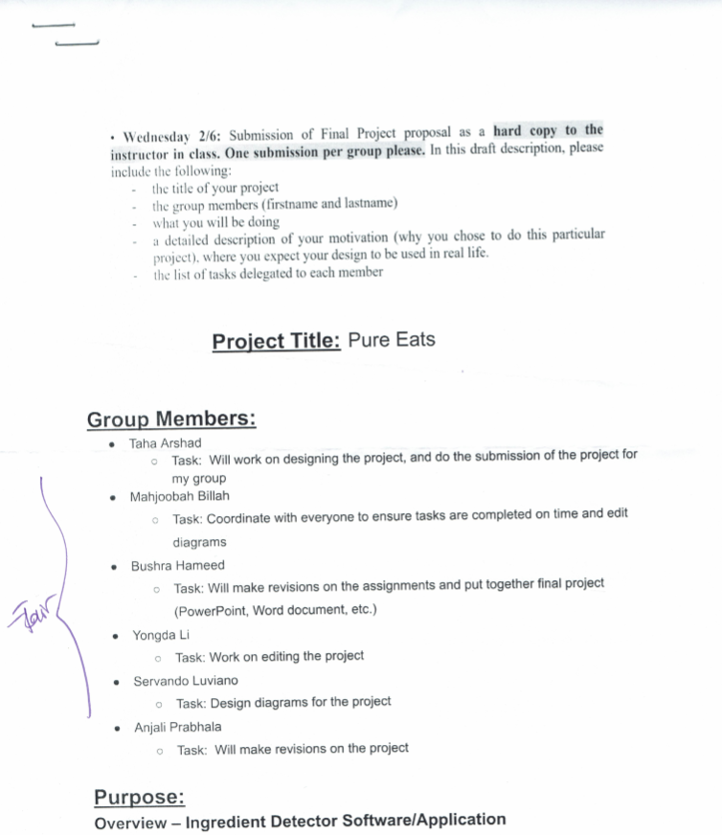

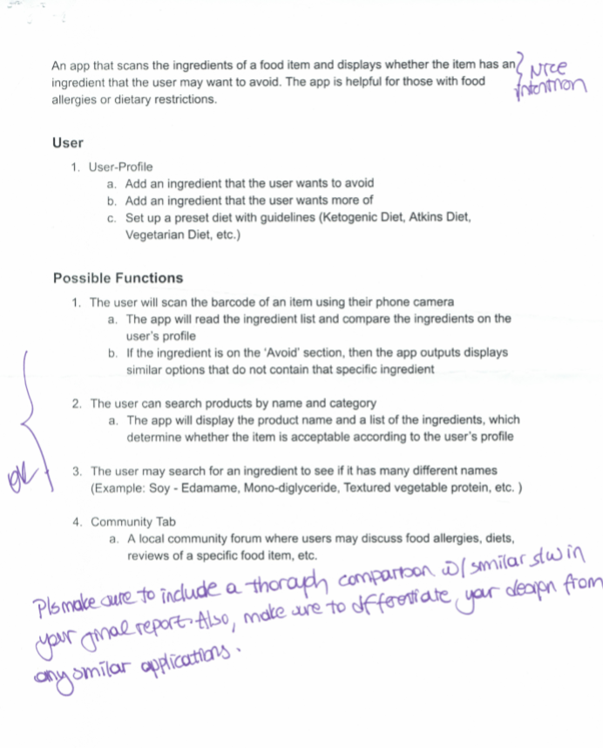

1. Address the feedback provided for your proposal by listing what you are doing to comply with the proposed changes/requests for additions to your project.
2. Delegation of tasks:
   1. Anjali Prabhala oversees addressing the feedback provided for our proposal and deciding which software process model is being employed in our project.
   2. Mahjoobah Billah oversees the lists of software engineering requirements.
   3. Taha Arshad will provide the use case diagram for our project.
   4. Yongda Li will provide the sequence diagram for each use case of our project.
   5. Bushra Hameed will provide the class diagram of our project.
   6. Servando Luviano will provide the architectural design of the project.
3. Which software process model is employed in the project and why?

# Software Requirements:

# Use case diagram:

# Sequence diagram:

# Class diagram:

# Architectural design:

