Selenium & Sahi Test Automation Business Case

# Product Pricing

|  |  |
| --- | --- |
| Sahi | Selenium |
| * **Sahi Pro Desktop Add-on Per Licence** (Multiple users, no concurrent usage) - $995/annum * **Sahi Pro Desktop Add-on Per User** (One user) - $695/annum   **Extra Comments:**  Does not include support for Desktop Applications .Net, Java or Silverlight   * **Sahi Pro + Sahi Pro Desktop Add-on Per Licence** (Multiple users, no concurrent usage) - $1,990/annum * **Sahi Pro + Sahi Pro Desktop Add-on Per User** (One user) - $1,390/annum   **Extra Comments**  Includes support for Java/.NET desktop applications, and Silverlight support | * No upfront licencing costs |

# Browser Support

|  |  |
| --- | --- |
| Sahi | Selenium |
| * Internet Explorer Version 6+ * Mozilla Firefox Version 2+ * Google Chrome Version 6+ * Safari Version 5+ * Opera Version 9+ * PhantomJS Version 1+ * Microsoft Edge Version 25+   **Extra Comments**  Recorder supports Chrome, Firefox, Internet Explorer, Safari, Opera, PhatomJS and Desktops | * Internet Explorer (Not Version 6) * Mozilla Firefox * Google Chrome * Safari * Opera * PhantomJS * HtmlUnit   **Extra Comments**  Selenium IDE only support recorder for Chrome and Firefox, possibly open source alternatives with extra setup |

# Programming Language Support

|  |  |
| --- | --- |
| Sahi | Selenium |
| * Sahi Script * Java * Ruby Sahi Script * Drivers for:   PHP, Java, Ruby  **Extra Comments**  ‘Note that the Java and Ruby drivers let you control the browser, but do not have any of Sahi’s features like automatic reports, distributed playback etc. You may need to write your own framework or use some else’s framework if you use the java or ruby driver’ | * C#   Frameworks available: NUnit   * Haskell * Java   Frameworks available: Junit, TestNG   * JavaScript   Frameworks available: WebdriverJSm WebdriverIO,NightwatchJS,NemoJS   * Objective-C * Perl * PHP   Frameworks available: Behat + Mink   * Python   Frameworks available: unittest, pyunit, robot framework   * R * Ruby   Frameworks available: RSpec, Test::Unit |

# Setup Effort

|  |  |
| --- | --- |
| Sahi | Selenium |
| * Has been setup in company before * Run installer via company software library * Setup a webserver as test execution requires one * Turn off auto-detect proxy settings * Run Sahi manager | * Create project * Install Selenium Webdrivers via NuGet on Visual Studio * Setup a webserver as test execution requires one |

# Usability

|  |  |
| --- | --- |
| Sahi | Selenium |
| * Has an easy to use recorder for more browsers * Could be used by testers after being shown however may needs some engineers input if facing difficulties i.e. needs to reply to alerts * Does not support alert windows, may be a solution round this * Issues getting IE recorder to work, it does not work on local host   **Extra Comments**:  Could be used by testers with support  Could be used by engineers | * Has an easier to use recorder for chrome and Firefox, however does not cover others * Recorder could be used by testers however this is only currently available for chrome * Probably needs engineers, however once it is set up and tests are written it shouldn’t be difficult to maintain tests * Able install package easily an quickly from NuGet.   **Extra Comments**:  Could be used by testers with support on Chrome  Could be used by engineers |

# Testing Options – Automated vs Manual

|  |  |
| --- | --- |
| Sahi | Selenium |
| * Supports manual testing through recorder playback and script execution * Possible solution for automated testing, create batch script that executes Sahi scripts from command line * Use of task scheduler | * Supports manual testing through recorder playback and script execution * Tests written in Visual Studio can be compiled into an .exe, other solutions possible |

# Updating Tests

|  |  |
| --- | --- |
| Sahi | Selenium |
| * Sahi Script is syntactically simple and steps are logically separated, making tweaks easy * New tests can be written easily with recorder | * In Visual Studio the C# test code is again relatively simple and traceable, making tweaks easy. However a basic understanding of C# would make things easier * It has a custom language however it is does not seem very user friendly |

# Load Testing

|  |  |
| --- | --- |
| Sahi | Selenium |
| * Optional, unsure on expense | * Optional but expensive for the results   (according to forums) |

# Working vs not working Screenshots

## Selenium

Fail

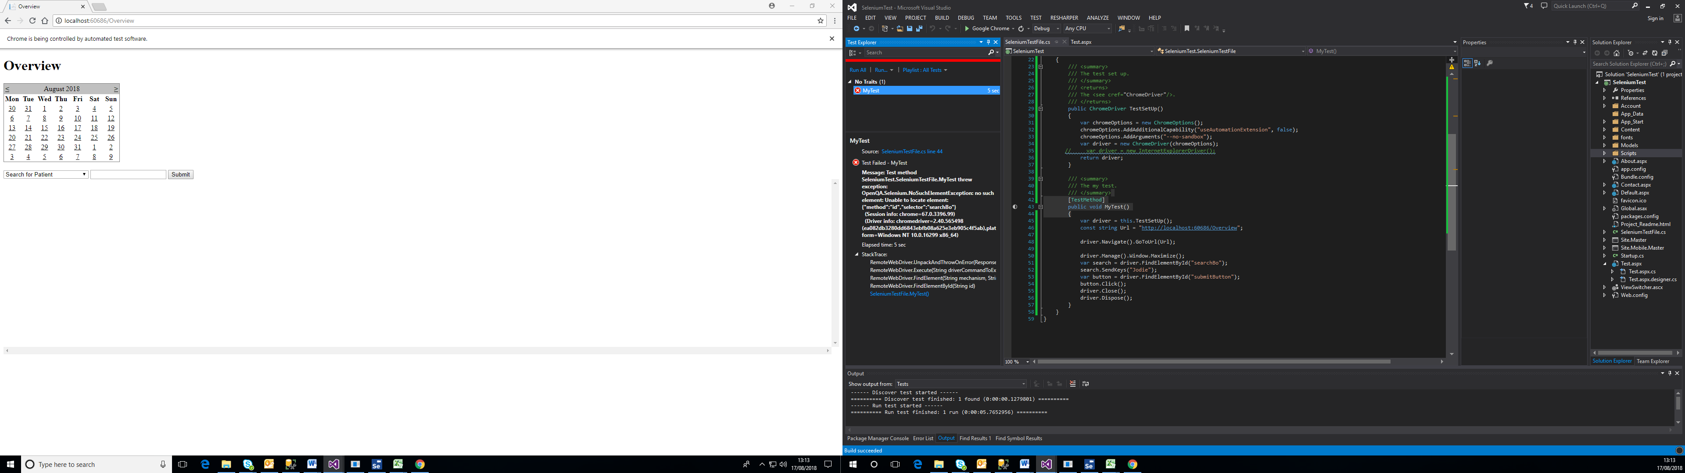

Success

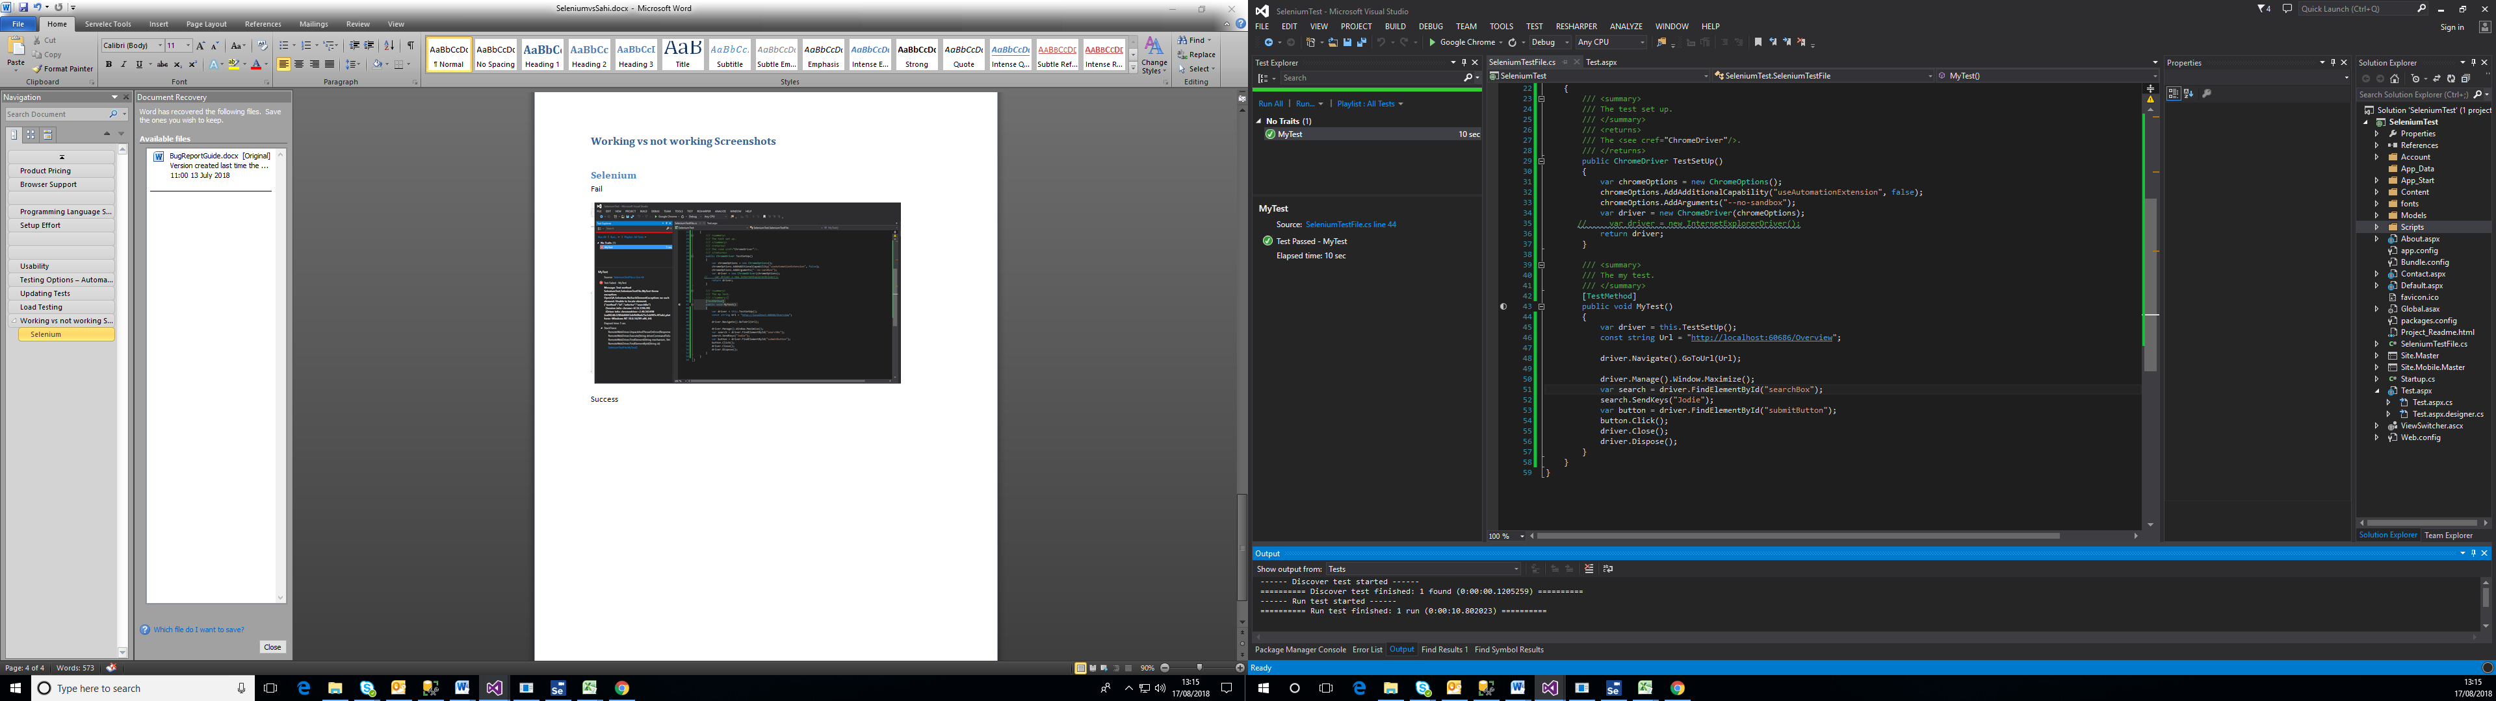

## Sahi

Fail

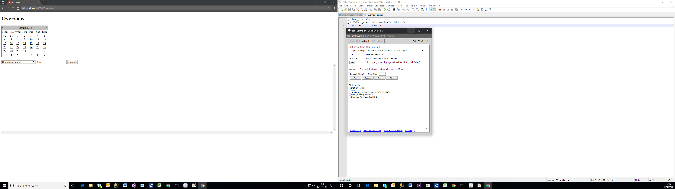

Success

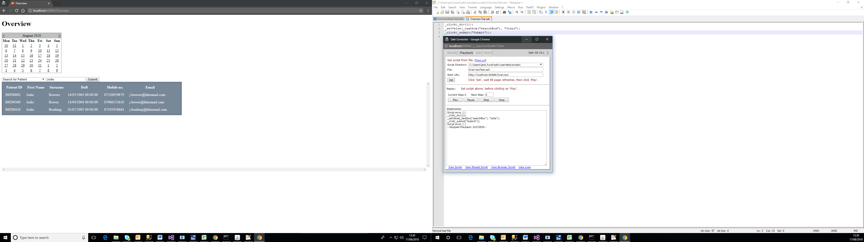

# Extra Pieces:

In protractor for selenium waits and sleeps are no longer needed.

Protractor can be used on Angular JS on any browser using Angular JS; this would need an engineer to script the tests.

Selenium is Open source so has many other things we haven’t seen or considered

Sahi can work with Angular