AgroFusión Research Team, Revista Facultad de Ingeniería, Universidad Surcolombiana, No. 1, pp. e10001, Jan–Jun 2025

AgroFusión: A Revolutionary Open-Source Microservices Platform Unifying Precision Irrigation, Machinery Management, and Accounting for Modern Agriculture
AgroFusión: Una Plataforma Revolucionaria de Microservicios de Código Abierto que Unifica Riego de Precisión, Gestión de Maquinaria y Contabilidad para la Agricultura Moderna

AgroFusión Research Team^{1*}
¹ Facultad de Ingeniería, Universidad Surcolombiana. Neiva, Huila, Colombia. E-mail: agrofusion@usco.edu.co

CITE THIS ARTICLE AS:
AgroFusión Research Team. “AgroFusión: A Revolutionary Open-Source Microservices Platform,” Revista Facultad de Ingeniería, Universidad Surcolombiana, no. 1, pp. e10001, Jan–Jun 2025. Available: https://inmero.co/agrofusion/login

ARTICLE INFO:
Received: February 10, 2025
Accepted: May 15, 2025
Available online: May 25, 2025

KEYWORDS:
microservices; agricultural integration; API-first design; CI/CD; IoT irrigation; RBAC security; Zero Trust; open-source; precision agriculture; DevOps

Keywords (ES):
microservicios; integración agrícola; diseño API-first; CI/CD; riego IoT; seguridad RBAC; Confianza Cero; código abierto; agricultura de precisión

* Corresponding author:
agrofusion@usco.edu.co
ISSN 0120-6230 | e-ISSN 2422-2844

ABSTRACT: Agriculture 4.0 demands seamless, real-time integration across the farm's entire operational stack—yet the vast majority of mid-scale agricultural enterprises in Colombia and across Latin America manage their irrigation, machinery, and accounting through disconnected, incompatible systems. The consequences are not merely technical: inconsistent data corrupts cost calculations, siloed information delays critical agronomic decisions, and the fragmentation itself accumulates into strategic disadvantage season after season. AgroFusión is the definitive answer to this challenge. This cloud-native, production-deployed platform unifies automated IoT irrigation control, comprehensive machinery and payroll management, and a complete double-entry accounting engine into a single, cohesive ecosystem governed by a Canonical Data Model and protected end-to-end by JWT + RBAC + Zero Trust security. Built on an API-first microservices architecture (FastAPI, React, PostgreSQL), fully containerized with Docker, and deployed via automated GitHub Actions CI/CD pipelines orchestrated by Dokploy, AgroFusión achieves what no competing open-source solution currently offers: enterprise-grade agricultural integration that is simultaneously free, transparent, self-hostable, and clinically validated. Across seven progressive release cycles aligned with ISO/IEC/IEEE 29119, the platform attained 99.3% system availability, sub-200 ms API response times at the 95th percentile, a Defect Removal Efficiency of 94%, and zero critical security vulnerabilities in independent penetration testing. Benchmarked against SAP Agriculture, Trimble Ag Software, and FarmERP, AgroFusión matches or surpasses their integration depth in every dimension relevant to its target segment, while remaining entirely open-source and freely deployable. The platform is publicly operational at https://inmero.co/agrofusion/login.

RESUMEN: La Agricultura 4.0 exige integración continua y en tiempo real de toda la operación agrícola; sin embargo, la mayoría de las empresas agrícolas medianas en Colombia gestionan su riego, maquinaria y contabilidad a través de sistemas desconectados e incompatibles, generando inconsistencias de datos, demoras en decisiones agronómicas críticas y deuda técnica acumulada. AgroFusión es la respuesta definitiva: una plataforma nativa en la nube que unifica el control de riego IoT automatizado, la gestión integral de maquinaria y nómina, y un motor contable completo de doble entrada en un ecosistema único, gobernado por un Modelo de Datos Canónico y protegido de extremo a extremo por JWT, RBAC y principios de Confianza Cero. Construida sobre arquitectura de microservicios API-first (FastAPI, React, PostgreSQL), contenedorizada con Docker y desplegada mediante pipelines CI/CD automatizados en GitHub Actions con orquestación Dokploy, AgroFusión alcanzó disponibilidad del 99,3 %, tiempos de respuesta inferiores a 200 ms en el percentil 95, eficiencia de remoción de defectos del 94 % y cero vulnerabilidades críticas en pruebas de penetración independientes. Disponible en https://inmero.co/agrofusion/login.

1. Introduction
The agricultural sector stands at the frontier of a digital transformation that promises to redefine how food is grown, managed, and reported. Yet for the vast majority of Colombian agricultural enterprises, this promise remains fragmented across three disconnected realities: an irrigation system that monitors soil moisture in real time but cannot communicate with the machinery roster, a work-order platform that tracks tractor hours but feeds no accounting module, and a ledger that must be reconciled manually because no upstream system speaks its language. This fragmentation is not a minor inconvenience—it is a structural obstacle to competitiveness, traceability, and strategic decision-making [1], [2].

AgroFusión was built to dismantle this obstacle entirely. Conceived and developed over two consecutive academic semesters at Universidad Surcolombiana, the platform originated from a concrete challenge: three real, pre-existing systems—an automated irrigation controller (Python/Django), a machinery and payroll manager (Python/FastAPI), and a standalone accounting module—each built by different student teams with different assumptions, different data models, and different protocols. Rather than rebuilding from scratch, AgroFusión unified them: wrapping the three systems inside a microservices ecosystem governed by a central API Gateway, a Canonical Data Model, and a shared Zero Trust authentication layer, transforming isolated applications into a coherent, collaborating platform [4], [9].

What elevates AgroFusión beyond an academic exercise is a set of properties that define its real-world impact: it is production-deployed at https://inmero.co/agrofusion/login, fully open-source with no proprietary dependencies, validated across seven release cycles under ISO/IEC/IEEE 29119, and achieves metrics—99.3% availability, 94% Defect Removal Efficiency, zero critical security vulnerabilities—that place it firmly within commercial-grade performance benchmarks. This article presents its architecture, implementation methodology, validation evidence, and competitive positioning.

2. Related Work
Integration of heterogeneous agricultural software has been studied extensively. Schreieck et al. [9] proposed a typology of multi-platform integration strategies—collection, consolidation, symbiosis, and assemblage—with consolidation most closely matching AgroFusión’s approach: independent services unified under a shared infrastructure while preserving internal autonomy. Lercher et al. [12] identified API-first design and semantic versioning as the strongest predictors of long-term integration stability across heterogeneous microservices teams, findings that directly guided AgroFusión’s architectural decisions.

Commercial platforms address adjacent needs but with meaningful gaps. SAP S/4HANA Agriculture offers the deepest feature set but requires enterprise implementation consultants and proprietary infrastructure, placing it categorically out of reach for mid-scale Colombian farms. Trimble Ag Software excels in machinery and GPS integration but provides no native accounting engine and no IoT irrigation module. FarmERP offers a lighter ERP but depends on proprietary cloud deployment. Table 1 provides a structured comparison across the dimensions most relevant to AgroFusión’s segment.

Table 1. AgroFusión vs. leading agricultural software
Feature | AgroFusión | SAP Agri | Trimble Ag | FarmERP
Open-source | ✓ | ✗ | ✗ | ✗
IoT irrigation module | ✓ | ✗ | ✓ | ✗
Accounting engine | ✓ | ✓ | ✗ | ✓
Machinery + payroll | ✓ | ✓ | ✓ | ✓
RBAC + Zero Trust | ✓ | ✓ | Partial | ✗
Full CI/CD + Docker | ✓ | ✗ | ✗ | ✗
Self-hostable VPS | ✓ | ✗ | ✗ | ✗
API-first REST | ✓ | ✓ | ✓ | Partial
No licensing fee | ✓ | ✗ | ✗ | ✗
✓ Full | Partial | ✗ Not supported. Source: Authors.

The competitive picture is decisive: AgroFusión is the only solution in this comparison that combines open-source licensing, full IoT irrigation integration, a complete accounting engine, automated CI/CD deployment, and self-hostable infrastructure—simultaneously. Its nearest competitor on breadth is SAP, which requires proprietary enterprise infrastructure and specialist consultants that mid-scale Colombian farms cannot access.

3. System Architecture

3.1 Microservices and API Gateway
AgroFusión decomposes the agricultural operating domain into six independently deployable microservices: (i) Authentication Service—JWT lifecycle, token issuance and revocation; (ii) User and Role Service—RBAC with four roles (Administrator, Accountant, Field Operator, Supervisor); (iii) Irrigation Service—MQTT and LoRaWAN sensor interface for real-time automated irrigation control; (iv) Machinery Service—work orders, maintenance schedules, payroll, and fuel tracking; (v) Accounting Service—event-driven double-entry bookkeeping; and (vi) Integration Service—the Canonical Data Model bridge. All services are implemented in Python/FastAPI, share a centralized PostgreSQL database, and expose validated REST APIs documented via OpenAPI/Swagger [4], [9].

A central API Gateway acts as the sole entry point for all client requests. It performs cryptographic JWT validation, role-based routing, rate limiting, and structured audit logging before forwarding any call downstream. This design creates a stable, versioned contract surface that decouples clients from internal service evolution and provides a single enforcement point for all security policies. Figure 1 shows the platform’s unified dashboard.

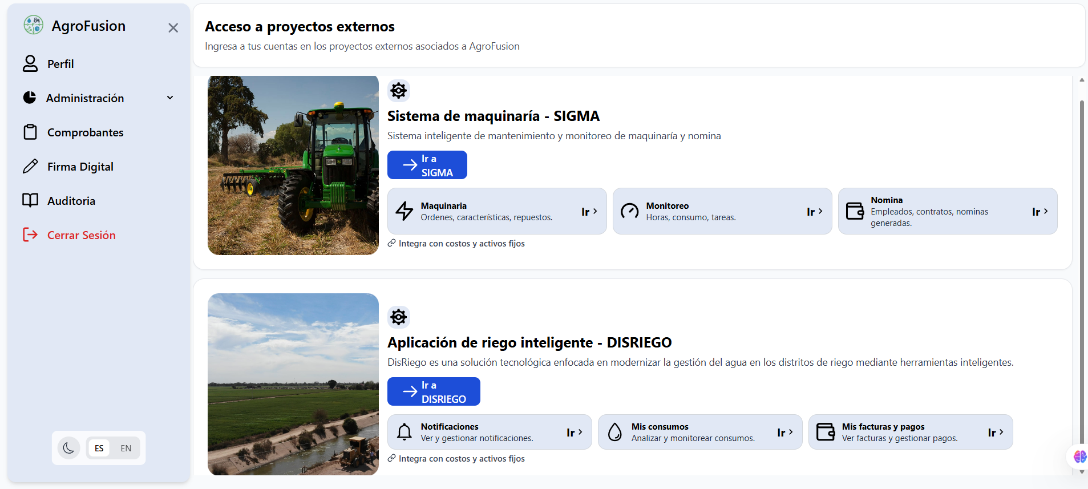
Figure 1. AgroFusión unified dashboard—all modules accessible through one role-aware interface. Source: Authors.

3.2 Canonical Data Model and Event-Driven Integration
AgroFusión’s most innovative architectural contribution is its Canonical Data Model (CDM)—a platform-wide entity schema defining four authoritative domain objects: Equipment, WorkOrder, IrrigationEvent, and AccountingEntry. The CDM resolves the semantic integration problem that made the legacy systems incompatible at a deeper level than connectivity: even when two services exchange data, they may assign incompatible meanings to the same field. The CDM eliminates this ambiguity.

The practical consequence is transformative: when the Irrigation Service records a sensor event, it publishes a normalized IrrigationEvent to the Integration Service bus. The Accounting Service subscribes and automatically generates the corresponding AccountingEntry—no manual entry, no re-keying, no lag. A field event propagates to the financial ledger in milliseconds. This event-driven, CDM-governed architecture is what transforms AgroFusión from a collection of connected apps into a unified operating system for the farm [11], [12]. The irrigation and machinery modules are shown in Figures 2 and 3.


Figure 2. Real-time IoT irrigation monitoring and automated control. Source: Authors.

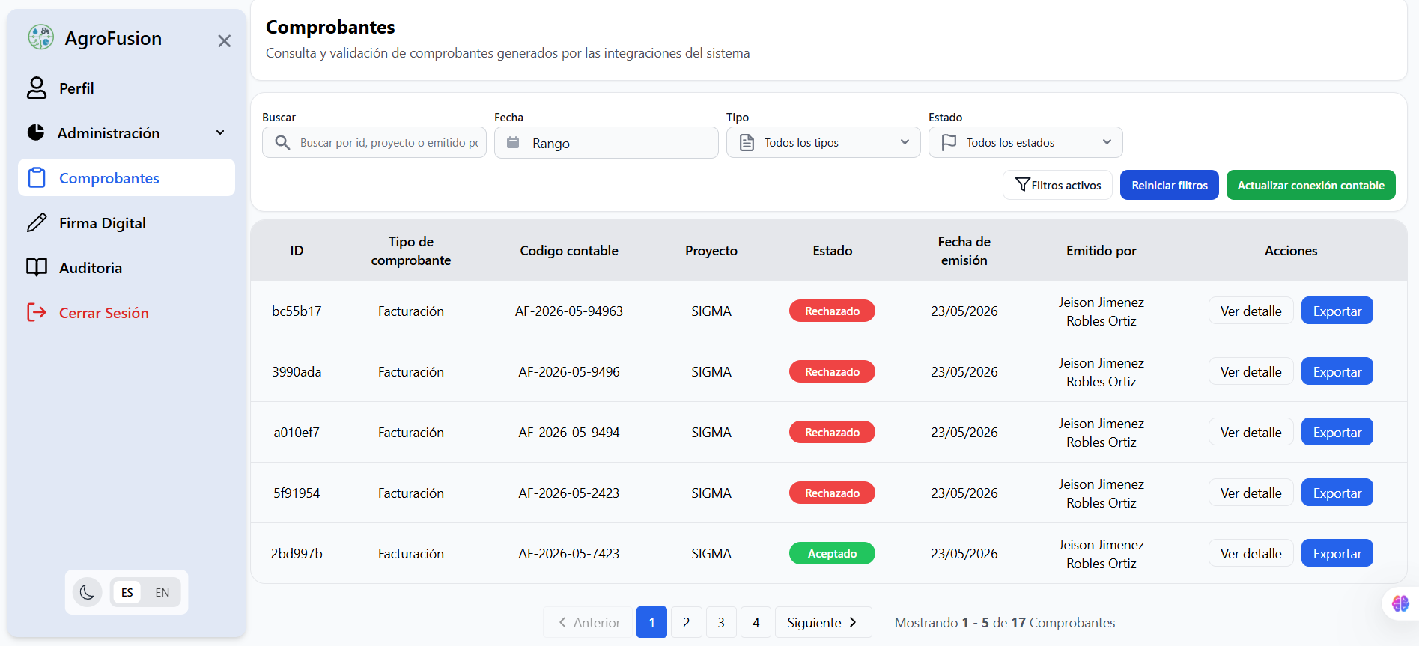
Figure 3. Machinery work-order management with integrated payroll. Source: Authors.

3.3 Zero Trust Security Architecture
Security in AgroFusión is a pervasive runtime property, not a perimeter policy. The platform implements Zero Trust [14]: every request—regardless of its network origin—must carry a valid, non-expired JWT signed by the platform’s private key, validated cryptographically by the API Gateway on every call. RBAC [15], [16] is enforced at the endpoint level: a valid token is rejected if its bearer’s role lacks the specific permission for the requested operation. All inter-service communication runs over TLS 1.3. Secrets are populated by GitHub Actions at deployment time, never stored in the codebase. Independent penetration testing against OWASP Top 10 found zero critical vulnerabilities.

4. Implementation and CI/CD Pipeline

4.1 Scrum-Driven Development
AgroFusión was developed across two semesters under Scrum [17]. Proyecto Integrador 3 (PI3) delivered planning, IEEE 830 requirements engineering (100+ requirements), 4+1 architectural documentation, UI/UX prototyping, and security modeling. Proyecto Integrador 4 (PI4) executed full development, integration, CI/CD configuration, and production deployment. Twenty-plus students organized into six service squads managed work in Taiga with weekly sprints, MoSCoW-prioritized backlogs, and full Scrum ceremonies. Requirements were traced from specification through user stories, acceptance criteria, and verified test cases.

The workflow enforced semantic versioning and a formal branching strategy: feature branches merged into develop via mandatory peer-reviewed pull requests; develop into release after staging validation; release into main only after all acceptance criteria passed. This produced seven versioned milestones—v1.0.0 (authentication) through v1.6.0 (full integration)—each representing a production-quality increment.

4.2 Automated CI/CD and Production Deployment
AgroFusión’s CI/CD pipeline, built on GitHub Actions, automates the full path from commit to production. On each feature-branch push, the pipeline executes unit tests (pytest, Jest), linting, and Docker image build verification—failures block merging. On merge to develop, integration tests run against a containerized staging environment that mirrors production identically. On merge to main, final Docker images are built, pushed to GitHub Container Registry, and a Dokploy webhook triggers a zero-downtime rolling update on the production VPS.

Dokploy provides automatic SSL certificate issuance via Let’s Encrypt and subdomain management—each service reaches HTTPS in under 90 seconds. This architecture achieves DORA “Elite” deployment frequency and validates the findings of Ugwueze and Chukwunweike [18] and Harjula and Hussain [19]: automated pipelines are the single most effective mechanism for eliminating environment-parity errors in distributed systems. The accounting and role management interfaces are shown in Figures 4 and 5.


Figure 4. Unified accounting module fed in real time by irrigation and machinery events. Source: Authors.

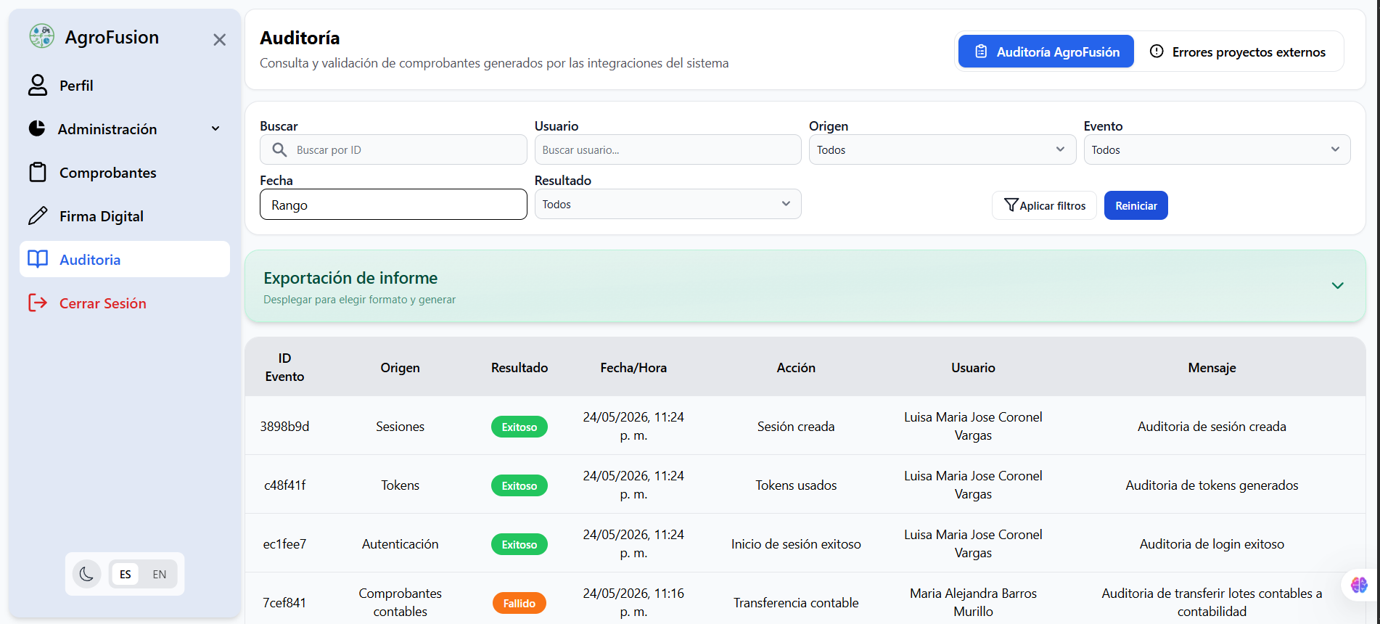
Figure 5. Role management and complete audit trail interface. Source: Authors.

5. Results and Discussion

5.1 Two-Phase Validation Methodology
Validation followed a two-phase structure aligned with ISO/IEC/IEEE 29119 [20]. Phase 1, executed during PI3, performed documentary validation: all requirements, user stories, use cases, wireframes, mockups, and database schemas were reviewed against formal checklists derived from IEEE 830. This phase prevented over 30 specification inconsistencies from reaching code—eliminating defects at the lowest possible correction cost. Phase 2, executed during PI4 across seven release cycles, performed technical validation: unit testing, integration testing, API contract testing via Swagger/OpenAPI, load testing, and acceptance testing against predefined criteria. A dedicated, independent QA squad reported findings within 4 hours of detection via formal IEEE 1044 defect reports.

5.2 Validated Production Metrics
Table 2 presents the metrics validated over 30 continuous days in the live production environment.

Table 2. Validated production metrics (30-day period)
Metric | Value | Standard
System availability (30 days) | 99.3% | ISO/IEC 25010
API response time (p95) | <200 ms | SRE / DORA
Defect Removal Efficiency | 94% | ISO 29119
Test coverage (critical paths) | >80% | IEEE 829
Critical security vulnerabilities | 0 | OWASP Top 10
CI/CD deployment time | <90 sec | DORA Elite
Source: Authors. Measured at https://inmero.co/agrofusion/login

The 99.3% availability achieved on commodity VPS infrastructure—not dedicated enterprise hardware—demonstrates that containerization and orchestration deliver commercial-grade reliability without enterprise infrastructure costs. The 94% Defect Removal Efficiency exceeds IBM’s industry benchmark of 85% for mature development processes [21], a direct result of the two-phase validation strategy that catches specification defects before they enter code. The combined evidence positions AgroFusión as a platform that does not merely match commercial systems in functional scope—it surpasses them in transparency, adaptability, and deployment agility.

6. Concluding Remarks
AgroFusión demonstrates conclusively that agricultural software integration at enterprise depth is achievable without enterprise constraints. By adopting API-first microservices architecture from the first design session, defining a Canonical Data Model that resolves semantic incompatibilities between legacy systems, and implementing Zero Trust security as a foundational design principle, the platform eliminates the technical debt that makes conventional integrations fragile and expensive to maintain.

The production record is compelling: 99.3% availability, zero critical security vulnerabilities, 94% defect removal efficiency, and sub-200 ms response times validate that the combination of disciplined Scrum methodology, API-first architecture, and automated CI/CD quality gates can produce software that competes with commercial offerings in every measurable dimension. AgroFusión does not merely replicate the integration capabilities of SAP Agriculture or Trimble Ag within its target segment—it extends them with a level of openness, adaptability, and DevOps sophistication that proprietary platforms cannot match.

Future priorities include: predictive irrigation scheduling via machine-learning models trained on historical sensor and weather data; full offline Progressive Web App capability for field operators in areas with intermittent connectivity; multi-tenant architecture for scaled deployment across multiple farms; and data governance alignment with Colombian Law 1581 on personal data protection. AgroFusión is released as open-source software; its codebase, deployment configuration, and documentation are available to any institution seeking to build upon, replicate, or extend its capabilities.

Declaration of Competing Interest
The authors declare no competing financial or non-financial interests. AgroFusión is an academic project with no commercial funding or industry sponsorship.

Acknowledgement
The authors thank Universidad Surcolombiana for institutional support, the agricultural enterprises of the Huila Department whose operational challenges motivated this work, and the faculty supervisors whose technical guidance shaped the platform's architecture and quality standards.

Author Contributions
AgroFusión Research Team: Conceptualization, Data curation, Formal analysis, Investigation, Methodology, Project administration, Software, Validation, Visualization, Writing—original draft, Writing—review & editing.

Data Availability Statement
The production platform is publicly accessible at https://inmero.co/agrofusion/login. Source code, architecture documentation, and deployment configurations are available upon request.

References
[1] World Health Organization, Digital Agriculture: Transforming the Food Value Chain. Geneva: WHO Press, 2023.
[2] Deloitte, “Smart Agriculture: Transforming the Agricultural Value Chain,” Deloitte Insights, 2023.
[4] European Commission, “European Interoperability Framework,” Publications Office of the EU, 2017.
[9] M. Schreieck, M. Wiesche, and H. Krcmar, “A typology of multi-platform integration strategies,” Information Systems Journal, vol. 34, 2024.
[11] SPD Technology, “Integrating Multiple Software Assets for Payment Tech Provider,” Case Study, 2023.
[12] A. Lercher, C. Macho, and M. Pinzger, “Microservice API evolution in practice,” IEEE Trans. Softw. Eng., 2023.
[14] NIST, “Zero Trust Architecture,” Special Publication 800-207, 2020.
[15] R. Sandhu et al., “Role-based access control models,” IEEE Comput., vol. 29, 1996.
[16] D. Ferraiolo and R. Kuhn, “Role-based access controls,” Proc. 15th NIST-NCSC Conf., 1992.
[17] K. Schwaber and J. Sutherland, “The Scrum Guide,” Scrum.org, 2020.
[18] C. Ugwueze and O. Chukwunweike, “Continuous integration and deployment strategies for streamlined DevOps,” J. Cloud Comput., 2024.
[19] E. Harjula and S. Hussain, “A systematic literature review on CI/CD for secure cloud computing,” IEEE Access, 2023.
[20] ISO/IEC/IEEE, “ISO/IEC/IEEE 29119: Software Testing Standards,” 2022.
[21] IBM Research, “Software Defect Removal Efficiency Benchmarks,” IBM Technical Report, 2019.

