1. 淘宝：https://s.taobao.com/search

|  |  |
| --- | --- |
| 数据 | 信息 |
| s.taobao.com | 目标网站 |
| /search | 目标资源的URL |
| q=%E8%80%B3%E6%9C%BA&imgfile=&js=1&stats_click=search_radio_all%3A1&initiative_id=staobaoz_20191008&ie=utf8 | URL参数 |
| GET | 请求类型 |
| text/html,application/xhtml+xml,application/xml;q=0.9,image/webp,image/apng,*/*;q=0.8,application/signed-exchange;v=b3 | 浏览器可接受的网页信息 |
| gzip, deflate, br | 可接受压缩类型 |
| zh-CN,zh;q=0.9 | 可接受语言 |
| max-age=0 | Cache控制 |
| thw=cn; t=8693497672a314f6710370c6321f79b2; cna=16PyFXbesGYCAXrggMIMTtMj; lgc=%5Cu7AF9%5Cu5F71%5Cu6E05%5Cu98CE0771; tracknick=%5Cu7AF9%5Cu5F71%5Cu6E05%5Cu98CE0771; tg=0; enc=wJ9dAVP1%2FXsX7XYN%2Bp8rV90zmXrrdqcn1eYrRgPSaWxeqQNj5YTdEosUzJGK0Ag0U2U%2FgXeI1i3Rt%2FhzlFNuRg%3D%3D; hng=CN%7Czh-CN%7CCNY%7C156; x=e%3D1%26p%3D*%26s%3D0%26c%3D0%26f%3D0%26g%3D0%26t%3D0%26__ll%3D-1%26_ato%3D0; miid=728705401361426289; uc3=lg2=VT5L2FSpMGV7TQ%3D%3D&vt3=F8dByuHb9uFxbz%2ByIxs%3D&id2=UUBb06g6A1HiwQ%3D%3D&nk2=tboP0xV4fui5hWMV; uc4=nk4=0%40tw4uZUEONOqClu8YLqj6JTm1jE1or5k%3D&id4=0%40U2LJ2wiDpM5Wos8Am4owyolpj00X; _cc_=URm48syIZQ%3D%3D; mt=ci=-1_0; v=0; cookie2=1ddf05fece159dc3e09d7227c2f51800; _tb_token_=3e733e173783b; alitrackid=www.taobao.com; lastalitrackid=www.taobao.com; JSESSIONID=FCC9853512CFD6A06B1C9794AB8A8A46; uc1=cookie14=UoTbnV0nqHYtNQ%3D%3D; swfstore=140343; l=cBLVkq9gqy8z2fxMBOfaKurza77T6IdbzsPzaNbMiICPOgf656VVWZBKw2TBCnGVKss2R3yE78S3BvY5DyCqJxpsw3k_J_f..; isg=BNfX_mBxRrLtkMLNNbA6QZ6pZkshHKt-ppRqfikFC6YNWPWaMehbztM6vrhjsIP2 | 客户端cookies信息 |

京东：

https://search.jd.com/Search

https://search.jd.com/attrlog.php

https://search.jd.com/im.php

|  |  |
| --- | --- |
| 数据 | 信息 |
| search.jd.com | 目标网站 |
| /Search | 目标资源的URL |
| keyword=%E8%80%B3%E6%9C%BA&enc=utf-8&pvid=7f5a0c8ac2bd44b9982ee5ceed73c208 | URL参数 |
| GET | 请求类型 |
| text/html,application/xhtml+xml,application/xml;q=0.9,image/webp,image/apng,*/*;q=0.8,application/signed-exchange;v=b3 | 浏览器可接受的网页信息 |
| gzip, deflate, br | 可接受压缩类型 |
| zh-CN,zh;q=0.9 | 可接受语言 |
| max-age=7776000 | Cache控制 |
| __jdu=1536833318; shshshfpa=cf24b869-6f37-34e5-f464-888ee67fcf9e-1567852653; xtest=9178.cf6b6759; shshshfpb=xvMD6ziAa%2Fs%2FZBhl%207%2F1xUA%3D%3D; qrsc=3; mt_xid=V2_52007VwMWUFpRUFgdSRBsVWMAQlRUC1tGHkwbXBliURRUQVFWUhpVEQkEb1RABVQPUA9IeRpdBW8fE1pBW1dLHEgSXQNsAhtiX2hSahxIGlkMYgAaUW1bUFka; unpl=V2_ZzNtbUtfEUcnXERWc01fVmIAQQ8RUxcUfVoVXX4QCAA3BkVcclRCFX0URlVnGFUUZAAZXUZcRxJFCEdkeB5fA2AFEFlBZxBFLV0CFi9JH1c%2bbRJcRV5CE3cPRVB7Gmw1ZAMiXUNnQxF3D09WeRtcDFczFW1yZ0MTcAhDZHopXTUlV05ZQ1BLEnVFRlB5HlUHZQESVHJWcxY%3d; __jdv=76161171|baidu-search|t_262767352_baidusearch|cpc|106807362512_0_89ccce339e2b42bcb5e09cb848e4a4f0|1570544156695; areaId=15; ipLoc-djd=15-1213-1214-0; PCSYCityID=CN_330000_330100_330110; __jda=122270672.1536833318.1567852651.1570108895.1570544157.9; __jdb=122270672.2.1536833318|9.1570544157; __jdc=122270672; shshshfp=06be8756ec9d54ecb4e0f5be78cba460; shshshsID=83d19675ffda722fc0e72a166af0552b_2_1570544160119; rkv=V0700; 3AB9D23F7A4B3C9B=NWDR4ICXHTMSKXYQFHAGSL6CBI7ATKUFMC7NYPJDIUYUFZLRQRMXAERCUYMMW4TTJLUXSFG5YF2ZFLLDPZL7Q6Q6DM | 客户端cookies信息 |

1.状态都是200，表示成功

2.数据格式都是text/html

3.数据类型和呈现方式是UTF-8

1. 淘宝：

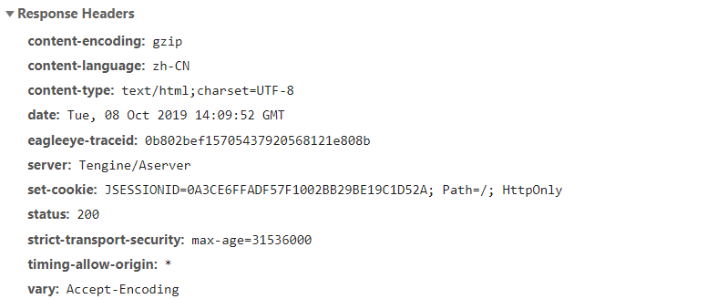

京东：

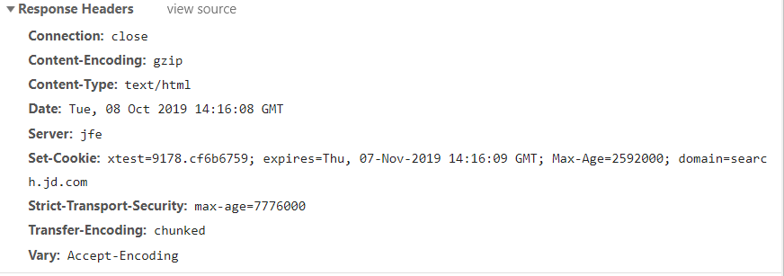

1. 淘宝有更多的编码信息
2. Server方面，淘宝是Tengine/Aserver，京东是jfe
3. Cookie格式不同