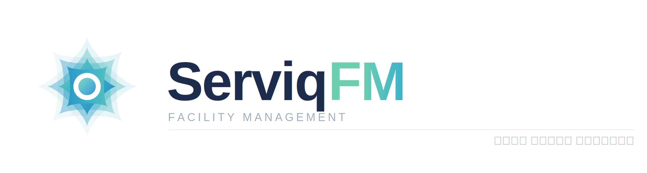
Brand Guidelines & Design System
Version 2.0 · 2026 · Confidential
DM Sans (English) · Readex Pro (Arabic) · Palette: Teal → Blue

1. Logo
FULL LOCKUP — LIGHT BACKGROUND

Use above 120px wide. Minimum clear space = height of the "F" in FM on all sides.

ICON MARK — APP ICON · FAVICON · AVATAR

Use below 48px wide. App icon 1024×1024px. Favicon 32×32px.

USAGE RULES
● Always use the full lockup (icon + wordmark) at sizes above 120px wide
● Use icon mark only at sizes below 48px — app icon, favicon, avatar
● On dark navy backgrounds, use white wordmark with full-colour icon
● Never recolour the wordmark — navy on light, white on dark only
● Never stretch, rotate, or apply shadows to the icon
● Never place on a busy photo without a solid colour overlay

2. Brand colours
PRIMARY PALETTE

Navy  #1E2D4E | Teal  #6DCFB0 | Teal-blue  #3AAECC | Blue  #1A7FC1 | Teal light  #B8DDD8

SUPPORTING PALETTE

Teal bg  #E8F7F3 | Blue light  #E6F1FB | Navy light  #E8ECF2 | Off-white  #F8FAFC | Muted  #A0B0BF

SEMANTIC / STATUS

Success #22C997  #22C997 | Warning #F5A623  #F5A623 | Danger #E24B4A  #E24B4A | Info #1A7FC1  #1A7FC1 | Neutral #A0B0BF  #A0B0BF

3. Typography
English: DM Sans · Arabic: Readex Pro
Weight rule: EN-500 → AR-600 · EN-600 → AR-700
Line-height rule: EN body 1.7 · AR body 1.9

Style / Spec |  | English sample | Arabic sample
Display  EN 36px 600 · AR 36px 700 |  | Facility management | إدارة المنشآت
H1  EN 28px 600 · AR 28px 600 |  | Work order #1042 | أمر العمل رقم ١٠٤٢
H2  EN 22px 500 · AR 22px 600 |  | Asset registry | سجل الأصول
H3  EN 17px 500 · AR 17px 600 |  | PM schedule | جدول الصيانة الوقائية
Body  EN 14px 400 lh1.7 · AR lh1.9 |  | HVAC unit due Thursday | وحدة التكييف موعدها الخميس
Caption  EN 12px 400 · AR 12px 400 |  | Last updated 14 Apr 2026 | آخر تحديث ١٤ أبريل ٢٠٢٦
UI Label  EN 11px 500 tracked · AR 11px 600 |  | ASSIGNED TECHNICIAN | الفني المعيّن

4. Spacing scale
Token | Value | Use case | Example
xs | 4px | Icon gaps | Icon + label gap
sm | 8px | Component inner | Badge padding
md | 16px | Default padding | Card padding
lg | 24px | Section gaps | Between form fields
xl | 32px | Page sections | Between sections
2xl | 48px | Large gaps | Page top padding
3xl | 64px | Hero spacing | Landing page hero

5. Border radius
Token | Value | Use on | Notes
input | 4px | Text inputs | Crisp, form-like
btn | 8px | Buttons, badges | Approachable
card | 12px | Cards, panels | Friendly
modal | 16px | Modals, drawers | Prominent
pill | 24px | Status chips | Rounded ends
full | 9999px | Avatars | Perfect circle

6. UI components
BUTTONS
Variant | Background | Use case | AR weight
Primary | #1E2D4E Navy | Primary CTA — assign, save | Readex Pro 600
Secondary | Transparent + border | Secondary — view, cancel | Readex Pro 600
Accent | Teal→Blue gradient | Marketing CTA — trial | Readex Pro 600
Danger | #E24B4A Red | Destructive — delete | Readex Pro 600

STATUS BADGES
Completed | In progress | Overdue | Assigned | New | On hold
مكتمل | قيد التنفيذ | متأخر | معيّن | جديد | معلّق

EN / AR PAIRING RULES
Element | EN spec | AR spec | Note
Display | DM Sans 600 | Readex Pro 700 | AR 1 weight heavier
Headings | DM Sans 500 | Readex Pro 600 | AR 1 weight heavier
Body | 14px lh 1.7 | 14px lh 1.9 | AR more line-height
Caption | 12px lh 1.5 | 12px lh 1.6 | Legible at small size
UI Label | 500 tracked | 600 | No tracking on AR

ServiqFM Brand Guidelines · Confidential · Version 2.0 · 2026

