Material Textarea

This component is based on [Material](https://material.angularjs.org/latest/) design.

Link to the original Material design : https://material.angularjs.org/latest/demo/input

**Component name**: Text area

**Description**: This is like a general text area field, based on Angular Material design.

**Current version**: 1.0.0

**State**: alpha

**Source** : [Angular Material Text area Field](https://material.angularjs.org/latest/demo/input)

**Screenshots**:

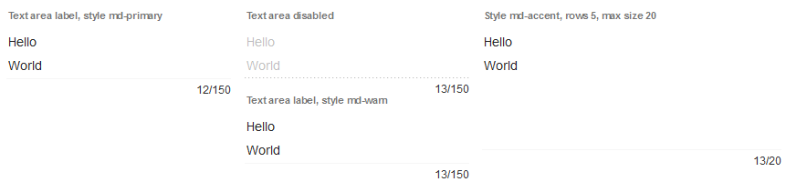

Styling

The Material input field can be styled using styleClass property or customize the style of the component from your solution’s style sheet.

The inputs are styles by default with the CSS class “md-primary”.

The component provides it's own CSS selectors for easy restyle of the components. Combine these selector with the class selector of the Material for the grade customization.

| CSS Selector |
| --- |
| **.md-input**  Class selector to style the Material text area field |

Summary

| Event Summary | |
| --- | --- |
|  | onAction  The method that is executed when the component is clicked |
|  | onDataChange  Method that is executed when the data in the component is successfully changed. |
|  | onRightClick  The method that is executed when the component is right clicked. |

| Property Summary | |
| --- | --- |
| String | label  The label of the input field. |
| String | datprovider  The dataprovider of the component. |
| String | styleClass  The name of the style class that should be applied to this component. |
| Number | rows  The minimum number of rows to show in the component |
| Number | maxLength  Maximum length of the string that can be accommodated in the text area |
| Number | tabSeq  An index that specifies the position of the component in the tab sequence. |
| String | toolTipText  The text displayed when hovering over the component with a mouse cursor. |
| Boolean | readOnly  The readonly state of the component, default false. |
| Boolean | enabled  The enable state of the component, default true. |
| Boolean | visible  The visible property of the component, default true. |
| String | location  The x and y position of the component, in pixels, separated by a comma. |
| String | size  The width and height (in pixels), separated by a comma. |

| Event details |
| --- |

onAction

The method that is executed when the component is clicked.

onDataChange

Method that is executed when the data in the component is successfully changed.

Parameters

oldValue - old value

newValue - new value

{JSEvent} event - the event that triggered the action

onRightClick

The method that is executed when the component is right clicked.

|  |
| --- |
| Property details |

label

The label displayed in the input field.

Returns

String

dataprovider

The dataprovider used to displayed the button text.

Returns

String

styleClass

There are some material style classes that can be used for a button. Like : "md-primary","md-warn","md-raised","md-fab","md-accent","md-hue-1","md-hue-2","md-hue-3". Apart from that you can use custom style classes, which is defined in the style sheet associated with the solution.

Returns

String

rows

The minimum number of rows to display in the text area component. Default is 2. This affects the height of the component.

Returns

Number

maxLength

The maximum characters supported by the text area. Default is 150. So by default 150 characters are supported and after that the component shows red color to visually show that the text area is having more number of characters than supported. Also no data change is triggered when having more than max length of characters are inserted into the component.

Returns

Number

tabSeq

An index that specifies the position of the component in the tab sequence. The components are put into the tab sequence in increasing order of this property. A value of 0 means to use the default mechanism of building the tab sequence (based on their location on the form). A value of -2 means to remove the component from the tab sequence.

Returns

Number

toolTipText

The text displayed when hovering over the component with a mouse cursor.

Returns

String

format

The format that should be applied when displaying the data in the component.

There are different options for the different dataprovider types that are assigned to this field.

For Integer fields, there is a display and an edit format, using http://docs.oracle.com/javase/7/docs/api/java/text/DecimalFormat.html and the max (string) length can be set.

For Text/String fields, there are options to force uppercase,lowercase or only numbers. Or a mask can be set that restrict the input the pattern chars can be found here: http://docs.oracle.com/javase/7/docs/api/javax/swing/text/MaskFormatter.html

A mask can have a placehoder (what is shown when there is no data) and if the data must be stored raw (without literals of the mask). A max text length can also be set to force

the max text length input, this doesn't work on mask because that max length is controlled with the mask.

For Date fields a display and edit format can be set by using a pattern from here: http://docs.oracle.com/javase/7/docs/api/java/text/SimpleDateFormat.html, you can also say this must behave like a mask (the edit format)

A mask only works with when the edit format is exactly that mask (1 char is 1 number/char), because for example MM then only 2 numbers are allowed MMM that displays the month as a string is not supported as a mask.

Some examples are "dd-MM-yyyy", "MM-dd-yyyy", etc.

The format property is also used to set the UI Converter, this means that you can convert the value object to something else before it gets set into the field, this can also result in a type change of the data.

So a string in scripting/db is converted to a integer in the ui, then you have to set an integer format.

This property is applicable only for types: TEXT_FIELD, COMBOBOX, TYPE_AHEAD, CALENDAR and SPINNER.

Returns

String

readOnly

The read-only state of the component, default false.

Returns

Boolean – read only state

enabled

The enable state of the component, default true.

Returns

Boolean - enabled state

visible

The visible property of the component, default true.

Returns

Boolean - visible state

location

The x and y position of the component, in pixels, separated by a comma.

Returns

String

size

The width and height (in pixels), separated by a comma.

Returns

String