Material Auto Complete Field

This component is based on [Material](https://material.angularjs.org/latest/) design.

Link to the original Material design : https://material.angularjs.org/latest/demo/autocomplete

**Component name**: Auto Complete

**Description**: This is like a general typeahead field, based on Angular Material design.

**Current version**: 1.0.0

**State**: alpha

**Source** : [Material Autocomplete](https://material.angularjs.org/latest/demo/autocomplete)

**Screenshots**:

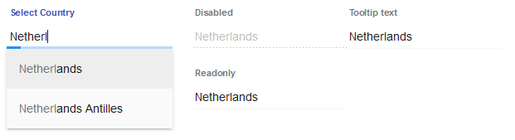

Styling

The Material autocomplete field can be styled using styleClass property or customize the style of the component from your solution’s style sheet.

The inputs are styles by default with the CSS class “md-primary”.

The component provides it's own CSS selectors for easy restyle of the components. Combine these selector with the class selector of the Material for the grade customization.

| CSS Selector |
| --- |
| **.md-input**  Class selector to style the Material auto complete field |

Summary

| Event Summary | |
| --- | --- |
|  | onAction  The method that is executed when the component is clicked |
|  | onDataChange  Method that is executed when the data in the component is successfully changed. |
|  | onRightClick  The method that is executed when the component is right clicked. |

|  |  |
| --- | --- |
| Property Summary | |
| String | label  The label of the input field. |
| String | datprovider  The dataprovider of the component. |
| String | styleClass  The name of the style class that should be applied to this component. |
| Number | valuelist  The valuelist that is used by this field when displaying data. |
| Number | tabSeq  An index that specifies the position of the component in the tab sequence. |
| String | toolTipText  The text displayed when hovering over the component with a mouse cursor. |
| Boolean | readOnly  The readonly state of the component, default false. |
| Boolean | enabled  The enable state of the component, default true. |
| Boolean | visible  The visible property of the component, default true. |
| String | location  The x and y position of the component, in pixels, separated by a comma. |
| String | size  The width and height (in pixels), separated by a comma. |

| Event details |
| --- |

onAction

The method that is executed when the component is clicked.

onDataChange

Method that is executed when the data in the component is successfully changed.

Parameters

oldValue - old value

newValue - new value

{JSEvent} event - the event that triggered the action

onRightClick

The method that is executed when the component is right clicked.

|  |
| --- |
| Property details |

label

The label displayed in the input field.

Returns

String

dataprovider

The dataprovider used to displayed the button text.

Returns

String

styleClass

There are some material style classes that can be used for a button. Like : "md-primary","md-warn","md-raised","md-fab","md-accent","md-hue-1","md-hue-2","md-hue-3". Apart from that you can use custom style classes, which is defined in the style sheet associated with the solution.

Returns

String

valuelist

The valuelist that is used by this field when displaying data.

Returns

Number

tabSeq

An index that specifies the position of the component in the tab sequence. The components are put into the tab sequence in increasing order of this property. A value of 0 means to use the default mechanism of building the tab sequence (based on their location on the form). A value of -2 means to remove the component from the tab sequence.

Returns

Number

toolTipText

The text displayed when hovering over the component with a mouse cursor.

Returns

String

readOnly

The read-only state of the component, default false.

Returns

Boolean – read only state

enabled

The enable state of the component, default true.

Returns

Boolean - enabled state

visible

The visible property of the component, default true.

Returns

Boolean - visible state

location

The x and y position of the component, in pixels, separated by a comma.

Returns

String

size

The width and height (in pixels), separated by a comma.

Returns

String