EPS 351

Lab 6: ANOVA and ANCOVA in SPSS

Name: Carolina Mojena

Dataset: Cosmetic Surgery.sav

Open/Import/Read Dataset: File -> Open -> Data. Select **All Files** from Files of type to show the file you’re looking for. Select the correct file and click **Open**.

You are interested in determining if depression levels post-surgery are different based on the clinic that patients went to. In other words, is there an association with clinics and depression?

**State the null and alternative hypotheses**

**H­­0: Depression levels are not different based on the clinic that patients went to.**

**H1: Depression levels are different based on the clinic that patients went to.**

Analyze -> Compare Means -> One-Way ANOVA. Move variable “BDI” to Dependent List. Move Clinic to Factor. Click the “Estimate effect size for overall tests” button.

Click the Post Hoc button and select “Tukey”. Press continue.

Click the “Options” button and select “Descriptive” and “Homogeneity of variance test”. You can also select “Means plot” but for this lab it’s optional. Click Continue. Then Click Paste.

**Take a screenshot of your syntax and paste it here:**

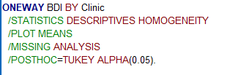

**Run the test (highlight the syntax and click the green triangle button). Take a screenshot of the ANOVA table of your output and paste it below (you DO NOT need to include the whole output, just the ANOVA table):**

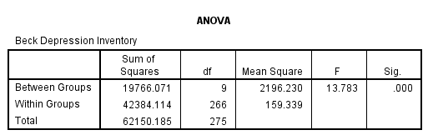

**What do your results indicate?**

Based on a one-way ANOVA, there is a significant difference in the measure of depression based on the clinic that patients used (F(9, 266) = 13.78, *p* < .001). Post hoc analyses using Tukey adjustments indicate that clinic 1 had a significantly higher mean of depression than clinic 7 (MD = 14.33, *p* = .002), clinic 8 (MD = 12.89, *p­* = .018), and clinic 9 (MD = 12.44, *p* = .025). …

**Following this pattern, complete the write up for the rest of the pairwise comparisons below.**

Clinic 2 had a significantly higher mean of depression than clinic 7 (MD = 20.46, *p* = .000), clinic 8 (MD = 19.02, *p­* = .000), and clinic 9 (MD = 18.57, *p* = .000).

Clinic 3 had a significantly higher mean of depression than clinic 7 (MD = 15.02, *p* = .000), clinic 8 (MD = 13.58, *p­* = .005), and clinic 9 (MD = 13.13, *p* = .007).

Clinic 4 had a significantly higher mean of depression than clinic 7 (MD = 23.91, *p* = .000), clinic 8 (MD = 22.47, *p­* = .000), clinic 9 (MD = 22.01, *p* = .000) and clinic 10 (MD = 12.41, *p* = .006).

Clinic 5 had a significantly higher mean of depression than clinic 7 (MD = 19.10, *p* = .000), clinic 8 (MD = 17.66, *p­* = .000), and clinic 9 (MD = 17.21, *p* = .000).

Clinic 6 had a significantly higher mean of depression than clinic 7 (MD = 18.45, *p* = .000), clinic 8 (MD = 17.01, *p­* = .000), and clinic 9 (MD = 16.56, *p* = .000).

Clinic 10 had a significantly higher mean of depression than clinic 7 (MD = 11.5, *p* = .010).

~~~~~~

ANCOVA: Using the same dataset , you want to check to see if quality of life after surgery is impacted by the specific clinic that a patient goes to. You will start by running a regular ANOVA. Below is an alternative method to run the ANOVA.

Analyze -> General Linear Model -> Univariate. Move “Post_QoL” to the Dependent Variable line and “Clinic” to the Fixed Factor(s) line. Click on the Post Hoc botton, move Clinic over to the Post Hoc Tests for box, and select Tukey. Click Continue. Click options and select “Descriptive”, “Homogeneity tests”, and “Estimate effect size”. Click continue. Click paste.

**Screenshot your Syntax and results below:**

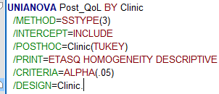

**What do your results mean? You do not need to write up the full results for the post hoc tests. Only write up the F test results.**

The quality of life after surgery is impacted by the specific clinic that a patient goes to shown by the p value of 0.000 indicating enough statistical significance.

**Do you think its possible that there may be other factors contributing to differences in quality of life?**

**Yes.**

**Let’s see if there is any effect of the pre-operative quality of life on the post-op quality of life.**

Follow the same procedure as you did before but this time, also move “Base_Qol” to the Covariate(s) box. Click on the EM Means box, move “Clinic” over to the Display means for box, and select “Compare main effects”. Under “Confidence interval adjustment”, select Bonferroni. Click Continue. Click paste.

**Screenshot your syntax below:**

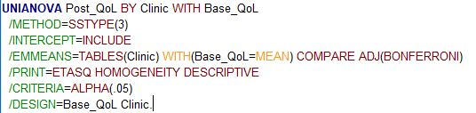

**Screenshot your Tests of Between-Subjects Effects table below.**

**Write up your results below (finish the started write-up):**

Based on an ANCOVA analysis, after controlling for baseline quality of life, clinic has a significant effect on the quality of life after surgery.

**Bonus:**

Using your own dataset (or another we’ve used in class previously), perform any ANOVA or ANCOVA and write up your results. Provide the hypotheses, and a description the analysis you performed.