EPS 351

Lab 5: Chi-Square Test and Correlation in SPSS

Name: Carolina Mojena

Dataset: Grade_Chi-square.sav

1. Open/Import/Read Dataset: File -> Open -> Data. Select **All Files** from Files of type to show the file you’re looking for. Select the correct file and click **Open**.

1. Goodness of Fit. Test whether students’ GPA were equally distributed across five letter grades.

**State the null and alternative hypotheses**

**H­­0: Students’ GPA were equally distributed across five letter grades.**

**H1: Students’ GPA were not equally distributed across five letter grades.**

Analyze -> Nonparametric Tests -> Legacy Dialogs -> Chi-square. Move variable “Letter Grade” to Test Variable List.

**Take a screenshot of your syntax and paste it here:**

**Run the test (highlight the syntax and click the green triangle button). Take a screenshot of the output and paste it below:**

**What do your results indicate?**

**The results indicate that the students’ GPA are not equally distributed across the five letter grades. The p value was <.000.**

1. Test for Independence Open the dataset **School_Type** and determine if there is a significant relationship between school types and classifications.

School type: 1 = school 1, 2 = school 2, 3 = school 3

Classification: 1 = Remedial, 2 = Passable, 3 = Proficient, 4 = Outstanding

Analyze -> Descriptive Statistics -> Crosstabs. Move a variable to Row and the other variable to Column.

**Screenshot your Syntax and results below:**

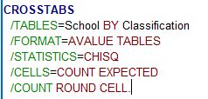

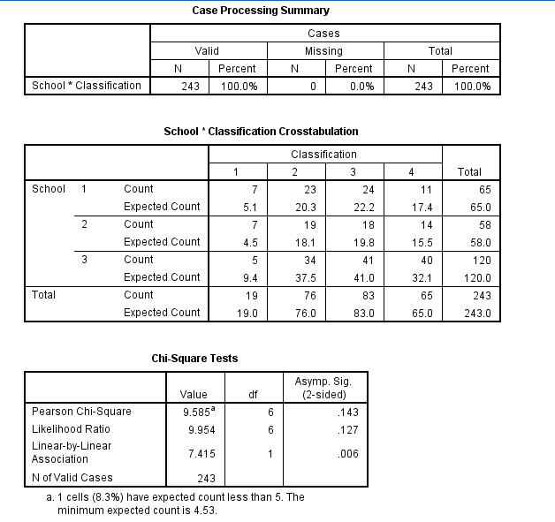

**What do your results mean?**

**The p-value of Pearson Chi-square being .143 which is greater than alpha indicates that there is no significant relationship between school type and classifications.**

**How does the test for independence relate to correlation?**

Both tests are used to determine whether there is a relationship between two variables. The test for independence is used for categorical variables while correlation is used for continuous variables.

Dataset: Reading.sav

1. Open/Import/Read Dataset: File -> Open -> Data. Select **All Files** from Files of type to show the file you’re looking for. Select the correct file and click **Open**.

1. Correlation. Test whether there is a statistically significant correlation between students’ baseline test score and their posttest score.

**State the null and alternative hypotheses**

**H­­0: There is no significant correlation between students’ baseline test score and their posttest score**

**H1: There is significant correlation between students’ baseline test score and their posttest score**

Analyze -> Correlate -> Bivariate -> Move variables to Variables box -> Check Pearson -> Paste.

**Take a screenshot of your syntax and paste it here:**

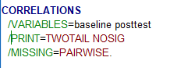

**Run the test (highlight the syntax and click the green triangle button). Take a screenshot of the output and paste it below:**

**What do your results indicate (explain in your own words)?**

**From the results, there is no significant correlation between students’ baseline test score and their posttest score.**

APA write up: To assess the linear relationship between students’ baseline score and their posttest score, a Pearson correlation coefficient was computed. Based on the Pearson correlation coefficient, there is not a significant correlation between baseline score and posttest score (*r*(98) = .074, *p* = .461).

Practice:

Dataset: Math.sav

1. Do a Pearson correlation test to evaluate whether there is a statistically significant correlation between time spent on math homework and math achievement score.

**State the null and alternative hypotheses**

**H­­0: There is no statistically significant correlation between time spent on math homework and math achievement score.**

**H1: There is statistically significant correlation between time spent on math homework and math achievement score.**

**Screenshot your Syntax and results below:**

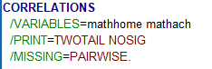

**What is the effect size? (hint: you’ll need to calculate it by hand; r2)**

**r2 = 0.1024**

**Using APA format, write up your results. Be sure to include a statement regarding the direction of the relationship (if there is one), your effect size, and an interpretation of the effect size.**

**From the results of Pearson correlation test above, there is a significant relationship between the time spent on Math Homework per week and math achievement test score (r(98) =.320, p = 0.001). The relationship is positive given the r is positive and with the effect size of 0.1024 the relationship is small.**