EPS 351

Lab 2: Descriptive Statistics with SPSS

Name: Carolina Mojena

Dataset: sandwich.sav

Open the dataset in spss. **File -> Open -> Data -> find the file location (make sure you have the right type of file selected -> Open**

**Exploring the data**

1. Go to “Variable View” to fill out the table below

|  |  |  |  |  |
| --- | --- | --- | --- | --- |
| Variable | Categorical or Continuous? | Levels of Measurement | Original Question | Values |
| ID | Categorical | Nominal | ID | None |
| Gender | Categorical | Nominal | What’s your Gender? | 1 = Male  2 = Female  3 = Other |
| Age | Continuous | Scale | What is your age? | None |
| State | Categorical | Nominal | Which state or country are you from? | None |
| Sandwich | Categorical | Nominal | Which brand has THE BEST sandwich? | 1 = Chick-fil-la  2 = Shake-Shack  3 = Burger King  4 = Wendy’s |

**Creating graphs in SPSS**

1. Create a bar chart: **Graphs -> Legacy Dialogs -> Bar -> Choose “Summaries for groups of cases” -> Define -> move variable “Sandwich” to Define Category Axis -> Paste.**

1. Highlight your syntax and click the Run button (the green triangle). Copy and paste a screenshot of your syntax and a screenshot of your bar chart below.

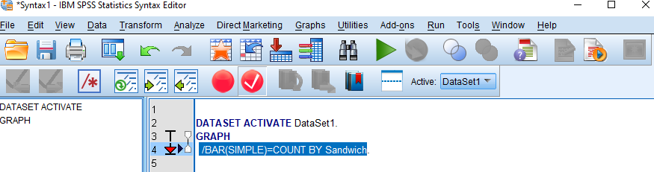

1. Create a pie chart: **Graphs -> Legacy Dialogs -> Pie -> Choose “summaries for groups of cases” -> Define -> move variable “sandwich” to Define slices by -> Paste**
2. Highlight your syntax (just the new lines) and click the Run button. Copy and paste a screenshot of your syntax and a screenshot of your pie chart below.

1. Create a frequency histogram: **Graphs -> Legacy Dialogs -> Histogram -> move variable “Age” to Variable -> Check Display normal curve -> Paste.**

1. Highlight your syntax and hit the Run button. Copy and paste a screenshot of your syntax and a screenshot of your histogram below.



**Descriptive Statistics in SPSS**

1. Get your descriptive statistics: **Analyze -> Descriptives -> Move variable “Age” to Variables -> Click Options -> Choose different statistics -> Continue -> Paste**

1. Highlight your syntax and hit the Run button. Copy and paste a screenshot of your syntax and a screenshot of your output table below.



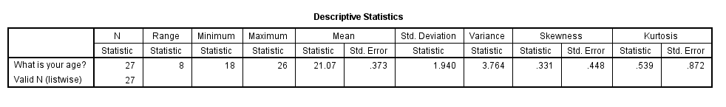

**Interpreting Results**

1. Open datafile : pisa_us.sav
2. Create a histogram and get the descriptive statistics for the variable **wleread** (Warm estimate in reading – variable 290). Take a screenshot of your histogram and output table and paste them below.

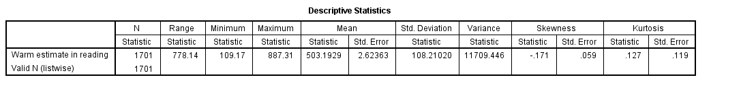

1. Describe the shape of the data (symmetrical? Positively/negatively skewed? Unimodal/bimodal/multimodal?)

**The data is symmetrical and Unimodal.**

1. What are the mean, median and mode?

Mean = 503.1929

Median = 510.72

Mode = 558.62

1. Describe the variability of the data (variance or standard deviation).

The data had a standard deviation of 108.21.

1. What are the skewness and Kurtosis?

Skewness = -0.171

Kurtosis = 0.127

1. Is the data normally distributed? (general rules for normality: -1 < skewness < 1; -1 < kurtosis < 2)

**The data is normally distributed inferred from the skewness and kurtosis results**