EPS 351

Lab 1: Getting Started with SPSS

Name: Carolina Mojena

Dataset: Lab1_In Class Exercise

1. What are the three variables in this dataset?

|  |  |  |
| --- | --- | --- |
| Variable | Categorical or Continuous? | Levels of Measurement |
| Student ID | Categorical | Nominal |
| Hours spent on Academic Activities outside class | Continuous | Ratio |
| How often one has used the library. | Categorical | Ordinal |

1. Open/Import/Read Dataset: File -> Open -> Data. Select **Excel** from Files of type to show the file you’re looking for. Click **Open**, select the option “Read variable names from the first row of the data”, click **OK**.

Another way that you can do this is by using: File -> Import Data -> Excel

**Take a screenshot of your dataset after it opens and paste it below:**

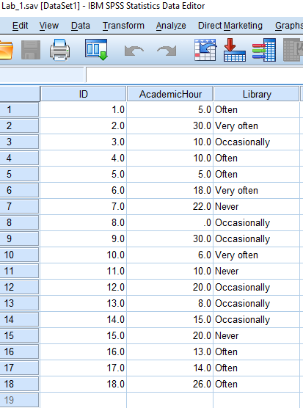

1. Saving your dataset: File -> Save as -> Save.

**Save the file onto your desktop as a .sav and upload it to Black Board with this document.**

1. Past and Syntax: Analyze -> Descriptive Statistics -> Frequencies -> Move “Library” into “Variable(s)” -> select “Display frequency tables” -> PASTE.

1. Highlight the syntax and click the run button.

If you want to add notes to your syntax, ‘*’ at the beginning and “.” At the end of the text will allow you to insert text that will not be read as syntax.

1. Save your syntax (.sps): In the syntax editor go to File -> Save as…

**Save your syntax and upload it with this file.**

1. Output (.spv):

**Save your output and upload it along with this document.**

1. Double check your variables using the “Variable View” tab.

**Change your “Measures” to the correct option and paste a screenshot below:**

