INST 327-WB21: DATABASE DESIGN & MODELING

Final Project

July 27, 2022

**Team 1:** Joseph Bertz, John Connor, Jeremy Kiggundu, Steven Yang, Se Oh

# Introduction

As a team, we have decided to create a database that will contain all obtainable information related to the restaurants and fast food chains in College Park, MD which will be easily accessible for students, staff, and anyone who lives in College Park, MD area. The main mission of this database is to concentrate all available information about food and drink establishments in the College Park area. The results of creating a database containing specific data will result in students, staff, and residents having an easier time deciding what they would like to eat or finding a new cuisine to try out. The database will contain data that is achieved through the data of the mobile business application, Yelp. Yelp is an application that allows consumers to gain information, such as location, cuisine, opening/closing hours, and pictures that consumers post on the application. We will take the information Yelp provides and categorize it based on location. Although our team gains information from Yelp, we will be creating our categorization and organization system.

Recent technology innovations have made it easier than ever to help consumers locate places of interest. This includes services such as standard online maps, to services such as Yelp, whose mission is to provide users with objective information about businesses.

However, these services tend to ignore entire demographics, and do not reflect most communities well in terms of what they have to offer, furthermore, they create a monopoly on a system that used to be public domain, formally known as the yellow books or white pages. There have been many orchestrated efforts to decentralize public domain boards like these and recreate them in a community-oriented manner. One example of this, PlanetTerp, is the University of Maryland version of RateMyProfessor, and the former is used more by Maryland students than the latter as it provides institution-specific information and goes more in-depth than RateMyProfessor which operates on a centralized system. Therefore, we have created a database of food options around College Park, aimed at increasing transparency to the consumer and facilitating organization within businesses in College Park.

**Database Description:**

We are creating a database that will contain all obtainable information related to the restaurants and fast-food chains in College Park, MD. The database will be easily accessible to students, staff, and anyone who lives in College Park, MD area. The main mission of this database is to concentrate all available information about food and drink establishments in the College Park area. The results of creating a database containing specific data will result in students, staff, and residents having an easier time deciding what they would like to eat or finding a new cuisine to try out.

The database will contain data that is achieved through the data of the mobile business application, Yelp. Yelp is an application that allows consumers to gain information, such as location, cuisine, opening/closing hours, and pictures that consumers post on the application. We will take the information Yelp provides and categorize it based on location. Although our team gains information from Yelp, we will be creating our categorization and organization system.

Our data will consist of seven tables: “restaurants”, “menu_items_restaurants”, “menu_items”, “delivery_options_restaurants”, “delivery_options”, “available_positions_restaurants”, and “available_positions”. Our tables have been the most recent updates as of August 9th, 2022.

# Logical Design:

# Image 1. Entity Relationship Diagram for restaurant database.

# Physical Design:

While our database intends to provide information regarding food and beverage options in the College Park area, the first iteration of our database’s design consisted of much more information. We included information such as menu items and prices in our final database, but information such as employee contact information, and complex location information were included in our initial draft. The second iteration was completed after we learned about normalizing, and after a discussion of what information was needed or relevant for our final database. From the discussion, we decided to add information regarding hiring options, as college students may be looking for a job, and decided to remove information that users would not need which included all information related to employees of restaurants and restaurants at multiple locations.

With the knowledge of what information our database would include, we normalized a sample data input to create the tables in our final database with one exception. In the second iteration, the menu_items and menu_items_restaurants were designed as follows: menu_items_restaurants had CPK’s menu_item_id and rest_id with one column named item_price. Menu_items restaurants had a PK menu_item_id and one column named item_description. When we began to fill in the data, these two tables seemed to be copies of each other. In order to fix this, we added an additional column to menu_items_restaurants named item_name_specific. From here on, menu_items consisted of the generic types of food and menu_items_restaurants held the actual records of data.

In our final iteration, we decided to drop the column that held restaurants email because only two of the 25 restaurants we selected as data provided emails. We also had to change the data type of rest_rating from INT to DECIMAL(2,1) to account for ratings that were not even numbered. With this, all of our data was able to import properly and the tables functioned as expected.

# Sample Data:

Due to the scope of our database, being that it will store information regarding real businesses/ restaurants, the majority of the information we need is readily available online.

To begin collecting data, we intend to select popular restaurants from personal experiences, as well as from a business review site such as Yelp ([https://www.yelp.com/search?find_desc=Resta urants&find_loc=College+Park%2C+MD](https://www.yelp.com/search?find_desc=Restaurants&find_loc=College+Park%2C+MD)). Once the list of sample restaurants has been finalized, we can begin to scour the web for information such as location, menu items, ratings, and much more. This information is likely on or associated with the restaurant's website.

A small amount of information will need to be created by our team. Not all restaurants will have their hiring information readily available online. Restaurants whose hiring information we cannot find will be made up with information deemed appropriate. Some restaurants may not have data in the hiring (available positions) tables, which is intended to show that the company is not hiring.

# Image 2: Snippet of our restaurant's table:

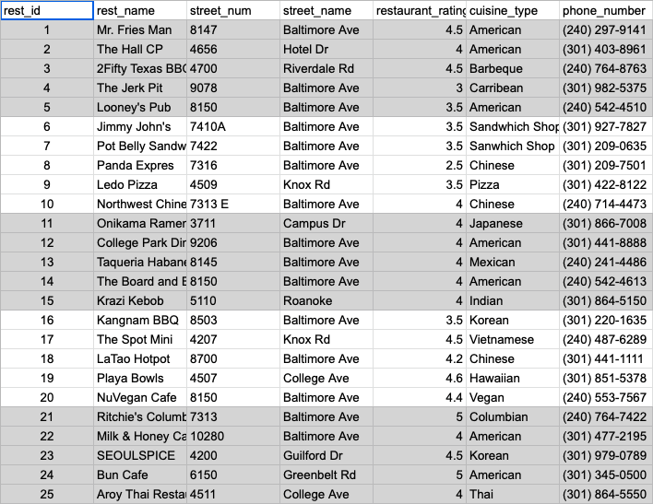

**Image 3:Snippet of our Menu_Items_Restaurants table:**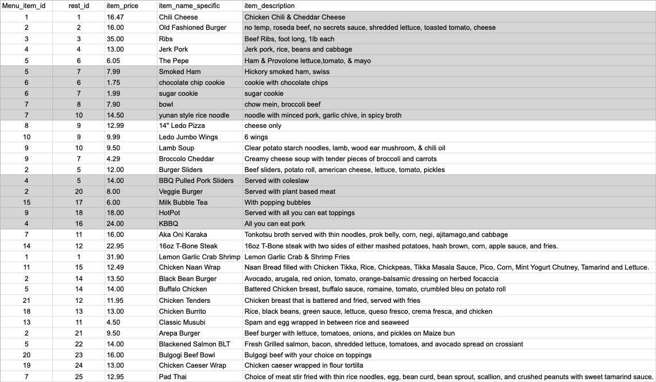

**Image 4: Snippet of our Menu_Items table:**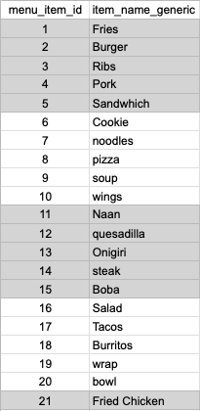

**Image 5: Snippet of our Delivery_Options_Restaurants Table:**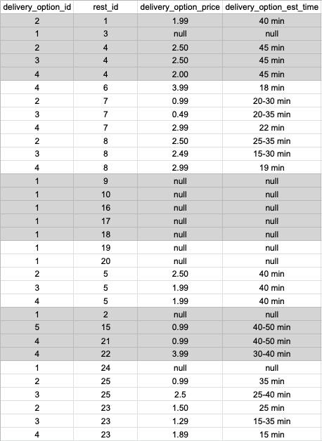

**Image 6: Snippet of our Delivery_Options table:**

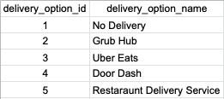

**Image 7: Snippet of our Available_Positions_Restaurant**

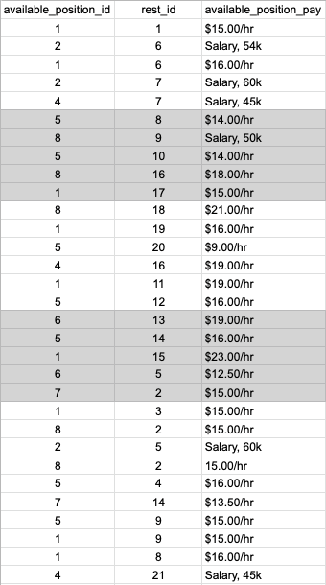

**Image 8: Snippet of our Available_Positions table:**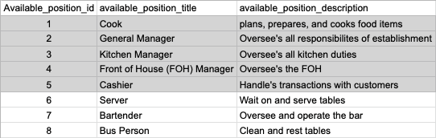

# Views / Queries:

| **View Name** | **Req. A** | **Req. B** | **Req. C** | **Req. D** | **Req. E** |
| --- | --- | --- | --- | --- | --- |
| restaurants_serving_noodles | X | X |  | X |  |
| Burgers_on Baltimore | X | X | X | X |  |
| number_restaurants_hiring_cashier | X | X | X | X |  |
| restaurants_using_grub_hub | X | X |  | X | X |
| generic_item_amount_average | X |  | X |  |  |
| **TOTAL** | **5** | **4** | **3** | **4** | **1** |

**The following list describes what each query we wrote for our database displays:**

**Query 1:** Creates a view that shows which restaurants serve noodles.

**Query 2:** Creates a view for restaurants that sell burgers on Baltimore Ave.

**Query 3:** Creates a view of restaurants that are hiring cashiers

**Query 4:** Creates a view of restaurants that use Grub Hub for delivery service.

**Query 5:** Creates a view of the average cost range.

**Changes from the original design:**

Several changes have been made to our database from our initial proposal, primarily designed around protecting user security. Given the scope of our deliverable and our mission to the community, we made the decision to remove all semblances of PII in our database and instead generalized all information. This had the greatest impact on the available positions table, whereas before there was information on applicants to each of the restaurants and included information such as their name, phone, and address. Another database change came once we started to think about the views we would create of information in our database. The menu_items table used to have an extra column with the restaurant ID number, however, the item name had redundancies with the same name under different restaurant ID numbers, creating an unnecessary one-to-many relationship which made querying difficult. We decided to change to only having one column with a primary key value called menu_item_id which can be referenced in our larger table menu_items_restaurants which goes into more depth about the different variations of foods at restaurants. For example, there can be a burger menu item yet one restaurant has a beef burger and another restaurant has a veggie burger, but it all falls under the menu_items_id corresponding to the burger.

**Database Ethics Considerations:**

An important consideration that our database needs is security, especially if it will be used in practice. Only trained database administrators from each of the specific restaurants should have the authority to make changes to information about their restaurant only. Furthermore, we hope that with this increased transparency, the restaurants will proactively manage their in-house and back-end activities in the exact same way. Given the current economy; it would be common, but unethical for a menu item to be at a higher price in the restaurant than it is listed on our database. This extends to our available positions table in our database where we list positions and their wages, we hope that these restaurants will accurately offer potential employees accurate wages based on what is being advertised.

**Lessons Learned:**

There were times when we were brainstorming ideas for database design and the logical flow of the relationships between the tables. And our initial draft was either redundant or irrelevant. After the week of learning normalization, we were able to make sense of our tables and organize our database to be more efficient. Updating the database with the team continuously was initially difficult. We decided to delegate parts of the tables and delegate the tasks and update any of our changes asynchronously to our GroupMe group chat.

Populating the table for hiring information was a challenge because we didn’t have any actual data regarding that for each restaurant. So we had to create the best relevant information to emulate the realism of the data we have in our database.

Initially, we were having trouble creating the tables on their own and connecting primary and foreign keys to other tables. After we learned how to forward and reverse engineer using the ERD diagrams, visually and logically we were able to create a database that made sense to our purpose much more easily.

**Potential Future Work:**

Partnering with one of the delivery apps and integrating their actual database into ours would be a huge improvement in regard to realistic statistical analysis. Perhaps getting data on which restaurants are most frequently clicked using the count function could be interesting information. Using the geographic location of each restaurant we could find which locations are most popular with what types of food and geotarget for customers, restaurants, and employees.

# References

*403 Forbidden*. (2022). Potbelly. https://potbelly.com/

A., V. (2022, June 28). *Mr. Fries Man - College Park, MD*. Yelp. https://www.yelp.com/biz/mr-fries-man-college-park

D., S. (2022, May 11). *Panda Express - College Park, MD*. Yelp. https://www.yelp.com/biz/panda-express-college-park-4

E., S. (2022, May 22). *Potbelly Sandwich Shop - College Park, MD*. Yelp. https://www.yelp.com/biz/potbelly-sandwich-shop-college-park-2

*Home - Kang Nam BBQ Sports Bar & Grill*. (2022). Kang Nam. https://www.kangnambbqcollegepark.com

*I Love NuVegan – Where Nutrition Meets Compassion*. (2022). NuVegan. https://www.ilovenuvegan.com

J., A. (2022, July 30). *The Jerk Pit - College Park, MD*. Yelp. https://www.yelp.com/biz/the-jerk-pit-college-park

Jimmy John’s. (2021). *Jimmy John’s | Order Sandwiches for Delivery or Pick Up*. https://www.jimmyjohns.com/

*Latao Hot Pot Rstaurant*. (2022). Latao Hotpot. https://lataohotpot.com

Ledo Pizza. (2022, March 23). *Ledo Pizza | Carryout Experts Since 1955 | Pizza Near Me*. https://ledopizza.com

*Looney’s Pub | College Park*. (2021). LooneysPub. https://www.looneyspubmd.com/college-park

M., L. (2022, July 2). *The Hall CP - College Park, MD*. Yelp. https://www.yelp.com/biz/the-hall-cp-college-park-2

*NORTH WEST CHINESE FOOD - COLLEGE PARK, MD 20740 (Menu & Order Online)*. (2022). Https://Www.Northwestchinesefood.Com/Order#/. https://www.northwestchinesefood.com/order#/

O., G. (2022, August 3). *Northwest Chinese Food - College Park, MD*. Yelp. https://www.yelp.com/biz/northwest-chinese-food-college-park-3

*Onikama Ramen Bar*. (2022). Onikama Ramen Bar. https://www.onikamaramenbar.com/

*Order Online*. (2018). Krazi Kebob. https://www.krazikebob.com/?location=11ebbcab015218fd8474ac1f6bbbcc9c

*Panda Express - An American Chinese Restaurant*. (2021). Panda Express. https://www.pandaexpress.com

Playa Bowls. (2022, July 30). *Home*. https://www.playabowls.com

*The Spot Mini*. (2022). The Spot. https://www.thespotmini.com

*Taqueria Habanero*. (2022). Taqueria Habanero. https://www.taqueriahabanero.com/

W., L. (2014, May 5). *Jimmy John’s - College Park, MD*. Yelp. https://www.yelp.com/biz/jimmy-johns-college-park

W., L. (2022, March 14). *Ledo Pizza - College Park, MD*. Yelp. https://www.yelp.com/biz/ledo-pizza-college-park-2

Yang, J. (2022, January 1). *Home*. The Board and Brew. https://www.theboardandbrew.com/