System Requirements

Core HW Requirements
- 16GB RAM
- 100 GB+ HD
- Network Access to Internet

Core OS Requirements – Windows Based
- Windows 11
- WSL2 and Virtual Machine Platform – Windows Hypervisor Platform is not required.
- WSL2 Based Ubuntu 24.04 App installed
- Docker Desktop for Window – with WSL2 Integration with Ubuntu 24.04

SW Requirements – Windows Based
- VS Code
- Terraform
- GIT Client with git command line interface and git bash support
- AWS CLIs – Core AWS CLI, SAM CLI, EB CLI

Core OS Requirements – Ubuntu 24 Based
- Ubuntu 24.04
- GIT client
- Sudo access to install docker, Kubernetes and Other SW
- Optional – GUI Desktop – to ease use of Linux Based Machines

SW Requirements – Windows Based
- VS Code – If GUI is present
- Terraform
- AWS CLIs – Core AWS CLI, SAM CLI, EB CLI – Note for EB CLI, you will also require Python.

Developer SW
- Node.JS V22 (Even Numbers LTS Releases)
- OpenJDK 17
- Maven
- VS Code Extensions for Java, Node and Maven.
- VS Code extensions – AWS Toolkit and AWS Toolbox
- Nice to have but purely optional – Terminal with Nerd Fonts Installed.
- Nice to have but purely optional – Oh My Posh and Clink

Notes
- Other SW including Jenkins, Mini Kube, Nexus, Prometheus, Grafana, Loki and ELK will be installed as Docker Containers.
- Maven and NuGet builds will require access to the internet
- The following services accounts are required
  - GitHub/GitLab account – It is recommended that Users have inserted SSH keys into their respective GitHub/GitLab accounts
  - Optional – recommended – Docker Hub Account – Personal
  - AWS Account – Usage will be via non-root IAM account.

Notes on AWS Accounts
- AWS Usage are liable to be chargeable and require a valid Credit card to activate accounts. Charges incurred, if any, by using non free tier resources, are the responsibility of users.

PLEASE READ THIS BEFORE PROCEEDING
- Only install SW from the links provided by your organization.
- If Any of the below software is not listed in the approved list of SW by your organization, please do not install it – instead talk to your course coordinator on alternatives.

Installing the Software on Windows
Refer to the links provided by Amazon itself on where to obtain the SW. Here is the recommended installation steps. NB: These instructions are for Windows Machines. On Macintosh, there is no need to install Bash or WSL.
- Install WSL2 and BASH
Navigate to Control Panel->Programs->Programs and Features->Turn Windows Features on or off. Ensure that your system does have the following checked.
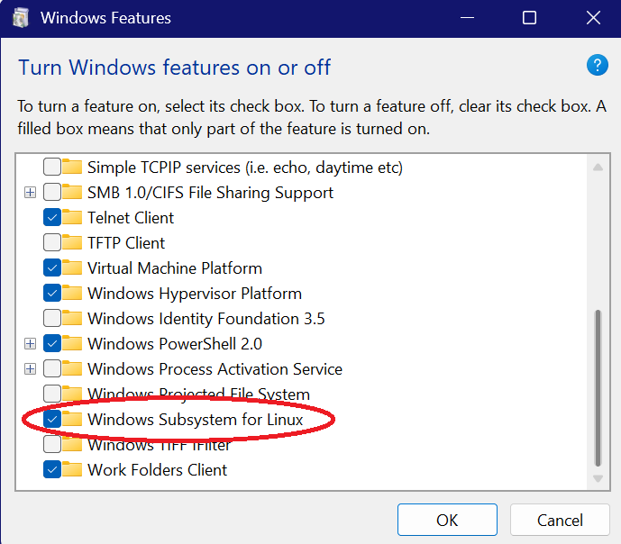
It may ask you to restart your machine. Once done and rebooted, you can verify this by opening a command prompt
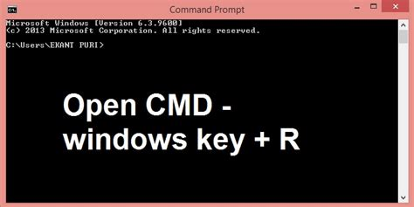

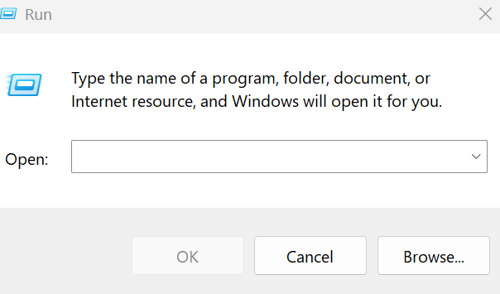
Type cmd and Press OK to stat a command prompt.
At the command prompt, either wsl or bash should display a bash window. You could alternatively use the Windows Appstore to install Ubuntu (search for it and click install)
- Install GIT on Windows
Use the recommended link provided by Amazon. Double click on the installer and just use the defaults. From a command prompt, use the following commands
- git config –global user.name <your git name>
- git config –global user.email <your email address>
That’s it.
- Install Docker for Desktop on Windows
Use the recommended link provided by Amazon. Double click on the installer and just use the defaults. Reboot the machine if required.
Optional - If you have Ubuntu installed, enable WSL2 integration for Docker for each Ubuntu installation. That way, if you run an Ubuntu terminal, you can still use docker.
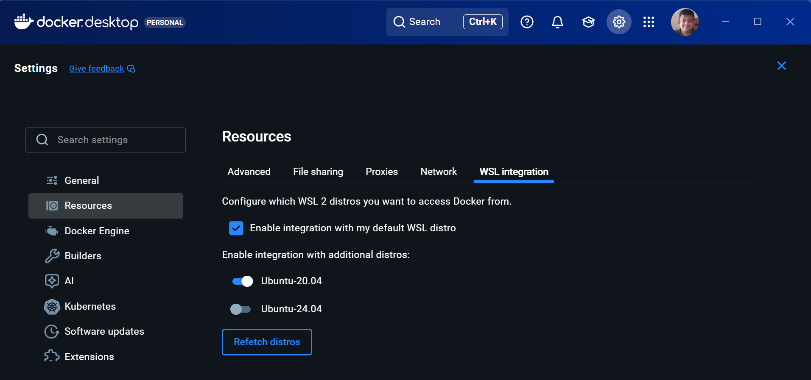
In the above, I have Docker integrated with Ubuntu 20.04 but not for Ubuntu 24.04.
- Install JDK and Maven on Windows
For JDK, use the default installer link provided by your organization.
In Control Panel, go to System
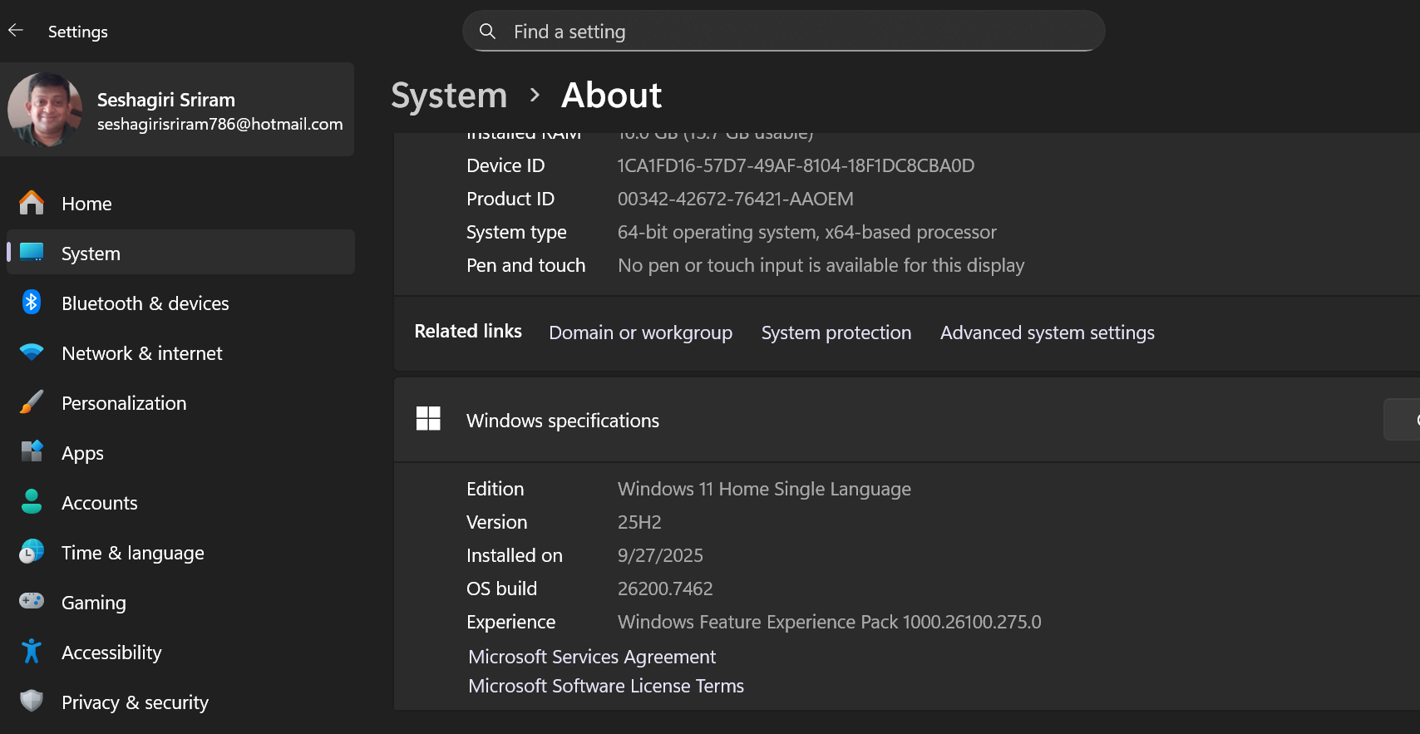
Click on Advanced System Settings.
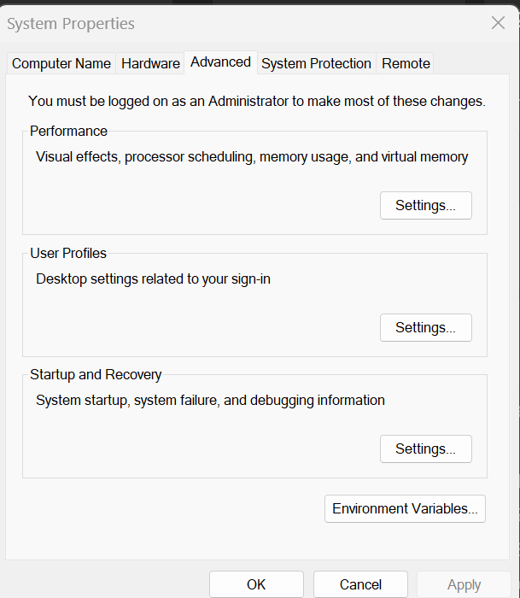
Choose Environment Variables and add an entry for JAVA_HOME to point to the folder where you have installed JDK.
Edit PATH variable to include %JAVA_HOME%\bin
Maven does not have an installer. Instead unzip the file from link provided by your organization.
Similar to JAVA settings, add an environment variable MAVEN_HOME to include the folder where you have unzipped Maven. Similarly edit PATH variable to include %MAVEN_HOME%\bin
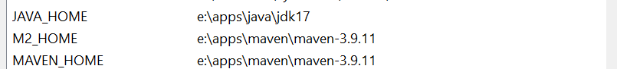
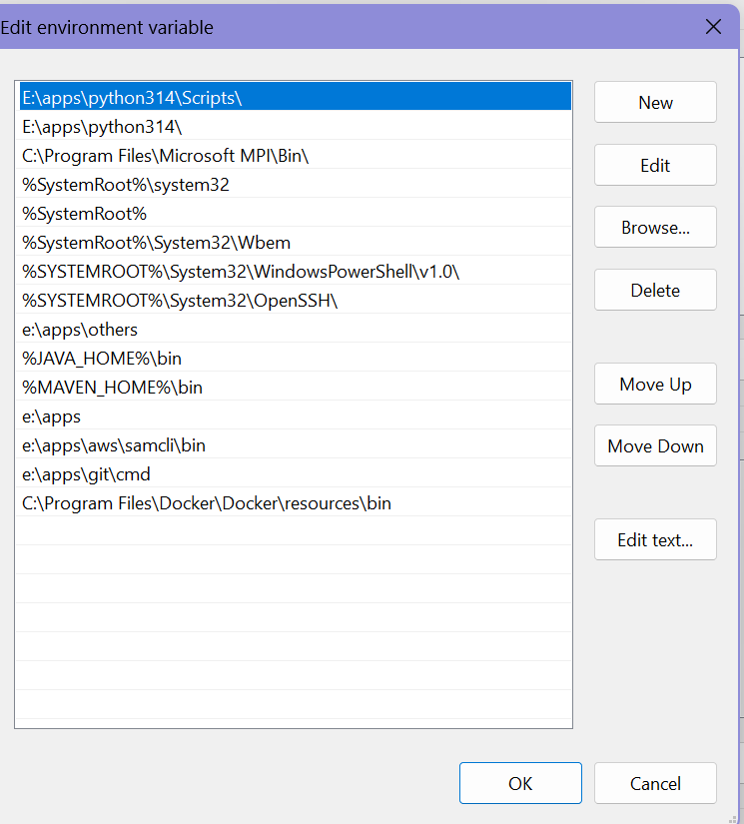

- Install NPM and Node JS
The preferred way is to install nvm. If you are working only with one version of Node, then download the installer from the links provided by your organization. That’s it.
If you plan on using nvm, install NVM from the approved link provided your organization. This would typically be:
https://github.com/coreybutler/nvm-windows/releases
Double click the executable, change install directories if needed. That’s it.
From a command prompt, type
nvm –version
nvm list available
To install say Node.js 24.12.0 as an example, type
nvm install 24.12.0 https://docs.aws.amazon.com/cli/latest/userguide/getting-started-install.html
nvm use 24.120
Both node.js and npm will be installed. Enjoy !
- Install Python 3
On Windows, download the Python installer from approved links. Double click on the installer, choose all defaults (or change as required). (NB: Python is required for AWS CLI and other AWS Product CLI)
- AWS and AWS Product CLI
Refer to the documentation here (https://docs.aws.amazon.com/cli/latest/userguide/getting-started-install.html) for AWS CLI.
For AWS Elastic Bean CLI, refer here (https://docs.aws.amazon.com/elasticbeanstalk/latest/dg/eb-cli3.html). It is recommended that this be installed in a virtual environment to avoid clashes with other PIP packages.

Macintosh Notes
On Macintosh, the default shell used in zsh. The examples we present should largely work in zsh also. If not, you can always run bash using bash at terminal (Be aware that its’ an older version of bash due to licensing restrictions)
Installing git and docker on Mac
Mac machines come pre-installed with git. However, git –version may prompt you to install Xcode Command line Tools (not to be confused with the full Xcode IDE). To summarize it,
Tool | Needs Xcode? | Alternative Install | Typical Size | Notes
Git | ❌ Full Xcode not required (only lightweight Command Line Tools if using Apple’s preinstalled Git) | Homebrew (brew install git) or git-scm.com | ~50–100 MB via Homebrew | Homebrew gives latest version
Docker | ❌ No Xcode needed | Docker Desktop app | ~500 MB | Requires macOS ≥ Catalina, 4 GB RAM
Nvm | ❌ No Xcode needed | Homebrew (brew install nvm) | ~5 MB | Manages multiple Node.js versions
JDK | ❌ No Xcode needed | Homebrew (brew install openjdk) | ~200 MB | OpenJDK version
Maven | ❌ No Xcode needed | Homebrew (brew install maven) | ~50 MB | Java build tool

Key Takeaways for Macintosh
- Skip full Xcode **unless** you’re developing iOS/macOS apps.
- For Git, use Homebrew to avoid Xcode prompts.
- For Docker, just install Docker Desktop — no Xcode involvement.
- For Node.js, use nvm to manage versions cleanly.
- For Java development, install OpenJDK and Maven via Homebrew.

What about MobaXTerm?
This is not required as we are not using any GUI functionality.
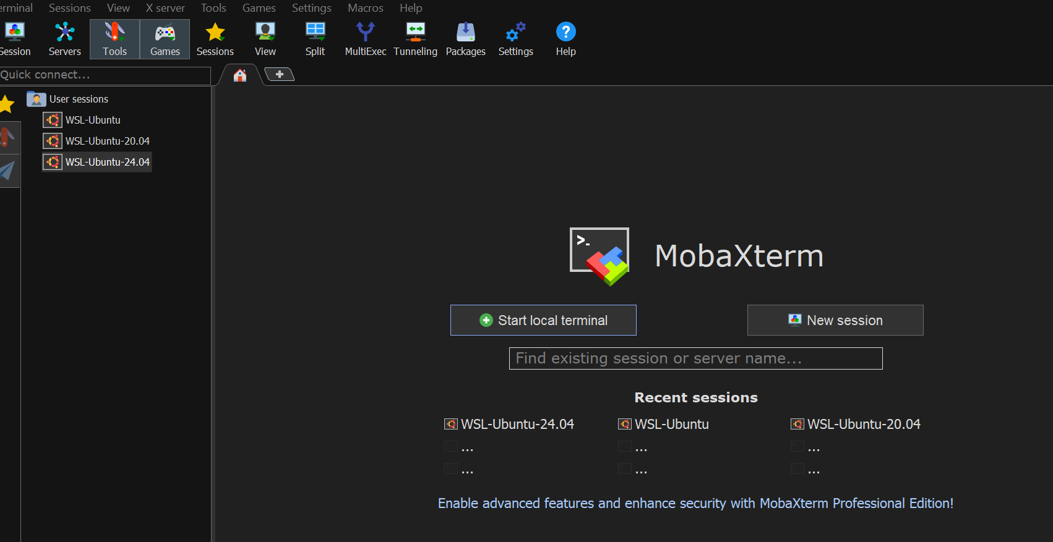
You do have the benefit that you can start a local terminal or use any existing WSL Distro.

