Air Quality Pollution Level Classification Using Machine Learning Algorithms

Abstract: Air pollution contributes to significant health and environmental hazards in the world. This paper utilizes machine-learning techniques to categorize NO₂-based air-quality levels based on 18,862 records of spatial and temporal characteristics. The three classes of pollution (low, medium, and high) were compared using Logistic Regression, SVM (RBF), and optimized KNN. The models were very successful, with the accuracy of 98.33%, 97.56%, and 95.92% respectively. The dynamic change over time and spatial hotspots identified the areas that required immediate attention. Outlier management and time feature engineering were very effective in enhancing performance. The results have implications for the real-world use of air-quality measurements and city environmental management.
Keywords: Air Quality Classification, Machine Learning, Nitrogen Dioxide (NO₂), Logistic Regression, Support Vector Machine (SVM).

Introduction
The air pollution affecting the world has increased due to rapid urbanization, industrial development, and fossil fuel use, and one of the pollutants, including PM2.5, PM10, CO₂, NO₂, and SO₂, is highly associated with respiratory, cardiovascular, and death, making it important to provide precise air-quality predictions (Hardini et al., 2023). Conventional monitoring and simulation strategies tend to fail in complexity and uncertainty, but machine-learning mechanisms are able to capture non-linear pollution trends. Random Forest, SVMs, neural networks, and ensemble models are among the algorithms that demonstrate high predictive performance (Madan et al., 2020). Recent studies also show that LSTM and hybrid models are temporally capturing and predictive of traditional regression-based and tree-based approaches. The current project is thus the application of machine learning to the air-quality forecasting task and enhance health and environmental planning.

Problem and Dataset Description
Problem Statement:
The Air-Quality involves the necessity to correctly classify nitrogen-dioxide-based air pollution over time and place, to allow uninterrupted monitoring, more precise health warnings, more precise pollution management, and improved urban planning and policy-making to safeguard human health.
Dataset Characteristics:
The data in this study are recorded in the form of environmental monitoring stations in Figure 1, where there are 18,862 observations and 12 variables, which include the time, space, and measurement data. The nitrogen dioxide (NO 2) is the major pollutant, and the pollution has three target levels.
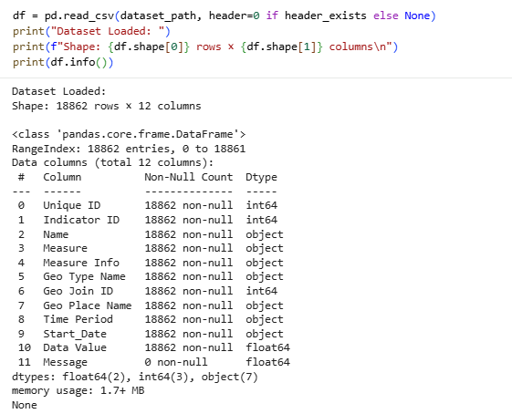
Figure 1 Dataset Loading and Structural Overview
The dataset structure includes:
The data includes the early date, seasonal measurement period, location, geo-type, and measurement of NO₂ ppb values, and Metadata, including unique identifier, indicator ID, measure type, and descriptive information.
Data Distribution and Patterns:
According to Liang et al. (2023), a sample of the dataset presented in Figure 2 indicates a variety of regions and districts, which facilitate a full examination of spatial pollution patterns.
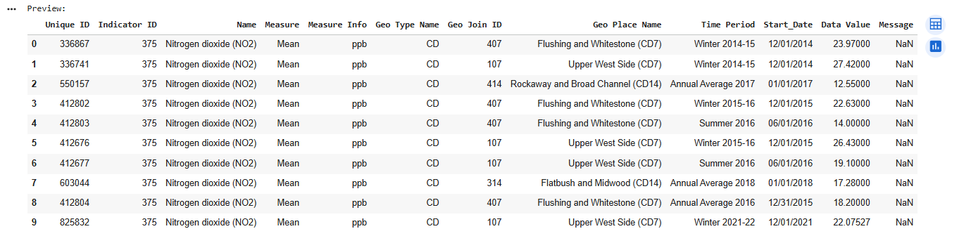
Figure 2 Preview of Initial Dataset Records
The descriptive statistics presented in Figure 3 demonstrate a large variability in the levels of NO₂, with a mean of 21.05 ppb and a large range of measurements (Jain et al., 2022).
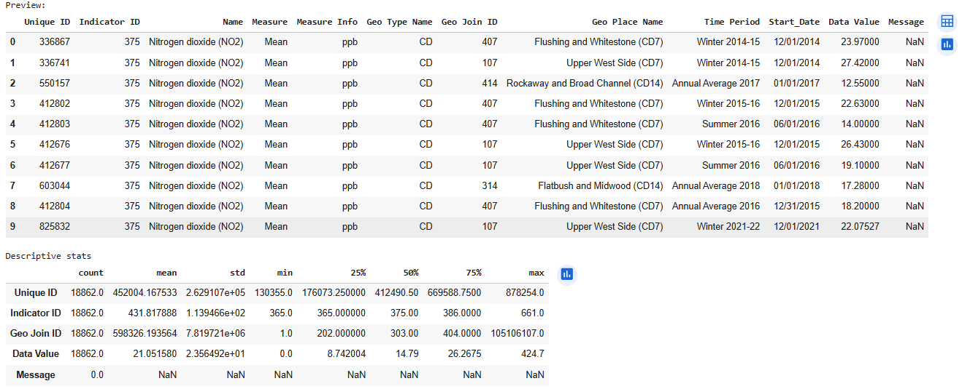
Figure 3 Dataset Preview and Descriptive Statistics
Significance:
The classification problem will be useful in promoting early warning of health (Meckawy et al., 2022), environmental justice, effective policies, and better urban planning, through machine-learning models, temporal feature engineering, and strict validation, to analyze spatial-temporal patterns of pollution.

Methods
The three machine learning algorithms that are applied to classify the pollution levels are listed in this section, and each has a different theoretical background and computational properties.

Logistic Regression
The multinomial model based on maximum likelihood and Logistic Regression is an efficient and interpretable predictor, according to Pate et al. (2023), as it estimates the probability of each class and picks up the highest one, which gives some simple and useful probabilistic measure of confidence.
The model setup is shown in figure 4 with a multinomial model, 1000 iterations, equal weights of the classes, and a fixed random state of 42.
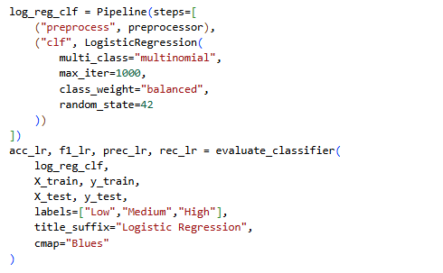
Figure 4 Logistic Regression Pipeline

Support Vector Machine (SVM) with RBF Kernel
RBF-kernel SVM is able to represent complex non-linear boundaries with the mapping of data to higher dimensions, maximizing the class margins, the use of similarities (C, 2025) with the help of kernels, and the ability to represent high-dimensional data with minimal sensitivity to outliers.
The SVM model represented in Figure 5 has an RBF kernel, balanced class weights, and a random state of 42, allowing it to make probability estimates.
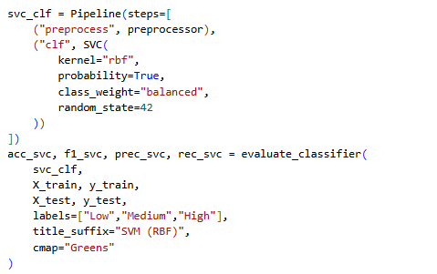
Figure 5 SVM Model Pipeline

K-Nearest Neighbors (KNN)
KNN is a non-parametric, instance-based clustering classifier, which is based on k and distance and optimized with SMOTE and GridSearchCV with tuned neighbors, weights, and p-values.
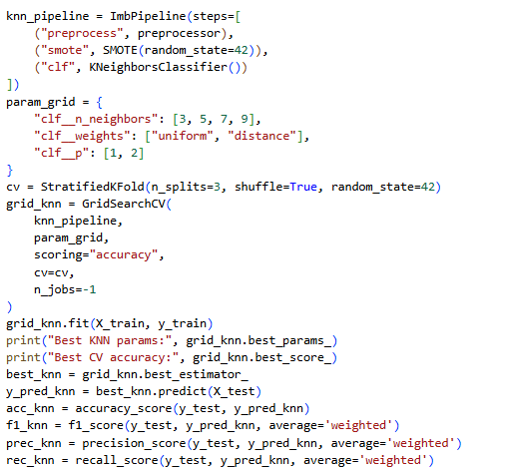
Figure 6 KNN Grid Search Pipeline
Distance weighting provides a greater weight on the neighbors that are closer, which suits the pollution patterns. All of the models, according to Zhou et al. (2024), were applied to scikit-learn, which allows them to compare linear, non-linear, parametric, and non-parametric methods of learning.

Experimental Setup
Data preprocessing consisted of deleting the column with all-missing values and getting rid of duplicates, and performing the IQR-based outlier capping. The engineered features were temporal (year, month, weekday, season). StandardScaler/OneHotEncoder used, an 80-20 stratified train-test split used to maintain class balance.

Data Preprocessing
Early data quality evaluation showed that there were severe problems that needed to be fixed:
Missing Value Analysis:
According to Emmanuel et al. (2021), the missing value analysis in Figure 7.
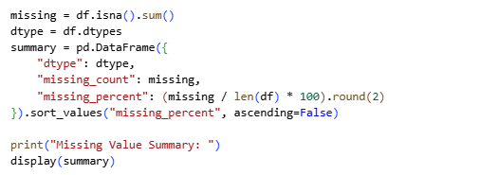
Figure 7 Checking Missing Values
Full data are provided in Figure 8, which shows that the Message column has 100% missing values (18,862 missing entries), and the "Message" feature is then deleted.

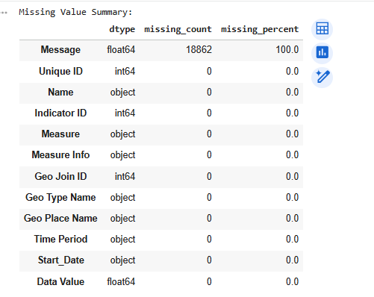
Figure 8 Missing Value Summary Table
The absence of duplicates, the elimination of the Message column, and the integrity of the dataset are proven in Figure 9.
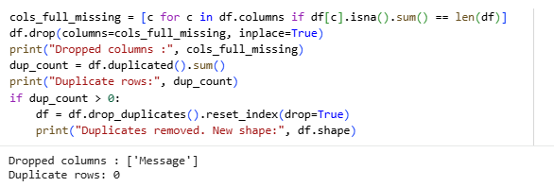
Figure 9 Removal of Missing and Duplicate Data

Temporal Feature Engineering
Temporal feature engineering was also an essential part, which converted raw data into valuable patterns:
The use of the temporal features (year, month, day, weekday, weekend) allowed a more in-depth look at the trend, which showed the distinct seasonal, daily, and weekly trends in air-quality indicators, as in Figure 10.
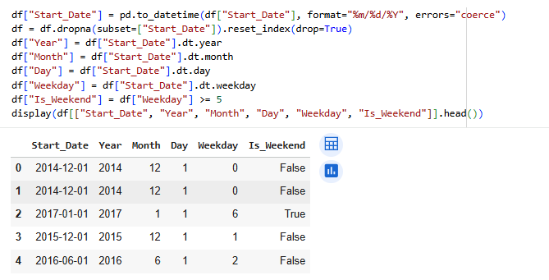
Figure 10 Date Feature Extraction Output
The feature of Season introduced in Figure 11 classifies the time periods, based on Winter, Spring, Summer, Fall, or Unknown, which allows better temporal grouping when measurement periods are different.
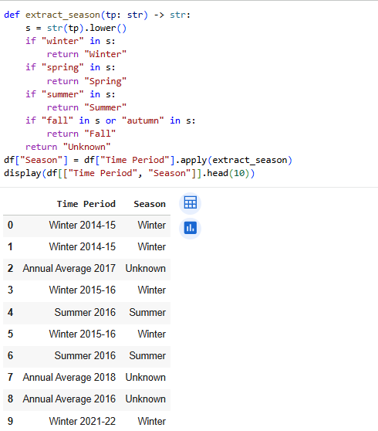
Figure 11 Season Extraction from Time Period

Exploratory Data Analysis
Distribution Analysis:
According to Pozzer et al. (2022), the distribution of pollution measurements in Figure 12 is skewed to the right, and the majority of the values fall within the 1020ppb range, with a long tail to the right exceeding 400ppb.
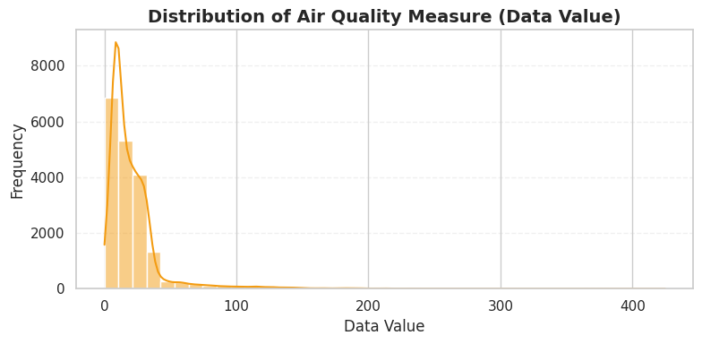
Figure 12 Distribution of Data Values
Geographic Analysis:
The mean pollution distribution, as shown in Figure 13, is balanced between geo types, though UHF+2, Borough, and Citywide have the highest contribution, and therefore, geo type alone does not hold much discriminative power (Salari, 2024).
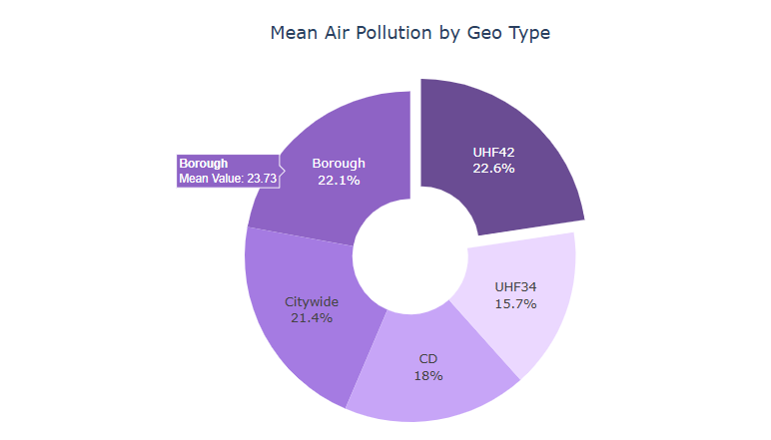
Figure 13 Mean Air Pollution by Geo Type
The Geographic analysis in Figure 14 cited the hotspots of pollution: High Bridge-Morrisania (38.11 ppb), Hunts Point-Mott Haven (36.74 ppb), and Crotona-Tremont (36.19 ppb). East Harlem, Central Harlem, the Bronx, and Manhattan came next with a concentration of between 28-34 ppb, which reveals areas that need specific environmental action.

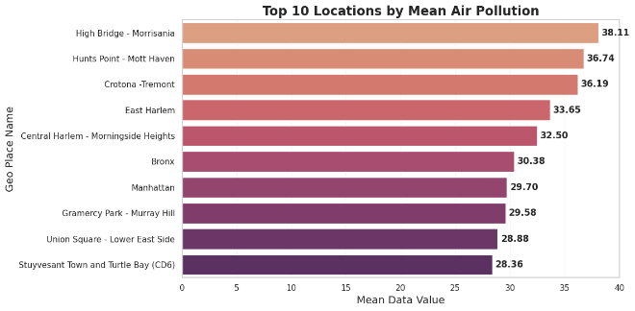
Figure 14 Top Locations by Mean Air Pollution
According to Figure 15, an unfavorable annual pollution rate is observed between 2005 and 2022, with 2006 being the highest and 2018 being the lowest, a measurable enhancement of the management of the environment.
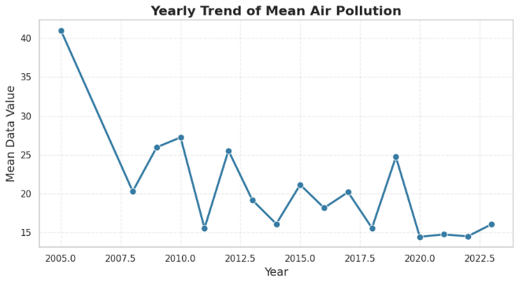
Figure 15 Yearly Trend of Mean Air Pollution
Correlation Analysis:
The analysis in Figure 16 indicates fewer correlations between numeric features, with only some strong or moderate relationships. The majority of features demonstrate a weak correlation with pollution levels (Sakaa et al., 2022); hence, all were kept to represent possible nonlinear interactions.
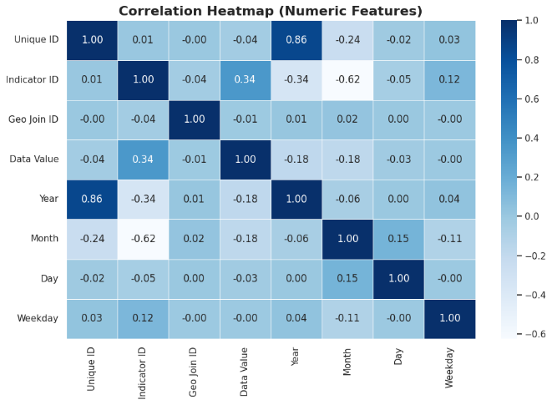
Figure 16 Correlation Analysis of Numerical Variables
Pollutant Analysis:
Pollutant box plots with different ranges of concentration, observable outliers, and distribution statistics are presented in Figure 17, with nitrogen dioxide (NO₂) as the ultimate pollutant of interest.
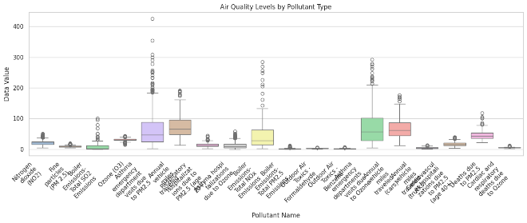
Figure 17 Air Quality Levels by Pollutant Type
Outlier Treatment:
The outlier-capping technique of IQR (Praveen et al., 2024) used in Figure 18 employs group-wise bounds to cap extreme values to prevent skewing distribution at the expense of the total distribution, and lowers the algorithm sensitivity to unusually large values.
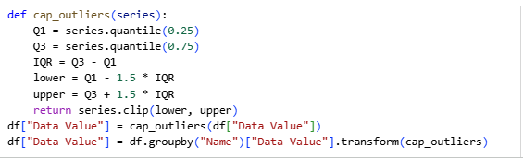
Figure 18 IQR-Based Outlier Capping
The result of the outlier treatment, as reflected in Figure 19, is that there are fewer extreme values, and the overall distribution remains intact, and the data integrity is maintained.
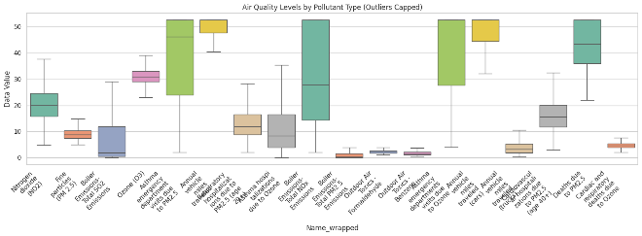
Figure 19 Pollutant-wise Air Quality After Outlier Capping
The distribution of low, medium, and high pollution levels in figure 20 is balanced, making learning in all classes fair and without bias.
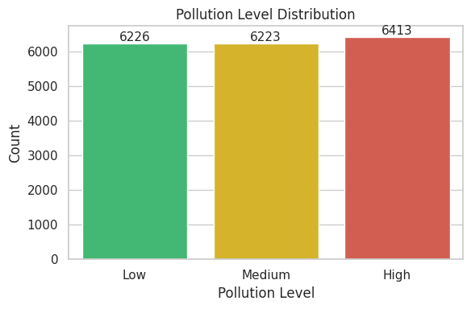
Figure 20 Pollution Level Distribution

Data Transformation and Splitting
Train-Test Split:
The 80-20 stratified split in Figure 21 has maintained class balance, fixed random state, and the same shape of training and testing datasets.
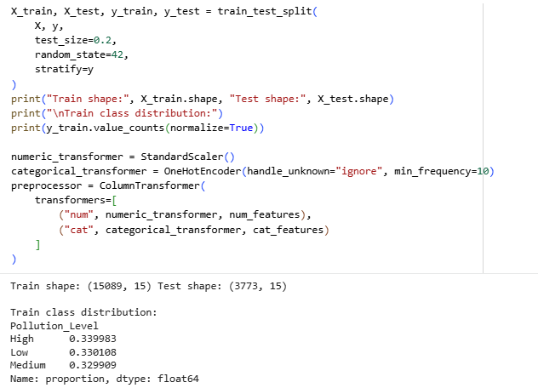
Figure 21 Train–Test Split Summary
StandardScaler is used in the preprocessing pipeline on the numeric features, whereas OneHotEncoder is used in the categorical fields to provide a balanced scaling of features as well as a standard transformation using a single ColumnTransformer.

Evaluation Methodology
The accuracy, precision, recall, F1-score, confusion matrix analysis, and cross-validation were evaluated in a comprehensive way and considered a measure of model performance, prediction reliability, and generalization ability (Owusu-Adjei et al., 2023).

Results
Performance of the logistic regression will be evaluated by comparing the number of correct predictions with the number of incorrect ones.

Logistic regression performance
The logistic regression performance will be assessed by comparing the number of correct predictions to the number of incorrect ones.
The model performance indicated in Figure 22 is 98.33% accuracy, with relatively high values of precision, recall, and F1-scores among all classes of pollution, and supported by macro and weighted averages of 0.98.
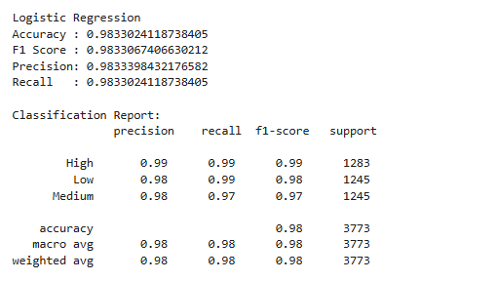
Figure 22 Logistic Regression Performance Metrics
The confusion matrix is presented in Figure 23, indicating that most of the predictions are correct and the misclassifications are within the same categories, with no Low-High or High-Low errors.
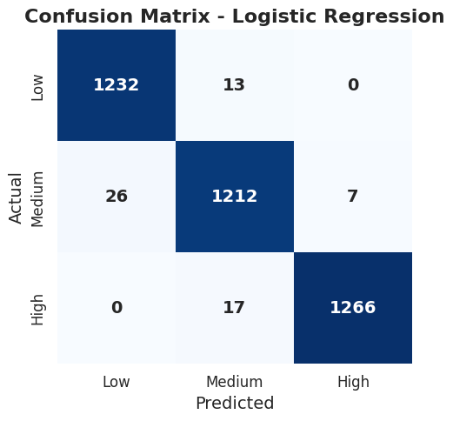
Figure 23 Logistic Regression Confusion Matrix
The SVM in figure 24 is 95.92% accurate with high precision and recall on all pollution classes and macro and weighted averages of 0.96.
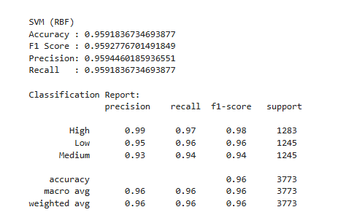
Figure 24 SVM (RBF) Model Performance Summary
The SVM confusion matrix is presented in Figure 25, where most predictions were accurate, and misclassifications were largely between Low-Medium and Medium-High, as the borderline cases between Medium and High were more challenging to classify.
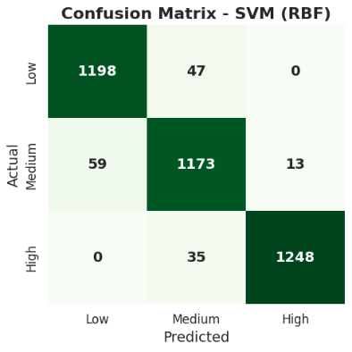
Figure 25 Confusion Matrix for SVM (RBF) Model

Optimized K-Nearest Neighbors Performance
The best KNN with optimized results in Figure 26 provides a test accuracy of 97.56% and a high cross-validation of all pollution classes with high precision and recall values of all pollution classes with tuned parameters.
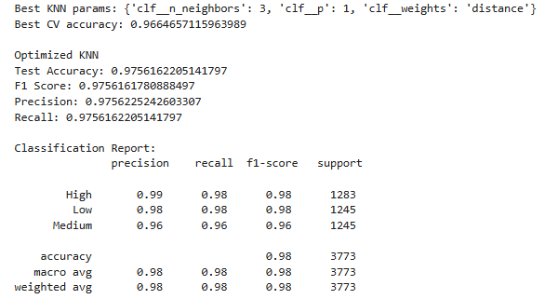
Figure 26 Optimized KNN Classification Performance Summary
The KNN confusion matrix in Figure 27 has been optimized, and most predictions are correct with few misclassifications, and only one extreme High-to-Low error.
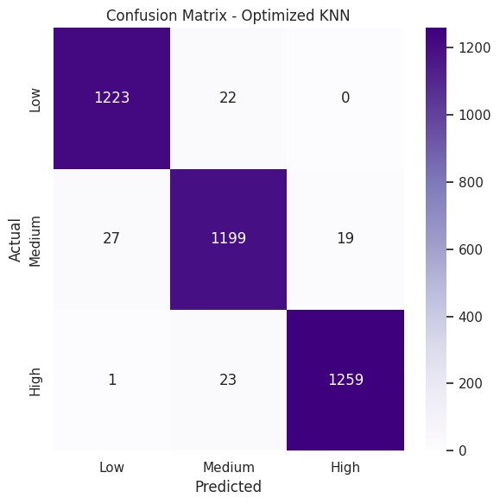
Figure 27 Confusion Matrix for Optimized KNN Model

Comparative Analysis
All models are compared in Figure 28 with the lowest accuracy difference between Logistic Regression and optimized KNN and SVM, and high precision, recall, and F1-scores across algorithms.
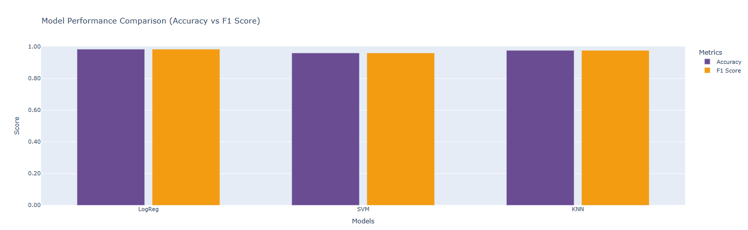
Figure 28 Model Performance Comparison

Dimensionality Reduction Visualization
PCA-based visualization of KNN predictions in Figure 29 indicates that there are distinct clusters of pollution levels with slight overlap of Medium, which confirms that the features extracted are meaningful.
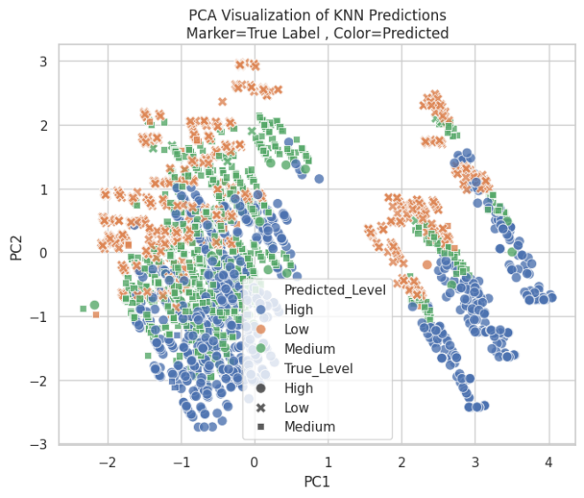
Figure 29 PCA Plot of KNN Classification Results
The misclassified samples in Figure 30 are mostly in cluster overlap areas, which suggests the boundary-zone ambiguity where the classes have close feature values, which makes it difficult to separate them.
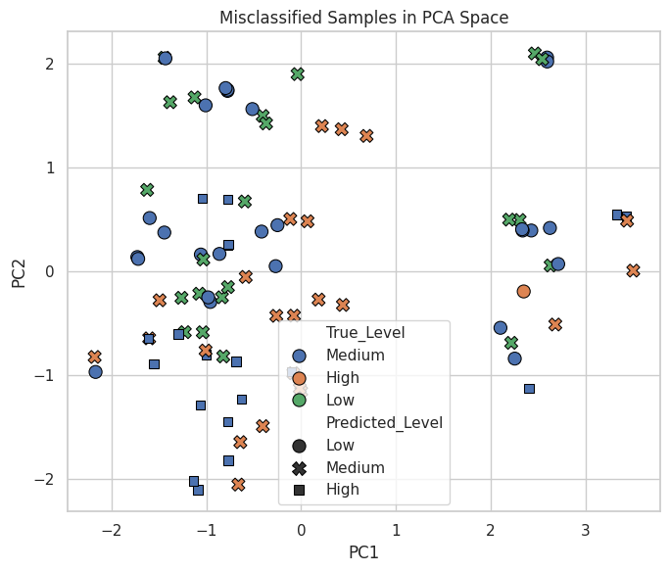
Figure 30 PCA Visualization of Misclassified Samples

Cross-Validation Analysis
Additional evaluation in Figure 31 demonstrates that ROC-AUC is significant, and cross-validation scores are stable, which supports strong generalization, and these scores are consistent over subsets of data.
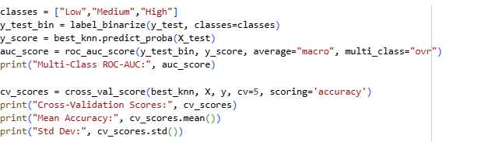
Figure 31 KNN ROC-AUC and Cross-Validation Results

Discussion and Conclusions
The machine-learning models achieved an accuracy of more than 95%, with the best results with Logistic Regression (98.33%), tuned KNN (97.56%), and SVM (95.92%). The temporal analysis revealed a downward trend in pollution from 2006 to 2022, whereas the spatial pattern revealed hotspots. The majority of the misclassifications were within related classes, which implies boundary ambiguity. The system helps in real-time monitoring, health alerts, and policy assessment, but dependence on individual pollutant data and simplified labels is still a limitation. Multi-pollutant modelling, deep learning, and adaptive systems should be incorporated in future work. The research study demonstrates that machine-learning models can effectively classify air quality levels, enabling environmental monitoring and protecting people's health. Powerful preprocessing, time feature engineering, and model optimization created reliable systems that were ready to the real world. This will be further improved by expansion to multi-pollutant and real-time approaches K-Nearest Neighbors (KNN), Environmental Monitoring.

References

Bilal, O., Mohammad, T. and Hakkala, A. (2025). Anomaly Detection and Prevention in IoT Using AI. [online] Available at: https://www.utupub.fi/bitstream/handle/10024/182739/Bilal_Osama_Thesis.pdf?sequence=1 [Accessed 24 Nov. 2025].
C, P. (2025). Transforming Clustered Non-Linearly Separable Data using Nonlinear Mapping Functions in SVM for Enhanced Classification. EKSPLORIUM-BULETIN PUSAT TEKNOLOGI BAHAN GALIAN NUKLIR, [online] 46(1), pp.1446–14571446–1457. Available at: https://eksplorium.com/index.php/journal/article/view/174 [Accessed 24 Nov. 2025].
Emmanuel, T., Maupong, T., Mpoeleng, D., Semong, T., Mphago, B. and Tabona, O. (2021). A survey on missing data in machine learning. Journal of Big Data, [online] 8(1), pp.1–37. doi: https://doi.org/10.1186/s40537-021-00516-9
Jain, N.D., Bergi, J. and Trivedi, R. (2022). A Comparative Study Focusing the Effect of Criteria Pollutants, Volatile Organic Compounds and Meteorological Parameters on Ambient Air Quality of Various Cities of India. Applied ecology and environmental sciences/Applied ecology and environmental science, [online] 10(3), pp.131–146. doi: https://doi.org/10.12691/aees-10-3-9
Liang, L., Daniels, J., Bailey, C., Hu, L., Phillips, R. and South, J. (2023). Integrating low-cost sensor monitoring, satellite mapping, and geospatial artificial intelligence for intra-urban air pollution predictions. Environmental Pollution, [online] 331, p.121832.doi: https://doi.org/10.1016/j.envpol.2023.121832
Madan, T., Sagar, S. and Virmani, D. (2020). Air Quality Prediction using Machine Learning Algorithms –A Review. 2020 2nd International Conference on Advances in Computing, Communication Control and Networking (ICACCCN). doi: https://doi.org/10.1109/icacccn51052.2020.9362912
Marviola Hardini, Richard Andre Sunarjo, Marsani Asfi, Riza, H. and Yulia Putri Ayu Sanjaya (2023). Predicting Air Quality Index using Ensemble Machine Learning. ADI Journal on Recent Innovation (AJRI), 5(1Sp), pp.78–86. doi: https://doi.org/10.34306/ajri.v5i1sp.981
Meckawy, R., Stuckler, D., Mehta, A., Al-Ahdal, T. and Doebbeling, B.N. (2022). Effectiveness of early warning systems in the detection of infectious diseases outbreaks: A systematic review. BMC Public Health, 22(1), p.2216. doi: https://doi.org/10.1186/s12889-022-14625-4
Owusu-Adjei, M., James Ben Hayfron-Acquah, Frimpong Twum and Gaddafi Abdul-Salaam (2023). Imbalanced class distribution and performance evaluation metrics: A systematic review of prediction accuracy for determining model performance in healthcare systems. PLOS digital health, [online] 2(11), pp.e0000290–e0000290. doi: https://doi.org/10.1371/journal.pdig.0000290
Pate, A., Riley, R.D., Collins, G.S., Maarten van Smeden, Ben Van Calster, Ensor, J. and Martin, G.P. (2023). Minimum sample size for developing a multivariable prediction model using multinomial logistic regression. Statistical Methods in Medical Research, [online] 32(3), pp.555–571. doi: https://doi.org/10.1177/09622802231151220
Pozzer, A., Anenberg, S.C., Dey, S., Haines, A., Lelieveld, J. and Chowdhury, S. (2022). Mortality attributable to ambient air pollution: A review of global estimates. GeoHealth. doi: https://doi.org/10.1029/2022gh000711
Praveen, S.P., Hasan, M.K., Huda, N., Uddagiri Sirisha, Mani, K., Islam, S., Rayan, F., Ahmed, T.E., Ayman Afrin Noboni, Sampedro, G.A., Yeun, C.Y. and Ghazal, T.M. (2024). Enhanced feature selection and ensemble learning for cardiovascular disease prediction: hybrid GOL2-2 T and adaptive boosted decision fusion with babysitting refinement. Frontiers in Medicine, 11. doi: https://doi.org/10.3389/fmed.2024.1407376
Sakaa, B., Elbeltagi, A., Boudibi, S., Chaffaï, H., Islam, A.R.Md.T., Kulimushi, L.C., Choudhari, P., Hani, A., Brouziyne, Y. and Wong, Y.J. (2022). Water quality index modeling using random forest and improved SMO algorithm for support vector machine in Saf-Saf river basin. Environmental Science and Pollution Research, 29(32), pp.48491–48508. doi: https://doi.org/10.1007/s11356-022-18644-x
Salari, M. (2024). Exploring the interrelationships between urban form and air quality. figshare. [online] doi: https://doi.org/10.25916/sut.27950043.v1
Zhou, W., Yan, Z. and Zhang, L. (2024). A comparative study of 11 non-linear regression models highlighting autoencoder, DBN, and SVR, enhanced by SHAP importance analysis in soybean branching prediction. Scientific Reports, [online] 14(1), p.5905. doi: https://doi.org/10.1038/s41598-024-55243-x

Appendix
Code File Link:
https://colab.research.google.com/drive/1WW9wCbeKJUu94WoILB2XfPPtRVhuhcIN?usp=sharing

