TEXT IMAGE FUSION MODEL FOR ENTITY RECOGNITION AND RELATION

PREDICTION

A PROJECT REPORT
Submitted by

Harini Muthulakshmi K | 2022506119
Varshini R | 2022506031
Vaishnavi J | 2022506068
Seshavarshan M | 2022506109

Under the supervision of
Dr Sunil Retmin Raj C
In partial fulfillment for the award of the degree of

BACHELOR OF TECHNOLOGY
in
INFORMATION TECHNOLOGY


DEPARTMENT OF INFORMATION TECHNOLOGY MADRAS INSTITUTE OF TECHNOLOGY CAMPUS ANNA UNIVERSITY, CHENNAI – 60004
BONAFIDE CERTIFICATE

Certified that this project report titled “TEXT IMAGE FUSION MODAL
FOR ENTITY RECOGNITION AND RELATION PREDICTION” is the bonafide work of Harini Muthulakshmi K (2022506119), Varshini R(2022506031), Vaishnavi J (2022506068) and Seshavarshan M (2022506109) who carried out the project work under my supervision.

Signature | Signature
Dr. Sunil Retmin Raj C | Dr. Radha Senthil Kumar
SUPERVISOR | HEAD OF THE DEPARTMENT
Teaching Fellow | Professor
Department of Information Technology | Department of Information Technology
MIT Campus, Anna University  Chennai – 600044 | MIT Campus, Anna University  Chennai – 600044

ACKNOWLEDGEMENT
It is essential to mention the names of the people, whose guidance and encouragement made us accomplish this work.
We express our thankfulness to our project supervisor Dr Sunil Retmin Raj C Department of Information Technology, MIT Campus, for providing invaluable support and assistance with encouragement which aided to complete this work.
We are thankful to the panel members Dr. P. Anandha Kumar, Professor and Dr.M. Hemalatha, Assistant Professor(Sr.Gr.) Department of Information Technology, MIT Campus for their invaluable feedback in reviews.
Our sincere thanks to Dr. Radha Senthil Kumar, Head of the Department of Information Technology, MIT Campus for catering all our needs giving out limitless support throughout the project phase.
We express our gratitude and sincere thanks to our respected Dean of MIT Campus, Dr. P. Jayashree, for providing excellent computing facilities throughout the project.
HARINI MUTHULAKSHMI K | 2022506119
VARSHINI R | 2022506031
VAISHNAVI J | 2022506068
SESHAVARSHAN M | 2022506109

ABSTRACT

Multimodal learning has become an important area in artificial intelligence, enabling systems to process and understand information from multiple data sources such as text and images. Traditional natural language processing approaches rely only on textual data, which limits their ability to capture complete context in real-world scenarios like social media, where visual content plays a significant role. To address this limitation, a multimodal deep learning framework is developed for Named Entity Recognition (NER) and Relation Extraction (RE) by integrating textual and visual information.
The framework utilizes DeBERTa-v3 as a text encoder to generate contextual embeddings from input text, and ConvNeXt-Tiny as an image encoder to extract visual features. In addition, the BLIP model is used to generate captions from images, providing semantic alignment between image content and text. These features are combined using an attention-based multimodal fusion mechanism with dynamic gating to enhance representation learning.
For entity recognition, a Conditional Random Field (CRF) layer is employed to ensure structured and accurate sequence labeling. For relation extraction, a biaffine classifier with attention-based span pooling is used to identify relationships between detected entities. The system is trained and evaluated on multimodal datasets such as Twitter-2015, Twitter-2017, and MNRE, which contain both textual and visual annotations.
The proposed framework incorporates robust preprocessing, feature alignment, and training strategies to handle noisy and complex real-world data. Experimental results demonstrate improved performance in both entity recognition and relation extraction tasks compared to unimodal approaches. The inclusion of image-based captions further enhances contextual understanding and model accuracy.
This work demonstrates the effectiveness of multimodal learning in advanced natural language understanding tasks and highlights its potential applications in social media analysis, information extraction, and intelligent content understanding systems.
TABLE OF CONTENTS
CHAPTER  NO | TITLE |  | PAGE NO
 | ABSTRACT  LIST OF TABLES  LIST OF FIGURES  LIST OF ABBREVIATIONS | iv  viii  ix  x
1 | INTRODUCTION
 | 1.1 Overview | 1
 | 1.2 Research Challenges | 1
 | 1.3 Objective  1.4 Scope of the Project  1.5 Contribution  1.6 Organization of the Thesis | 2  2  2  3
2 | LITERATURE SURVEY  2.1 Multimodal Entity Recognition and Relation Extraction Approaches  2.2 Advanced Multimodal Models and Techniques  2.3 Summary of Literature Survey | 4  7  8
3 | SYSTEM ARCHITECTURE AND DESIGN
 | 3.1 System Architecture | 9
 | 3.2 Multimodal Entity Recognition and Extraction  Process | 10
 | 3.2.1 Entity Recognition and Relational Extraction  Mechanism | 11
 | 3.3 Attention-Based Multimodal Fusion Approach | 12
 | 3.3.1 Elements of the Multimodal Fusion Framework | 13
4 | ALGORITHM DEVELOPMENT AND IMPLEMENTATION  4.1 Deep Learning Based Approach
 | 4.2 Proposed System Implementation  4.2.1 Data Preprocessing  4.2.2 Feature Extraction and Detection  4.2.3 Cross Modal Fusion and NER Detection | 15  16  16  16
 | 4.2.4 Post-Processing  4.3 Algorithm  4.4 Attention Mechanism Policy-Cross Modal  Discriminator and BLIP Alignment  4.4.2 Cross Modal Discriminator  4.4.3 Bidirectional Cross-Attention Fusion | 17  17  19
+ | 4.5 Implementation Environment | 20
5 | RESULTS AND DISCUSSIONS
 | 5.1 Detection and Segmentation Results | 21
 | 5.2 Evaluation Metrics  5.2.1 Precision  5.2.1 Recall  5.2.2 F1 Score  5.3 Results  5.4 Performance Analysis | 21  22  25
6 | CONCLUSION AND FUTURE WORK
 | 6.1 Conclusion  6.2 Future Work  REFERENCES | 27  27  28

LIST OF TABLES
TABLE NO | TITLE | PAGE NO
4.1  5.1  5.2 | Parameter Table  Results Table  Evaluation Table  viii | 18  22  25
LIST OF FIGURES
FIGURE NO | TITLE | PAGE NO
3.1  4.1  4.2  4.3 | System Architecture  Proposed YOLOv8-Ultimate CBAM architecture  SAM Architecture  Architecture of the Multi-Stage Attention Mechanism | 10  18  19  20

ix

LIST OF ABBREVIATIONS
Abbreviation | Full Form
NER | Named Entity Recognition
RE | Relation Extraction
MNER | Multimodal Named Entity Recongnition
MRE | Multimodal Relational Extraction
NLP | Natural Language Processing
BLIP | Bootstrapping Language-Image Pretraining
CRF | Conditional Random Field
LLM | Large Language Model
CNN | Convolutional Neural Network
DeBERTa | Decoding-enhanced Bidirectional Encoder Representations from Transformers
ViT | Vision Transformer
SAM | Segment Anything Model
IoU | Intersection Over Union
VLM | Vision-Language Model
BERT | Bidirectional Encoder Representations from Trasnformers
LSTM | Long Short-Term Memory
MNRE | Multimodal Named Relation Extraction Dataset
BIO | Begin-Inside-Outside Tagging Scheme
mAP | Mean Average Precision
JSON | JavaScript Object Notation
GPU | Graphics Processing Unit

x

CHAPTER 1

INTRODUCTION

OVERVIEW
The rapid growth of digital content, especially on social media platforms, has led to an increase in multimodal data that includes both textual and visual information. Traditional Natural Language Processing (NLP) techniques primarily rely on text, which limits their ability to fully understand context when images also play an important role in conveying meaning. Multimodal learning addresses this limitation by integrating information from multiple sources, enabling more accurate and context-aware analysis. In tasks such as Named Entity Recognition (NER) and Relation Extraction (RE), combining textual and visual features helps improve the identification of entities and their relationships, particularly in complex and noisy real-world scenarios. This work focuses on developing a multimodal deep learning framework that effectively combines text and image data to enhance performance in information extraction tasks.

RESEARCH CHALLENGES

Designing an effective multimodal framework for Named Entity Recognition and Relation Extraction involves several challenges due to the complexity of handling both textual and visual data. One major challenge is the alignment of information between text and images, as both modalities may convey different or incomplete aspects of the same context. Handling noisy and unstructured social media data, including informal language, abbreviations, and irrelevant visual content, further complicates the task. Another challenge lies in extracting meaningful features from images and integrating them with textual embeddings in a way that improves overall model performance. Additionally, identifying relationships between entities becomes more difficult when contextual cues are distributed across multiple modalities. Ensuring efficient training, managing computational complexity, and achieving real-time performance are also important concerns. These challenges highlight the need for robust preprocessing, effective feature fusion techniques, and advanced deep learning models to build a reliable multimodal system.

OBJECTIVE

- To identify whether the image and text in a post genuinely match before processing them together
- To improve visual understanding by generating meaningful image captions.
- To build a fusion mechanism that adjusts how much importance to give to visual and textual data dynamicaly.
- To combine image features, captions, and text in a unified model to improve entity recognition and relation extraction
- To achieve better accuracy and consistency than existing multimodal approaches on benchmark datasets.

SCOPE OF THE PROJECT

The scope of this work focuses on the design and development of a multimodal deep learning framework for Named Entity Recognition and Relation Extraction by integrating textual and visual data. The system processes social media content that includes both text and images, enabling a more comprehensive understanding of real-world information. It involves text encoding using transformer-based models, image feature extraction using convolutional neural networks, and caption generation to bridge the semantic gap between modalities. The framework performs end-to-end processing, including data preprocessing, feature extraction, multimodal fusion, entity recognition, and relation extraction. The proposed approach is aimed at improving accuracy and contextual understanding in noisy and unstructured environments. Furthermore, the system can be applied to various domains such as social media analysis, information retrieval, intelligent content monitoring, and real-world knowledge extraction systems, with the potential for future extension to additional modalities like audio and video.

CONTRIBUTION
This work contributes to the field of multimodal learning by developing an integrated deep learning framework for Named Entity Recognition and Relation Extraction using both textual and visual data. It combines advanced models for text encoding, image feature extraction, and caption generation to enhance contextual understanding. The proposed system introduces an effective multimodal fusion mechanism that improves feature representation and enables more accurate identification of entities and their relationships. It also addresses challenges related to noisy and unstructured social media data by incorporating robust preprocessing and alignment techniques. Additionally, the framework integrates structured prediction methods for entity recognition and advanced classification techniques for relation extraction, resulting in improved overall performance compared to traditional unimodal approaches. The work further supports explainability by providing insights into model predictions, making it more reliable for real-world applications.

ORGANIZATION OF THE THESIS
This thesis is organized into six chapters. Chapter 1 presents the introduction, including the overview, research challenges, objectives, scope, and contributions of the work. Chapter 2 provides a detailed literature survey of existing approaches in multimodal learning, Named Entity Recognition, and Relation Extraction, along with their limitations. Chapter 3 describes the system architecture and design of the proposed multimodal framework, explaining the overall workflow and integration of different modules. Chapter 4 discusses the algorithm development and implementation details, including preprocessing, feature extraction, fusion techniques, and model training. Chapter 5 presents the experimental results, evaluation metrics, and performance analysis of the proposed system. Finally, Chapter 6 concludes the thesis by summarizing the key findings and suggesting possible directions for future work.

CHAPTER 2

LITERATURE SURVEY

Multimodal Named Entity Recognition (MNER) and Relation Extraction (MRE) have gained significant attention due to the increasing availability of social media data that contains both text and images. Traditional text-based approaches often fail to capture the complete context, especially when visual information plays a crucial role. Recent advancements in deep learning, particularly transformer-based models and vision-language techniques, have improved the ability to integrate multimodal data. This chapter reviews existing approaches, discusses their advantages and limitations, and highlights the research gaps that motivate the proposed work.

  - MULTIMODAL ENTITY RECOGNITION AND RELATION
EXTRACTION APPROACHES
Zhang Q. et al. (2024) proposed a dynamic visual-textual enhanced fusion model that extracts visual features using SE-ResNet and Faster R-CNN, generates captions, and processes text using BERT. The model filters mismatched image-text pairs and combines modalities using dynamic gating. Evaluated on Twitter-2015 and Twitter-2017 datasets, it achieves improved mAP and precision. However, the model is computationally complex and requires high-end GPUs.
Xu M. et al. (2025) introduced a multimodal NER framework based on topic prompting and multi-curriculum denoising. This approach improves alignment between text and images by using semantic prompts and gradually reducing noise during training. While it enhances robustness, it increases computational cost and depends heavily on the quality of captions and topic modeling.
Zhang Y. et al. (2025) developed a multi-scale interaction network for joint entity recognition and relation extraction. The model integrates multi-scale visual features with textual embeddings to improve performance and reduce error propagation. However, the architecture is complex and sensitive to noisy or weakly relevant images.

2.2 ADVANCED MULTIMODAL MODELS AND TECHNIQUES
Zeng Q. et al. (2025) proposed a relevance prediction method using large language models (LLMs) to evaluate the alignment between text and images before fusion. This helps in filtering irrelevant visual features and improves overall model accuracy. However, the approach increases computational cost and depends on external LLM performance.
Ko H. et al. (2025) introduced the MDCKE framework, which integrates object detection, hierarchical caption generation, and multi-scale visual features with BERT embeddings for joint NER and relation extraction. This improves cross-modal understanding but increases system complexity and introduces dependency on intermediate modules.
Zhang R. et al. (2025) proposed the ImagePrompt framework, which uses prompt-based learning for multimodal relation extraction. This method is parameter-efficient and leverages image information to improve relation prediction. However, it relies on carefully designed prompts and strong pre-trained models.
Wang G. et al. (2024) developed a joint multimodal entity-relation extraction model using temporal enhancement and similarity-gated attention. The approach uses BLIP-based similarity scoring to reduce noise and improve alignment. However, it depends on external models and may struggle when relevance signals are weak.
Hongping T. (2025) proposed a multi-head attention fusion model that combines text, visual, and audio data for multimodal recognition tasks. While it effectively utilizes multiple modalities, it requires well-aligned datasets and high computational resources.
Yu Y. et al. (2023) introduced a joint extraction model using interactive encoding and attention mechanisms for entity and relation extraction. The model improves relation prediction accuracy but is limited to text-only data and does not incorporate multimodal features.

2.3 SUMMARY OF THE LITERATURE SURVEY

Existing research in multimodal Named Entity Recognition (NER) and Relation Extraction (RE) shows that integrating textual and visual information significantly improves performance compared to traditional text-only approaches. Various techniques such as dynamic fusion, attention mechanisms, multi-scale interaction networks, and prompt-based learning enhance cross-modal understanding and model accuracy. Additionally, methods like relevance prediction and image captioning help improve alignment between text and images. However, these approaches face challenges including high computational complexity, dependence on large pre-trained models, and difficulty in handling noisy or mismatched social media data. To overcome these limitations, the proposed work focuses on developing a robust multimodal framework that effectively combines text, image, and caption features, improves alignment, and enhances overall performance in real-world scenarios.

CHAPTER 3

SYSTEM ARCHITECTURE AND DESIGN

SYSTEM ARCHITECTURE

The system architecture of the proposed work is designed to perform multimodal Named Entity Recognition (NER) and Relation Extraction (RE) by integrating textual and visual information from social media data. As illustrated in Figure 3.1, the workflow begins with the input dataset consisting of tweet text and corresponding images, where both modalities are preprocessed and aligned to ensure consistency. The next stage involves image caption generation using a pre-trained BLIP model, which converts visual content into textual descriptions, enabling semantic alignment between image and text modalities. These captions, along with the original tweet text, are passed to a relevance scoring module, where a DeBERTa-v3 cross-encoder evaluates the semantic similarity between the text and image caption, producing a relevance score. Based on this score, the system dynamically routes the input either to a multimodal processing pipeline or a text-only pipeline, thereby reducing the impact of noisy or irrelevant images.
In the multimodal pipeline, textual features are extracted using the DeBERTa-v3 transformer model, while visual features are obtained using the ConvNeXt-Tiny image encoder. These features, along with caption embeddings, are combined through an adjusts the importance of each modality using gating techniques. The fused representation is then passed through the NER module, which uses a structured prediction framework with a Conditional Random Field (CRF) layer to identify entity labels following BIO tagging schemes. Subsequently, the relation extraction module employs attention-based span pooling and a biaffine classifier to determine relationships. The system outputs structured results including detected entities, their categories, and the relationships between them. The model is evaluated using standard metrics such as Precision, Recall, and F1-score, ensuring accurate and robust performance in handling noisy multimodal social media data.

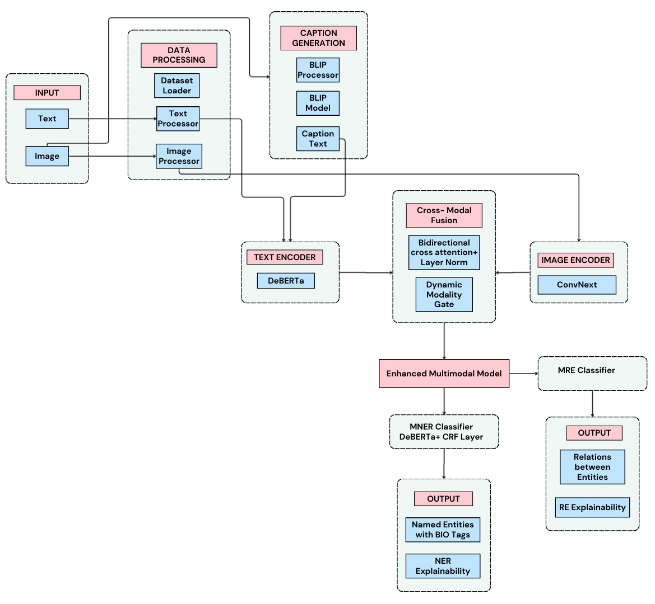

Figure 3.1 – System Architecture

MULTIMODAL ENTITY RECOGNITION AND RELATION

EXTRACTION PROCESS
The multimodal entity recognition and relation extraction process in this work is structured to accurately analyze social media data by combining textual and visual information using a deep learning-based framework. Social media posts often contain informal language, abbreviations, and ambiguous expressions, while images may include irrelevant or misleading content. These challenges reduce the effectiveness of traditional text-only models. To address this, the proposed system integrates image captioning and relevance scoring mechanisms to ensure that only meaningful visual information contributes to the analysis.
The workflow begins with the acquisition of tweet text and associated images, followed by preprocessing steps such as text cleaning, tokenization, image resizing, normalization, and caption generation. The generated captions act as a bridge between image and text modalities. A relevance scoring model then evaluates the alignment between text and captions, ensuring that irrelevant image-text pairs are filtered out. The filtered inputs are processed using multimodal fusion, where textual and visual features are combined to create a unified representation.
During training, the system optimizes multiple components, including NER loss and relation extraction loss, while handling noisy data through strict preprocessing and sampling strategies. The model learns to identify entities and their relationships even in complex and ambiguous scenarios. During inference, the system processes new inputs to generate outputs consisting of entity labels, relationships, captions, and relevance scores. The effectiveness of the system is evaluated using metrics such as Precision, Recall, and F1-score, demonstrating improved performance compared to traditional approaches.
    - ENTITY RECOGNITION AND RELATION EXTRACTION MECHANISM
The entity recognition and relation extraction mechanism employed in this work is based on a structured and attention-driven approach that enables accurate identification of entities and their relationships. The mechanism begins once the fused multimodal features are obtained from the fusion layer. The textual and visual embeddings are combined to form a rich representation that captures both semantic and contextual information.
For entity recognition, the system uses a deep learning architecture consisting of Layer Normalization, fully connected layers, and a Conditional Random Field (CRF) decoder. The CRF layer ensures valid BIO tagging sequences and improves consistency in entity labeling by modeling dependencies between tags. This enables accurate detection of entities such as persons, organizations, locations, and miscellaneous categories.
For relation extraction, the system employs an attention-based span pooling mechanism that computes weighted representations of entity spans. These span representations are then passed to a biaffine classifier, which models interactions between entity pairs and predicts their relationships. The biaffine function captures both linear and bilinear interactions, enabling precise relation classification. This mechanism ensures that relationships are identified accurately even when contextual information is distributed across multiple modalities.
During inference, the model produces outputs that include entity labels, relation types, and confidence scores, providing a structured representation of the input data. This integrated mechanism enhances the system’s ability to perform complex information extraction tasks in noisy and multimodal environments.

3.3 ATTENTION-BASED MULTIMODAL FUSION APPROACH

The attention-based multimodal fusion mechanism implemented in this work enhances the model’s ability to effectively integrate textual and visual features. The fusion process is designed to dynamically adjust the importance of each modality based on its relevance to the task. This is achieved using attention mechanisms and dynamic gating strategies that refine feature representations.
The process begins with the extraction of text embeddings using DeBERTa-v3 and visual embeddings using ConvNeXt-Tiny. These embeddings are further enriched using caption representations generated by the BLIP model. A cross-attention mechanism is applied to capture interactions between text and visual features, enabling the model to focus on relevant information across modalities. Additionally, a dynamic modality gate computes weights for each modality, allowing the model to prioritize either text or image features depending on their importance.
Mathematically, the fusion process can be represented as a weighted combination of text and image features, where learnable parameters determine the contribution of each modality. This mechanism helps suppress noisy or irrelevant visual information while enhancing meaningful features that contribute to entity recognition and relation extraction.

ELEMENTS OF THE MULTIMODAL FUSION FRAMEWORK
The multimodal fusion framework consists of several key components that work together to improve model performance. The text encoder extracts contextual representations from input text, while the image encoder captures visual features from images. The caption generator bridges the gap between vision and language by converting images into textual descriptions. The relevance scoring module ensures that only meaningful image-text pairs are processed further.
The attention-based fusion module integrates these features by applying cross-modal attention and dynamic gating, resulting in a unified representation. This representation is then used by the NER and relation extraction modules to generate structured outputs. By combining multiple modalities and refining feature representations through attention mechanisms, the framework achieves improved accuracy, robustness, and contextual understanding compared to traditional unimodal approaches.

CHAPTER 4

ALGORITHM DEVELOPMENT AND IMPLEMENTATION

DEEP LEARNING BASED APPROACH
The proposed system adopts a deep learning-based multimodal approach that jointly processes textual and visual information to perform Named Entity Recognition (NER) and Relation Extraction (RE) on social media content. Unlike conventional single-modality models that rely only on text, this pipeline leverages the additional semantic information present in accompanying tweet images, which helps improve entity disambiguation and relation inference.
The overall framework is built on three pre-trained deep neural backbones: DeBERTa-v3-base for contextual text representation, ConvNeXt-Tiny for hierarchical visual feature extraction, and BLIP (Bootstrapping Language-Image Pre-training) for image captioning and cross-modal semantic alignment. These components are integrated through a learnable Cross-Modal Discriminator, a Bidirectional Cross-Attention Fusion module, and a Dynamic Modality Gate, which together adaptively balance the contributions of text and image at the sample level.
The NER sub-task is formulated as a sequence labeling problem using the BIO (Beginning–Inside–Outside) tagging scheme. A CRF layer is employed for decoding, ensuring valid label transitions and improving prediction consistency. The RE sub-task focuses on classifying the semantic relationship between a head and tail entity span, using attention-weighted span pooling followed by a biaffine scoring mechanism. Both tasks are trained jointly using a weighted combined loss to enable shared learning across tasks.

PROPOSED SYSTEM IMPLEMENTATION
The system follows a modular pipeline consisting of the following stages:
data preprocessing → feature extraction and encoding → cross-modal fusion → task-head inference (NER + RE) → post-processing with explainability.

Data Preprocessing
The raw data is obtained from three multimodal Twitter benchmark datasets — Twitter-2015 (TW15), Twitter-2017 (TW17), and MNRE — where each sample includes tweet text in BIO format along with a corresponding image. The preprocessing pipeline performs the following steps:
- Data Cleaning:
Samples with missing text, unavailable images, or invalid BIO labels are removed to maintain data quality and avoid training errors.
- Tokenization and Label Alignment:
Text is tokenized using the DeBERTa tokenizer. Since some words are split into subwords, labels are carefully aligned so that each sub-token retains the correct entity label. The sequence length is limited to 96 tokens using padding or truncation.
- Image Handling:
Images are loaded by checking multiple file formats across dataset folders. If an image is missing, a placeholder image tensor is used to maintain consistency in the data pipeline.
- Image Augmentation:
During training, images are enhanced using standard augmentation techniques such as random transformations and color adjustments. Validation and test images are only resized and normalized.
- Class Balancing:
To reduce class imbalance in relation labels, underrepresented classes are oversampled to ensure more balanced training.

- Span Preparation:
Entity spans are prepared for relation extraction. During training, both actual and predicted spans are used, while during testing, only predicted spans are considered.

Feature Extraction and Detection
Feature extraction is carried out separately for both textual and visual data, after which they are transformed into a unified representation for further processing. For textual features, the tweet content is processed using the DeBERTa-v3-base model, which produces contextual embeddings for each token along with an overall sentence-level representation; to improve training efficiency, some layers of the model are kept frozen. For visual features, images are processed using the ConvNeXt-Tiny model to extract high-level representations, which are then converted into a compact feature vector, while intermediate feature maps are retained for later visualization purposes. Additionally, image captioning is performed using the BLIP model, which generates a descriptive caption for each image; this caption is encoded to capture its semantic meaning and compared with the tweet text to assess their semantic alignment. Finally, a cross-modal relevance module, implemented as a lightweight neural network, evaluates the relationship between text and image features and produces a relevance score; when this score is low, the system dynamically prioritizes textual information over visual features to ensure more reliable predictions.

Cross-Modal Fusion and NER Detection
Text and image features are combined using a cross-attention mechanism, where both modalities interact and enhance each other’s representations.

A dynamic gating mechanism determines how much importance to assign to text and image features for each input. This ensures that irrelevant images do not negatively affect the results.
The combined representation is then passed to the NER module, which identifies entities in the text using the BIO tagging scheme. A CRF layer is applied to ensure consistent and valid label predictions.

Post-Processing
After entity recognition, continuous label sequences are grouped together to form complete entity spans, which represent meaningful entities within the text. These identified spans are then paired systematically to determine potential relationships between them. The relation extraction module evaluates each pair of entities and predicts the type of relationship that exists, using attention mechanisms to focus on the most relevant features of each entity and improve prediction accuracy.
The final output generated for each tweet includes the identified entities along with their corresponding types, the relationships established between these entities, the caption generated from the associated image, the relevance score indicating the alignment between the textual and visual content, and the contribution weights that reflect the relative importance of text and image features in the overall prediction

ALGORITHM
The proposed YOLOv8–Ultimate CBAM architecture is shown in Figure 4.1.

PREPROCESSING
- Load multimodal dataset
D = {(tweeti ,imagei ,BIO_labelsi ,relation_labelsi )}
- For each sample in dataset D, perform preprocessing:
2.1 Remove samples with missing text, invalid labels, or unavailable images
2.2 Tokenize tweet text using DeBERTa tokenizer
2.3 Align BIO labels with subword tokens
2.4 Limit sequence length to 96 tokens using padding or truncation
2.5 Load corresponding image
2.6 If image is missing, replace with a dummy image tensor
2.7 Apply image augmentation (training only)
2.8 Normalize images using standard values
2.9 Balance dataset by oversampling minority relation classes

TRAINING PHASE
- Initialize models:
DeBERTa-v3-base (text encoder)
ConvNeXt-Tiny (image encoder)
BLIP (caption generator)
- For each batch of data:
4.1 Extract text features using DeBERTa
4.2 Extract image features using ConvNeXt
4.3 Generate image captions using BLIP
4.4 Compute similarity between tweet and caption
4.5 Compute relevance score using Cross-Modal Discriminator
4.6 Perform cross-attention fusion of text and image features
4.7 Compute modality weights for text and image
4.8 Generate fused feature representation

NER DETECTION
- For each fused representation:
5.1 Pass features through NER network
5.2 Predict BIO labels for each token
5.3 Apply CRF decoding for valid label sequences

RELATION EXTRACTION
- For each detected entity pair:
6.1 Extract head entity representation
6.2 Extract tail entity representation
6.3 Apply attention-based pooling
6.4 Predict relation using classifier

LOSS AND OPTIMIZATION
- Compute total loss by combining:
7.1 NER loss
7.2 Relation extraction loss
- Update model parameters using AdamW optimizer
- Apply gradient clipping and learning rate scheduling
- Save best model based on validation performance

TESTING PHASE
- For each test sample:
11.1 Extract text and image features
11.2 Perform cross-modal fusion
11.3 Predict entity labels using NER model
11.4 Extract entity spans
11.5 Predict relations between entity pairs
11.6 Generate image caption
11.7 Compute alignment score and modality weights

OUTPUT GENERATION
- For each input sample, produce:
12.1 Entity list with labels
12.2 Relation triplets (head, relation, tail)
12.3 Generated image caption
12.4 Alignment score
12.5 Modality contribution weights

Table 4.1 – Parameter Table

Parameter | Value
Input Size | 640 × 640
Batch Size | 16
Learning Rate | 0.001
Optimizer | Adam
Epochs | 100–150
Backbone | CSPDarknet
Neck | PANet
Head | YOLOv8-Seg
Attention Module | CBAM (Channel + Spatial)
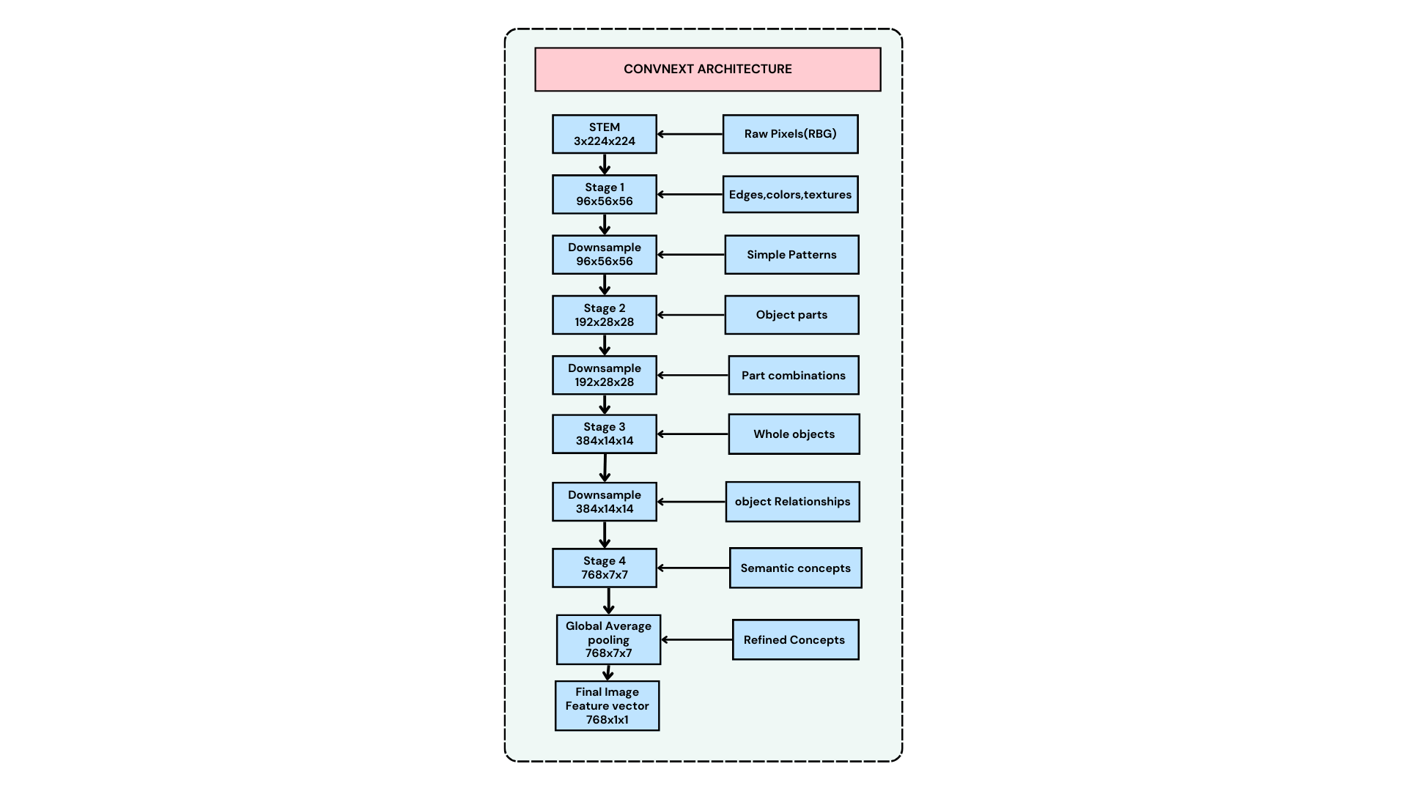
Figure 4.2 –Convnext Architecture

Figure 4.2 –Convnext Architecture

Attention Mechanism Policy – Cross-Modal Discriminator and BLIP Alignment
The system employs two complementary mechanisms to control how visual information is incorporated into the multimodal representation. These mechanisms ensure that only relevant image information contributes to the final prediction, thereby improving robustness and accuracy.
4.4.1 BLIP Caption-Based Cosine Alignment
For each image, the BLIP model generates a descriptive caption using beam search. The tweet text and the generated caption are then encoded independently to obtain their respective sentence-level representations.
A cosine similarity score is computed between these two representations to measure semantic alignment. A higher score indicates that the image and tweet convey similar information (for example, a sports-related tweet accompanied by a relevant action image). In contrast, a lower or negative score suggests weak or no semantic connection, which may occur in cases such as unrelated images or memes.
This alignment score serves as an initial indicator of how useful the image is for the given text.

4.4.2 Cross-Modal Discriminator (CMD)
The Cross-Modal Discriminator is a neural network component designed to evaluate the overall relevance between textual and visual features. It takes as input the text representation, the image representation, their interaction capturing combined multimodal information, and the alignment score obtained from the BLIP model. These inputs are integrated and passed through multiple layers of the network to produce a relevance score ranging between 0 and 1.
A threshold-based policy is then applied to guide modality usage: if the relevance score is below 0.4, the image is considered uninformative and the system relies solely on textual features; otherwise, both text and image features are utilized for further processing. During training, this relevance score functions as a soft gating mechanism, enabling the model to progressively learn which image–text pairs are meaningful and should contribute to tasks such as Named Entity Recognition (NER) and Relation Extraction (RE).

4.4.3 Bidirectional Cross-Attention Fusion
To integrate textual and visual features, the system employs a bidirectional cross-attention mechanism that enables deep interaction between the two modalities. In the text-to-image attention phase, each text token attends to the image features, allowing the textual representation to be enriched with relevant visual context. Conversely, in the image-to-text attention phase, the image representation attends to all text tokens, making it more aware of the underlying textual semantics. The outputs from both attention directions are then combined and normalized to form a unified multimodal representation.
To further refine this integration, a Dynamic Modality Gate is applied, which adaptively balances the contributions of text and image features. Based on the computed relevance score, the gate assigns appropriate weights to each modality, ensuring that less relevant visual information does not negatively impact the model’s performance. The resulting fused representation is then utilized by both the Named Entity Recognition (NER) and Relation Extraction (RE) modules for final predictions.

IMPLEMENTATION ENVIRONMENT
The framework is implemented on Kaggle using Python 3.10 with NVIDIA Tesla T4 GPUs (16 GB VRAM). DeBERTa-v3-base and BLIP are loaded via Transformers, and ConvNeXt-Tiny via timm, all running on PyTorch 2.x. To optimize memory, gradient accumulation (effective batch size 32), checkpointing, mixed precision, and partial layer freezing are applied. Training takes about 2–3 hours for 5 epochs, with outputs saved as a compressed file

CHAPTER 5

RESULTS AND DISCUSSIONS

ENTITY RECOGNITION AND RELATION EXTRACTION RESULTS
The proposed multimodal framework effectively performs Named Entity Recognition (NER) and Relation Extraction (RE) by integrating textual and visual information from social media data. The system processes tweet text along with corresponding images, where image captions generated using the BLIP model act as a bridge between visual and textual modalities. The relevance scoring module ensures that only semantically aligned image-text pairs are processed further, thereby reducing noise and improving prediction accuracy.
The model successfully identifies entities such as persons, organizations, locations, and miscellaneous categories from unstructured and noisy tweet data. The relation extraction module further determines relationships between detected entities using attention-based span pooling and a biaffine classifier. The integration of image features and captions improves contextual understanding, especially in cases where textual information alone is ambiguous. The combined output includes entity labels, relation types, and confidence scores, enabling accurate and structured representation of real-world information.

EVALUATION METRICS

Precision:
Precision indicates the proportion of correctly predicted entities and relations out of all predictions made by the model. It measures how accurate the system is in its predictions and is calculated using Equation (5.1).
Precision =
True Positives

True Positives + False Positives
(𝟓. 𝟏)

Recall:
Recall represents the proportion of actual entities and relations that are correctly identified by the model. It measures the ability of the system to detect all relevant instances and is calculated using Equation (5.2).
True Positives
Recall = True Positives + False Negatives (𝟓. 𝟐)

F1 Score:
F1-score provides a balanced measure of precision and recall by taking their harmonic mean. It is useful when both false positives and false negatives need to be considered equally, as shown in Equation (5.3).
2 * ( Precision * Recall )
F1 Score = Precision + Recall (5.3)

5.2.4 Accuracy:
Accuracy measures the overall correctness of the model by comparing the total number of correct predictions to the total number of predictions made, as shown in Equation (5.4).
TP+TN
Accuracy =
TP+TN+FP+FN (5.4)

    - Mean Average Precision (mAP):
Mean Average Precision (mAP) evaluates the overall performance of the model across all entity and relation classes by averaging precision values. It provides a comprehensive measure of the model’s effectiveness in information extraction tasks, as shown in Equation (5.5).

mAP=N1​∑i=1N​APi​
(5.5)

RESULTS

A qualitative comparison of the proposed multimodal NER and relation extraction system is illustrated through sample results, including the original tweets with images, ground-truth annotations, and the predicted outputs generated by the model. As shown in Table 5.1, these examples demonstrate the effectiveness of the approach in accurately identifying named entities and extracting semantic relationships by leveraging both textual and visual information in complex social media scenarios.
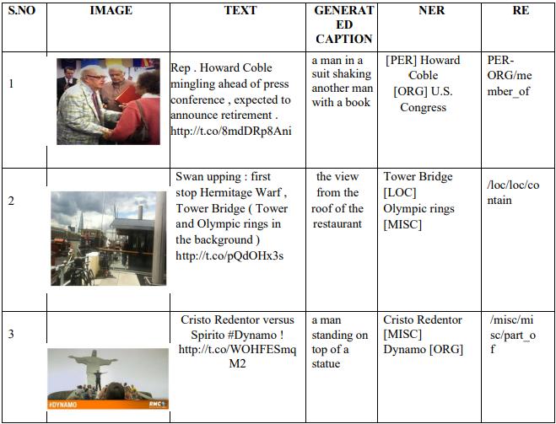
Table 5.1 – Results Table

PERFORMANCE ANALYSIS

Table 5.2 – Evaluation Table

Relation Extraction (RE) | Precision | Recall | F1-score
Named Entity Recognition (NER) | 55.1% | 53.7% | 54.0%
Relation Extraction (RE) | 35.1% | 25.1% | 27.4%

The comparative evaluation presented in Table 5.2 highlights the performance of the proposed multimodal NER and relation extraction system across key metrics. For the Named Entity Recognition (NER) task, the model achieves a Precision of 55.1%, Recall of 53.7%, and F1-score of 54.0%, indicating a well-balanced ability to correctly identify and classify entities in social media text. This balanced performance reflects the effectiveness of integrating textual and visual features, which helps improve entity recognition, especially in contextually ambiguous scenarios.
In contrast, the Relation Extraction (RE) task records a Precision of 35.1%, Recall of 25.1%, and F1-score of 27.4%. While the precision suggests that many predicted relations are correct, the comparatively lower recall indicates that some relationships are not fully captured by the model. This can be attributed to the inherent complexity of relation extraction, which depends heavily on accurate entity detection and deeper semantic understanding of both text and image context.
Overall, the results demonstrate that the proposed multimodal framework performs effectively for entity recognition and shows promising capability in relation extraction. The incorporation of cross-modal alignment and attention mechanisms contributes to improved contextual understanding; however, further refinement may enhance the model’s ability to capture more complex relationships. These findings confirm that leveraging both textual and visual information provides a meaningful advantage over traditional text-only approaches in social media analysis.

CHAPTER 6

CONCLUSION AND FUTURE WORK

6.1 CONCLUSION

The proposed work presents a multimodal deep learning framework for Named Entity Recognition (NER) and Relation Extraction (RE) by integrating textual and visual information from social media data. The system overcomes the limitations of traditional text-only approaches by incorporating image features and caption-based representations, which improve contextual understanding. The use of image captioning and relevance scoring ensures better alignment between modalities, reducing noise and enhancing prediction accuracy.
The framework combines advanced models such as DeBERTa-v3 for text encoding and ConvNeXt-Tiny for image feature extraction, along with an attention-based fusion mechanism for effective feature integration. The use of structured prediction techniques and relation classification methods enables accurate identification of entities and their relationships. Overall, the system demonstrates improved performance, robustness, and reliability in handling complex and noisy real-world data.

6.2 FUTURE WORK
Future work can focus on enhancing the system by incorporating additional modalities such as audio and video to further improve contextual understanding in multimodal environments. The use of more advanced vision-language models and large-scale pre-trained transformers can also help improve accuracy and generalization. Additionally, improving caption generation and relevance scoring techniques can lead to better alignment between text and visual data.
Another important direction is optimizing the model to reduce computational complexity and enable real-time deployment in resource-constrained environments. Expanding the dataset with more diverse and large-scale multimodal data can improve robustness and adaptability. Furthermore, integrating explainable AI techniques can provide better interpretability of model predictions, making the system more suitable for real-world applications such as social media analysis, healthcare, and intelligent content monitoring.

REFERENCES

- Zhang, Q., Li, Z., Kong, J. and Zuo, M., 2024. Multimodal Entity Recognition and Relation Extraction via Dynamic Visual-Textual Enhanced Fusion for Social Media Applications in Consumer Electronics. IEEE Transactions on Consumer Electronics.

- Xu, M., Peng, K., Liu, J., Zhang, Q., Song, L. and Li, Y., 2025. Multimodal Named Entity Recognition based on topic prompt and multi-curriculum denoising. Information Fusion, p.103405.

- Zhang, Y., Li, G., Gao, H. and Dang, D., 2025. Multi-scale interaction network for multimodal entity and relation extraction. Information Sciences, 699, p.121787.

- Zeng, Q., Yuan, M., Su, Y., Mi, J., Che, Q. and Wan, J., 2025. Improving multimodal named entity recognition via text-image relevance prediction with large language models. Neurocomputing, p.130982.

- Xu, M., Hou, F., Liu, J., Zhang, M., Shi, L., Kou, F., Guo, L., Yu, P.S. and Hu, X., 2025. Multimodal named entity recognition in the era of large pre-trained models: A comprehensive survey. Information Fusion, p.103767.

- Ko, H., Yoo, J. and Jeong, O.R., 2025. MDCKE: Multimodal deep-context knowledge extractor that integrates contextual information. Alexandria Engineering Journal, 119, pp.478-492.

- Zhang, R., Hu, Y., Liu, T. and Cao, J., 2025. ImagePrompt: Image-Enhanced Prompt-tuning for Multimodal Relation Extraction. Neurocomputing, p.131264.

- Wang, G., Liu, J., Xie, J., Zhu, Z. and Zhou, F., 2024. Joint multimodal entity-relation extraction based on temporal enhancement and similarity-gated attention. Knowledge-Based Systems, 304, p.112504.

- Hongping, T., 2025, February. Multi-Modal Recognition Via Multi-Head Attention Fusion of Text, Visual and Audio Content on Video Datasets. In 2025 International Conference on Electronics and Renewable Systems (ICEARS) (pp. 1405-1410). IEEE.

- Yu, Y., Zhang, Y., Liu, X. and Zhu, S., 2023. A Novel Joint Extraction Model for Entity Relations Using Interactive Encoding and Visual Attention. IEEE Access, 11, pp.132567 132575

- Zheng, C., Wu, Z., Feng, J., Fu, Z. and Cai, Y., 2021, July. MNRE: A chalenge multimodal dataset for neural relation extraction with visual evidence in social media posts. In 2021 IEEE International Conference on Multimedia and Expo (ICME) (pp. 1-6). IEEE Computer Society.

- Jia, W., Jin, L., Wei, K., Shang, Y., Liu, N., Lu, Z., Liu, Q., Zhang, L., Zhong, J. and Hu, Y., 2025, October. U-MERE: Unconstrained Multimodal Entity and Relation Extraction with Colaborative Modeling and Order-Sensitive Optimization. In Proceedings of the 33rd ACM International Conference on Multimedia (pp. 4349-435)

