**1 Write a program that takes an integer minutes and converts it to seconds**

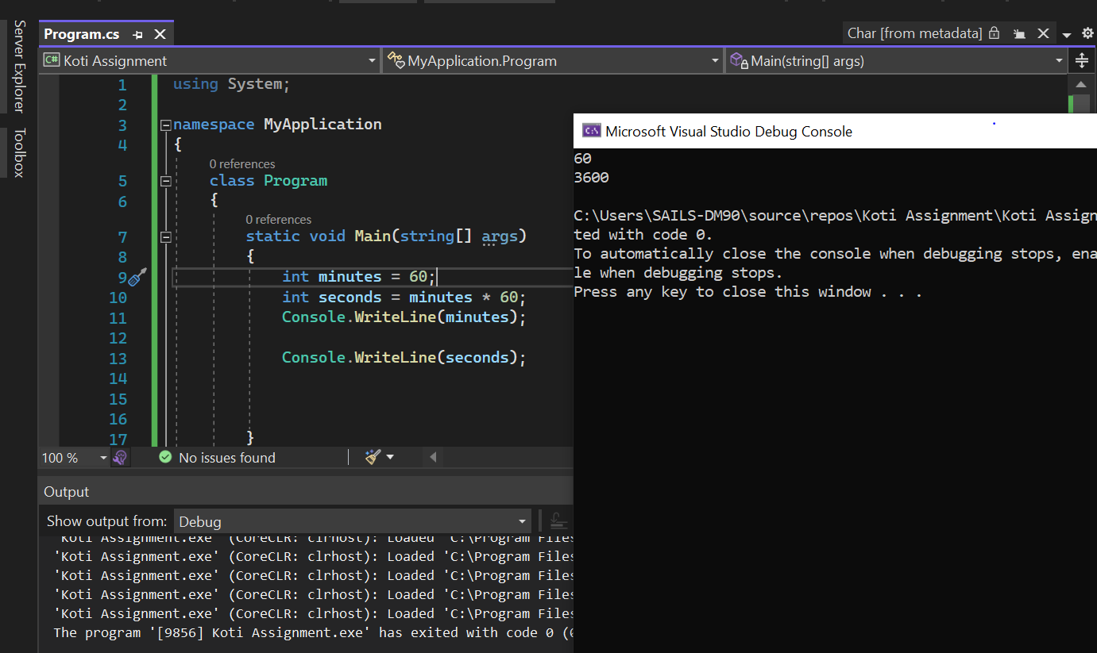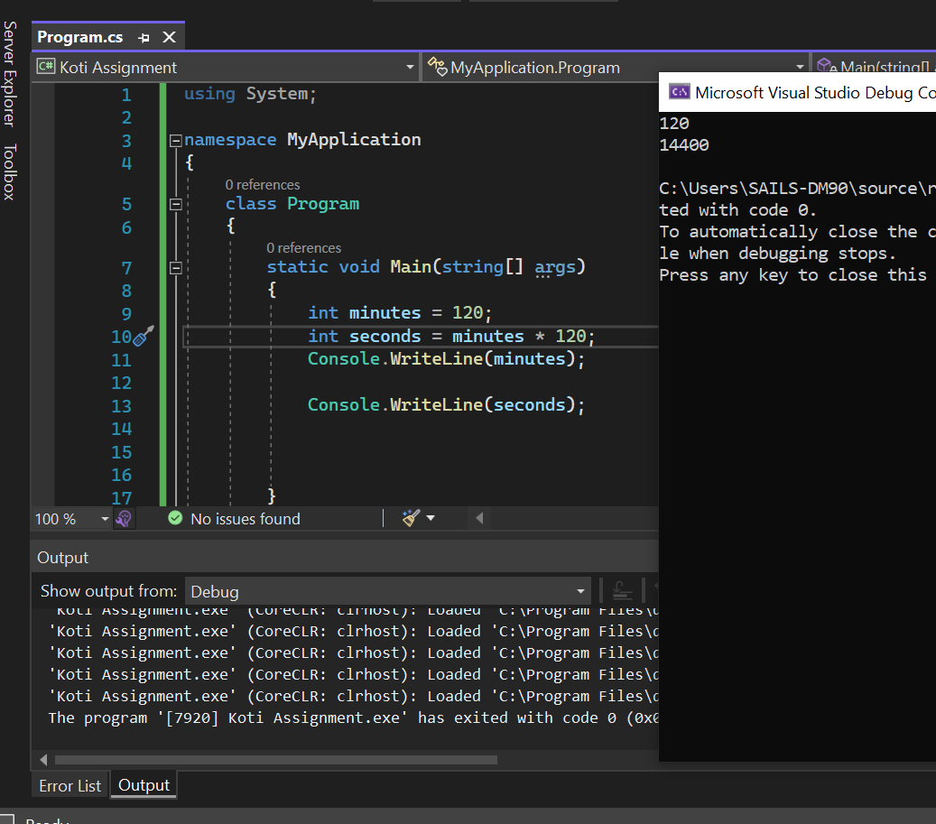

**2 Write a program that takes the age in years and returns the age in days**

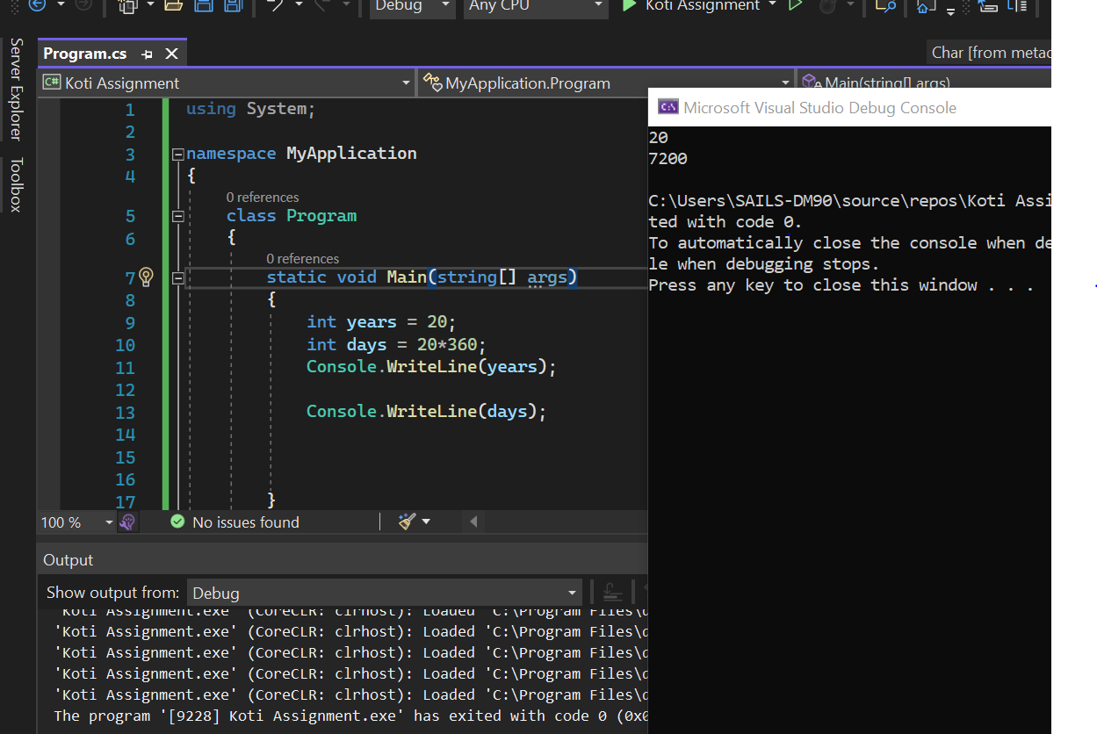

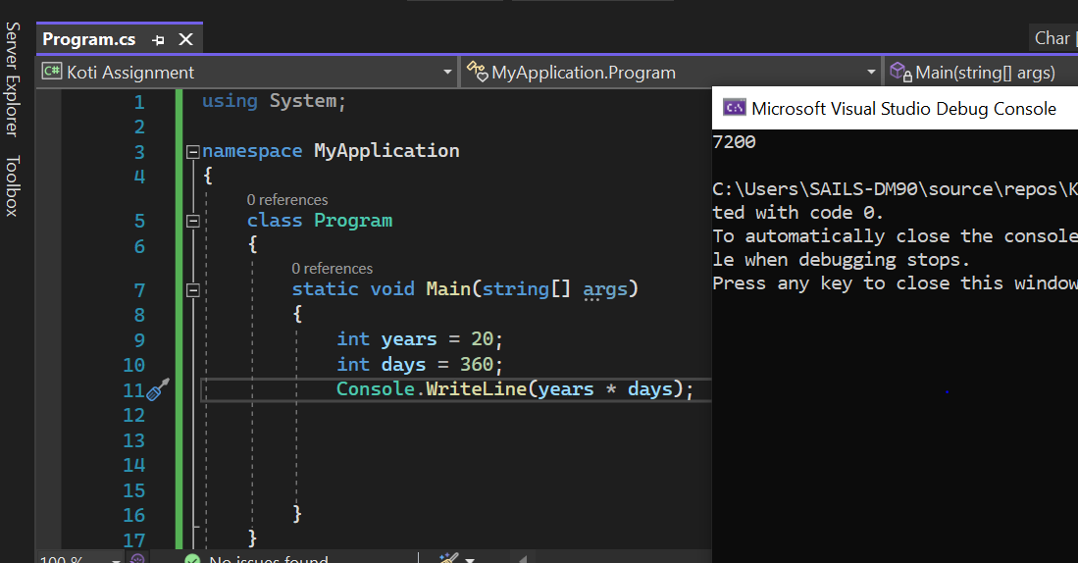

**3 Write a program that takes the base and height of a triangle and returns its area.** The area of a triangle is: (base * height) / 2

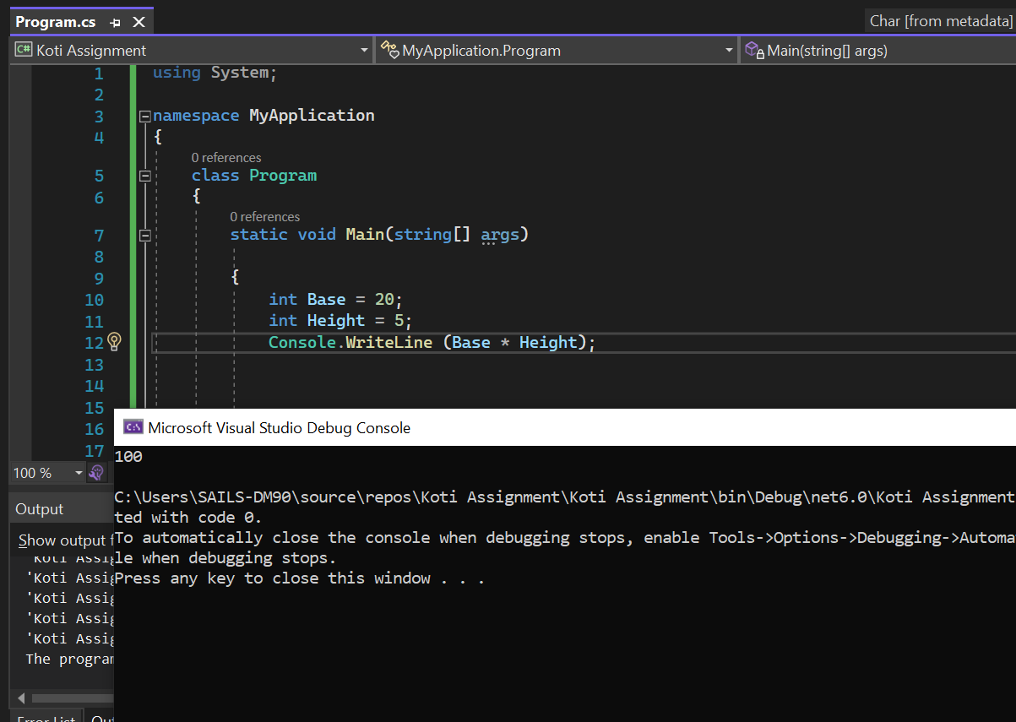

**4 Write a program that takes length and width and finds the perimeter of a rectangle.**

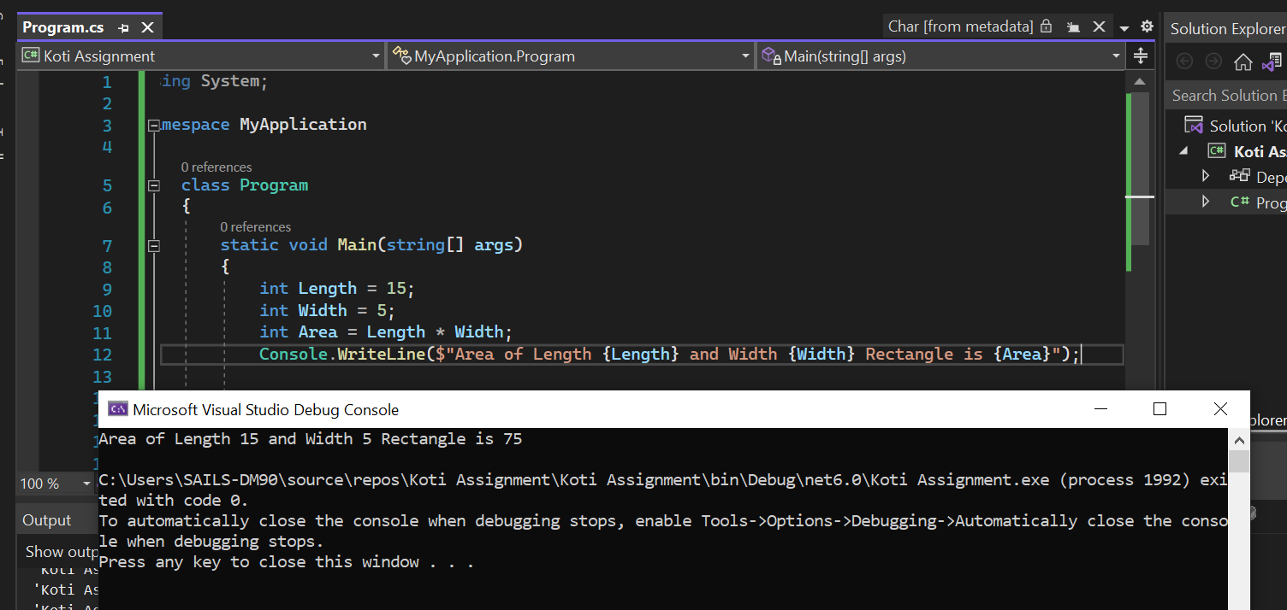

**5 Write a program that returns true if an integer is evenly divisible by 5, and false otherwise.**

