1. Write a program to get Output as “C# Introduction”?

1. Fill the Missing Part. And Output should be “Hello World”?

static void (string[] args)

{

("Hello World!");

}

1. What should I use to not execute “ The code below will print the words Hello World to the screen, and it is amazing”?

using System;

namespace HelloWorld

{

class Program

{

static void Main(string[] args)

{

The code below will print the words Hello World

to the screen, and it is amazing

Console.WriteLine("Hello World!");

}

}

}

1. Create a string variable with your name?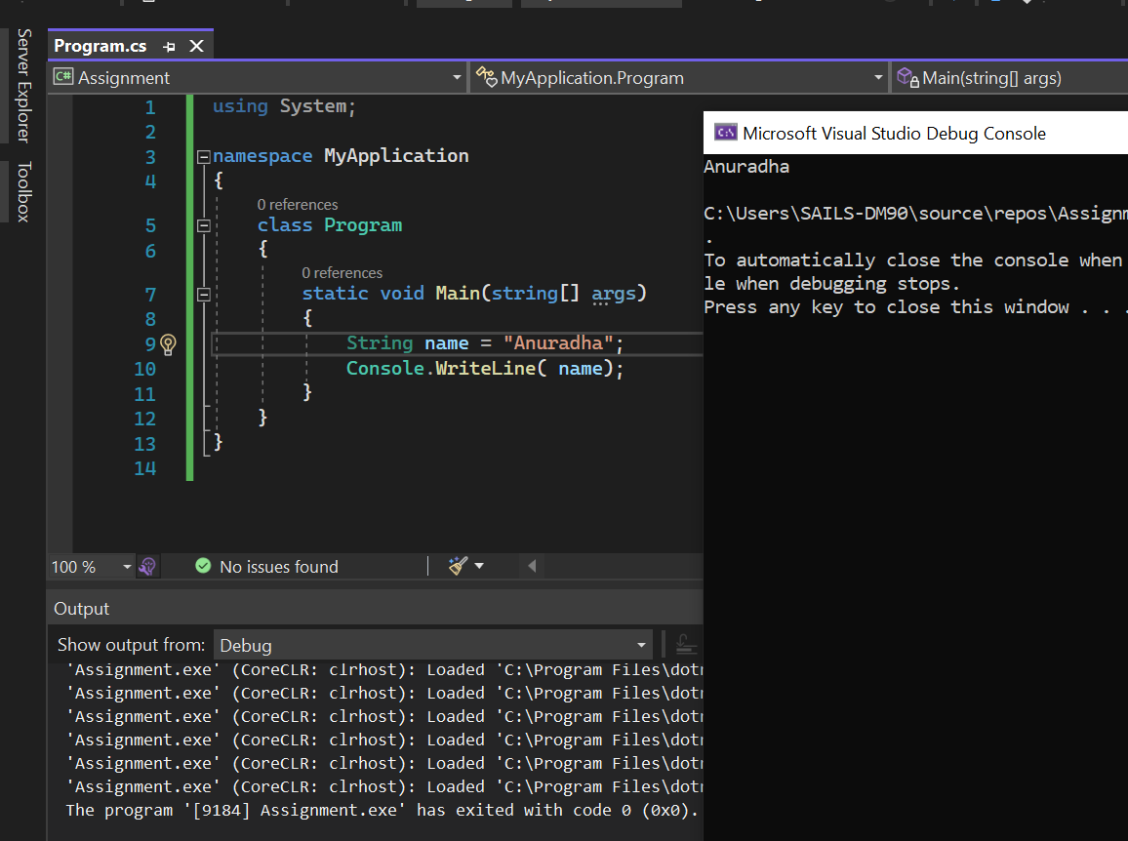
2. Create a integer variable with output as 2560?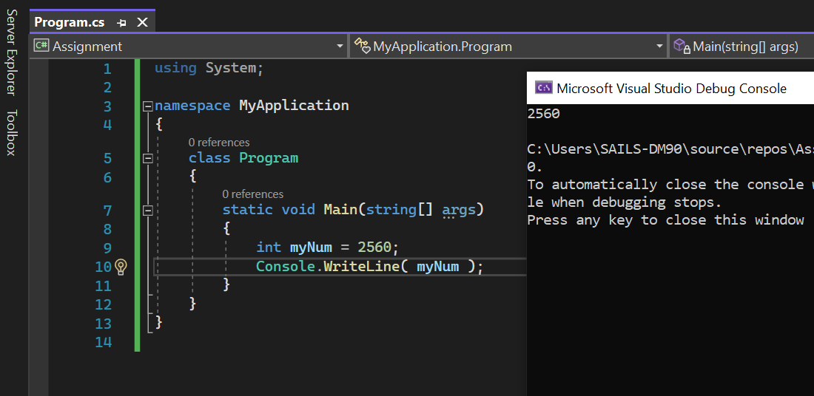
3. Overwrite 15 to 20 as output using datatype.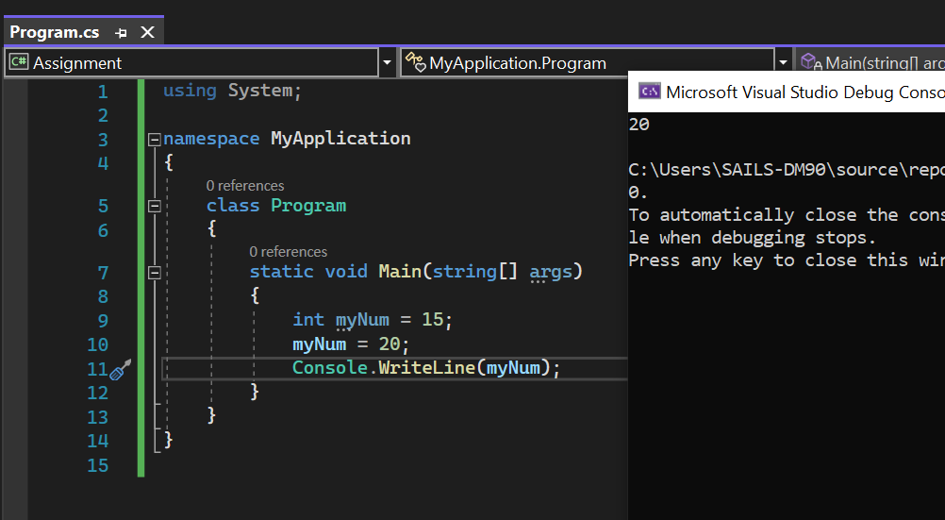
4. Combine 18 and 25, and show output sum of the two?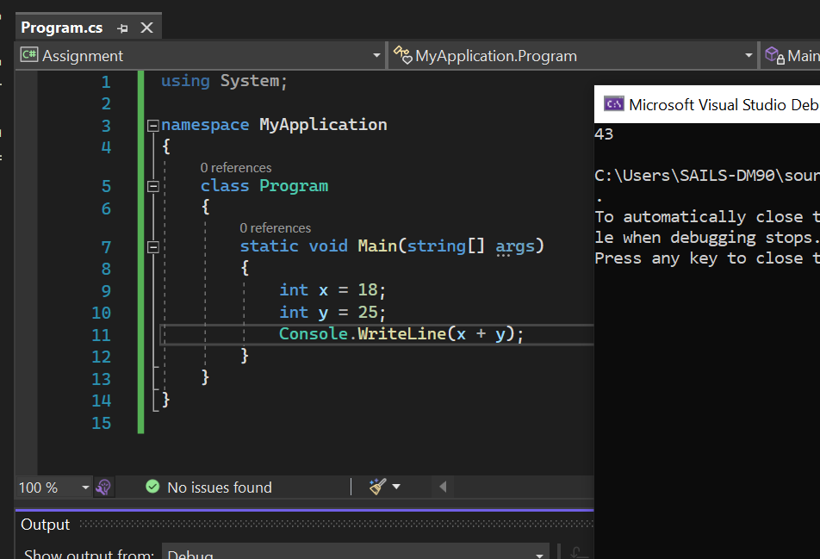
5. Write one example on each datatype and show the output?
6. Give One example using all operators and show the output?
7. Write one program on Bool operation and show output?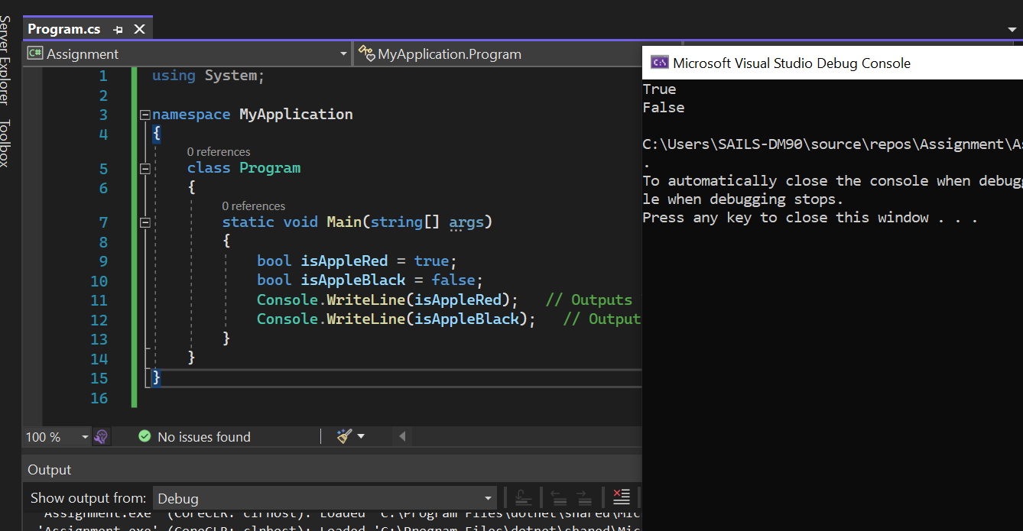
8. How can I declare a constant value to any variable name? with example.
9. What is identifier in below program?

using System;

namespace MyApplication

{

class Program

{

static void Main(string[] args)

{

int minutesPerHour = 60;

int m = 60;

Console.WriteLine(minutesPerHour);

Console.WriteLine(m);

}

}

}

A: int minutesPerHour = 60;

1. What is difference between float and double, with one example each?
2. Double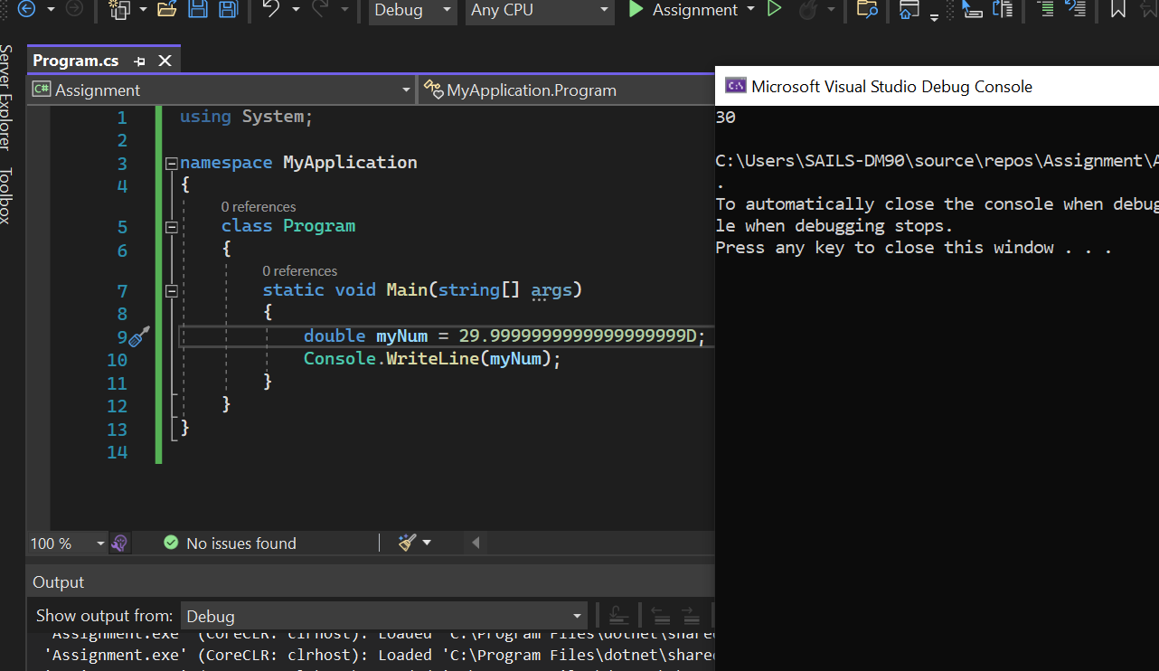 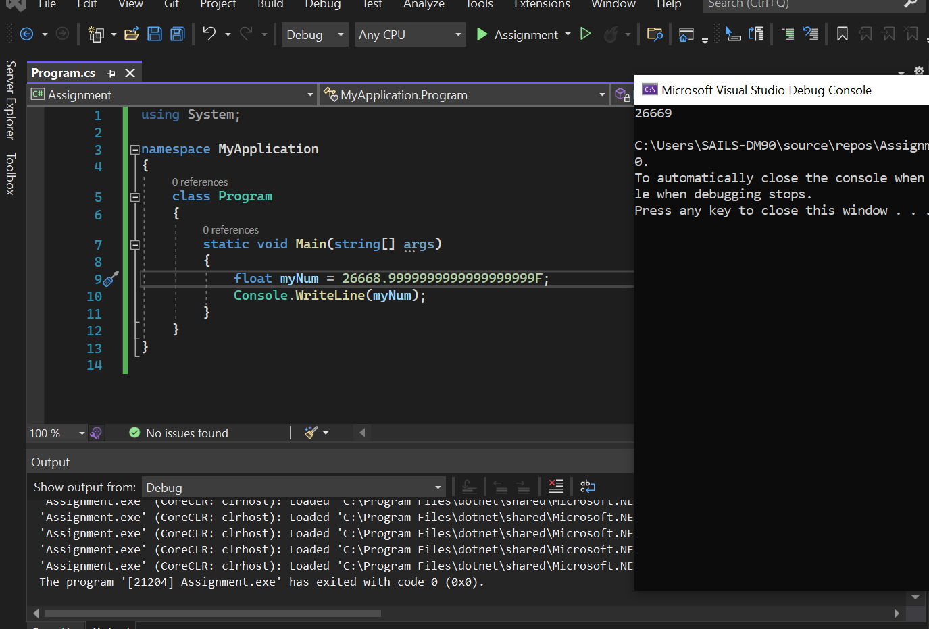
3. What is the output for below?

using System;

namespace MyApplication

{

class Program

{

static void Main(string[] args)

{

int x = 5;

int y = 2;

Console.WriteLine(x % y);

}

}

}

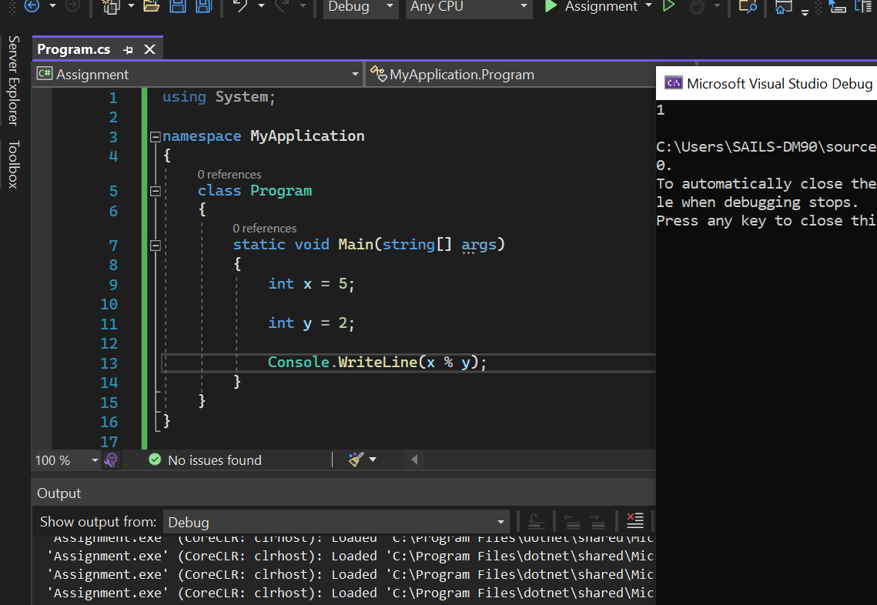

1. What is string Concatenation, give me with one example.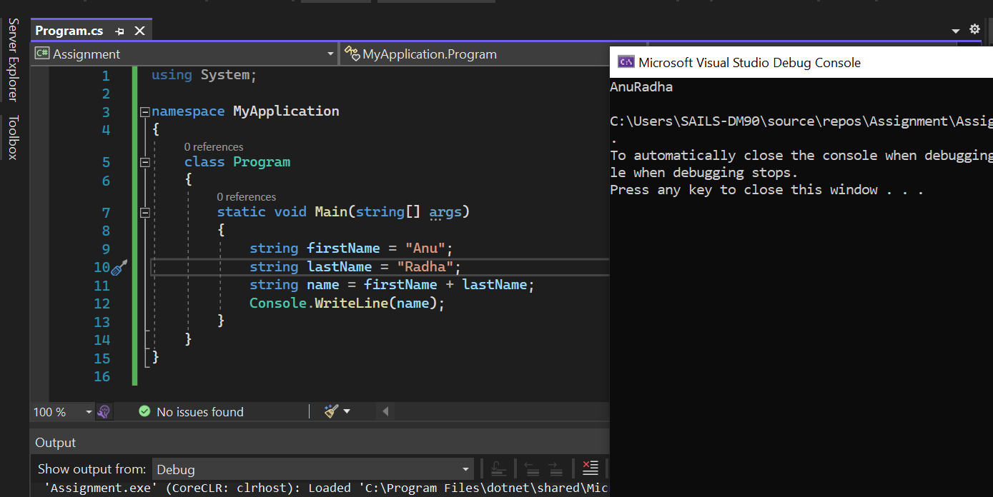
2. Which of the following are NOT Relational operators in C#.NET?

>=

!=

Not

<=

<>=

A. 1, 3

B. 2, 4

C. 3, 5

D. 4, 5

E. None of these

1. Which of the following statements are correct about the following code snippet?

int a = 10;

int b = 20;

bool c;

c = !(a > b);

There is no error in the code snippet.

An error will be reported since ! can work only with an int.

A value 1 will be assigned to c.

A value True will be assigned to c.

A value False will be assigned to c.

A. 1, 3

B. 2, 4

C. 4, 5

D. 1, 4

E. None of these

1. What is the expected output?

using System;

namespace MyApplication

{

class Program

{

static void Main(string[] args)

{

int x = 5;

x \*= 3;

Console.WriteLine(x);

}

}

}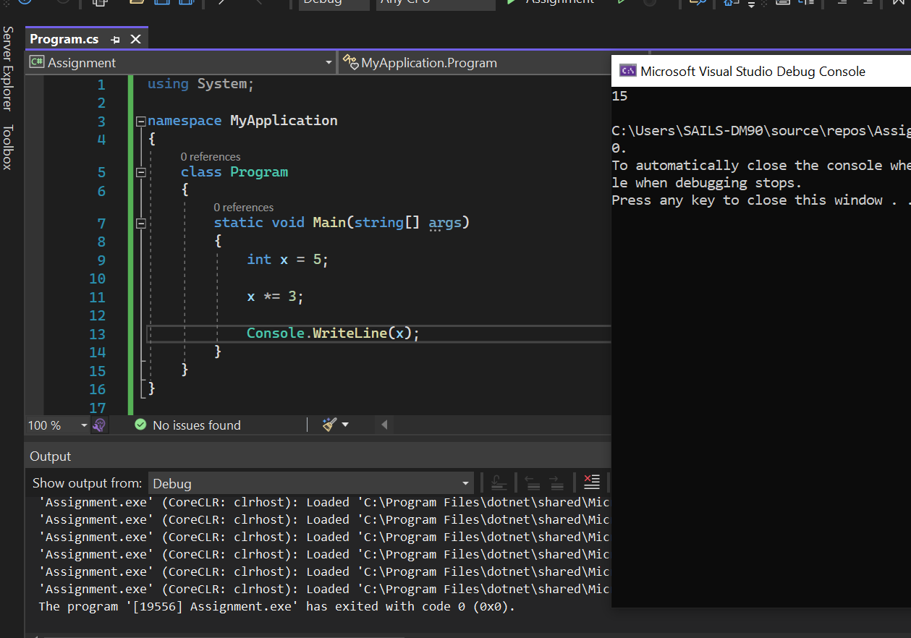

1. Write the output?

using System;

namespace MyApplication

{

class Program

{

static void Main(string[] args)

{

int x = 12;

Console.WriteLine(x > 3 || x < 14);

}

}

}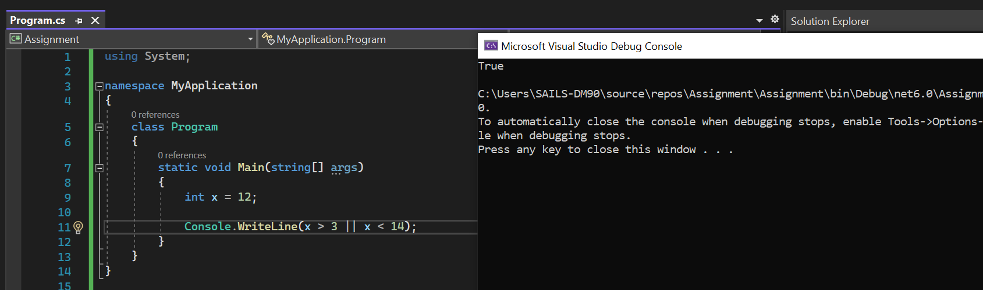

1. What is output?

string firstName = "John ";

string lastName = "Doe";

string name = string.Concat(firstName, lastName);

Console.WriteLine(name);

